These noteheads should be combined with stems and flags as necessary to create complete notes. In text-based applications, per the Unicode Musical Symbols documentation:

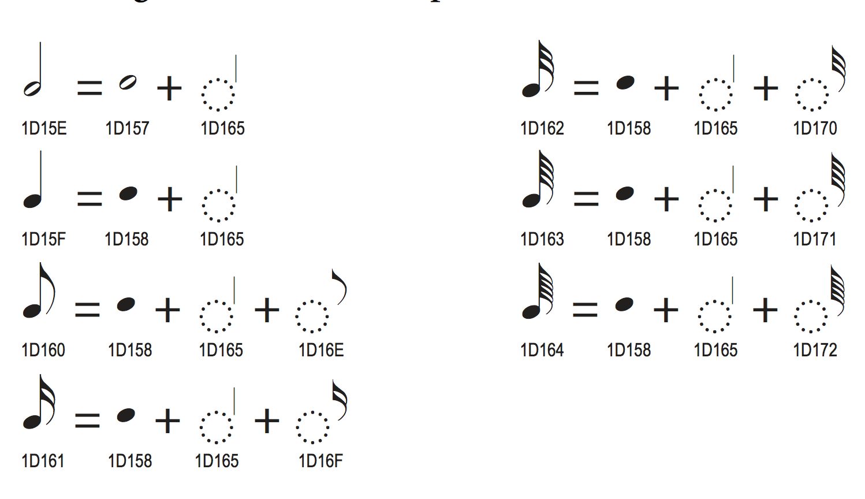

Scoring applications should draw stems using primitives, rather than using stem (i.e. U+1D165 as shown in the above image[1]), so that they can be drawn to the correct length.

*See also* the implementation notes for flags.

1. From Chapter 15 “Symbols”, *The Unicode Standard, Version 6.2*. Ed. Julie D. Allen et al. Mountain View; The Unicode Consortium, 2012.