**contact information**

* Alexander boyev 314393158

alexabo4@ac.sce.ac.il

* Moshe Faerman 204469449

moshesh81@ac.sce.ac.il

**Description**

In this project, we will try to build a simple neural network for the “hhd_dataset[1].represents 5073 pictures of the Hebrew alphabet letters. The Hebrew alphabet contains 27 letters, so each letter represents a class and contains about ~188 images of handwritten letters.

The program will execute the following steps:

* We will load the data from previous work, assignment (1) to a "dict" variable.
* The data is padded, greyscaled, resized, and split randomly but equally distributed into three categories: Train, Validation, and Test. With the sizes of 80% : 10% : 10% accordingly.
* We will turn each image negative.
* Since our goal is a categorical classification problem, we will need to “One-Hot” encode our label.
* We will build a neural network model with the following layers:
  + Input layer with 1024 neurons, according to the image size 32*32, using the activation function of “ReLU”
  + Hidden layer with 512 neurons.
  + Another Hidden layer with 512 neurons.
  + Output layer with 27 neurons, according to 27 Hebrew alphabet letters, using the “ SoftMax “ activation function.
* We will try to achieve the best model using different configurations on train and validation data such as:
  + No configuration
  + L1 Regularization with λ=0.01 and λ=0.001 for each layer except the output layer.
  + L2 Regularization with λ=0.01 and λ=0.001 for each layer except the output layer.
  + Adding Dropout=0.5 to each layer except the output layer.
  + L2 Regularization with λ=0.01 and λ=0.001 and Dropout=0.5 for each layer except the output layer.
* The model will be compiled using the “rmsprop” optimizer and “categorical cross-entropy” loss function.
* Now we can save the best model for future use.
* The best-saved model could be loaded, now we can fit the “test” set and report the results.
* We will generate a “result.txt” file that will contain:
  + Model configurations.
  + The accuracy of each letter.
* We will provide a confusion matrix, that will be saved on a CSV file.
* We will provide an image of the Loss curve for training & validation sets.

**Environment**

The script was developed and ran on Windows 10 pro edition, PyCharm 2019.3.3 (Community Edition) with Python 3.7 interpreter.

**Requirements**

To run the program, you will need to install the following libraries:

**import** cv2  
**import** numpy **as** np  
**import** pandas **as** pd  
**from** sklearn.metrics **import** confusion_matrix  
**import** pickle  
**import** sys  
**import** matplotlib.pyplot **as** plt  
**import** itertools  
**from** keras **import** Sequential  
**from** keras.layers **import** Dense  
**from** keras.layers **import** Dropout  
**from** keras **import** regularizers  
**from** keras.utils **import** to_categorical

**How to Run Your Program**

**Preconditions:**

1) install all the required models.

2) The assignment is delivered with the pickle file “data_resized_padded_greyscale” which represents the preprocessed data from the assignment (1).

3) You can load the best-saved model using the “model_and_parameters” file or skip to step (4) to run the entire program.

4) just cancel the comments and make functions available again, this way the script will make all the pipeline from scratch. Load -> Negative -> Train Best Model -> load Best Model -> Test -> Results.

Press “Run” in the PyCharm environment or any other python script IDE.

**Input Assumptions**

For such data, we achieved decent accuracy of 69.1% on the test set and 70.9% on the train & validation set using dropout=0.5 in each layer except the output layer and L2 regularization with λ=0.01. for so many classes (27 letters), we could use more data, especially when neural networks are involved.

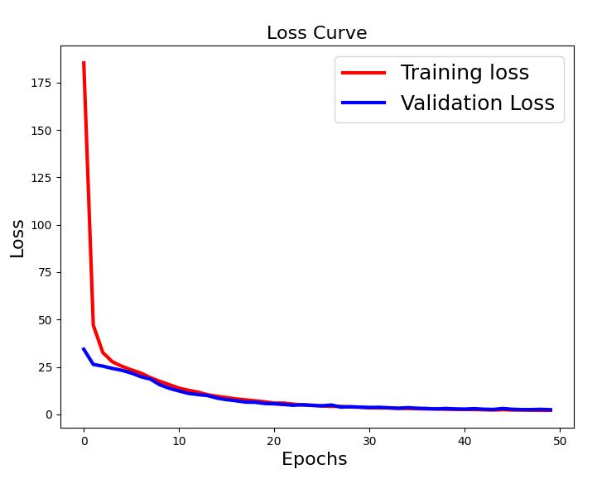

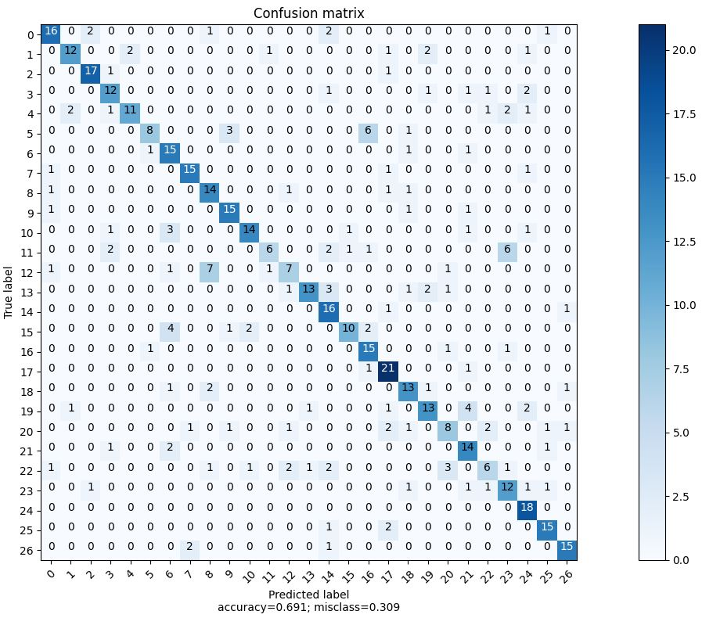

**References**

[1] I. Rabaev, B. Kurar Barakat, A. Churkin and J. El-Sana. The HHD Dataset. The 17th International Conference on Frontiers in Handwriting Recognition, pp. 228-233, 2020.