|  |  |
| --- | --- |
| Student name | Student ID |
| Alexander Boyev | 314393158 |
| Adir Sabag | 312581747 |
| Mor Biton | 205774078 |

|  |  |  |  |  |
| --- | --- | --- | --- | --- |
| Task # | Network | Data | Accuracy | Data |
| 1 | Dense | ready | Cars: 0.96  Cats: 0.81  Dogs: 0.81 | 25% of supplied data random split |
| 2 | Dense | your own | Cars: 0.80  Cats: 0.53  Dogs: 0.64 | My photos – test.rar |
| 3 | CNN | ready | Cars: 0.99  Cats: 0.83  Dogs: 0.87 | 25% of supplied data random split |
| 4 | CNN | your own | Cars: 0.67  Cats: 0.66  Dogs: 0.66 | My photos – test.rar |

Notes:

The results are in the next page, both after running 50 epochs, we couldn’t find a way to print accuracy for each class.

The accuracy for each class in the table is taken from F1-Score, according to google:

**F1** is usually more useful than **accuracy**, especially if you have an uneven class distribution.

Part1:

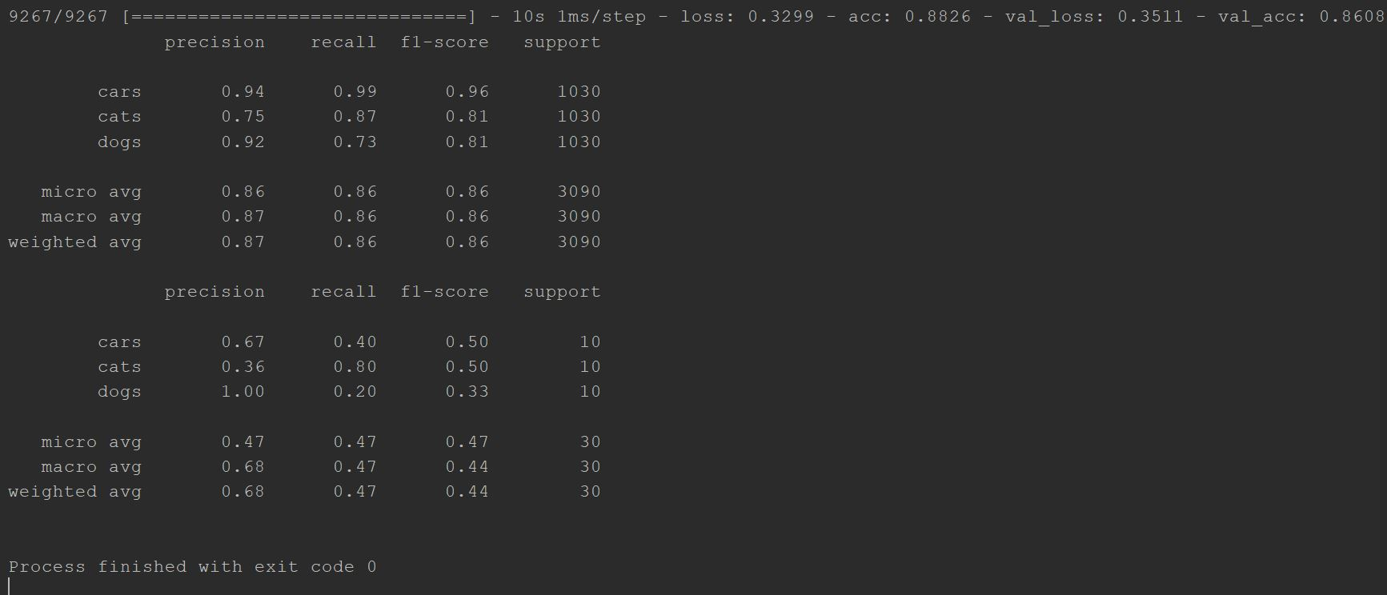Part2:

