Write calculator application according to the following prototype (approximate design)

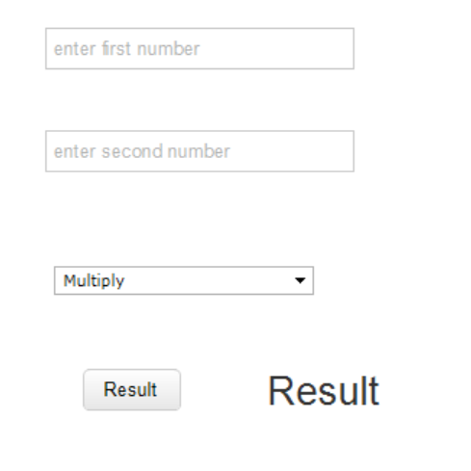

Input field “enter first number” is intended for inputting a first number

Input field “enter second number” is intended for inputting a second number

Select field is intended for selection one from the following options

* Multiply
* Divide
* Add
* Subtract

Button “result” triggers the following actions:

1. According to the selected action an operation is performed
2. Result of the operation should be inserted to the label – Result in the format like 50 + 30 = 80
3. Resetting input fields
   1. For resetting an input field you should put empty string into the appropriate element, for example: firstInput – element for inputting first number, then to reset this field you should perform firstInput.value = ‘ ‘ (two sequential quotes mean empty string)