1. Write new project for JavaScript string operations that should contain 3 HTML files (substring.html, indexof.html, delete-substrings.html)
   1. substring.html should present the following design

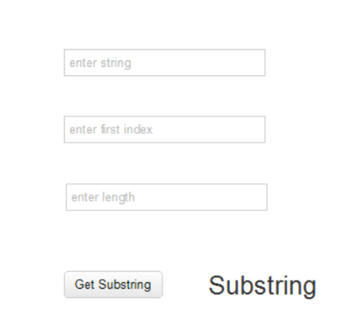

* + 1. ‘enter string’ allows typing any string
    2. ‘enter first index’ allows typing any number as the first index
    3. ‘enter length’ allows typing any number as the substring length
    4. Button ‘get substring’ triggers presenting substring of the string with the given length at the label content
  1. Indexof.html should present the following design

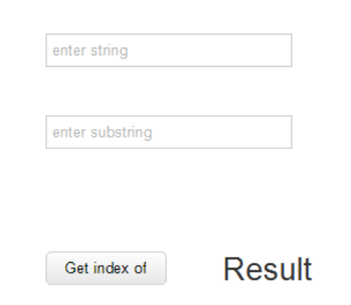

* + 1. ‘enter string’ allows typing any string
    2. ‘enter substring’ allows typing any string
    3. Button ‘get index of’ triggers presenting index of the substring or text “substring doesn’t included”
  1. Delete-substrings should present the following design

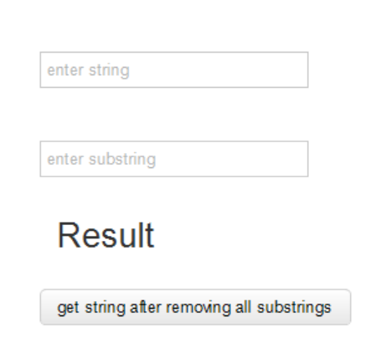

* + 1. ‘enter string’ allows typing any string
    2. ‘enter substring’ allows typing any string
    3. Button ‘get string after removing all substrings’ triggers presenting result according to following examples
       1. String: ‘abcdlmncdqcd’; substring: ‘cd’; result: ‘ablmnq’
       2. String: ‘abcdlmncdqcd’; substring: ‘acd’; result: ‘abcdlmncdqcd’