1. Write project PersonsObjects similar to the classwork #9 (BooksObjects)
   1. Approximate design

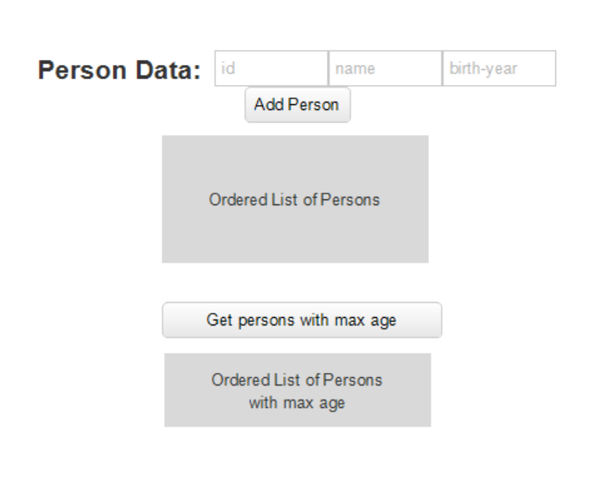

* 1. Each person object should contain the following properties
     1. ***id*** – a person’s identifier
     2. ***name*** – a person’s name
     3. ***birthYear*** – a person’s birth year
  2. Button ‘Add Person’ should trigger adding person object into array of persons and into view of the ordered persons list (see design)
  3. Button ‘Get persons with max age’ triggers viewing all the oldest persons in ‘Ordered List of Persons with max age’

Challenges:

1. Each time the user presses button “Get persons with max age” the persons shouldn’t be duplicated in the view. ***Implementation hint***: removing all children of a specified DOM element (see ***Google*** how to do it)
2. To use only one ***forEach*** for defining the oldest persons. ***Implementation hint***: updating max age during adding new person object