1. Update project PersonsObjects from the previous homework
   1. Approximate design

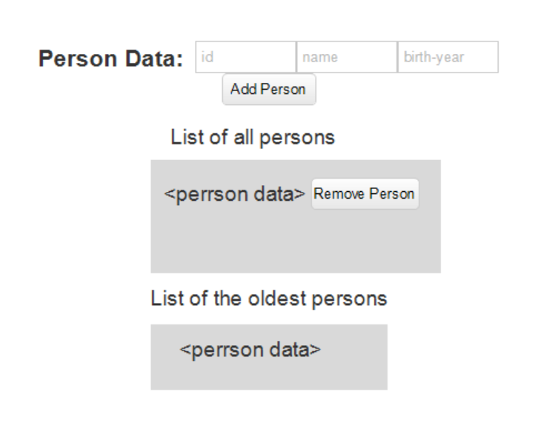

* 1. Button ‘Add Person’ should be enabled just if there applied all following requirements.
     1. Id should be unique number among existing persons in the range [100-999]
     2. Birth Year should be number in the range [1920-2020]
     3. If any requirement isn’t applied you should call method ***alert*** containing the proper message. If id is not unique you should call the method ***alert(‘id isn’t unique’)*** .If birth year is wrong you should call the method ***alert(‘Birth Year value should be in the range [1920-2020]).*** If id is unique but has wrong value you should call the method ***alert(‘id value should be in the range [100-999]’)*** idElement and birthYearElement should have listeners on the event ‘***change’.*** Each listener should run the following:
        1. idElement listener function should check id value and if it is wrong the listener function should call the proper alert; if it is right the listener function should check whether the birthYearElement.value isn’t empty string, and if so the listener function calls addButtonElement.disabled = false
        2. birthYearElement listener function should check birthYear value and if it is wrong the listener function should call the proper alert; if it is right the listener function should check whether the idElement.value isn’t empty string, and if so the listener function calls addButtonElement.disabled = false

* 1. Label “List of all persons” – regular <label> element
  2. List of all persons should contain the <li> elements. Each <li> element should contain
     1. Person data (JSON.stringify)
     2. Button ‘Remove Person’
        1. Pressing the button should trigger removing person (Data and View should be consistent )
  3. Label “List of the oldest persons” – regular <label> element
  4. List of the oldest persons should contain the <li> elements containing just person data (JSON.stringify). Note that the button ***‘get persons with max age’*** is taken out. The data in the list should be updated online each time a new person is added or an existing person is removed