1. Update HW #12 adding new functionality of the name statistics.
   1. Panel of buttons should contain new button “Name Statistics”



* 1. Pressing button “Name Statistics” should hide main menu (panel of buttons) and show the following view

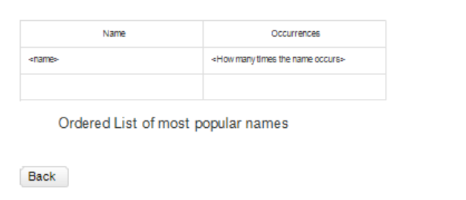

* + 1. Table presents rows containing a name value and an amount of occurrences in the array of all persons. The table should be sorted according to the names
    2. “Ordered List of most popular names” presents HTML element <ol> with <li> items containing the most popular names (Names with maximal amount of occurrences)
    3. Button “Back” hides the view and shows the main menu with the panel of the buttons