1. Update HW #15
   1. Application appears with the following panel of buttons that is shown constantly.

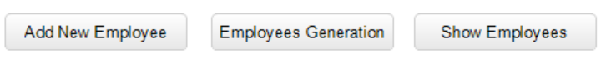

* + 1. Pressing button “Add New Employee” triggers the existing view of the form (see HW #15) for adding new Employee object
    2. Pressing button “Employees Generation triggers the following view for entering the generation data

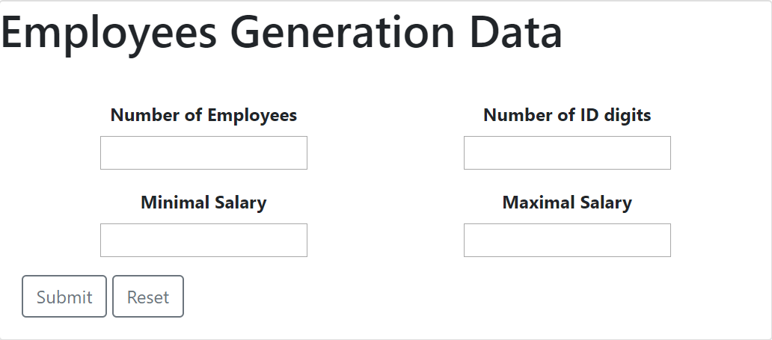

* + - 1. Number of employees – any positive number greater than 0 and less than 100. If the entered number is wrong the alert message “Wrong number of employees” should appear
      2. Number of ID digits – any positive number greater than 1 and less than 5. It defines number of digits of an Employee ID. For example, for 3 digits generated value of ID will be from 100 to 999. If the entered number is wrong the alert message “Wrong number of digits for ID” should appear
      3. Minimal Salary – any positive number defining minimal possible value of the salary
      4. Maximal Salary – any positive number defining maximal possible value of the salary. If minimal salary value exceeds the maximal value the alert message “Maximal value is less than minimal value” should appear
      5. Button “Submit” for submitting the form
      6. Button “Reset” for resetting the form
    1. Pressing button “Show Employees” triggers the view of the table from the previous HW plus the column for removing
  1. Update file employees.js
     1. Add function removeEmployee(id) removing an employee having the specified id
  2. Replace the file table.js with the one we have written at the class. You may do copy/paste but try to do it with complete understanding of each code line
  3. Update file main.js for performing the following functionality
     1. Adding new employee (done in the previous HW)
     2. Adding random generated employees based on the entered generation data.
        1. Create new file random.js with the following functions
           1. getRandomNumber(min, max) – returns a random number in the range [min, max] similar to what we have done for the previous projects
           2. getRandomElement(array) – returns random element from the array (consider applying getRandomNumber(0, array.length – 1))
     3. Showing the table of the employees (all employees regardless of a way of creation should be shown). Each the table row should contain the button “Remove” allowing removing an employee object and the appropriate row