**BUA 235 lab #3: more HTML and CSS tricks**

In the last three labs, you learned how to create a basic HTML web site, and get started adding visual style with CSS. Naturally those tutorials were just brief introductions to these languages which have been developing for the past couple of decades. This week will be a little bit of a review of the basics, as I add in some new tricks that you might find useful.

**HTML Tables**

Tables are defined with the <TABLE> tag. Nested inside this are rows defined by the <TR> tag, and nested within those are cells defined by the <TD> tag (or you can use <TH> for a “header” cell). The content therefore is specified from the top to the bottom, left to right. Example:

<table>

<tr>

<th>First Name</th>

<th>Last Name</th>

<th>Zip Code</th>

</tr>

<tr>

<td>Joe</td>

<td>Clark</td>

<td>04444</td>

</tr>

<tr>

<td>Paul</td>

<td>Bunyan</td>

<td>04401</td>

</tr>

</table>

Sometimes you want to add a wide or tall <TD> that takes up the space of more than one cell, maybe for a caption or a label. You can do this by using “colspan” or “rowspan” attributes.

<tr>

<td colspan="3">Table 1. Names and Zip Codes</td>

</tr>

Tables can be styled with CSS, like other HTML elements. If you set their borders to zero, they will be invisible. This is helpful for positioning things like links and images on the page.

table, th, td { border: 1px solid black; border-collapse: collapse }

See W3schools for more on tables: <https://www.w3schools.com/html/html_tables.asp>

**Layout with DIV tags**

DIV tags are also useful for layout, but work differently than tables. Remember a <DIV> is like a <P> paragraph, except that it doesn’t have a blank line above and below it. A <DIV> is a “block”, meaning it can have borders, margins, padding, and other style attributes. In this example we have three DIVs, one containing a picture, one containing our headline, and one containing the text of the page:

<div class="picture">

<img src="photo.jpg">

</div>

<div class="headline">

<h1>Title of the Page</h1>

</div>

<div class="article">

<p>The first paragraph begins like so...</p>

</div>

Without a stylesheet, these three blocks will appear one on top of the other. However, we can use the “float” property to make the picture sit to the left of the headline. (More specifically, whatever comes after the picture will “wrap” around it.) In the CSS, do:

.picture { float: left }

Now, if the picture is tall enough, the article’s paragraphs will also wrap around the picture’s right edge. If I only want the headline to the right of the picture, and want the article’s text to be placed below them both, I can give the article a CSS property to “clear” the float effect:

.article { clear: all }

When using the “float” and “clear” styles, you’ll often want to pay attention to width, height, margin, padding, borders, and other CSS styles to make your blocks look good. For more on layout with CSS, check W3Schools: <https://www.w3schools.com/css/css_float.asp>

**Embed a video**

Just like you can add images to your page, you can embed audio and video files. If you have some of these, use the <AUDIO> or <VIDEO> tags, as in these examples:

<video width="320" height="240" controls>

<source src="movie.mp4" type="video/mp4">

</video>

<audio controls>

<source src="horse.mp3" type="audio/mpeg">

</audio>

**Youtube** is a popular platform for video, and it has its own way to embed videos. This is convenient because the video lives on Youtube’s server (you don’t have to copy it to your own drive… these are big files). On Youtube, click “Share” and then “Embed” and it gives you exactly the code you need:

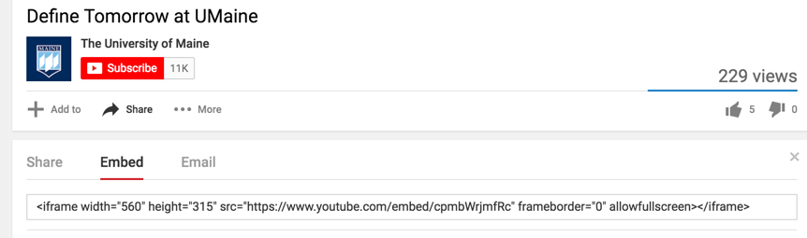

Copy the line beginning **<iframe width="560"** into your HTML. Notice that every Youtube video has a unique identification code (highlighted in yellow below).

<iframe width="560" height="315" src="https://www.youtube.com/embed/cpmbWrjmfRc" frameborder="0" allowfullscreen></iframe>

For more on audio and video media on web pages, see W3Schools: <https://www.w3schools.com/html/html_media.asp>

**Some additional tricks from W3Schools**

Some examples of ways to create navigation (“nav bars”) using CSS to style a list of links:

<https://www.w3schools.com/css/css_navbar.asp>

An image gallery with captions:

<https://www.w3schools.com/css/css_image_gallery.asp>

Adding cute “icons” to your page. These can be turned into links or simply used in a sentence as if they were letters:

<https://www.w3schools.com/css/css_icons.asp>

All kinds of things you can do with backgrounds, including colors, pictures (tiled or not), and gradients: <https://www.w3schools.com/css/css_background.asp>

As you can see, from this lab I’ve shamelessly borrowed ideas from W3schools. Although there are several places to find web development classes, such as CodeAcademy and Coursera, this site (W3Schools) seems to be the most comprehensive “reference” for HTML and CSS. If there’s something else you want to do, chances are you can find it there.