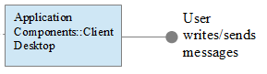
Application Components::HTTP Server
Application Components::Client Desktop
User writes/sends messages
...
Send Event message
Respond to Event

Franziska Drobnik, 742079
Alexander Brückner, 742830

