Cloud Computing SS17
Prof. Dr. Marcus Schöller

Design Documentation Exercise 1 Group D
Alexander Brückner 742830,
Franziska Drobnik 742079

Use Case Diagram for the chat
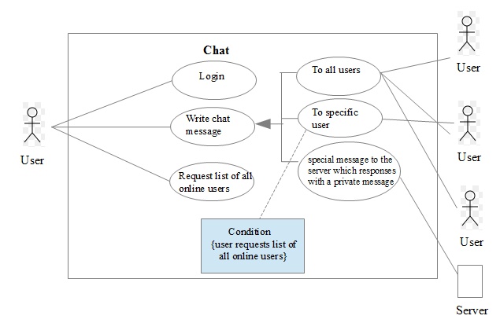
Our chatroom should contain the possibility for a new user to login with a nickname and join the chatroom. After a new user has loged in, there is a message shown to all other users that someone has joined the chat. Each user has the possibility to either send a direct message to a specific user (in this case he/she can request a list of all online users via a click of the button) or send a message to all online users of the chatroom.

Design Mockup for the chat

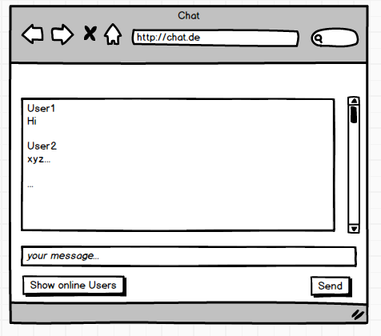

Component Diagram

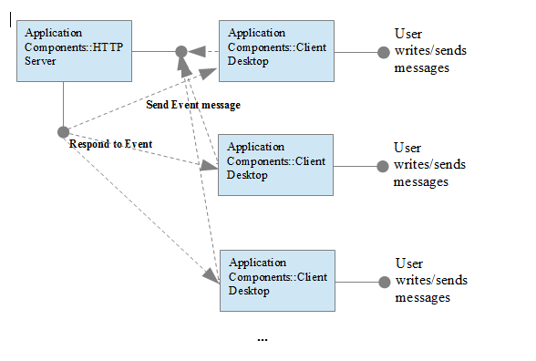

Our Node.js Chat-Server

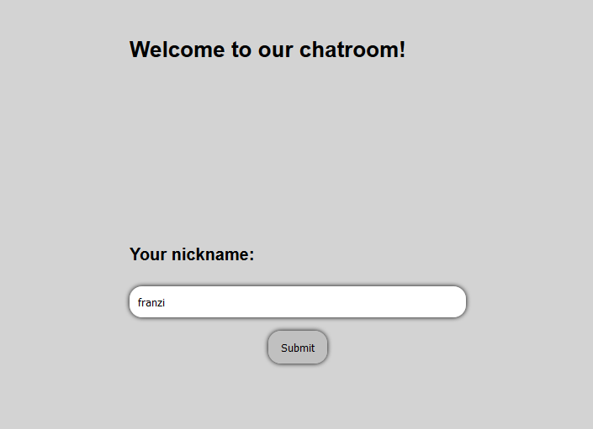
Login - area
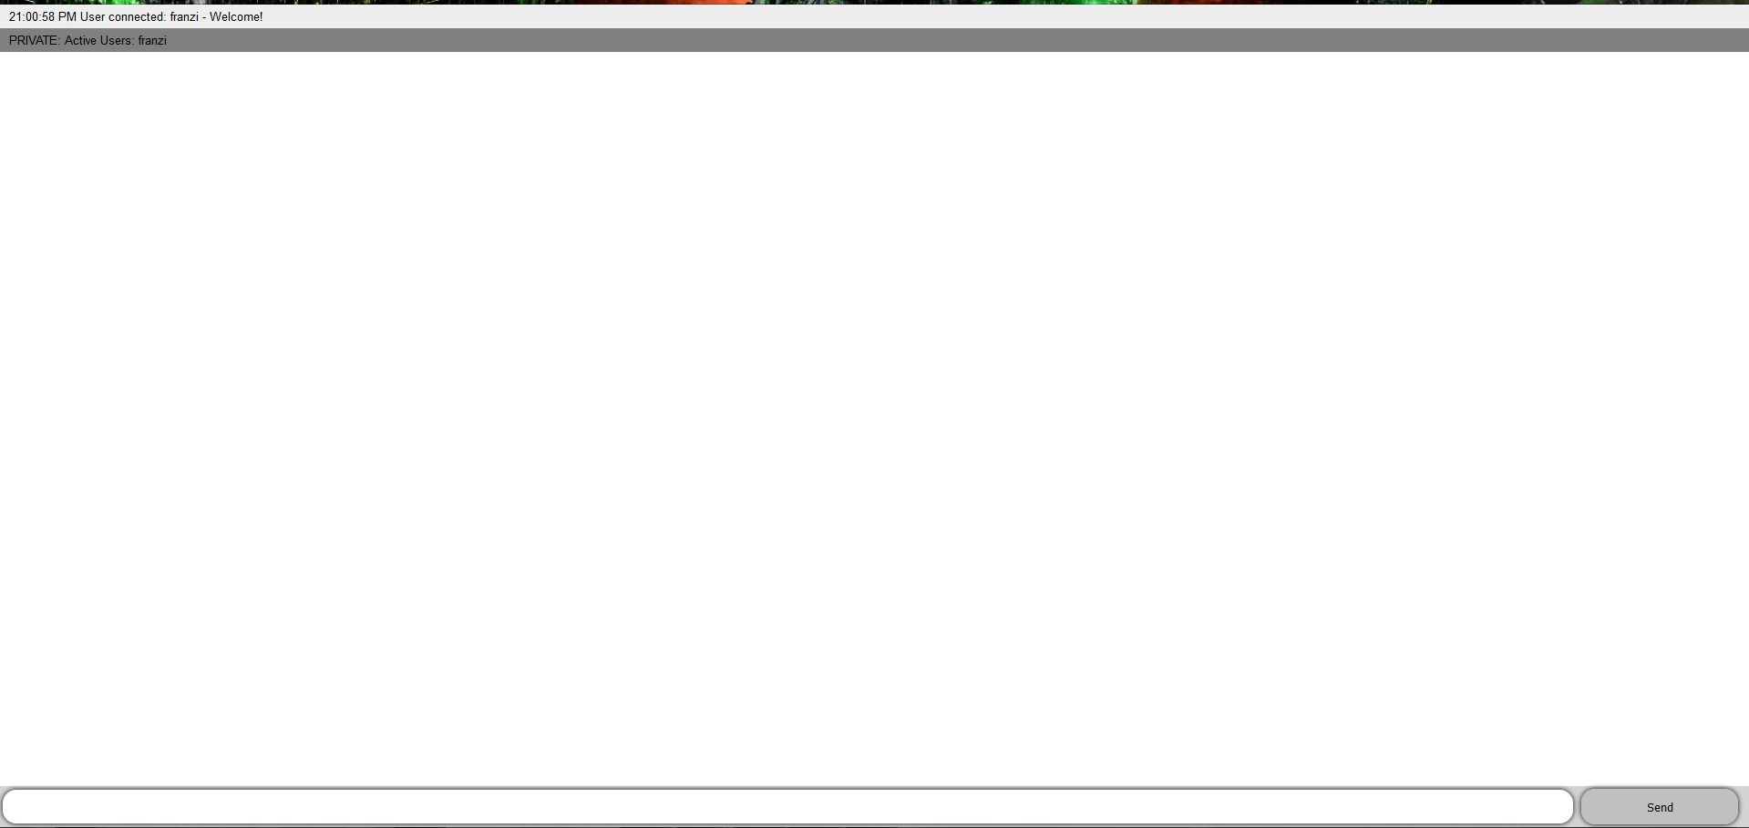
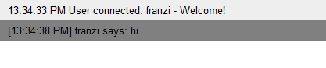
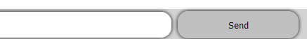
chatroom - area

html

- chat.html
contains the html description for the chatroom area and the chat message events for the server if the users are typing messages.

- index.html
contains the html description for the login area of the chatroom.

javascripts

- enternickname.js
stores the nicknames of the users.

- index.js
contains the setup of the application, initializes the instance of socket.io and listens to the connection for incoming sockets. Furthermore the chat message events of the chat.html are printed out here.

Lessons learnt

- Using the Node.JS web framework
- Intergration of Socket.IO in a Node.JS project
- Dont forget to Check if You closed your div Tags properly. 6 people looked at the Problem and nobody saw it

