University of Puerto Rico

Mayaguez Campus

INEL 4206 - Microprocessors 1

Prof. Luis B. Roa

**Is the A/C on?**

Team MAR A/C

Luis A. Santiago

Mark A. Alvarez

Ramón J. Rosario Recci

**LOGIC VIEW**:

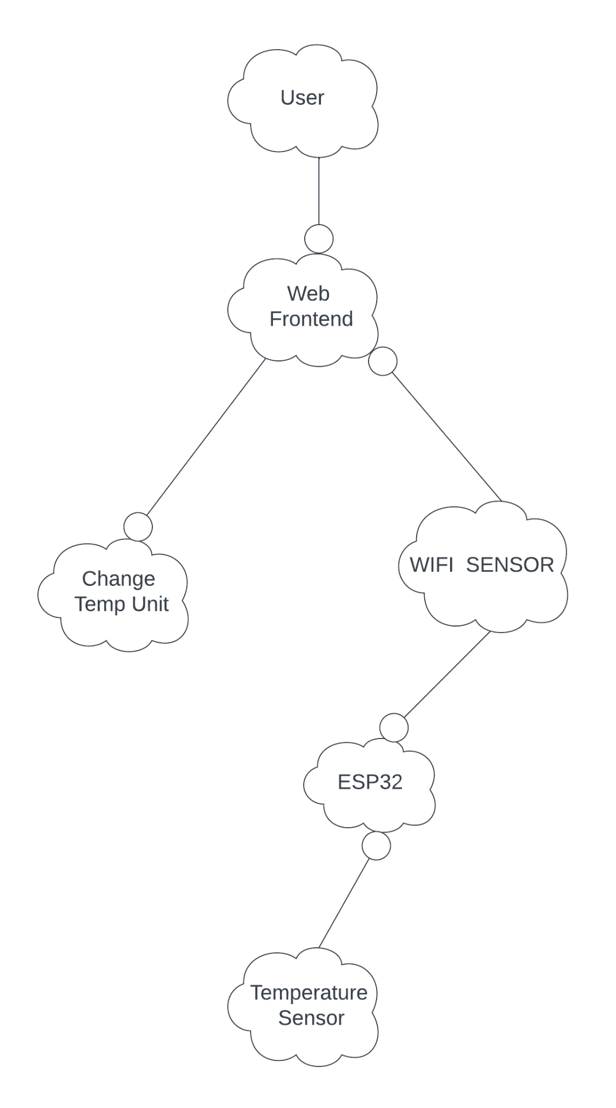

This point touches on interactions. The interaction between the "user" and the device is shown. The device interacts with the unit changer and at the same time via Wi-Fi interacts with the ESP32. This microprocessor interacts with the temperature sensor. With all this thread of interactions the user will get what he needs.

**PROCESS VIEW:**

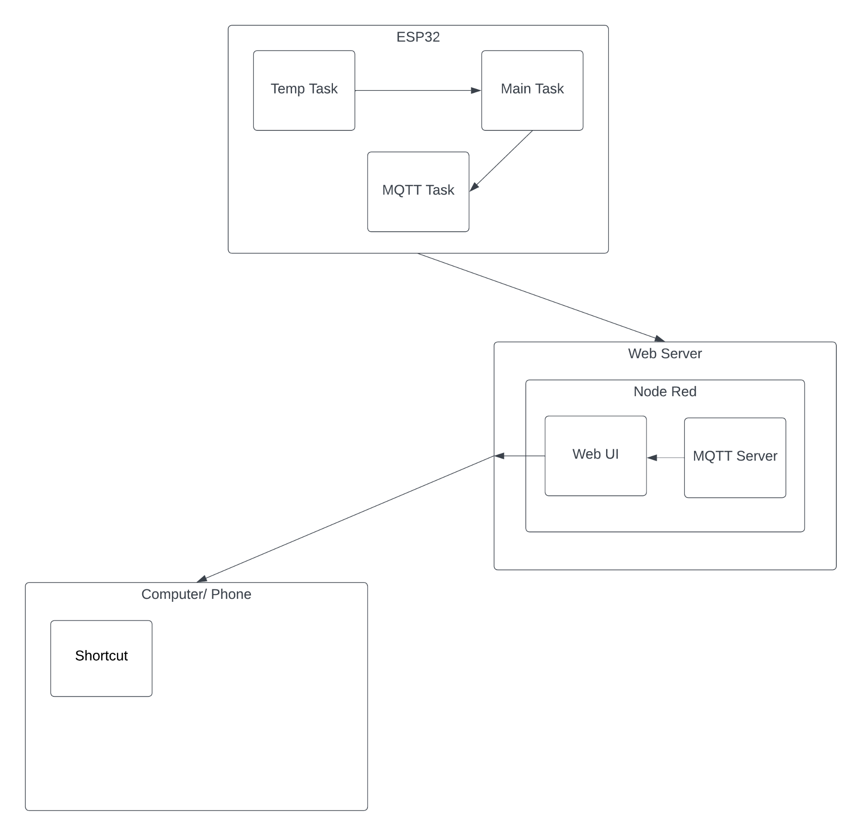

This view projects the way in which the processes and the functions to be used communicate with each other. From the different tasks in the microprocessor, to the web server and its processes, and to finish the end user’s device.

**DEVELOPMENT VIEW:**

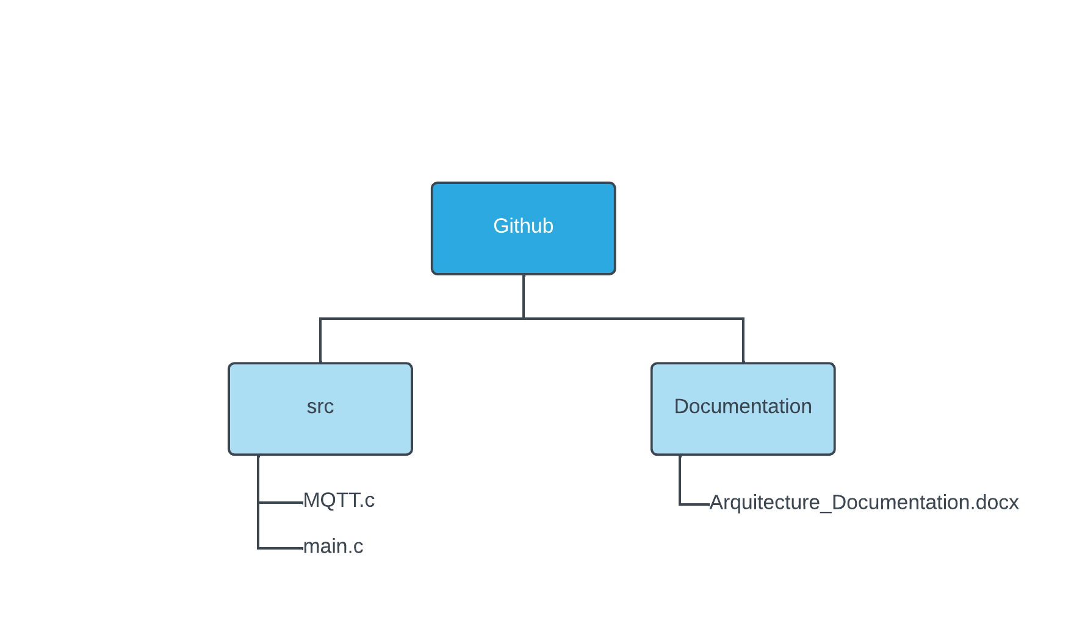

This is a preliminary representation of the file organization of our project, separate folders for the documentation and the code implementation

**PHYSICAL VIEW:**

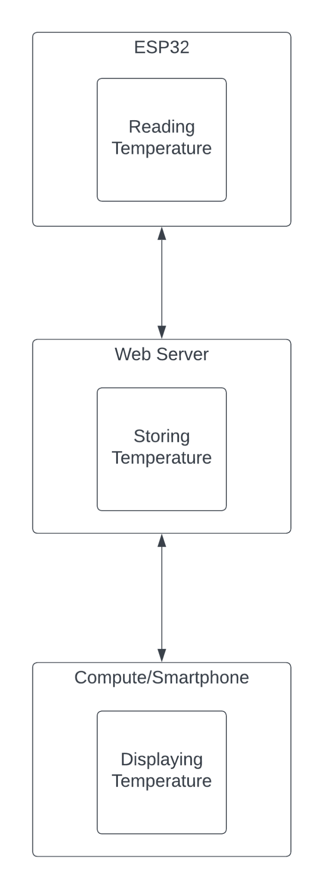

This view will show us the way in which the device behaves and its processes in the same way

**SCENARIOS:**

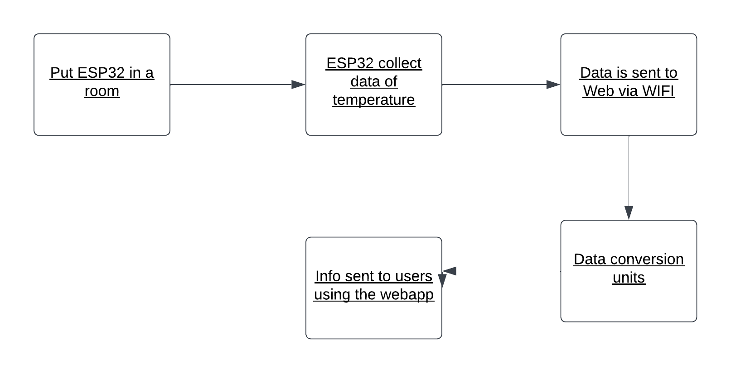

The way to proceed would be firstly placing the esp32 with its temperature sensor in a room. After setting it up, this microprocessor and its sensor will read the surrounding temperature taking data at the same time. That data is sent via Wi-Fi to a server where it will be converted to temperature units. Then the user, using a device that has access to the web, will read this data easily.