Java installed
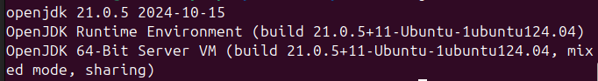
JAVA_HOME
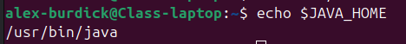

Compiling
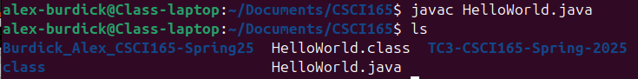
Execution
System properties
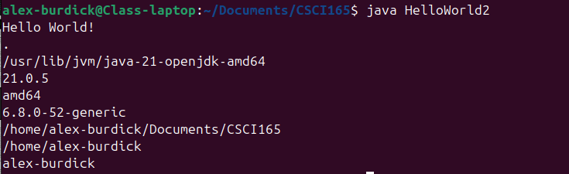

Shapes
