# About

The MathAct is Scala toolset for modeling, simulating and analyzing of dynamic systems. It similar to [Mathlab Simulink](https://en.wikipedia.org/wiki/Simulink) but uses the Scala instead of Mathlab language and based on the messages propagation instead of state iteration. You can use it as additional toolset in your research/testing/playing projects.

Currently it is more like research project and it contain small number of tool. However, I will continue to work on (since it used in other projects) and encourage you to contribute in.

# Getting Started

You need to have installed [JDK 1.8+](http://www.oracle.com/technetwork/java/javase/downloads/jdk8-downloads-2133151.html) and [SBT 0.13+](http://www.scala-sbt.org/download.html), also some Scala IDE will be helpful.

Download or clone this repository somewhere on your local machine, for example with Git: **git clone https://github.com/AlexCAB/MathAct.git**

Navigate to MathAct folder: **cd MathAct**

Now you can run examples with a command: **sbt mathact_examples/run examples.Simple**

In addition, you can import SBT project to your favorite IDE and run **examples.Simple** object from there.

# Demo

Running of couple of sketches:

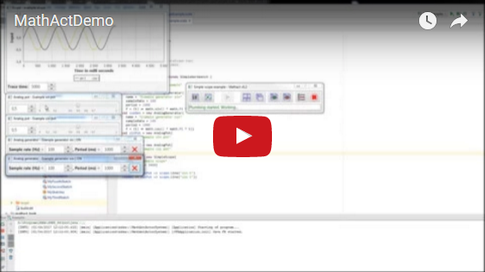

# Project Structure

Project comprises of next subprojects:

* Core – contains common and service definitions.
* Tools – set of tools, which can be used to compose the sketch.
* Examples – contains a set of examples that demonstrate a using of the MathAct toolset.

# Defining of Sketch

Typical developing process of whatever complicated enough include modeling stage. I.e. when you already have an idea about how to solve some issue but you not sure enough in this to start of developing of concrete solution, so you include a modeling step for making an inexpensive evaluation of your idea. Building of mathematical model of your idea and then run its simulation is good option for this.

To define and simulate an model in MathAct you can create a sketch. In fact sketch is just a Scala class that extends *Workbench tool class. Inside this you able to place any Scala definitions.

Next simple example of the sketch (MyFirstSketch.scala <добавить ссылку>):

package manual.sketches

import mathact.tools.workbenches.SimpleWorkbench

class MyFirstSketch extends SimpleWorkbench {

//TODO Add my definitions here

}

Most likely, you will need more than one sketch in the project so it will useful to make a compact list of them. For this, you can create a list object extended from the Sketches class and register your sketches there. This object will have a **main()** method so you can start MathAct application here. After application starts, you will see list of all your sketches (unless you not set auto-start for some sketch).

Sext example of list of sketches:

package manual.sketches

import mathact.tools.Sketches

object MySketches extends Sketches{

SketchOf[MyFirstSketch](

name = "My first sketch",

description = "The first sketch that I define but not implemented.",

logger = true,

visualisation = true)

SketchOf[MySecondSketch](

name = "My second sketch",

description = "The second sketch that I wrote.")

SketchOf[MyThirdSketch](

name = "My third sketch",

description = "The third complex sketch.",

logger = true)

//TODO Add more

}

After launch of MySketches object you will see something like next:

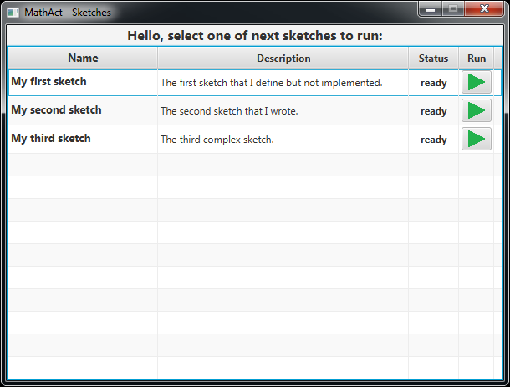

Now you can hit the RUN button (green triangle) and actually launch the selected sketch. After sketch starts, you will see sketch control panel (read about UI below in this document):

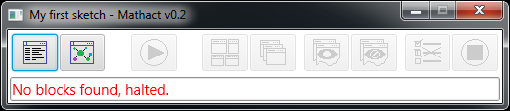

Nothing more interesting happens, since the sketch not contain any block.

# Sketch (model) Structure

Similarly, to the Mathlab Simulink, you can compose your model from the blocks.

Unlike in the Simulink, you define a model in text format using Scala language. I am personally prefer the text format since I think it give more flexibility (especially when Scala used :) ), but also plan to implement graphical editor same like in Simulink.

Huge deferens from the Simulink is in using of [reactive streams](https://en.wikipedia.org/wiki/Reactive_Streams) to implement blocks interactions. I.e. the model can be represented as a graph where nodes (blocks) is the message processors and edges that connect the blocks, is the paths of message distribution (message streams).

Each block have one or more connections points (inlets and outlets) that can be connected. Figuratively you can think about blocks like about electronic components (or [pneumatic automation](https://www.youtube.com/watch?v=IqIqpTwKMPI) components or hydraulic components) which could be composed to form some device and think about the messages like about electricity (or air or liquid) that circulate between components.

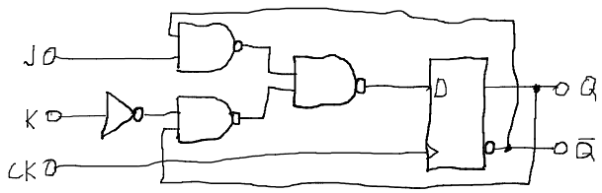

Internally the connections are implemented as messages queues, that reactive and buffering messages from other blocks till it will processed. During processing of income messages (received by inlet) block may send some outcome messages (via outlet) to other connected blocks.

Block structure may be visualized like next:

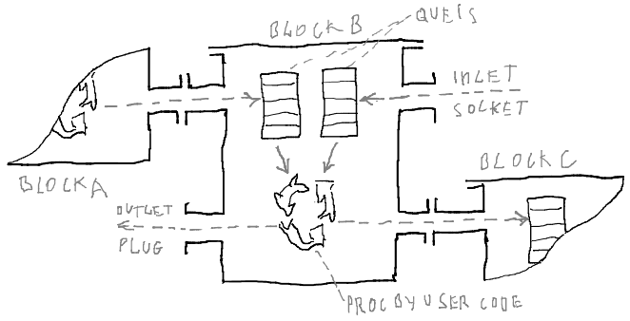

The code of the block B from image above may look like next:

package manual.sketches

import mathact.core.bricks.plumbing.wiring.fun.FunWiring

import mathact.tools.EmptyBlock

import mathact.tools.workbenches.SimpleWorkbench

class MySecondSketch extends SimpleWorkbench {

//Blocks

class BlockB extends EmptyBlock with FunWiring {

//Connection points

val in1 = In[Double]

val in2 = In[String]

val out1 = Out[Double]

val out2 = Out[String]

//Wiring

in1.map(_.toString) >> out2

in1.filter(_ != 0) >> out1

in2.map(s ⇒ "Received: " + s) >> out2

}

//Connecting

//TODO

}

Read more about composing of blocks below in this document.

For connecting of the blocks used DSL similar to [akka-streams DSL](http://doc.akka.io/docs/akka/2.4.14/scala/stream/stream-composition.html), next example <ссылка на исходник> show connecting of A and B and C blocks:

package manual.sketches

import mathact.core.bricks.linking.{LinkIn, LinkOut, LinkThrough}

import mathact.core.bricks.plumbing.wiring.fun.FunWiring

import mathact.core.bricks.plumbing.wiring.obj.{ObjOnStart, ObjWiring}

import mathact.tools.EmptyBlock

import mathact.tools.workbenches.SimpleWorkbench

import scala.concurrent.Future

class MyThirdSketch extends SimpleWorkbench {

//Blocks

object BlockA extends EmptyBlock with ObjWiring with ObjOnStart with LinkOut[Double]{

//Parameters

name = "BlockA"

//Wiring

private val gen = new Outflow[Double] {

def start(): Unit = Future{

(0 to 10).foreach{ i ⇒

pour(i)

Thread.sleep(500)}}}

protected def onStart(): Unit = gen.start()

//Connection points

val out = Outlet(gen) }

object BlockB extends EmptyBlock with FunWiring with LinkThrough[Double, String]{

//Parameters

name = "BlockB"

//Connection points

val in = In[Double]

val out = Out[String]

val out2 = Out[Double]

//Wiring

in.map(s ⇒ "Received: " + s) >> out

in.filter(_ % 2 == 0) >> out2 }

object BlockC extends EmptyBlock with FunWiring with LinkIn[String]{

//Parameters

name = "BlockC"

//Connection points

val in = In[String]

val in2 = In[Double]

//Wiring

in.foreach(v ⇒ logger.info("IN: " + v))

in2.foreach(v ⇒ logger.info("IN2: " + v)) }

object BlockD extends EmptyBlock with FunWiring with LinkIn[String]{

//Parameters

name = "BlockD"

//Connection points

val in = In[String]

//Wiring

in.foreach(v ⇒ logger.info("IN: " + v))}

//Connecting

BlockA ~> BlockB ~> BlockC //<-- Shortcut DSL

BlockB.out2 ~> BlockC.in2 //<-- Standard way of connecting

BlockB ~> BlockD

}

This sketch can be represented as next graph:

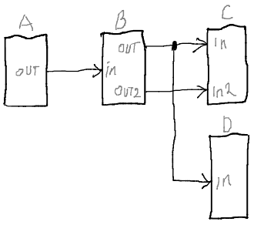

Each outlet can be connected to the several inlets (for example ‘out’ block B connected to ‘in’s of block C and D), in this case, outlet will broadcast messages to all connected inlets. Also each inlet can be connected to the several outlets, in this case messages from all connected outlets will enqueued to inlet queue in the received order.

To make a connecting of blocks easier and compact, you can use shortcut-linking DSL that allow you to connect blocks like next:

BlockA ~> BlockB ~> BlockC

Instead of using standard connation DSL:

BlockA.out ~> BlockB.in

BlockB.out ~> BlockC.in

In additional I encourage you to check and play with examples<ссылка на гитхаб примеры>.

# Simulation Approach

Same as in Simulink you can simulate discrete, continues and mixed models. However, because of parallel computing and message propagation nature of the reactive streams, the simulation approach is different.

Most of the modeled systems have a state, which chances during the time. Therefore, to be precise, models need to reflect the state too. To achieve maximum performance of parallel computing the state (i.e. data represented as values/objects that stored in variables) need to be distributed in some way between the computation units (i.e. blocks in our case) to minimize synchronization costs. Which is actually hard, especially when you using classical (i.e. blocking) synchronization approach, but I think using of the reactive approach make this task something simpler.

The main idea is in the taking apart of the model state and keeping of its parts inside the blocks. Moreover, in using of messages exchange to keep the spitted model state consist (i.e. to synchronize parts of model). You can imagine that as the parts of state evaluates independently from each other, and in the same time, the changes of the parts of state are propagated in between by messages exchange (sending of message by block with changed state and reaction on the changes by connected block).

Alternatively, you can design a model in the way where the divided state will stored in the messages itself and the blocks will just transform it (i.e. same as it happens in [Erlang language](https://en.wikipedia.org/wiki/Erlang_(programming_language)) for example). This will make your design work harder but give you opportunity to make simulation less buggy and more stable.

The practice shows that it is actually hard to deal with a loops and cycles in the message exchange. They prone to the dead-locks and life-locks. So avoid their where you can.

## Discrete models

In this kind of models, state is discrete, i.e. contain only variables with finite amount of possible values. In case of using of reactive streams for implement simulation, the limited amount of possible values reduce required amount of the message transaction to propagate the state changes. The simple example is a binary model where variables have only two possible value.

For example a simple discrete model to simulate of [D trigger](https://en.wikipedia.org/wiki/Flip-flop_(electronics)#Gated_D_latch) work:

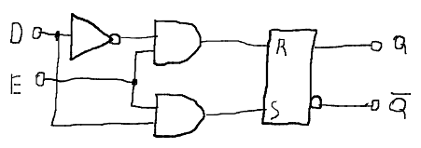

The sketch <ссылка на исходник> will look like next:

package examples.common

import mathact.tools.indicators.BoolIndicator

import mathact.tools.math.logic.bool._

import mathact.tools.pots._

import mathact.tools.workbenches.SimpleWorkbench

class DTriggerExample extends SimpleWorkbench {

//Sketch parameters

heading = "D-trigger example"

//Helpers

val dIn = new BoolSwitch{ name = "D in" }

val eIn = new BoolStrobe{ name = "E in" }

val indicator = new BoolIndicator{ name = "Out" }

//Operators

val fAnd = new And

val iAnd = new And

val flipFlop = new FlipFlop

//Connecting

dIn ~> new Not ~> fAnd ~> flipFlop.r

eIn ~> fAnd

eIn ~> iAnd

dIn ~> iAnd ~> flipFlop.s

flipFlop.out ~> indicator.in("Q")

flipFlop.inv ~> indicator.in("!Q")}

Discrete models are simple and useful to simulate of descript systems but unfortunately most of real word stuff are not discrete. For example to simulate flip-flop element on the couple NORs you will need to simulate the electronic transient processes, which have continuous nature.

## Continuous models

Simulation of continuous models with reactive streams is a harder than discrete, because of discrete nature of messaging and computers in general. So, to make continuous model work on top of discrete computation system you need [to discretize](https://en.wikipedia.org/wiki/Discretization) the values of the model in some way.

Distribution of the state changes between the blocks can be implemented as a sending of message each time when state stored inside the block changes more then on some epsilon value. This will require more message transactions against discrete models and the actual amount of transactions will depend on selected epsilon value (then less epsilon then more precise model and then more transaction required).

The next one is example of simulation of [negative feedback](https://en.wikipedia.org/wiki/Negative_feedback) in amplifier:

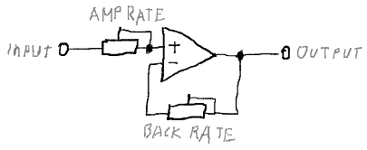

The sketch <ссылка на исходник> is next:

package examples.common

import mathact.tools.indicators.ValueIndicator

import mathact.tools.math.continuous._

import mathact.tools.pots.SettingDial

import mathact.tools.workbenches.SimpleWorkbench

class FeedbackExample extends SimpleWorkbench {

//Sketch parameters

heading = "Continuous math example"

//Helpers

val input = new SettingDial{ name = "input"; min = -2; max = 2; init = 1}

val amplifyingRate = new SettingDial{ name = "amplifying"; min = 0; max = 10; init = 2}

val feedbackRate = new SettingDial{ name = "feedback"; min = -2; max = 2; init = 0}

val output = new ValueIndicator{ name = "output" }

//Operators

val amplifier = new Multiplier

val feedback = new Multiplier

val adder = new Adder

//Connecting

amplifyingRate ~> amplifier

feedbackRate ~> feedback

input ~> adder ~> amplifier ~> output

adder <~ feedback <~ amplifier}

## Model time

Most of real systems are temporal (i.e. depend on the time), so to simulate their correctly, the time need to be reflected in the model. In the case of using of reactive streams, it is more complicated because of the distributed state and the synchronous interaction.

For precision simulation of time, the “virtual time” approach may be used, i.e. when model have own time that independent form real (computing) time. In this case, from the model viewpoint all computations will executed instantly and simultaneously.

For implementation of this approach, each piece of the model state, need to have a time mark, which indicate of time slice of the whole model state. In addiction in model should exist only one block that is a source of the time, i.e. provide current value of time mark for the rest of blocks.

See an example of such model in the next chapter.

# Build and Run Simple Model

Let us build and simulate a simple continuous and temporal model using the reactive streams. As example, we will use a model of the simple system that include a water tank with a fill and sink valves and PID regulator that control the fill valve to keep stable level of the water in the tank.

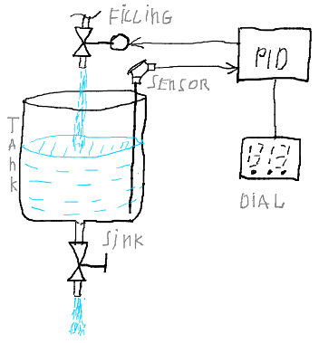

For the building of model, we will use regular math operators: addition, multiplication, sing inversion, integration and differentiation. Also we will use the TimeLoop block that provide virtual time, the SettingDial and the ChartRecorder for input and output of model parameters.

Next is a model block diagram:

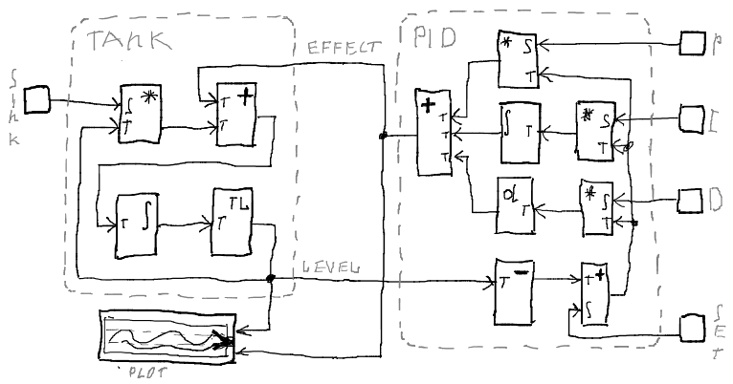

Next part of the sketch (full source see here <ссылка на исходник>):

class SimplePidExample extends SimpleWorkbench {

//Blocks

val timeLoop = new TimeLoop[TimedValue]{ ... }

val chart = new ChartRecorder{ minRange = 0 }

//Units

val dials = new {

val setPoint = new SettingDial{ ... }

val drainSpeed = new SettingDial{ ... }

val pPoint = new SettingDial{ ... }

val iPoint = new SettingDial{ ... }

val dPoint = new SettingDial{ ... }}

val tank = new {

//Blocks

val adder = new Adder

val integrator = new Integrator

val multiplier = new Multiplier

//Connecting

multiplier ~> adder

adder ~> integrator

//Pins

val effect = adder.inF

val feedback = multiplier.inF

val drain = multiplier.inS

val level = integrator.out}

val controller = new {

//Blocks

val signInverter = new SignInverter

val inAdder = new Adder

val integrator = new Integrator

val differentiator = new Differentiator

val pMultiplier = new Multiplier

val iMultiplier = new Multiplier

val dMultiplier = new Multiplier

val outAdder = new Adder

//Connecting

signInverter ~> inAdder

inAdder ~> pMultiplier ~> outAdder

inAdder ~> iMultiplier ~> integrator ~> outAdder

inAdder ~> dMultiplier ~> differentiator ~> outAdder

//Pins

val r = inAdder.inS

val y = signInverter.inF

val u = outAdder.out

val p = pMultiplier.inS

val i = iMultiplier.inS

val d = dMultiplier.inS}

//Connecting

dials.setPoint ~> controller.r

dials.drainSpeed ~> tank.drain

dials.pPoint ~> controller.p

dials.iPoint ~> controller.i

dials.dPoint ~> controller.d

tank.level ~> timeLoop.in

timeLoop.out ~> controller.y

timeLoop.out ~> tank.feedback

controller.u ~> tank.effect

controller.u ~> chart.line("effect")

tank.level ~> chart.line("level")}

Moreover, the short video of how it actually work:

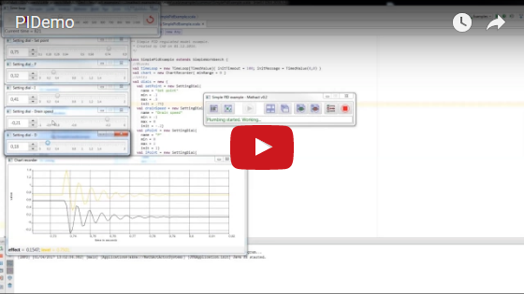

# User Interface

The application have simple UI for a selecting of the sketch to be launch and for managing of the launched sketch.

The sketch list that display a sketches registered in the Sketches object:

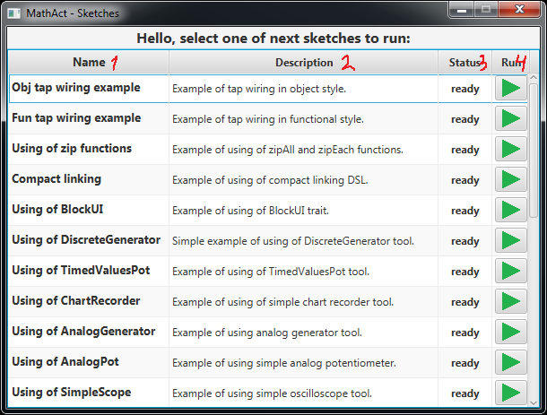

1. Name of sketch if set or class name.
2. Description of sketch if set.
3. State of the sketch: ready – can be launched, ended – was launched, failed – was launched and fail.
4. Run button to launch a sketch.

The sketch management panel, which will show after launch of sketch:

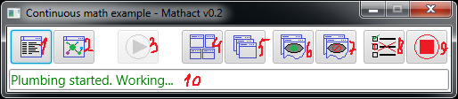

1. Show or hide the logger UI.
2. Show or hide visualization UI.
3. Start the sketch, on hit the user defined start functions will executed.
4. Fit block windows layout.
5. Stairs block windows layout.
6. Show all block windows.
7. Hide all block windows.
8. Skip frozen tasks (see “Compose Your Own Block” chapter).
9. Stop the sketch, on hit the user defined stop functions will executed.
10. String that display current status of the sketch.

By hit of button 1) you will see a logger UI. This is simple UI with basic filtering and search functionality:

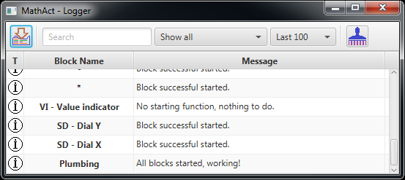

By hit of button 2) you will discover simple block connection graph visualization, currently it only show connection structure but in future I plan to add more functionality (see “future work” chapter):

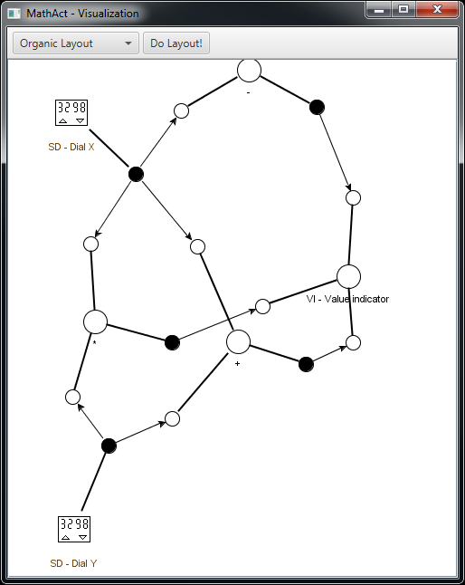

# Common Architecture

The toolset built on top of the AKKA actor’s library with using of ScalaFX for the UI. But for using of application you not need to have deal with actors (unless you want to) since app provide a simple OOP API for creating and composing of blocks.

Here is actors/objects diagram:

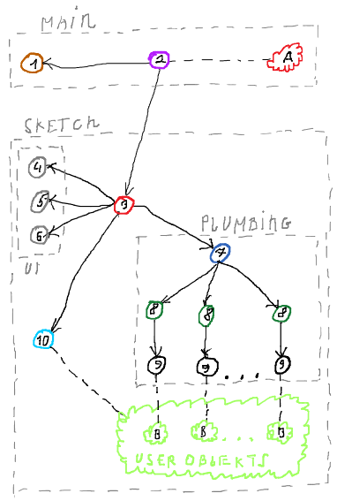

Whole application may be split on two parts:

* Main part – manage a sketches.
* Sketch part contain subparts:
  + UI – sketch manage, logger, visualization UI.
  + Plumping – handle messages exchange and start/stop functions.

The app contain next actor’s:

1. Sketch list UI actor.
2. Main app controller, contain the logic for the start and manage of sketch.
3. Sketch controller, contains the control and glue logic.
4. Sketch UI, where do start and stop buttons.
5. Logger UI actor.
6. Visualization UI actor.
7. Plumbing supervisor, manage a drives actors.
8. Drive actors, contains the message queues and logic of them handling, logic of block UI management.
9. Impeller actors is a user code executer (income messages handling, start and stop function).
10. User object construction actor, do construction of the user defined objects (workbench and blocks).

In addition, the next objects:

1. App singleton, where main() method locate, also used for the access of user defined objects to the actor system.
2. User defined objects, i.e. block objects.

This is just an approximate description, for learning more please brows the code.

# Compose Your Own Block

Creating of your own blocks is very easy. Here is two styles to do this: OOP style and functional style.

For creating of a block, you need to define inlets and/or outlets and to wire them in some way.

Let us define simple block that will take integer value convert it to the string and return string value.

OOP style (full source <добавить ссылку>):

object IntObjPrinter

extends EmptyBlock

with ObjWiring

with LinkThrough[Int, String]{

//Wiring

private val outflow = new Outflow[String] {

def send(str: String): Unit = pour(str)

}

private val inflow = new Inflow[Int] {

protected def drain(v: Int): Unit = {

outflow.send("Converted" + v.toString)

}

}

//Connection points

val in = Inlet(inflow)

val out = Outlet(outflow)

}

Functional style (full source <добавить ссылку>):

object IntFunPrinter

extends EmptyBlock

with FunWiring

with LinkThrough[Int, String]{

//Connection points

val in = In[Int]

val out = Out[String]

//Wiring

in.map(v ⇒ "Converted" + v.toString) >> out

}

The block may be defined as an object on class inside or outside sketch class, but it is important to create block object during sketch object construction (in the sketch class constructor), since block can’t be built after sketch started.

In this example used EmptyBlock call as a super class this used for creating a simple small blocks, but there is other classes on which block can be based, for example Tool class.

By mixin of the ObjWiring or FunWiring you select the wiring style that you want to use in the block.

Mixin of the LinkThrough is optimal, it just provide a shortcut connection DSL to your block, so you will able to connect like “BlockA ~> IntPrinter ~> BlockB” instead of “BlockA.out ~> IntPrinter.in” and “IntPrinter.out ~> BlockB.in”.

Defining of connection points is different for different wiring styles. I case of using a OOP style you need use the Inlet() and the Outlet() functions to generate points. These functions are require a handling objects that you need define before. I case of functional style you can define connection points by the In[] and the Out[] function with providing of connection type and then to wire them by mapping of the message streams.

The handling objects is a simple object that implement Inflow[] and/or Outflow[] traits. The first one require a implementing of the drain() method, which will called each time when inlet will receive new message. The second contain the pour() method, calling of it will send new message to other connected blocks.

In addition, to execute some code on start and/or on stop of sketch you can mixin the ObjOnStart/ FunOnStart and the ObjOnStop/FunOnStop traits. For OOP style they require methods implementation, which will, called during the sketch starting and stopping. For functional style they provide input streams that will produce Unit value on the starting and stopping.

Please check examples.wiring <добавить ссылку> package for more examples.

All external calls (staring, stopping and receiving of message) are synchronized in the block scope, so you can safely use Scala variables (var’s).

Inside the block you have imported ExecutionContext to use Scala Futures and method actorOf() to create your own actors that will child actors of the block drive actor. But in case of using of this you need take care about synchronization by yourself, so please make sure than you know what you do.

Also you can log some data to the sketch logged by using of logger.info(), logger.warn() and logger.error() methods inside block. However, not use it to widely sine it not designed for large amount of logging.

# Adding Block UI

In case you want a block to have some UI, for example for output and input of data or changing of block behavior during sketch execution, you can mixin the BlockUI trait, which provide a bunch of helper and the integration to create simple UI.

Let us for example add UI to the block from previous chapter, for displaying of last received value and send a new value by click of button:

OOP style with direct UI definition (full source <добавить ссылку>):

object ObjIntPrinter extends EmptyBlock with ObjWiring with BlockUI with LinkThrough[Int, String]{

//UI definition

class MyUI extends SfxFrame{

//Params

title = "MyFifthSketch - ObjWiring"

showOnStart = true

//Components

val label = new Label{

prefWidth = 200}

val button = new Button{

text = "Send Hi!"

onAction = handle{ sendEvent(SentMsg("Obj Hi!")) }}

//Scene

scene = new Scene{

root = new HBox {

prefWidth = 280

children = Seq(label, button)}}

//Commands reactions

def onCommand = { case UpdateVal(v) ⇒ label.text = "Last value: " + v }

}

//UI registration

UI(new MyUI)

//Wiring

private val handler = new Inflow[Int] with Outflow[String] {

//Binding reaction on UI event

UI.onEvent{ case SentMsg(m) ⇒ pour(m)}

//Income message handler method

protected def drain(v: Int): Unit = {

//Update UI

UI.sendCommand(UpdateVal(v))

//Convert and send message to next block

pour("Converted" + v.toString)

}

}

//Connection points

val in = Inlet(handler)

val out = Outlet(handler)

}

Functional style with FXML UI definition (full source <добавить ссылку>):

object FunIntPrinter extends EmptyBlock with FunWiring with BlockUI with FunUIWiring with LinkThrough[Int, String]{

//Connection points

val in = In[Int]

val out = Out[String]

//UI definition

UI( new FxmlFrame[MyFxmlUILike]("manual/sketches/my_fxml_ui.fxml"){

//Params

title = "MyFifthSketch - FunWiring"

showOnStart = true

//Set actions

controller.button.onAction = handle{ sendEvent(SentMsg("Fun Hi!")) }

//Commands reactions

def onCommand = { case UpdateVal(v) ⇒

controller.label.text = "Last value: " + v

}

})

//Wiring

in.map(v ⇒ UpdateVal(v)) >> UI

in.map(v ⇒ "Converted" + v.toString) >> out

UI.map{ case SentMsg(m) ⇒ m } >> out

}

Using of FXML also require static controller class to be defined, for example:

trait MyFxmlUILike{ val label: Label; val button: Button}

@sfxml class MyFxmlUI(val label: Label, val button: Button) extends MyFxmlUILike

You can that interaction with UI also implemented as messages (commands and events) exchange, this solve a JavaFX EDT synchronization problem.

In addition, please check examples.ui <добавить ссылку> package for more examples.

# Future Work

* More tools, extension of block library.
* Dynamic recompilation of the sketches, similar to recompilation in Play framework.
* Improving if blocks graph visualization. Adding more useful information like queues state for example. Some management of blocks, for example show/hide UI.
* Graphical sketch builder, similar to used in Simulink.
* Dynamic adding/removing and connecting/disconnecting of blocks in the launched sketch.