**Week 1 – Introduction to Networks**

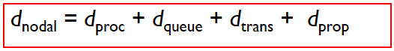

**Four Sources of Packet Delay**

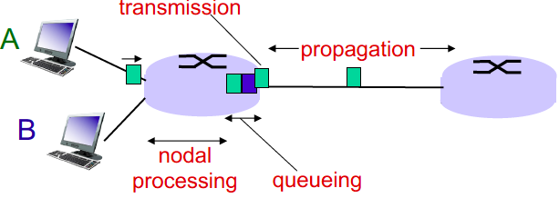

**Combined delay = END-TO-END DELAY**

N * [ proc + queue + trans + prop ]  
N = number of links

**1. Processing Delay (dPROC):** Checking bit errors, determine where to send the packet.

* **dPROC = < 1 millisecond. Usually done very quickly**

**2. Queuing Delay (dQUEUE):** Time waiting at the output link before transmission.

* **dQUEUE = Time spent in buffer**

**3. Transmission Delay (dTRANS):** Time required to push ALL BITS on the wire.

* **dTRANS = L / R where L = packet length / R = link bandwidth or rate**

**4. Propagation Delay (dPROP):** Time taken for ONE BIT to travel from the src 🡪 dest.

* **dPROP = d / s where d = physical length of link / s = propagation speed in medium**
* **(~2 x 108 meters/s = speed of light / fiber)**