**Local Area Network Addressing + ARP resolution protocol**

**Local Area Networks and MAC addresses**

**MAC** (or LAN / PHYSICAL / ETHERNET)

* A 48-bit addressed burned in a Network Interface Controller (NIC) memory (hex-based).
* Used “locally” to get a frame from one interface to another physically-connected interface, which is in the same network (IP-addressing sense).
* Are administered by the IEEE, of which manufacturers buy a portion of MAC address space.

**MAC address vs. IP address**

MAC address IP address

|  |  |
| --- | --- |
| **Hard-coded** in read-only memory when adaptor is built. | **Configured**, or learned dynamically. |
| Like a **social security number**. | Like a **postal address**. |
| **Flat name space** of 48 bits (e.g. 00-0E-9B-6E-49-76 hex) | **Hierarchical name space** of 32 bits (e.g. 12.17866.9 dec) |
| **Portable**, can move LAN cards from one LAN to another. | **NOT Portable**, depends on IP subnet of where host is attached |
| Used to get packet between interfaces on the same network | Used to get a packet to a destination IP subnet. |

**ARP: Address Resolution Protocol**

**Question:** how to determine an interface’s MAC address, know its IP address?

**ARP table**: each IP node (host, router) on LAN has a table of

* **<IP Address, MAC address, TTL>** where TTL is the time after which address mapping will be forgotten (typically 20mins)

ARP used in the same Local Area Network: Send datagram from A to B

1. A wants to send datagram to B 🡪 B’s MAC address is not in A’s ARP table.
2. A **broadcasts ARP query** packet, containing B’s IP address 🡪 All nodes on LAN receive broadcast packet.
3. B **receives A’s broadcast packet**, replies to A with B’s MAC address 🡪 Frame sent to A’s MAC address.
4. A **caches/saves IP-to-MAC address pair** in its ARP table until TTL is reached 🡪 **soft state**: info timeout unless refreshed

ARP used in different Local Area Networks: Send datagram from A to B via. R

* For A to send a datagram to B, A must know several things:
  + **B’s IP address** – subnet mask discovered via. DHCP
  + **1st hop router R’s IP address** – default router discovered via. DHCP
  + **R’s MAC address** – ARP

1. A creates IP datagram with src=(A) | dest=(B), and then link-layer frame with dest=(R’s MAC + IP datagram)
2. Link-layer frame is sent from A to R 🡪 Frame is received at R, datagram is detached and passed to IP.
3. R forwards datagram with IP_src=(A) | IP_dest=(B) using a forwarding table.
4. R creates a link-layer frame with dest=(B’s MAC + A_to_B IP datagram)

**Local Area Networks: Ethernet**

There are many different Ethernet standards, for diff physical layer media w/ diff speeds: fiber, cable etc.

However, they use a common MAC protocol and frame format.

**Ethernet topology**

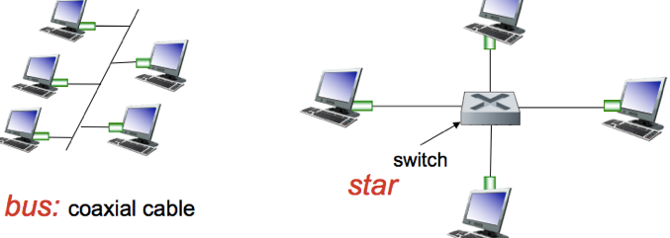

**BUS:** Popular through mid 90s, where all nodes can collide with each other. CSMA/CD for media access control.

**STAR**: Used today, where there is an active SWITCH in the centre.

* Each “spoke” runs a separate Ethernet protocol, so nodes do not collide with each other. No sharing, no CSMA/CD.

**Ethernet Frame Structure**

Sending adaptor encapsulates IP datagram (or other network layer protocol packet) in an **Ethernet Frame**.

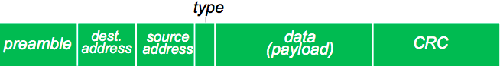

**Preamble:** Used to sync receiver and sender clock rates. 7 bytes.

**Addresses**: 6-byte source address + destination MAC addresses.

* If adapter receives frame with matching dest address, or with a broadcast addr (e.g. ARP packet), it passes data in the frame to the network layer protocol.

**Type**: Indicates a higher layer protocol (mostly IP but others possible)

**CRC**: Cyclic redundancy check at the receiver. If error is detected, frame is dropped.

**Ethernet: Unreliable, Connectionless**

**Connectionless**: no handshaking between sending and receiving NICs

**Unreliable**: receiving NIC doesn’t send ACKs/NACKs to the sender NIC. Data in dropped frames recovered only if initial sender uses a higher-layer Reliable Data Transfer (e.g. TCP) otherwise the dropped data is lost.

**Ethernet’s MAC protocol**: un-slotted CSMA/CD with binary backoff.

**Local Area Network: Ethernet Switches**

**Link Layer Device**: stores and forwards Ethernet frames.

* Examines incoming frame’s MAC address 🡪 selectively forwards the frame to one or more outgoing links.  
  🡪 uses CSMA/CD to access the segment.

**Transparent**: Hosts are unaware of the presence of switches.

**Plug-and-Play, Self-Learning**: Switches do not need to be configured.

**Switch: multiple simultaneous transmissions + forwarding table**

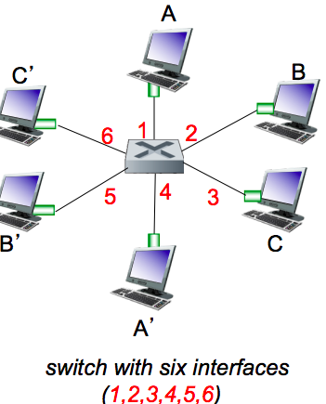

* Hosts have a dedicated direct connection to the switch.
* Switches buffer packets.
* **Ethernet Protocol** used on each incoming link, but no collisions  
  + full duplex (data can be transmitted in both directions at the same time)

Each link is its own collision domain.

* **Switching**: A-to-A’ and B-B’ can transmit simultaneously without collisions.

Q: How does switch know A’ is reachable via. interface 4, B’ reachable via. interface 5?

A: Each switch has a **Switch Table**, where each entry =  
 **<MAC addr of host, interface to host, time stamp>**

**Switch: Self-Learning + Frame filtering/forwarding**

A switch **learns** which hosts can be reached through which interfaces.

* When frame is received, the switch “learns” location of the sender in the incoming LAN segment.
* The switch records sender/location pair in a switch table.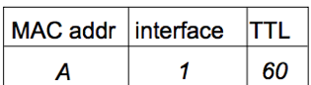

When a frame is received at the switch:

1. Record the incoming link, MAC address of the sender.
2. Index the switch table using the MAC destination address.
3. **IF** entry is found **{**   
    **IF** dest MAC on segment exists in the switch’s table / comes from same port 🡪 drop/filter packet  
    **ELSE** forward frame on the interface indicated by the entry. **} ELSE** flood /* forward frame to all the interfaces except the arriving interface */

**Interconnecting Switches**

Switches can be connected together.

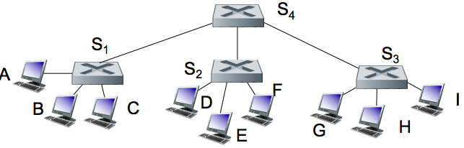

**Q:** Sending from A-to-G, how does S1 know to forward frame to G via. S4 and S3?  
**A: Self-learning again**! Works exactly the same way as in the single-switch case.

**Switches vs. Routers**

**Switches Routers**

|  |  |
| --- | --- |
| Both are store-and-forward + have forwarding tables. | Both are store-and-forward + have forwarding tables. |
| Link-Layer devices (examine link-layer headers) | Network-Layer devices (examine network-layer headers) |
| Learns forwarding table using **flooding, learning, MAC addresses** | Computes tables using **routing algos, IP addresses** |

**Security Issues**

In a switched LAN, once the switch table entries are established, frames are not broadcast.

* Sniffing frames is harder than sniffing pure broadcast LANs.
* NOTE: an attacker can still sniff broadcast frames and frames for which there are no entries (as they are still broadcast)

**Switch Poisoning**: Attacker fills up switch table with bogus entries by sending large # of frames with bogus src MAC addresses.

* Since switch table is full, genuine packets frequently need to be broadcasted as previous entries have been wiped out.

**Wireless Networks: Introduction**

Two important challenges:

(1) **Communication** over a wireless link (2) **Mobility:** Handling mobile user who changes point of attachment to the network.

**Wireless Network Calculations**

**Frequency** **= C / λ** , where C = speed of light | λ (lambda) = wavelength

**WaveLength** = **C / f**  , where C = speed of light | f = frequency

**Elements of a wireless network**

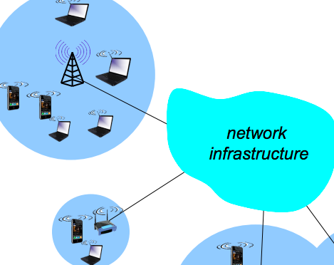

**Wireless hosts:** laptop, smartphone, running applications. May be stationary or mobile.

**Base station** (e.g. cell towers, 802.11 access points):

* Typically connected to wired network.
* **Relay** - responsible for sending packets between wired network and wireless hosts in its “area/vicinity”.

**Wireless Link**: typically used to connect mobiles to base stations.

* Multiple access protocol coordinates link access.
* Various data rates, transmission distances.

**Infrastructure Mode**:

* Base station connects mobiles into the wired network.
* **Handoff**: mobile changes base station providing connection into wired network.

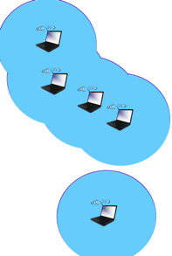

**Ad-Hoc Mode:**

* No base stations.
* Nodes can only transmit to other nodes within link coverage.
* Nodes organise themselves into a network: route among themselves.

**Wireless Network Classification**

|  |  |  |
| --- | --- | --- |
|  | **Single Hop** | **Multiple Hops** |
| **Infrastructure (e.g. AP’s)** | Hosts connect to base station, which connects to the larger internet. | Host may have to relay through several wireless nodes to connect to the larger internet. **Mesh net**. |
| **No Infrastructure** | No base station, no connection to the larger internet.  E.g. **Bluetooth, ad hoc nets** | No base station, no connection to the larger internet. May have to relay to each other a given wireless node. |

**Wireless Link Characteristics**

**Decreased signal strength / Path Loss**: radio signal’s effect reduces as it propagates through matter.

**Interference from other sources:** standardised wireless network frequencies shared by other devices e.g. phones can interfere

**Multipath Propagation**: radio signal reflects off objects ground, arriving at the destination at slightly different times.

This all makes communication across wireless links much more difficult

**Path Loss / Path Attenuation**



Things that can affect path loss / attenuation:

* Reflection, diffraction, absorption | Terrain contours (urban / rural) | Humidity

**Multipath Effects**

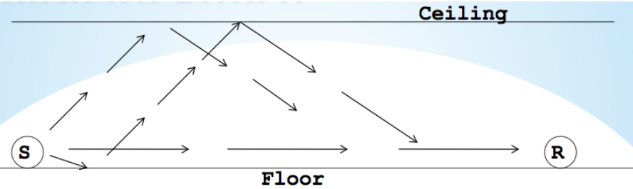

Signals bounce off surface and interfere with one another.

Self-interference.

**Wireless Link Characteristics cont.**

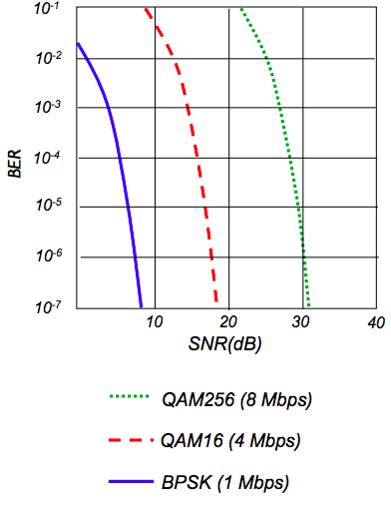

**Signal-to-Noise Ratio (SNR)**: The ratio between the maximum signal strength that a wireless connection can achieve and the noise present in the connection.

* Larger SNR = easier to extract signals from noise.

**Bit Error Rate (BER)**: #bit errors per unit of time.

SNR vs BER trade-offs

* Given a physical layer: AIM is to increase power 🡪 increase SNR 🡪 decrease BER
* Given SNR: AIM is to choose physical layer that meets BER requirement, giving highest throughput.
  + SNR may change with mobility: dynamically adapt physical layer (modulation technique, rate)

Multiple wireless senders / receivers create additional problems.

* **Hidden Terminal / Node Problem**: occurs when a node is visible from a wireless access point (AP) but not from other nodes communicating with that AP.  
  E.g. A 🡪 B 🡨 C , where A can communicate with B, C can communicate with B, but not A🡨🡪 C as they are out of range of each other and cannot communicate as they do not have a physical connection to each other.
* **Signal Attenuation**: B🡨🡪A hear each other, B🡨🡪C hear each other, but not A🡨🡪C as there is interference at B + signal strength reduces during transmission from both sides.
* **Exposed Terminals**: Is when a node is prevented from sending packets to other nodes because of a neighbouring node making a transmission due to **Carrier Sense** (protocol which a node verifies absence of other traffic b4 transmitting).

**Code Division Multiple Access (CDMA)**

CDMA is a channel access method, a unique “code” assigned to each user.

* All users share the same frequency, but each user has their own “chipping” sequence/code to encode data.
* Allows users to send data simultaneously over a single communications channel with minimal interference.

CDMA Encoding / Decoding:

* Assume data #1 = (1, 0, 1, 1) | chipping sequence cM = (1, -1)  
   data #2 = (0, 0, 1, 1) | chipping sequence cM = (1, 1)
* **Encoded Signal = (original data) modulated by (chipping sequence)**
* **Decoding = inner product (summation of bit-by-bit product) of encoded signal and chipping sequence**