**Exercise 1: Ping test**

|  |  |  |
| --- | --- | --- |
| **Host** | **Result** | **Reason** |
| CSE | **100% packet loss** | Most likely blocked by a firewall to prevent Denial of Service attacks. |
| Cancer Council | **100% packet loss** | Unreachable.  Not the legitimate website (cancercouncil.com.au) |
| Compnet.epfi | 123/132 received packets  6.8% packet loss | N/A reachable |
| Intel | 74/79 received packets  6.3% packet loss | N/A reachable |
| Telstra | 59/67 received packets  11.9% packet loss | N/A reachable |
| Hola.hp | **Cannot resolve, unknown host** | Unreachable.  DNS could not be found. |
| Amazon | 84/84 received packets  0% packet loss | N/A reachable. |
| Wkileaks | 57/58 received packets  1.7% packet loss | N/A reachable. |
| Tsinghua University | 103/106 received packets  2.8% packet loss | N/A reachable. |
| Kremlin | **100% packet loss** | Most likely blocked by a firewall to prevent Denial of Service attacks. |
| 8.8.8.8 | 33/49 received packets  17.5% packet loss | N/A reachable. |

**Exercise 2: Traceroute / Network Topology**

How many routers between my workstation and [www.nyu.edu](http://www.nyu.edu)?

* 16 routers

How many routers along the path are part of UNSW network?

* 0 routers

Between which two routers do packets cross the Pacific Ocean?

* Between #4 and #4
* #4 = still in Australia 🡪 #5 = in United Kingdom

Which router do the paths from your machine to the three destinations diverge?

* The paths diverge at the router **198.142.139.134**

Info about this router (whois):

* This router belongs to the Optus Centre is Sydney.

Is the number of hops on each proportional with the physical distance? (geographical distance)  
*Geographical distance is calculated by using straight line distance from my home to the dest*

* Hops to **UCLA**: 17 hops 🡪 12,071.663 km
* Hops to **UTOKYO:** 21 hops 🡪 7,836.810 km
* Hops to **LANCASTER:** 25 hops 🡪 17010.123 km
* The number of hops is not proportional, as we can see that UTOKYO, with the shortest geographical distance from Sydney, Australia still takes 21 hops before arriving at the the destination, compared with UCLA with nearly TWICE the geographic distance but taking only 17 hops before arriving at the destination.
* This is likely because there is less network infrastructure around UTOKYO which limits the ability for network traffic to go through a more direct route to the location, thus needs to hop around more routers before arriving at UTOKYO.

Traceroute from servers to home machine

* Traceroute from **Speedtest.com.sg to home**: 8 hops

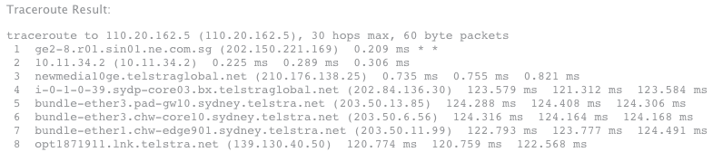  
From **home to Speedtest.com.sg**: 16 hops  
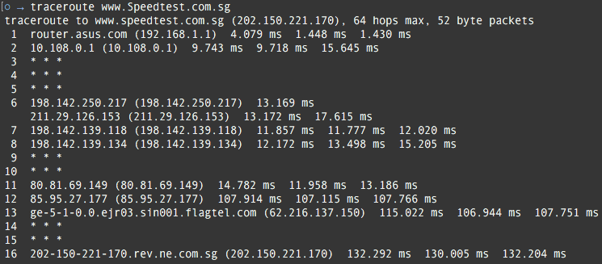

* Traceroute from **home to** **Telstra.net**: 5 hops  
  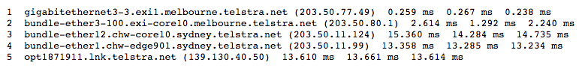

From **Telstra.net to home**: 10 hops  
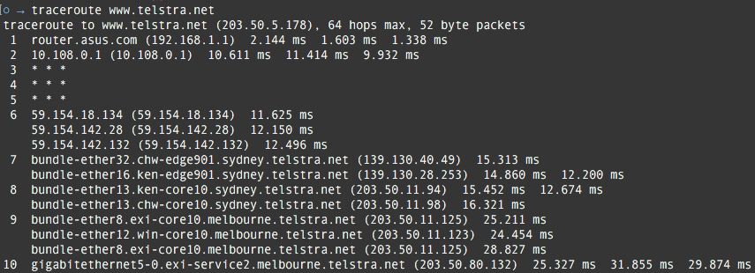

* From the output we can see that the reverse path **does NOT go through the same routers as the forward path** and also for some reason takes **twice as many hops to go from home 🡪 dest** as opposed to dest 🡪 home.
* This is likely because routes are determined based on each router. Each one would have its own set of routing rules so that path forward is not necessarily the same path home. They are determined by things such as neighbouring networks, default routing, administrative distance and metrics. Usually your ISP would route outbound traffic through filters to warn you if you do any “illegal” things such as pirating movies.

**Exercise 3: Ping / Network Performance**

Analysing the dependency of packet size and delay

Assuming propagation speed is the speed of light = **~(3 * 10^8) metres per second**

* Therefore, speed of light = **~(3 * 10^8 / 1000) km per second**
* Therefore, speed of light = **~300,000 km per second**

|  |  |
| --- | --- |
| **Approximate physical distance from UNSW**  **(straight line distance in KM)** | **Shortest Time (T) to reach destination from UNSW** |
| National University of Singapore: 6,297.62 km | T = ~0.021 seconds |
| Technical University of Berlin: 16,133.87 km | T = ~0.053 seconds |
| University of Queensland: 731.78 km | T = ~0.0024 seconds |