**Exercise 1: Understanding TCP Congestion Control**

**Q1** ns tpWindow.tcl 150 100ms

* With a window size of 150 packet at 100ms delay, the max congestion seems to go to 100 packets with the slow-start mechanism.
* Some packets are dropped because the 100 packet congestion > size of the queue (20 packets).
* It will keep alternating back to the slow start phase from packet congestion / dropping of packets.

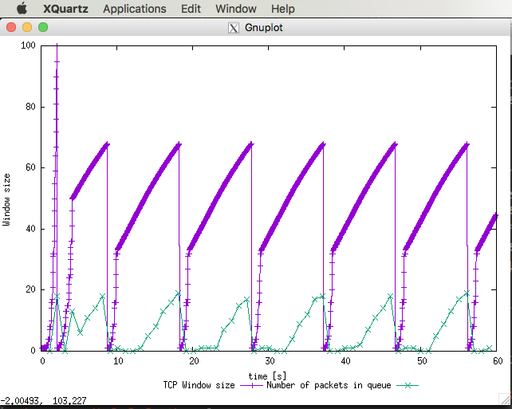­­

**Q2** What is the average throughput of TCP in this case?

* Throughput =
* Packets per second throughput = ~190 pps
* Bytes per second throughout:
  + IP + TCP Headers = 20 + 20 = 40 bytes
  + Payload = 500 bytes
  + = (500 + 40) * 8 bits per byte * 190 packets
  + **= 820,800 bps throughput**

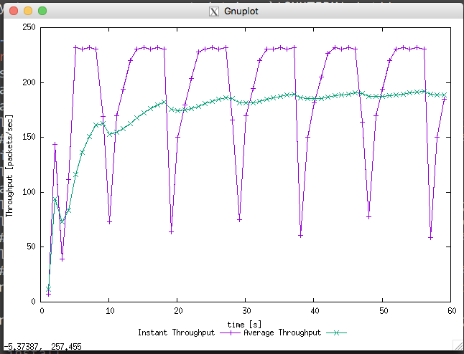

**Q3** Run the above again with different Max Congestion Size

**Q4** Repeat 1 and 2 again for TCP Reno.

Change 🡪 set tcp0 [new Agent/TCP/Reno]

$ns tpWindow.tcl 150 100ms

$gnuplot Window.plot

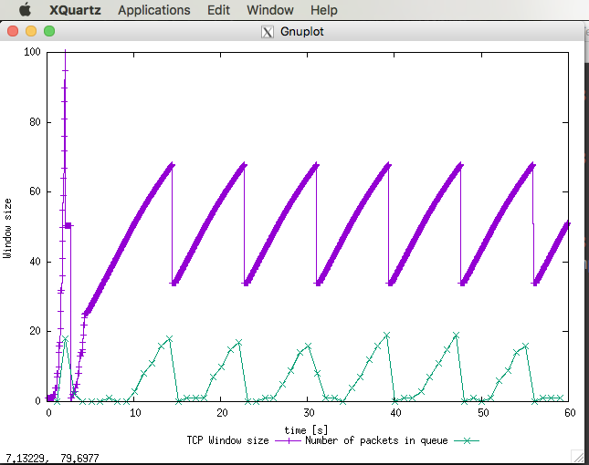

$gnuplot WindowTPut.plot

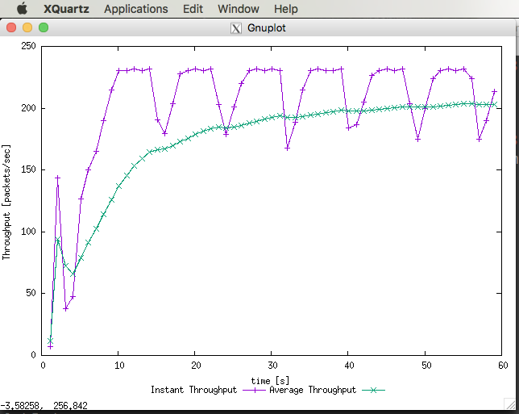

With TCP Reno, it does not re-enter a slow-start phase when loss occurs

TCP Reno throughput = 200 pps

* (500 + 40) * 8 bits * 200 **= 864,000 bps**

Throughput previously with TCP Tahoe was **820,800 bps**, therefore **TCP Reno performs better.**

**Exercise 2: Flow Fairness with TCP**

**Q1** Does each flow get an equal share of the capacity of the common link? Explain which observations lead you to this conclusion.

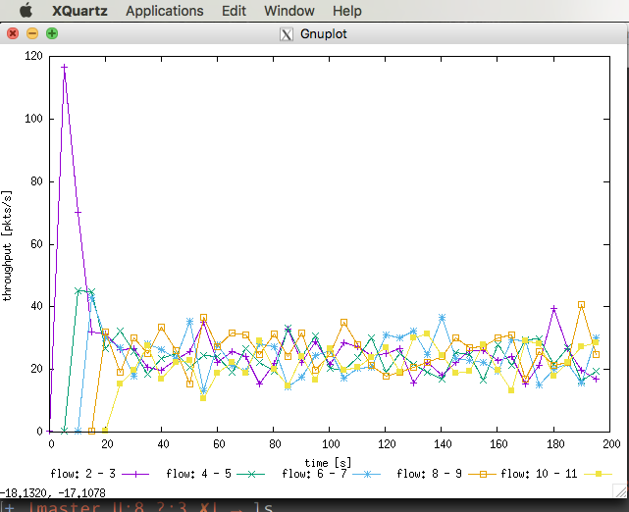

* Yes, each flow does get an equal share of the capacity of the common link.
* As observed in the graph, although throughput for the first few connections start off higher than the others that aren’t connected yet, it averages out to be fairly equal with some expected fluctuations in throughput.

**Q2**. What happens to the throughput of the pre-existing TCP flows when a new flow is created? Explain the mechanisms of TCP which contribute to this behaviour. Argue about whether you consider this behaviour to be fair or unfair.

* As mentioned above, throughput for the first few connections start off higher and then significantly decreases for each new flow that is created, then they are all averaged out over time.
* This is due to the congestion control mechanisms.
* I consider this to be fair behaviour, as each connection adjusts the size of the connection window when a new connection comes in, to allow sharing of the common link.

**Exercise 3: Flow Fairness with TCP**

**NOTE: Error with running ns tp_TCPUDP 🡪 Will answer questions as best as possible without graph**



**Q1**. How do you expect the TCP flow and the UDP flow to behave if the capacity of the link is 5 Mbps?

* I expect the UDP throughput to be higher than the TCP throughput.

**Q2.** Why does one flow achieve higher throughput than the other? Try to explain what mechanisms force the two flows to stabilise to the observed throughput.

* The UDP throughput should be higher than TCP throughput, as it has **no congestion control feature**.

**Q3.** List the advantages and the disadvantages of using UDP instead of TCP for a file transfer, when our connection has to compete with other flows for the same link. What would happen if everybody started using UDP instead of TCP for that same reason?

* If everyone started using UDP instead of TCP, the network could just collapse.