

**A4 - Report**

**COMP 4451 – Game Programming**

|  |  |
| --- | --- |
| Group ID  assigned by the course staff | 03 |
| Group Alias  connect.ust.hk email of any one of the members |  |
| Game Name  tentative name which can be changed later | Soul Knight (UST Version) |
| Group members Student name (connect.ust.hk email address) E.g.: *Pedro Sander (psander)* | CHEN, Siyu (schendf) |
| XIE, Zijun (zxieam) |

## 1. Summary of the idea

What the game is about and its overall objective. This can come directly from the proposal if it has not changed, though additions and subtractions are welcome.

This is a 2.5D single-player roguelike game. The main purpose is to protect the crystal from enemies.

There is a straight road, and the crystal lies on the middle while the enemies invade from both ends.

Players are free to choose the Hero, spend money to upgrade the Hero, build towers, buy weapons.

There will be endless waves if you don’t destroy the 6 enemy holes. As time goes by, the enemies will be stronger. Destroying all of the holes can win the game, otherwise, if the crystal is destroyed or all Heroes are dead, lose the game.

## 2. Screenshots

About 5-8 screenshots of your game that best demonstrates your programming challenges. Include a one-sentence description under each screenshot. For example, if you designed a particle system, pick a screenshot that best demonstrates it. There is no need to go into many details. Those should have already been discussed in the video.

**Challenge 1: Dynamic graph.**

手机屏幕截图

Some are 8 images per loop (e.g., Hero, wave), some are 4 (e.g., enemies, tower). Smooth shift from Hero_stand to Hero_run or Hero_power_mode.

AI

**Challenge 2: 2.5D view and Collision**

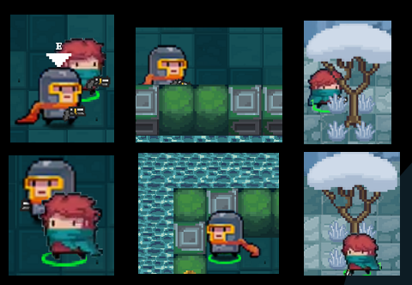

Draw every object from left upper corner to right bottom corner. And update their next image and move accordingly.

Move collision requires each object to specific their objects collision rectangle, and do rectangle collision detection for each move with each other’s collision rectangle.

**Challenge 3: Bullet collision**

电脑游戏的截图

墙上的海报

First need to get the image after rotated and scaled from the original image. Different bullet has different rotation center. This time do rectangle overlap first and then check each pixel in the overlapped area.

**Challenge 4: AI**

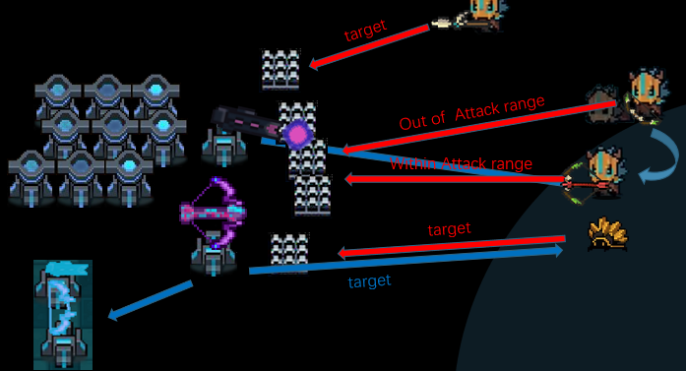

Check through all targets and find the closest one. If not in attack range of current weapon, (tower, AI Hero) wait and (enemy) run.

**Challenge 5: Interaction**

Detect which object you are interacting with and show instructions accordingly.

## 3. Programming challenge specifics

Specify the source files in your submission that include your own code. If you only implemented part of a file, please be specific on the range of lines of code that you implemented. For each range that you specify, describe briefly in one or two sentence what is the purpose of the code in your game. This is important for us to judge the level of programming effort and complexity that went into your game.

1. **All .h and .cpp file in the object filter:** all other objects (bullet, enemy, floor wall, Hero, NPC, Particle, Tower, Wave, Weapon) inherit from Point. These files are responsible for the implementation of all functions corresponding to the object.
2. **EasyxPng.h and EasyxPng.cpp:** original one only has putimage1() but that is also modified. This is used to put images to the window. putRotatedimage() and putRotatedimage2() that use function in “rotate.h” is written by me, but “rotate.h” is not implemented by me.
3. **Main.cpp:** this is used to handle all game issue. For example, transmit mouse and keyboard message to Hero. Draw map and add all Objects needed. Delete dead tower or enemies. Handle game over case and so on.
4. Resource.h is auto created by Resource.rc but all image name is modified for easy understanding.

## 4. Changes from proposal

Go back to all sections of your proposal and see what you have changed. Briefly describe all the changes (i.e., features that you added, or features that you no longer pursued due to time or interest in exploring other ideas).

Feature added:

1. Switch between two Hero (we can add more Hero easily if we have picture).
2. A nicer and bigger map.
3. Some surprise eggs.
4. Fix and upgrade tower function.
5. Third weapon slot. (one kind of buff)
6. Upgrade Hero’s current weapon. Higher damage.
7. Click for next wave.
8. Game summary. (Time, enemy eliminated, money earned)
9. More weapons than we originally want (14 > 9)
10. The trainer’s sandbags. (Can show current weapon damage)
11. Mini map (show all Hero tower enemies in a smaller map)
12. AI Hero (if don’t control the Hero at this time)

Feature not implemented:

1. Bullet effects. (ice, fire and so on)
2. Boss.
3. Bullet can be blocked or reflected by walls. (really takes time)
4. More powerful buff. (no time)

## 5. Work distribution (group projects only)

Specify the amount of effort of each group member as a percentage (e.g., John 60%, Bob 40%). If you do not agree on the percentage breakdown, please specify separately below what each member believes to be the breakdown. You may further elaborate briefly on what each member has done.

**XIE Zijun:**

XIE, Zijin: Total work (Around 35 - 40%). Code (30%) (this is the percentage of the total typed code, not the percentage of the code used in the final game program). Provide at least 55% images and all sound media.

Proposal and report (40%). Game Testing (70% - 80%)

Chen, Siyu: Total work (Around 60 - 65%). Code (70%) (this is the percentage of the total typed code, not the percentage of the code used in the final game program). Provide 45% images. Proposal and report (60%). Game Testing (20% - 30%)

For the code part, at the beginning I was busy for other things. Siyu codes very quickly, when I complete the other thing, Siyu has finished some parts of the game. I done some parts of the code, but Siyu provides better codes and finally his code is used.

My job is designing the template of bullet, weapons, parts of mouse handling, bullet detectionand remove of rubbish objects (e.g., bullet that hits enemy).

After the program is finished, I do quite a lot game testing and found some bugs and gave some suggestions to improve the game.

Siyu is hard working, and he provides more efforts. He always acts as a leader.

**CHEN Siyu:**

CHEN, Siyu:

Code (90%). Handle 246 images used. All video PPT.

Proposal and report (70%). Game testing (40%). Readme.txt (100%)

XIE, Zijin:

Code (10%). Handle 142 images used. Proposal and report (30%).

Game testing (60%).

It is not because I don’t want to let XIE to work more on the Code. But at the second time when XIE were available to help (2 weeks before A3DDL), I have almost finished the basic and most important parts. (lack of images) If he codes, he needs to spend more time to understand the code.

Besides, I do not trust his code and efficiency since I let him to write the type “BULLET” and “WEAPON” between A1and A2 (the first time he can help), He spent 2 days and that did not work well at all. So, I spend one afternoon to rebuild most of them and finished. So, at the second time he can help, I ask him to provide images needed instead of writing code. (He wanted to help with codes, but our time is tight)

I said I do 90% of the code because the final code used of our game are almost down by myself. I am not sure the amount of code XIE typed but not used in the final. (I have all game progress .zip records of the game from game1(1)->game1(10), game2(1)->game2(2), game3(1)->game3(8) which he doesn’t have as prove of my efforts.)