# Help Document

This document will outline how to uses and run the currency converter.

# Running the currency converter

1. Open the main file called install.py and run file by pressing run > run module.
2. Open main.py and run it by clicking on run > run module
3. Programme should display this screen:
4. 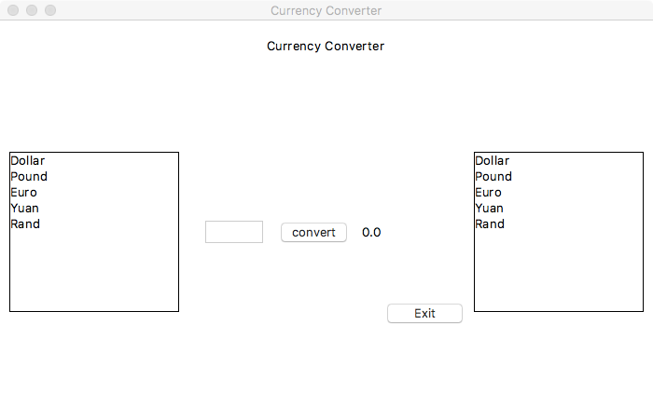
5. You have successfully run the python programme

# Using the Currency converter

1. Select a currency you wish to convert from in the left list Box: the selection should display a symbol of the currency selected next to the entry box.
2. Fill in the amount you wish to convert in the entry box.
3. Select a currency you with to convert to in the right list box.
4. Press the convert button to convert to convert the amount in the box to selected currency.
5. Press exit when finished to exit the programme
6. Press the HELP tab to get information about the author and to open this document again.