**Conference Manager System**

**Application documentation**

**Team Magic Wand,**

composed of:

Andra Cardaș,

Alexandru Cernov,

Bogdan Chelărescu,

Gerlinde Ciocea,

Patricia Truță.

**1 Table of contents**

1. **Table of contents**
2. **Application presentation**

**2.1 General description**

**2.2 Preliminary phase**

**2.3 Phase one**

**2.4 Phase two**

**2.5 Phase three**

**3 Team work-flow and organization**

**3.1 Version Control**

**3.2 Task management tools**

**3.3 Software used**

**4 Implementation**

**4.1 Database**

**4.1.1 Technologies used**

**4.1.2 Diagram**

**4.1.3 Tables**

**4.1.3.1 PC_Members**

**4.1.3.2 Committees**

**4.1.3.3 CallForPapers**

**4.1.3.4 Conferences**

**4.1.3.5 Sessions**

**4.1.3.6 Topics**

**4.1.3.7 Calls_Topics**

**4.1.3.8 Authors**

**4.1.3.9 Papers**

**4.1.3.10 Papers_Topics**

**4.1.3.11 Written_By**

**4.1.3.12 Abstracts**

**4.3 MVC**

**4.4 User Interface**

**5 Use cases**

**6 Classes**

**7 Interaction**

**8 Architecture**

**2 Project Presentation**

**2.1 General description**

The purpose of the Conference Management System application is to support the automatic management of information related to scientific conferences. Its aim is to provide a means to simplify the way in which researchers publish, get feedback on and expose their work in a certain field to the public. In addition to that, it allows for much easier planning and management of scientific conferences and sessions, from organization to attendance.

The organization of such an event can be split into three distinct phases, namely the preliminary phase, phase one, phase two and phase three.

**2.2 Preliminary phase**

This particular phase contains the sum of all the actions taken by the organizing team, called the Program Committee, in order to set up a conference session. This includes the registration of the individuals that make up the Program Committee, in case of a new conference, or the log-in of the Steering Committee, in the situation that the given conference is a recurring one. The following step would be for certain members of the Committee, namely the Chair or the Co-chairs, to create the „Call for papers” and set up the basic information about the conference, including location, deadline for abstract and proposal submission and various discussion topics. These members, and only them, have the permission to later update this information.

**2.1 Phase one**

Phase one represents the part of the life-cycle of the conference in which authors get to submit their papers, as candidates for the conference. In order to do so, the potential authors have to register using a new account or use an older, already created one. Once the scientist has been authenticated, they can create the abstract of the paper and the paper itself, which they will then submit to the „Call for papers”. The authors may submit proposals only until certain deadlines, and may submit a paper only if its topics correspond to the topics of the conference itself.

**2.2 Phase two**

During the second phase, Program Committee members are required to review each submitted paper, in order to determine whether a given proposal will be presented during the conference sessions. Each reviewer is required to bid the proposals, stating whether or not they are willing to review a given paper, until a given deadline. Following the bidding process, the conference chair and co-chairs split the papers between reviewers. A paper may not be reviewed by an individual which has declined it during the bidding process, and also may not be reviewed by less than three people.

**2.3 Phase three**

The third and last phase concerns the activities taking place during the actual conference, the most important of them being the presentation of the papers. A conference is structured on different sections, happening in parallel. Each section is supervised by a session chair, who is a member of the Program Committee and who is not allowed to preside over the sessions in which they also present their submitted paper. During the section, the authors of the paper being presented take on the role of speakers. Users who wish to participate to a specific section are required to mark their attendance, so that the Program Committee can have an overall idea of how many participants will be attending a certain session, information which will be used when assigning rooms for each session.

1. **Team work-flow and organization**

**3.1 Version Control**

Version control represents the management of changes made to any file or collection of information.

Our team has chosen to use Git as the software for version control, which is a form of distributed version control, meaning that each member of the team works directly with their own local repository, changes which are later merged into a single file. The remote repository is stored on GitHub, which is a web-based hosting service for version control using Git.

We have created distinct branches for each feature of our application (eg.: Login, Register), which are to be merged into the master branch when the feature has been completed and verified. Only the team leader has the right to merge the branches into the master branch.

**3.2 Task management tools**

For task delegation, as well as for progress monitorization, our team has chosen to use Trello, which is a web-based list-making application.

The team’s board on the platform is called “SSE” and is composed of three lists, namely “To Do”, “Doing” and “Done”, representing the current completion status of a certain task. From here, the team leader creates and assigns each member a number of tasks.

This way, the progress of a tasks can be easily monitored. Another perk of using this task management tool is that it nullifies the chance that two different people work on the same task at the same time.

**3.3 Software used**

<Write about Visual studio>

1. **Implementation**

**4.1 Database**

**4.1.1 Technologies used**

**<write about entity framework>**

**4.1.2 Diagram**

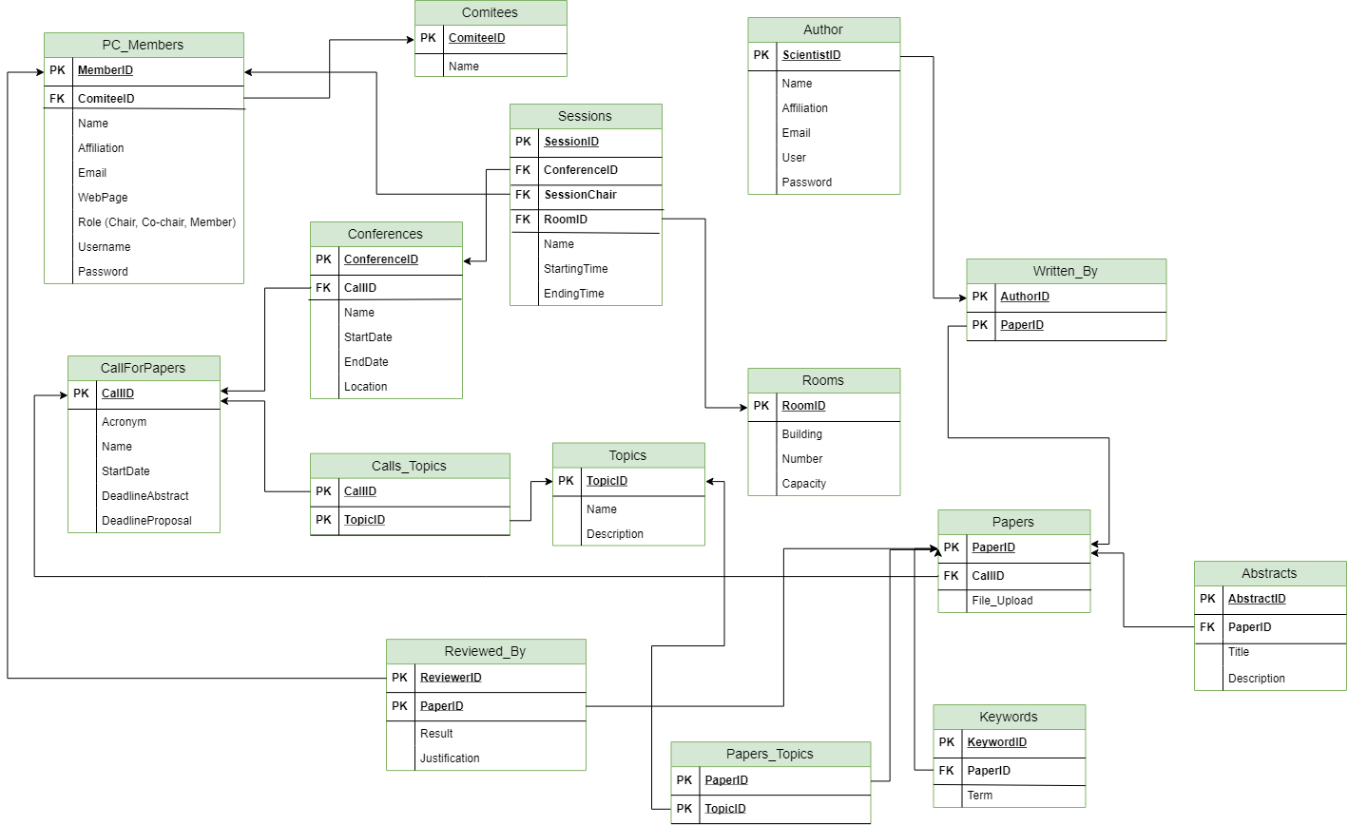

**4.1.3 Tables**

**4.1.3.1 Abstracts**

**4.1.3.2 Authors**

**4.1.3.3 CallForPapers**

**4.1.3.4 Calls_Topics**

**4.1.3.5 Committees**

**4.1.3.6 Conferences**

**4.1.3.7 Papers**

**4.1.3.8 PaperTopics**

**4.1.3.9 PC_Members**

**4.1.3.10 Reviews**

**4.1.3.11 Rooms**

**4.1.3.12 Sessions**

**4.1.3.13 Topics**

**4.1.3.14 Written_By**