Improving CPU Power Delivery Efficiency

Alexander Chapin

Glenelg High School

Mentorship I

Professor [Leila Chawkat](mailto:leila_chawkat@hcpss.org)

Mentor Jonathan Cohen

12/12/24

**Abstract**

A new system for CPU voltage regulation is proposed that improves the efficiency of the entire circuit. The solution achieves higher efficiency by eliminating the voltage stabilization on the output of the intermediate 12 VDC power supply. That results in a less stable voltage being fed into the switching VRM circuit. The VRM circuit was then modified to monitor the output voltage and vary the duty cycle of the switching VRM. Controlling the VRM is a system of 3 Op-Amps that compare the voltage of the output to a target voltage and then adjust the duty cycle of the system in order to compensate for any changes in input voltage or electrical noise in the 12 V supply. Simulated results are used to prove that the model will be applicable to desktop and mobile user segment devices.

**Table of Contents**

**Literature review………………………………………………………………………………**

**Data Collection…………………………………………………………………………………**

**Discussion…………………………………………………………………………………….…**

**Conclusion……………………………………………………………………………………....**

**References……………………………………………………………………………………….**

**Improving CPU Power Delivery Efficiency**

**Introduction**

Modern consumer CPUs (Central Processing Units) require DC (Direct Current) input voltages in the range of .7 to 1.4 volts. Thus the problem arises, how can 120 volt AC (Alternating Current) be regulated down to the acceptable range for CPUs. The existing systems typically consist of a transformer that takes 120 V and uses a transformer to convert the 120 VAC to a lower voltage, then a full bridge rectifier is used to convert the AC to DC, which is then regulated to produce 12 VDC. The 12 V power then flows through the motherboard and to the switching VRMs (Voltage Regulator Modules). The VRMs then convert the 12 VDC input into 1.x VDC and that is provided to the CPU. Because power consumption in both consumer and datacenter computing is on the rise, the existing system proves to be less efficient at providing large amounts of current efficiently. These systems are implemented everywhere and with 59.8 Million desktop computers being shipped out in Q1 of 2024 alone (Shirer); a marginal efficiency improvement can save a significant amount of power over the long run. A new system is required to more efficiently provide power to CPUs and this paper will propose one that more efficiently converts AC utility electrical power to a voltage that CPUs can use.

**Literature Review**

**Important Terms**

Before exploring the intricacies of electrical engineering and investigating different ideas for solutions, it is important to first define a few key electrical engineering terms. Voltage, measured in Volts, is a measurement of the electrical potential energy between two points. Voltage can also be crudely represented as water pressure, meaning the greater the change in voltage is between two points, the more forcefully the charge would flow. Current, measured in Amps, is a measurement of how much charge is passing through a certain point per unit time. Charges, meaning electrons, are moving around chaotically almost constantly but current measures the net flow of electrons through an area. It is important to note that current travels in the opposite direction as the flow of electrons. If, for instance, 10 electrons pass through an area moving to the left and 20 electrons move through the same area moving to the right, the net current would be to the left. Power, measured in Watts, is a measurement of how much total electrical energy is being expended or dissipated by a circuit. Calculating power is very simple, merely being voltage times current . A MOSFET is a Metal-Oxide-Semiconductor Field-Effect Transistor, meaning essentially a large transistor that uses electric fields to switch open or closed. A transistor allows for the opening or closing of a connection based on an external signal. Picture a tollbooth or drawbridge. An inductor consists of windings of a conductor; sometimes the conductor is wound around a ferrite metal core. When current flows through the conductor, it induces a magnetic field, whose changes induce voltage across the wire’s windings, an effect that is increased by the added core. By building up such a magnetic field, the inductor can store electrical energy. Inductors can be used in these applications to stabilize the output current of the system by having some energy stored, ready to be turned back into voltage when the current in the inductor falls. Capacitors act much the same way as inductors, although instead of using magnetic fields, capacitors create electric fields between two plates and store charge on those plates. By storing charge a capacitor is able to stabilize the voltage of a circuit. A Buck VRM is a circuit that uses two MOSFETs, an inductor, and a capacitor to switch on and off a circuit that alternately charges the capacitor and inductor then switches to charging the capacitor from the energy in the inductor. Then the output voltage can be varied by changing the duty cycle, or the amount of time the system is charging and discharging. A transformer is an inductor with two sets of windings, so that varying current in the primary produces a varying magnetic field, which then induces a voltage in the other winding.

**Defining the Problem**

Switching VRMs have been used for a long time and have been refined to impressive standards of efficiency. The most efficient commercial VRMs can reach as high as 95% percent efficiency (ROHM Semiconductor). But because of how many devices around the world use VRMs even the slightest of performance improvements can result in large worldwide power savings. For example an estimated 245 Million desktop computers were sold in 2024 (Shirer), and that doesn't even include any laptops, tablets, phones, or other devices. By making a slight improvement in efficiency an astounding amount of power could be saved. Yet another problem arises when the desire for faster and faster computers is considered. As computers get faster they will get more efficient in terms of IPS (Instructions per Second) / watt (Intel Corporation) but they will still use more power overall as more cores are added to keep up with performance expectations. Thus power delivery systems must be ready to supply even more power for the future; this points to a solution that would be able to handle hundreds or even thousands of amps of output current while minimizing the effect on efficiency that increase of amperage has.

Intel as a company has recently been an unfortunate example of how much power usage has been increasing. Their chips have drastically increased in power usage over the last few years going from the i7-6700k to the Ultra 7 265k with an increase in base power from 91 W to 125 W. However the most marked increase was between the boost or turbo power limits, going from 135 W to 250 W (Intel Corporation)(Intel Corporation). Modern power solutions must be ready to handle large variances in the amount of power being supplied; unfortunately there are even a few more factors to consider when designing a solution. As processors get faster their clock speeds also get faster. Clock speeds essentially tell the processor how quickly to complete operations. At higher clock speeds the switching between states of low load and states of high load can be surprisingly fast. This presents yet another issue for the designer of a power solution in that they must be able to handle a sudden change from a 10 A draw to a 250 A draw. But those loads can also happen transiently, meaning the CPU happened to schedule many tasks and suddenly needed 250 A for a few thousand clock cycles. A new power delivery system would have to be able to deal with not only these higher power draws but also these sudden load jumps and transient spikes.

Now before exploring other solutions to the problem it is important to understand where energy can be lost in a voltage regulation system. One place that energy can be lost is in an inductor or transformer. These magnetic electronics components have two main sources of loss, loss in the windings due to conduction loss, and core loss due to eddy currents and other magnetic properties of the transformer’s metal core. The next type of losses to consider are switching losses. Switching losses occur in components that switch on or off, in this case MOSFETs, and are transitory power dissipations as a result of the MOSFET not being fully switched to one state as it moves between the states of fully on and fully off. MOSFETs also lose energy through conduction across the channel of the MOSFET and through gate charge losses. Gate charge losses occur when the gate, or the section of the MOSFET that is charged in order to close the circuit, suddenly is switched to be connected to ground in order to close the circuit. At that point all of the charge being held on the gate, also known as QG is lost to ground. Energy can also be lost to conductive losses: whenever a current is conducted across a long distance there is a loss simply to the resistance of the wire. That loss is relatively minor but is a significant factor when considering the layouts of the components and what size wire to use. Capacitors can also create losses in a circuit. As a capacitor charges up there is some internal resistance and some energy is lost, some of this is due to imperfections in the dielectric medium inside the capacitor. Slight imperfections in the dielectric medium can result in leakage current across the capacitor, thus losing some electrical energy.

Having established the types of losses to combat in designing a power delivery architecture, it is logical to now consider how to minimize those losses. Starting with conductive losses, conductive losses are relatively easy to combat by simply making the length of physical cable run the shortest possible distance, by making components as close as they can possibly be. Reducing the distance between components drives down the unnecessary resistance of the circuit and allows more energy to get to the target destination. Minimizing the loss across MOSFETs is a bit more difficult because there are so many types of loss. Reducing conductive losses is as simple as reducing the amount of current flowing through the circuit, and that can be easily done by splitting the current into multiple different MOSFETs and creating multiple VRM phases. The switching loss in MOSFETs can be modeled by treating the transitions between on and off states as linear, expressing the lower loss as:

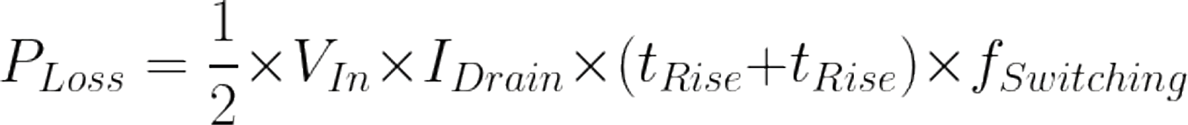(Keim)

By looking at this equation it becomes clear that switching losses can be minimized through reducing first the switching frequency; however, reducing the switching frequency of the circuit will result in a larger voltage ripple at the output. The input voltage of the MOSFET cannot be modified so what remains to minimize is the current through the MOSFET and the rise and fall times. The rise and fall times refer to the signal that is driving the MOSFET, reducing the rise and fall times will require designing a control system that will be able to produce a signal with rise and fall times as short as possible. Finally the current through the MOSFET can be minimized through splitting the system into multiple phases. Finally, losses to gate charge in MOSFETs can be minimized through reducing the surface area of the N-channel in the physical circuit. However this will also result in a smaller surface area for charges to flow when the MOSFET is open, likely leading to a larger loss to conduction than was previously lost to gate charge. For that reason gate charge losses will be essentially ignored because for most modern power MOSFETs the gates charge to 98 to 150 nC, resulting in relatively minimal gate losses at lower switching frequencies. When transformers are used in circuits, the largest source of loss is the loss to conduction in the windings of the transformer. By comparison, the losses to eddy currents in the core of the transformer are relatively small. In order to minimize the losses to conduction a few measures can be taken, mainly minimizing the number of cable turns that take place around the inductor and making sure that the gauge of wire being used to wrap the core is as large as possible while also keeping the core relatively small and manageable. In terms of minimizing capacitor losses the best advice is to minimize the size of capacitors in the circuit as most of the loss comes from the actual surface area of the capacitor plates. As smaller capacitors have less area and thus less potential for loss they are more optimal for use in efficient circuits. However using smaller capacitors is sometimes not feasible while maintaining stable voltages as often capacitors are used to stabilize the voltage in the circuit. Implementing all of these loss minimization techniques in the final design solution will optimally use components and techniques to improve efficiency.

**Previous Solutions**

In order to design the best system that synthesizes ideas from other research in this field it is important to first investigate and explain other existing prototypes. These ideas were selected from recent papers exploring VRM ideas. By using only recent papers these ideas will understand and better prepare for large current draws and transient spikes. These ideas will be evaluated on a number of criteria, with the most important being voltage conversion efficiency. This is easily measured by comparing the input power to the output power. The prototypes will also be rated based on the ease of implementation, meaning how easy is the system to build and implement in a real world environment. Really, this comes down to three things: the parts, the wiring, and control systems. For the parts and wiring it mostly comes down to how easy these parts are to find and manufacture. Then, for the control system, the complexity really matters when it comes to using the circuit in the real world and producing it at a large scale. A more complex system will result in higher costs in manufacturing and more hostility to industry adoption. Solutions will also be evaluated in terms of how much noise the systems create. These types of systems that often switch high currents at very high frequencies tend to create 3 types of interference. There is $\frac{dV}{dt}$ interference when the voltage in a component rapidly changes (Ouyang), resulting in electromagnetic interference that can cause signal issues in other nearby traces and causing performance issues in the computer system. While switching voltages can cause noise, similar issues with current, or $\frac{di}{dt}$ noise, can also arise. $\frac{di}{dt}$ noise tends to create the same sort of issues that $\frac{dV}{dt}$ noise creates (Larsson), leading to harmful electromagnetic interference. In terms of actual solution they will be evaluated on how much noise they would be expected to produce in a real circuit implementation. Obviously a solution would be preferred that produces the least amount of noise. The final type of interference that a VRM solution may produce is magnetic interference. Magnetic interference is most likely to be produced by inductive components like transformers or inductors. Magnetic fields are induced simply as a part of the operation of the circuit, but minimizing these fields is important because they can also impact the signals in nearby wires. The final factor to consider when evaluating solutions is the power density of the converter. In datacenter computers space is often quite limited so keeping power regulation circuitry dense will also allow more room for cooling and other essential parts of the computer system. Power density is measured in output watts per cubic inch. A good solution would minimize all of these different types of noise by keeping switching frequencies low, magnetic components small and far away from important signal wires, by splitting currents between multiple circuits or phases to minimize how much $\frac{di}{dt}$ noise affects the computer, and finally keeping the rest of the circuit dense.

One datacenter solution to explore is Fei and Chao’s solution for a two phase 48 V to 1 V converter for servers. In servers the power distribution rails are kept at 48VDC in order to minimize conduction losses from the power supplies for the server. In this paper the authors set forth a two phase solution that first converts the 48 V to either 12 or 6 V using a switching transformer then the final conversion from either 12 or 6 V to 1.8 V is done with a standard switching buck converter. (Fei) The primary rationale for using transformers and having two operating modes is to deal with efficiency at lower power usages. At low power draws, switching converters tend to be less efficient because they spend a lot more energy charging the components that are simply wasted. This system, when it detects a low power use situation, will switch to a half bridge converter, meaning that now the buck converter only has to convert 6 V to 1.8 V, which can be done more efficiently at lower currents. Then the system can switch over to the higher power operating mode when the power is demanded within 3.3μs. Then at that point the buck converter switches back over to converting 12 V to 1.8 V. This entire change was designed in order to improve the efficiency of the system at lower power levels, where servers will sometimes sit idle. Their final solution used a 4 phase buck converter and only used 3 phases when operating in 6 V mode. They would switch off half of the input 48 V of the transformer in order to switch between 12 and 6 V regulation modes. In terms of efficiency this solution was able to demonstrate 97 % peak efficiency with an increase in lower load efficiency over a standard transformer and buck converter. Unfortunately, the control system has to be relatively complicated to deal with the switching between states being able to quickly transition back to the higher power state. The controller they designed just switches the transformer at a constant rate and allows for enabling or disabling the second set of primary windings in the transformer. The other part of the controller simply has the ability to double the duty cycle of the switching VRM when the voltage is shifted into the lower state. While the control system is complicated, it is manageable and not terribly difficult to implement in a computer system. The only other issue with this design is that it does create a lot of electromagnetic interference: the DC switched transformers create strong magnetic fields and the fact that all of the current for the circuit is being rapidly switched across a transformer will have to be mitigated and kept away from any data transmission lines in the computer. Magnetic shielding can also help deal with the interference but the interference can be compensated for. The final factor for this design to consider is the power density of the system; according to the authors their design has a power density of 850 W / in3 which is impressive and will allow the system to fit well into data centers. Overall, this idea is very interesting and the use of transformers in any solution is almost essential as transformers can be as high as 99% efficient (Daelim Transformer).

The next solution to be explored is the 48 to 1 V Sigma Converter from Ahmed et al. Their proposed design revolves around a large transformer acting in series with a smaller buck converter. (Ahmed) By putting them in series, the natural voltage division principle applies and the system is configured in a way that the transformer receives 40 V across it while the buck converter has only 8 V supplied across it. The 40 V transformer then converts to an output of 1V and that is put in parallel with the output of the buck converter. By doing the conversion this way the transformer can handle the majority of the current while the buck converter is able to finely adjust the voltage above 1 V and deal with transient loads. This configuration allows the large transformers to carry the bulk of the amperage conversion loads while a smaller but less efficient buck converter handles the fine voltage control. This solution has a peak efficiency of 93.4 %, a surprisingly good figure because this converter has to transform 48 V to 1 V. Larger changes in voltage tend to be less efficient so an efficiency of 93 % is still quite good. In terms of power density this circuit provides 420 W / in3, taking up more space than the previous solution. When it comes to electromagnetic noise and interference, this system would also create relatively high interference because it operates by switching a large amount of power across the transformer to regulate 40 V to 1 V. These huge switching currents and magnetic fields produced by the operation of this prototype would require the distancing of this part from other data lines and important signals in a computer or would at least require some magnetic shielding. Overall this design is very promising and using natural voltage division to use multiple techniques for voltage regulation is a very good idea that could be implemented in computers with relative ease.

Auxiliary circuitry can also be added to any voltage regulation circuit in order to stabilize the voltage and improve system performance. For instance, Qian et al. demonstrated an auxiliary circuit that will reduce output voltage fluctuations as a result of changing loads. When a CPU changes load states there are sudden drastic changes in the amount of power required to complete the calculations that the CPU is trying to do. These huge fluctuations in power require a power system that can compensate for this and attempt to keep the voltage as stable as possible. Full stability in the face of a load change from 10 A to 150 A is not possible but quick reacting circuits can help to compensate for this sudden change. The authors here put forward a circuit that can be added on to the output of any VRM circuit to help deal with large changes in load by either adding or removing power through a smaller buck converter. The design uses a buck converter with two back to back MOSFETs that connect it to the output power source. When the system is operating normally the MOSFETs are open and the buck converter stays off. But when the auxiliary circuit detects that the output voltage has deviated from the target voltage it closes both of the MOSFETs and uses nonlinear control of the buck converter to drive the output voltage back to where it should be. Once the voltage has been assisted to return to the ideal level the MOSFETs open again and the circuit returns to normal. The nonlinear controller of the buck VRM drives the circuit in a way that reduces the difference between the output voltage and the target voltage. It will do this by sometimes going completely non-linear, meaning it will open or close the MOSFET in the buck converter completely, thus either drawing power out of the circuit and into the inductor, or providing power from the buck converter to the circuit. By doing this the auxiliary circuit is able to assist when the power changes are too great for the primary VRM to compensate fast enough. The authors found that this system decreased the amount of undershoot by 25% and overshoot by 51%. This kind of improvement is very impressive and will result in much more stable output voltage for CPUs. In terms of power density, the same grading standards don’t apply but the circuit is very small and a single circuit can be used to stabilize the voltage of many cores. In terms of creating electrical noise, this circuit remains relatively small, and the fact that it only comes into effect rarely and only really has a small inductor means that it can’t use too much power or switch any massive amount of current. In conclusion, this circuit would be relatively effective at assisting to stabilize the output voltage of circuit while not taking up much space or creating too much electromagnetic interference.

Finally, having evaluated a number of scholarly solutions to the problem of CPU voltage regulation and having gained knowledge and understanding into the design process for a new VRM solution, a new solution can be created.

**Data Collection**

**Creating a Prototype**

In order to create a solution first the focus must be on where in the system efficiency should be increased. In this case, loss of efficiency is seen in the system of regulating a very stable 12 V and then converting it to 1 V. The amount of circuitry and unnecessary losses to regulation of the 12 V bus voltage is seen as a point of loss where power can be saved. While multiple step voltage conversion is necessary, the amount of filtering and voltage regulation on the 12 V source is not necessary. In reality, a very simple 120 VAC rectifier and then a transformer that regulates down to 12 V but does not waste the efficiency in stabilizing the voltage or eliminating noise from the power lines can be much more efficient. Then the buck VRM that converts the 12 VDC to 1 V will need to have a more complicated control system that looks for irregularities and changes in the voltage supply and modifies the duty cycle of the buck converter to compensate for any voltage changes. In theory, this solution would remove all of the unnecessary losses from regulating the intermediate voltage. This solution involves using an analog controller for the buck voltage regulator. The controller compares the output voltage to the target voltage being set by the CPU and uses that feedback from the circuit, to set the duty cycles for the MOSFETs. By using that feedback from the output voltage, the regulator is able to modulate the duty cycle based on the observed output voltage. By doing this very quickly the system will be able to adapt to voltage fluctuations and irregularities in the 12 V bus, effectively using those voltage spikes or dips instead of needing to expend energy to smooth them. By using this system all of the fine voltage control is done in one spot and a very efficient but messy 12 V is able to be used in the motherboard.

Creating this prototype and testing it is a much more difficult task. Unfortunately, actual laboratory experiments were not possible at this time for this experiment, mainly because implementing these circuits would require expensive parts and a good lab space with proper equipment to set up large scale experiments. The other issue with real world testing is that these highly experimental circuits will have to be modified and tweaked often in order to attain the desired efficiency and changing a real world circuit on a whim is not the easiest task. That is not to even mention the physical danger of testing high power circuitry, especially experimental circuits. Considering these factors, actual physical testing would not be a feasible method of testing these ideas. This leaves the best remaining option for testing circuitry: computer simulation. By using computer simulations, costs, time, safety concerns, and ease of access can all be eased. Simulations can also provide more detailed information than a physical circuit can, even with a top of the line oscilloscope. Computer simulation programs like LTSpice allow for creation of custom circuitry and easy testing and measurement of created circuits. LTSpice also provides a very easy way to change portions of a circuit and quickly test different circuits and ideas. The LTSpice software runs a SPICE (Simulation Program with Integrated Circuit Emphasis) simulation of the given circuit and can be configured to collect and average certain data points while the simulation is running. By using a simulation, more data can be collected including extremely accurate power averages that can be used to measure the efficiency with more accuracy then real world measurement could yield.

One of the best benefits of computer modeling is that it is very easy to determine the power being lost from each component and eliminate losses in a circuit. This type of data can be collected either one of two ways: complicated modeling of each component can take place using many different complicated equations, or the software can simply calculate the power dissipated by each component. Using the equation based modeling system is beneficial once a final circuit is reached and it is worthwhile to check the other simulations with mathematical models. Many papers like (Yuancheng) provide a number of equations that can be used to calculate the power loss across any type of switching MOSFET. The authors of Yuancheng et al. provide comprehensive data and equations to calculate power loss to switching and other MOSFET related losses. The authors also provide very good reasoning as to why the equations are what they are and are able to accurately model real world circuits. Fortunately SPICE tends to implement models that are very close if not just approximations of the formulas and techniques laid out in papers like Eberle et al. By implementing a SPICE model, often a lot of the factors mentioned in modeling MOSFETs are quickly and accurately taken into account. Although much more detailed analysis is available with a lot more processing power and time to run calculations the difference between the approximated measurements done by SPICE and the full calculations is relatively small if not fully negligible. For that reason this data will all be collected in SPICE and an assumption will be made that the SPICE numbers are relatively close to the best simulation equations that exist out in the world. Modeling the only other significant source of loss in the circuit, the inductor, is also important and while specific mathematical models can be found, like in Ehrlich et al. It makes much more sense to rely on the SPICE simulation data because it is just so much easier to obtain and collect. Induction losses in SPICE simulations tend to overestimate the loss, leading to better real world performance than simulated performance, meaning that the real circuit would overperform it’s virtual counterpart. For more precise modeling it may make more sense to rely on models like Ehrlich to model specifically induction losses. Although SPICE modeling may not perfectly portray real world operating conditions it will certainly be close enough to real world performance for the purposes of this study.

In order to make a buck VRM that would adjust the duty cycle of the converter as the input voltage changes, the output voltage must be measured and used to adjust the duty cycle.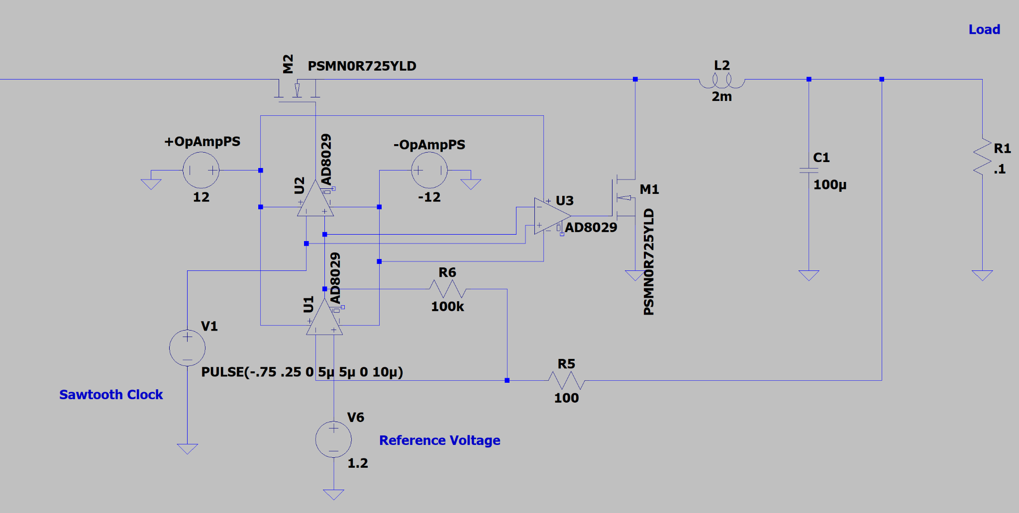

In this testing schematic, the Op-Amp measurement circuit with feedback from the circuit is clearly illustrated. In this case a load of .1 Ω is being used to simulate a CPU load. With the 1.2 V reference voltage set as the target voltage the power dissipated across R1 should be around 12 W. The first Op-Amp, U1 uses a set feedback gain set by the 100kΩ resistor in order to amplify the difference between the output voltage and the reference voltage. Then a sawtooth clock is used so that the Op-Amps that control the MOSFETs can, based on the calculated difference from the U1 Op-Amp, modulate which portion of the sawtooth clock the MOSFETs are on for. Creating a circuit that will increase and decrease the time on for the MOSFETs based on a reference set on a sawtooth wave. In order to actually test this circuit with an irregular or noisy power source the next step was to create a power supply that would yield an irregular voltage. The circuit below shows a sine wave or AC voltage being converted into an only positive sine pattern through a full wave rectifier, then the capacitor stabilizes the voltage and keeps the voltage above a certain threshold.

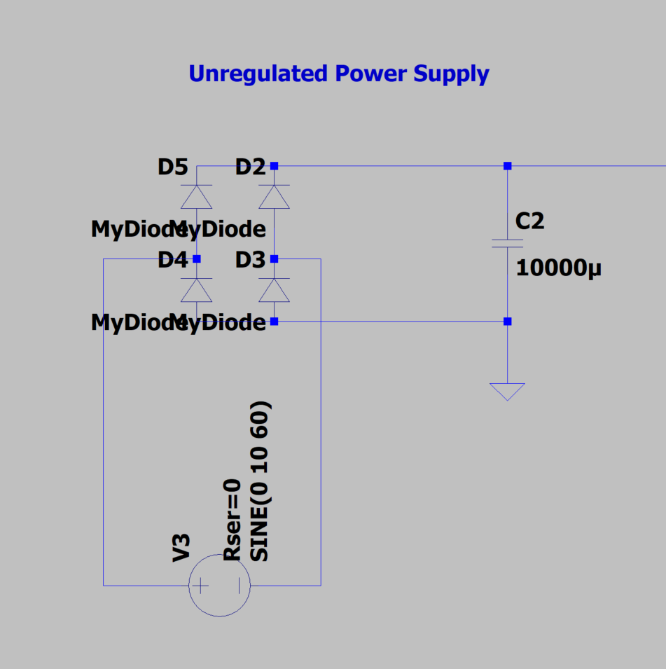

Power Supply Designed to Simulate Noisy Power Supply

Note: The 10mF capacitor is to stabilize the voltage as the simulator had difficulty with series inductors

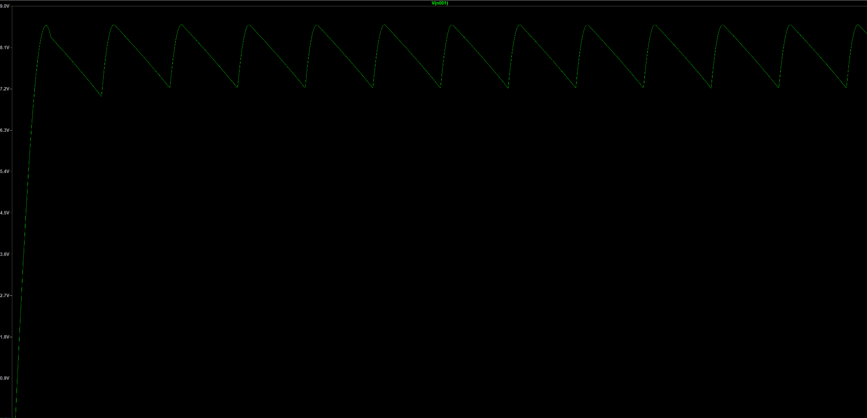

Input Voltage Waveform for VRM

After having created the circuit and the input voltage waveform, efficiency testing can begin. First to validate that the circuit is acting as expected and is varying the duty cycle to compensate with the changing input voltage. To do so it would be necessary to overlay the voltage in and the duty cycle of MOSFETs in the circuit. Below is an illustration of the output voltage of the primary MOSFET (red) and the input voltage (green), taken at the highest and lowest voltages.



Duty Cycle of MOSFET Duty Cycle of MOSFET,

Input Voltage 8.5 V Input Voltage 7.2 V

The duty cycle of the waveform at the lower input voltage is clearly much longer than the duty cycle at the higher voltage. So it is established that the circuit is adapting to the input voltage but now the most important question arises, how stable is the output voltage? In the graph below is shown the output voltage of the circuit, then next to that is an enlarged picture of the voltage ripple in the output waveform. 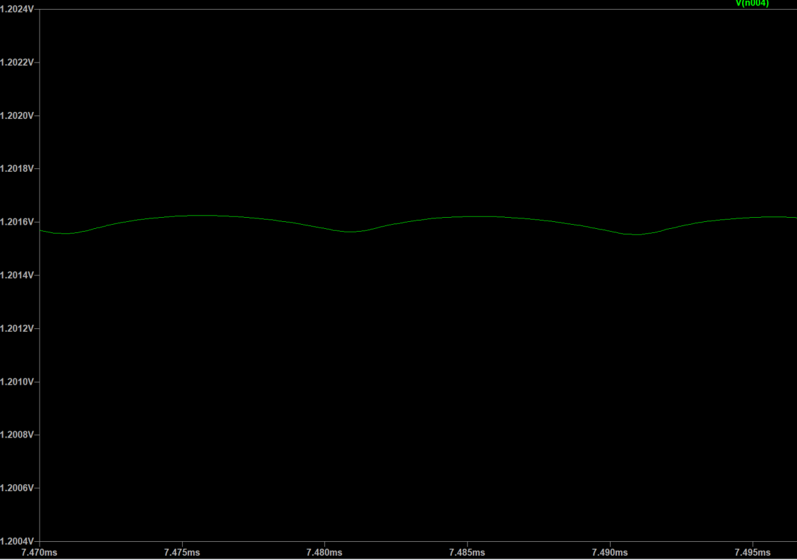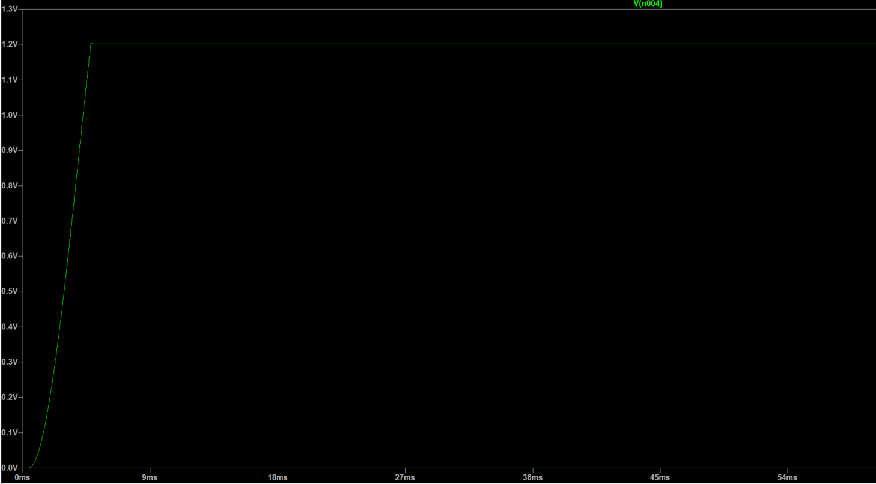

VRM Output Voltage VRM Output Voltage Ripple

The observed voltage ripple of the output was observed to be 1.35 mV at maximum. A very impressive number well within the voltage ripple tolerance of 5 mV. So the circuit produces a

voltage that would not only be well regulated to the required voltage for a CPU, but the circuit

also provides a small enough voltage ripple to be well suited as a CPU power supply. Now the final question is how efficient is the circuit? As the output voltage is very stable the output wattage of 14.5 W is very constant. In order to get accurate efficiency numbers the model parameters must be slightly changed and some readings ignored to account for real world parts performing better than for instance diodes in the circuit. The average power input to the circuit is 16.973 W. Now in order to calculate the efficiency of the circuit it is necessary to divide the output power of 14.46 W by 16.973 W. That yields an efficiency of 85.2%, a relatively good efficiency when considering what the circuit is converting.

**Improvement In Efficiency**

Really this amount of efficiency from the circuit is relatively impressive and demonstrates a functional use for the system. In reality, this circuit could be greatly improved by using and tuning industry power MOSFETs and using a more efficient regulation system. In practice 120 V to 12 V desktop power supplies can reach efficiency numbers in the mid 90s and by removing a lot of the voltage smoothing and regulation circuitry in the power supplies can result in a power supply with an efficiency of upwards of 95%. Combining that increase in efficiency with an increase in efficiency from actually implementing the circuit, adding additional phases to the circuit, and making the circuit with industry standard parts the total efficiency of the system from the wall voltage to the CPU could be as high as 87%. An increase of 5% over a system that is 90% efficient from 120 to 12 V and 90% efficient from 12 V to 1.x V. In total that results in an improvement of about 5% efficiency over the existing system that exists in desktops and laptops everywhere.

**Discussion and Moving Forward**

This idea has been demonstrated to be viable in a simulation but still has a long way to go before it is adopted in the computing industry. The next obvious step for testing this system would be to begin real world laboratory testing and create a real prototype that can be comprehensively tested and have data collected that would prove the utility of the prototype outside of the simulation environment where error obviously exists. This circuit can still be greatly improved in pursuit of better efficiency. Not only can more phases be added to the VRM portion it is possible that better Op-amps can be used in order to really make the system respond to changes in input voltage faster and not have so much power consumed by the Op-amp assembly. Another obvious change is to replace the reference voltage with a circuit that uses digital logic and instead interacts with the analog Op-Amp without having to regulate a separate voltage for using as a reference for the target voltage. The implementation of this circuit in the real world with industry standard equipment should result in a great uplift in efficiency from the simulation data. The solution could still benefit from further software testing, mainly to make sure that the system would be able to handle sudden load changes, that could best be done through a better software that would be able to do comprehensive load testing with variable output power. This software would be much more of an industry standard software that would be available to companies like ASUS and MSI that design motherboard and VRM hardware. This system in its current state is only intended for lower power consumption applications like laptops or desktops because it is designed to be lightweight and easy to implement. This system could be very easily adapted and modified to be used in a large power consumption data center application. All told this solution is quite effective and easy to implement in a real world device and would result in a significant increase in efficiency that would provide benefits for the power grid, environment, and heat generation in a specific device.

**Conclusion**

By synthesising ideas from scholars and previous VRM concept designs a novel design was created that improves efficiency by allowing an unstable unregulated 12 V intermediate voltage to flow through the motherboard. This design allows for the elimination of the extraneous voltage regulation circuitry at the output of the 120 VAC to 12 VDC power supply. This change required a novel control system for the buck VRM, using Op-Amps to adjust for abnormally-high ripple in the input power supply. By using this system, an improvement over a generic power supply and switching buck VRM of 5% efficiency was observed in a simulation. This system had an estimated conversion efficiency of as high as 87%, a marked improvement over existing user segment desktop and laptop computers. More real world testing is still required to prove that this system is fully viable outside of simulation environments but the data is promising.

**Works Cited**

Ahmed, Mohamed, et al. “High-Efficiency High-Power-Density 48/1V Sigma Converter Voltage Regulator Module.” 2022 IEEE Applied Power Electronics Conference and Exposition (APEC), 1 Mar. 2017, pp. 2207–2212, ieeexplore.ieee.org/stamp/stamp.jsp?tp=&arnumber=7931005, https://doi.org/10.1109/apec.2017.7931005. Accessed 10 Dec. 2024.

Daelim Transformer. “Transformer Efficiency: The Ultimate FAQs Guide - Daelim | Daelim.” *www.daelimtransformer.com*, www.daelimtransformer.com/transformer-efficiency-daelim.html.

Eberle, Wilson, et al. “A Practical Switching Loss Model for Buck Voltage Regulators.” IEEE Transactions on Power Electronics, vol. 24, no. 3, Mar. 2009, pp. 700–713, https://doi.org/10.1109/tpel.2008.2007845. Accessed 9 Dec 2024.

Ehrlich, Stefan, et al. “Comprehensive SPICE Model for Power Inductor Losses.” 2022 IEEE Applied Power Electronics Conference and Exposition (APEC), 1 Mar. 2019, pp. 1237–1244, ieeexplore.ieee.org/abstract/document/8722180, https://doi.org/10.1109/apec.2019.8722180. Accessed 12 Dec. 2024.

Fei, Chao, et al. “Two-Stage 48 V-12 V/6 V-1.8 v Voltage Regulator Module with Dynamic Bus Voltage Control for Light-Load Efficiency Improvement.” IEEE Transactions on Power Electronics, vol. 32, no. 7, 1 July 2017, pp. 5628–5636, https://doi.org/10.1109/tpel.2016.2605579. Accessed 13 Feb. 2025.

Intel Corporation. “Intel® CoreTM I7-6700K Processor (8M Cache, up to 4.20 GHz).” *Intel*, 2022, www.intel.com/content/www/us/en/products/sku/88195/intel-core-i76700k-processor-8m-cache-up-to-4-20-ghz/specifications.html. Accessed 2 Mar. 2025.

Intel Corporation. “Intel® CoreTM Ultra 7 Processor 265K (30M Cache, up to 5.50 GHz).” Intel, 2020, www.intel.com/content/www/us/en/products/sku/241063/intel-core-ultra-7-processor-265k-30m-cache-up-to-5-50-ghz/specifications.html. Accessed 2 Mar. 2025.

Intel Corporation. “Measuring Processor Power TDP vs. ACP.” Intel, 2011, https://www.intel.com/content/dam/doc/white-paper/resources-xeon-measuring-processor-power-paper.pdf Accessed 4 Mar. 2025.

Keim, Robert. “Introduction to MOSFET Switching Losses.” Allaboutcircuits.com, All About Circuits, 28 Apr. 2024, www.allaboutcircuits.com/technical-articles/introduction-to-mosfet-switching-losses/.

Larsson, Patrik. “Di/Dt Noise in CMOS Integrated Circuits.” *Analog Design Issues in Digital VLSI Circuits and Systems*, 1997, pp. 113–129, https://doi.org/10.1007/978-1-4615-6101-9_10. Accessed 13 Mar. 2025.

Ouyang, None Gong, et al. “Switching Voltage Regulator Noise Coupling to Signal Lines in a Server System.” IEEE International Symposium on Electromagnetic Compatibility, 1 July 2010, pp. 72–78, ieeexplore.ieee.org/abstract/document/5711250, https://doi.org/10.1109/isemc.2010.5711250. Accessed 9 Dec. 2024.

Quintero, J, et al. “Reduction of the Switching Frequency and the Number of Phases in Multiphase VRM by Applying Linear-Non-Linear Control.” IEEE Power Electronics Specialists Conference , vol. 37, 1 June 2006, pp. 1–6, ieeexplore.ieee.org/abstract/document/1711951, https://doi.org/10.1109/pesc.2006.1711951. Accessed 13 Dec. 2024.

ROHM Semiconductor. Application Note Switching Regulator IC Series Efficiency of Buck Converter. Nov. 2022.

Shirer, Michael. “Global PC Shipments Return to Growth and Pre-Pandemic Volumes in the First Quarter of 2024, according to IDC Tracker.” IDC: The Premier Global Market Intelligence Company, 8 Apr. 2024, www.idc.com/getdoc.jsp?containerId=prUS52019024.

Wickramasinghe, Thilini, et al. “Reduced‐Switch SCALDO: An Extra Low‐Frequency DC–DC Converter Technique for VRM Applications.” IET Power Electronics, vol. 10, no. 15, 30 Oct. 2017, pp. 2180–2189, https://doi.org/10.1049/iet-pel.2016.0420. Accessed 20 Jan. 2023.

Xu, Wei, et al. Switching Voltage Regulator Modeling and Its Applications in Power Delivery Design. 1 Aug. 2014, ieeexplore.ieee.org/abstract/document/6899087, https://doi.org/10.1109/isemc.2014.6899087. Accessed 8 Dec. 2024.

Yuancheng Ren, et al. “Analytical Loss Model of Power MOSFET.” IEEE Transactions on Power Electronics, vol. 21, no. 2, Mar. 2006, pp. 310–319, https://doi.org/10.1109/tpel.2005.869743.