**GENERAL INFORMATION**

### **TECHNOLOGIES AND TOOLS**

1. Spring Boot
2. Spring Data JPA
3. Spring Web
4. Spring Batch
5. H2 database
6. Lombok
7. ModelMapper
8. Several test libraries

**SYSTEM SUMMARY**

|  |
| --- |
| Given: a single CSV file as input.    Your solution may use whatever technologies you wish to build on:    · Web server software  · Database software  · Database interaction layer    The challenge will utilize the State of Iowa - Monthly Voter Registration Totals by County data set:    <https://data.iowa.gov/Communities-People/State-of-Iowa-Monthly-Voter-Registration-Totals-by/cp55-uurs>    Download the JSON, CSV or other and use that as your input. It contains 19 columns and over 20,000 rows. Now expose the data via a web API.    Your solution must implement the following API behaviors:    · A "get_voters" endpoint that takes the following optional arguments: county, month, party affiliation, active_status, and limit (the max number of results to return). The endpoint must return a JSON-formatted output, but the schema is up to you.  · All APIs must be RESTful    Example of URL: <http://127.0.0.1:8080/get_voters?county=Adair&month=3&limit=2&party=Republican>  Example of output:    {  "data": [  {  "County": "Adair",  "Date": "Sun, 01 Mar 2015 00:00:00 GMT",  "Grand Total": 5271,  "Republican - Active": 1906,  "Republican - Inactive": 61  },  {  "County": "Adair",  "Date": "Sat, 01 Mar 2014 00:00:00 GMT",  "Grand Total": 5552,  "Republican - Active": 1901,  "Republican - Inactive": 131  }  ],  "next_start": 2  } |

**USING THE SYSTEM**

1. To start the application, you can open source code in your preferable IDE and run StateOfLowaApplication class.

Example config:  
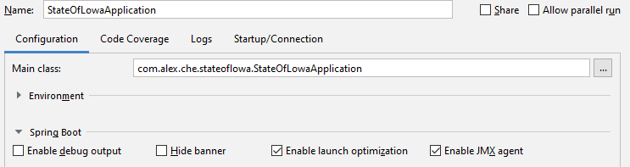  
  
Or you can use another way to run the application. You can use OS command line and execute file stateoflowa-0.0.1-SNAPSHOT.jar:  
  
java -jar stateoflowa-0.0.1-SNAPSHOT.jar

1. You can use the Postman application for testing.  
   For instance:  
     
   