Genetic drift

October, 2018

Table of Contents

# Some popular R packages for population genetics

Population genetics in R

<http://grunwaldlab.github.io/Population_Genetics_in_R/>

PopGenome: An Efficient Swiss Army Knife for Population Genomic Analyses

<https://cran.r-project.org/web/packages/PopGenome/>

# Simple genetic drift program

### Before starting, think what is genetic drift?

### 

#----- simulates drift  
# N is population size and p is initial allele frequency  
drift <- function(N,p) {  
 g=as.numeric()  
 t=0  
 while(p>0 & p<1) {  
 genotypes <- rbinom(N,1,p)  
 p<-mean(genotypes)  
 t=t+1  
 # the last column of each row contains current allele frequency  
 genotypes=cbind(t(genotypes),p)  
 g=rbind(g,genotypes)  
 }  
 return(g[,N+1])  
}

EXERCISE: Guess what the program does and why

HINT: look for help with ‘help(command)’ or ‘? command’

HELP in R: <https://www.r-project.org/help.html>

## Running the drift R function

# num of individuals  
N=20  
# initial allele frequency  
p0=.2  
f=drift(N,p0)

# list of colors for plotting each replicate  
color = grDevices::colors()[grep('gr(a|e)y', grDevices::colors(), invert = T)]  
plot(f, type='l', ylim=c(0,1), xlim=c(1,30), xlab='generation', ylab='f')  
for (rep in seq(100)) {  
 f = drift(N, p0)  
 lines(f, col=sample(color,1))  
}

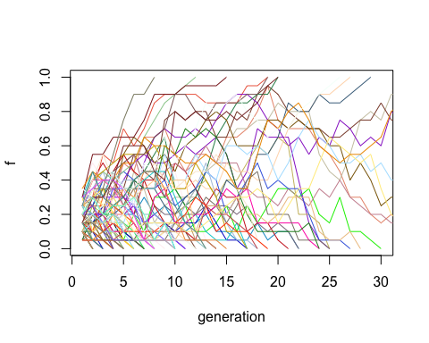

EXERCISE: try different sizes (N) an dinitial frequencies (p)

EXERCISE: What is the probability of fixation of allele 1 ?