1.Tài khoản phần quyền truy cập SVN

2. Plugin Subversive tải về eclip

3. Share dự án lên SVN

4. Eclipse Checkout, Checkin (update, commit )code lên SVN

5.Turtoise SVN Checkout, Checkin (update, commit) một file tài liệu bất kỳ lên SVN

6.Checkout revision cũ hơn

7. Merge

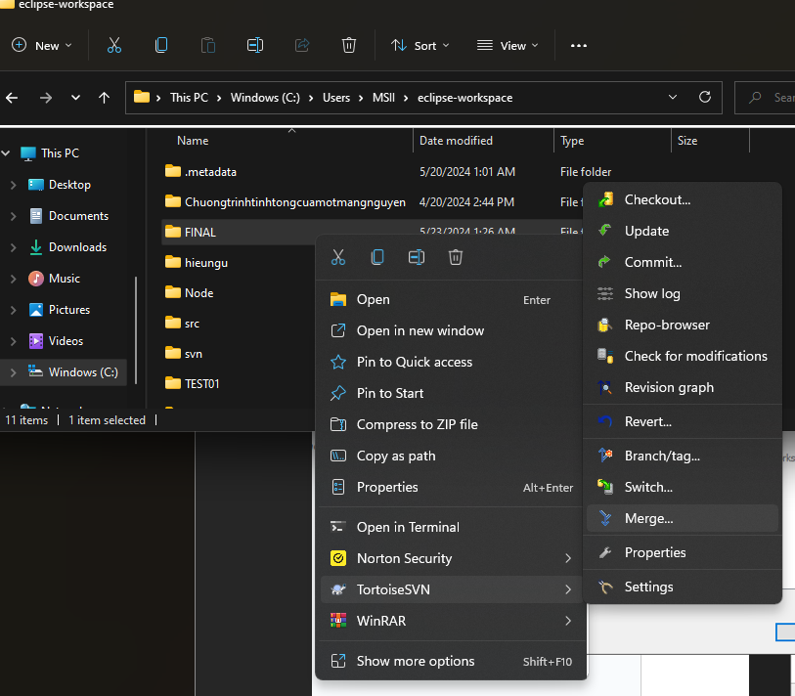

8. Hoàn Thành

