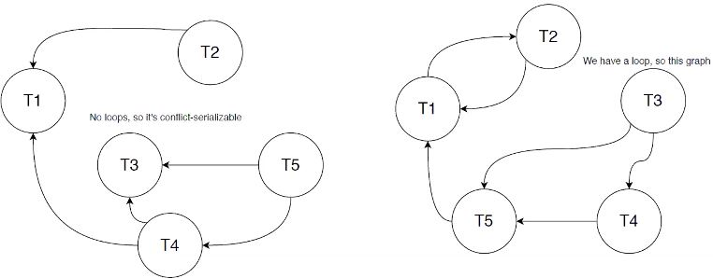 Conflict-serializability Not Conflict-serializability