**ECE470: Lab 1.5 - The Tower of Hanoi using the Teach Pendant**

Name of Student: Yuhang Chen

NetID: yuhang.17

Lab Partner: Yuxin Zhao

TA: Zhefan Lin

Section: Wednesday 3PM

Submitted on March 11, 2021

# Introduction

In this lab, the main task is to program the UR3 using its Teach Pendant to solve a three block Tower of Hanoi puzzle. The puzzle starts with three blocks in a neat stack in ascending order of size on the one location on the table, the smallest at the top. And the blocks from largest size to smallest size are named from block 1 to block 3.

The objective of the puzzle is to move the entire stack to another location on the table, meanwhile obeying the following simple rules:

1. Only one block can be moved at a time.
2. Each move consists of taking the upper block from one of the stacks and placing it on top of another stack or on an empty location.
3. No larger block may be placed on top of a smaller block.

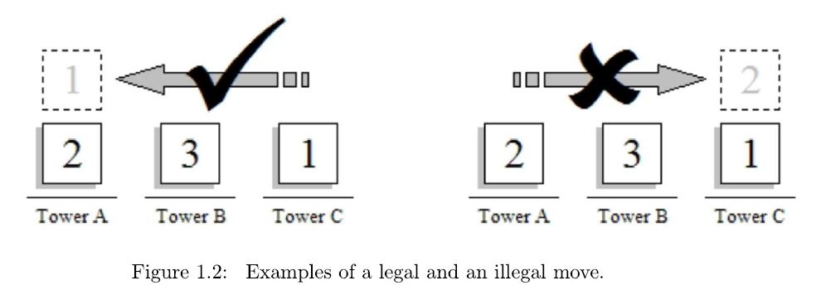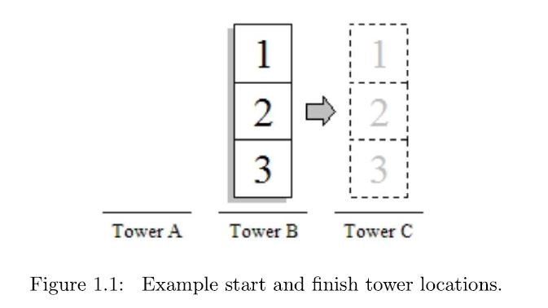

# Method

## Explain on the Solution

Given the initial condition that the three blocks with size in ascending order are placed in the Location A, our task is to move them to the Location C with size of ascending order, meanwhile obeying the rules of Hanoi Puzzle. We solve this puzzle by doing the following blocks moving

|  |  |
| --- | --- |
| Step | Operation |
| ① | Move Block 1 to Location C |
| ② | Move Block 2 to Location B |
| ③ | Move Block 1 to Location B (on top of Block 2) |
| ④ | Move Block 3 to Location C |
| ⑤ | Move Block 1 to Location A |
| ⑥ | Move Block 2 to Location C (on top of Block 3) |
| ⑦ | Move Block 1 to Location C (on top of Block 2) |

steps:

Table 2.1: The step operations on moving to solve a three block Hanoi Puzzle

Block 1

Block 2

Block 3

Figure 2.1: The Matching between block size/color and block number

Each moving mainly contains four operations: The first operation is use MoveL/MoveP command to move the end of the UR3 robot arm to be slightly above or next to the block. The second operation is to use Set command to make the digital output 0 to be high, which can make its end grip the block. The third operation is to use MoveP command to move the end of the UR3 robot arm to the particular location we want it to reach. And the last operation is to set the digital output 0 to be low to make the gripped block released.

## Discussion on the Circular Movement and the Way to Implement it

From the previous part 2.1 it is easy to find out that we use MoveP command instead of MoveJ or MoveL in the particular operations. The reason why we need to use MoveP is to make circular movement to adjust the real environment.

A

B

C

MoveJ/MoveL

MoveP

WayPoint_1

WayPoint_2

WayPoint_3

Figure 2.2 Circular Movement of the UR3 Robot Arm

As Figure 2.2 shows, we use the circular move in MoveP command to implement the circular Movement. Three Way_points are needed to set in each MoveP. Way_point 1 is the initial point to start moving while Way_point 3 is the final point to end moving. And Way_point 2 is a viapoint used for calculating the angular for a circular movement. In each MoveP operation of this lab, we can simply set Way_point 2 to be a random point that is high enough to avoid the collision of the blocks during the movement.

# Conclusion

# 3.1 Tips to keep the stack neat

In this lab, one goal worth to be noticed is to keep the stack neat. And to Achieve this goal, our team figure out that there exist two tips:

1. Adjust the end point of the movement properly and make the end to the surface of the below block or the table as close as possible, so that the released block can land smoothly without shake and keep the stack neat.
2. Use Wait command before the operation to turn the digital out 0 to be low, which ensures the end UR3 robot arm to reach the destination point. In this experiment we set the wait time to be 0.5 seconds.

# 3.2 Observations on MoveJ, MoveL, and MoveP

Just as the Lab Manual Suggests, among the three commands on moving, we figure that MoveJ is to simply move the Tool Center Point of UR3 directly to the destination point, and MoveL moves the Tool Center Point alone a straight line, while MoveP is a process move that keep the Tool Center Point moving at a constant speed and allows it to move alone circular arcs. And in some way, a MoveP can be replaced by two or more than two MoveJ/MoveL operations to achieve the same goal, although the process can never be completely equivalent.

# Reference

[1] *Tower of Hanoi-Wikipedia* <https://en.wikipedia.org/wiki/Tower_of_Hanoi>

[2] *ECE470 Lab Manual*