PHENIKAA UNIVERSITY

PHENIKAA SCHOOL OF COMPUTING



COURSE: SOFTWARE ARCHITECTURE
Lab 2: Layered Architecture Design for Hotel Management System

INSTRUCTOR: Vũ Quang Dũng
GROUP 7: Nguyễn Hưng Thành (23010688 – K17 KTPM)
Trần Ngọc An (23010283 – K17-KTPM) Lê Mạnh Đức (23010208 – K17-KTPM)
Phạm Thế Thủy Hoàng (23010960 – K17-KTPM)
CREDIT CLASS: CSE703110-1-2-25(N01)

Ha Noi, December 10, 2025
Contents
1. Abstract/Summary 3
2. Lab Specific Section: I. Defining Layers and Responsibilities 3
2.1. Description of Layers 3
2.2. Data Flow 4
3. Lab Specific Section: II. Component Identification (Product Catalog) 5
3.1. Identify Components 5
3.2. Define Interfaces 5
4. Lab Specific Section: III. Component Diagram Modeling 5
5. Conclusion & Reflection 6

1. Abstract/Summary
The Hotel Management System project aims to develop a comprehensive platform for managing reservations, facility, staff, rooms, check-ins/check-outs, and hotel services. This second lab focuses on designing the layered architecture.
It defines four tiers such as Presentation, Business Logic, Persistence, and Data with strict dependency rules. The Room Reservation feature components (Controller, Service, Repository) were identified. The design enhances Modifiability and Maintainability through separation of concerns. A UML Component Diagram models the structure, preparing the system for implementation.

2. Lab Specific Section: I. Defining Layers and Responsibilities
In this section, we define the four architectural layers for the Hotel Management System, strictly adhering to the Layered Architecture Pattern where a layer can only interact with the layer directly below it.

2.1. Description of Layers
Layer | Purpose/Responsibility | Output/Artifact
1. Presentation Layer (UI) | Handles HTTP requests, user authentication, session management, and renders the user interface. It ensures the separation of the frontend (HTML/CSS) from the backend logic. | Controllers (e.g., RoomController, BookingController), Templates (HTML views), Static Files (CSS/JS).
2. Business Logic Layer (Service) | Contains the core business rules, validation logic, and transaction management. It orchestrates data access and handles integrations with external systems (like the Payment Gateway). | Services (e.g., BookingService, PaymentService, RoomService).
3. Persistence Layer (Data Access) | Responsible for mapping business objects to database entities and executing CRUD (Create, Read, Update, Delete) operations. It abstracts the database queries from the business logic. | Repositories/DAOs (e.g., BookingRepository, RoomRepository).
4. Data Layer | The physical database storage system where all application data is persisted. | Database Schema (MySQL/PostgreSQL), Tables (Guests, Rooms, Bookings).

2.2. Data Flow

Scenario: Check Room Availability Flow

● Client Request: The user (Guest/Staff Portal) sends an HTTP GET request to the endpoint: /api/rooms/search?room_type=DELUXE&status=available (optional: &check_in=2025-12-20&check_out=2025-12-22 for date-range availability).

● Layer 1 (Presentation): The RoomController receives the request, applies auth middleware (X-User-Id) where required, and validates the request parameters. It then invokes Layer 2.

● Layer 2 (Business Logic): The RoomService executes search_rooms(room_type, status, check_in_date, check_out_date). The system applies business rules: filtering by room type and status, and when dates are provided, checking availability by date range (no overlap with existing bookings).

● Layer 3 (Persistence): For availability by date range, the BookingRepository constructs and runs the SQL (e.g. SELECT r.* FROM rooms r LEFT JOIN bookings ... WHERE r.room_type = %s AND ...) to find rooms free in that period. For search by type/status only, the RoomRepository runs queries (e.g. find_by_type, find_all) against the database.

● Layer 4 (Data): The MySQL database (hotel_management) executes the query and returns the raw rows.

● Return Path:

○ The repository (BookingRepository or RoomRepository) maps the raw rows into Room objects.

○ The RoomService returns the list of rooms (each room includes price from the model).

○ The RoomController returns the "Available rooms" response (JSON) to the client.

3. Lab Specific Section: II. Component Identification (Product Catalog)
This section breaks down the critical "Make a Reservation" feature into concrete software components residing in the top three layers.

3.1. Identify Components
Layer 1: Presentation Layer
- Component Name: BookingController
- Responsibility: Receives the booking request (POST /book), validates input format (forms), and delegates processing to the BookingService.
Layer 2: Business Logic Layer
- Component Name: BookingService
- Responsibility: Coordinates the reservation process. It checks room availability via RoomService, processes financial transactions via PaymentService (interface with Payment Gateway), and calculates total costs.
- Component Name: PaymentService
- Responsibility: Encapsulates the logic for communicating with the external Payment Gateway (Actor), ensuring security and isolating third-party dependencies.
Layer 3: Persistence Layer
- Component Name: BookingRepository
- Responsibility: Translates the finalized booking object into a database insert command (INSERT INTO bookings...) to persist the reservation.

3.2. Define Interfaces
The following interfaces define the contracts between layers:
- Interface provided by Business Logic (for Presentation):
  - IBookingService.createReservation(bookingRequest: Dict) -> BookingResult
- Interface provided by Persistence (for Business Logic):
  - IBookingRepository.save(booking: BookingEntity) -> void
  - IBookingRepository.findById(bookingId: int) -> BookingEntity

4. Lab Specific Section: III. Component Diagram Modeling
The UML Component Diagram below illustrates the logical view of the Layered Architecture for the Make Reservation functionality. It visually enforces the strict dependency rule (Layer 1 -> Layer 2 -> Layer 3):
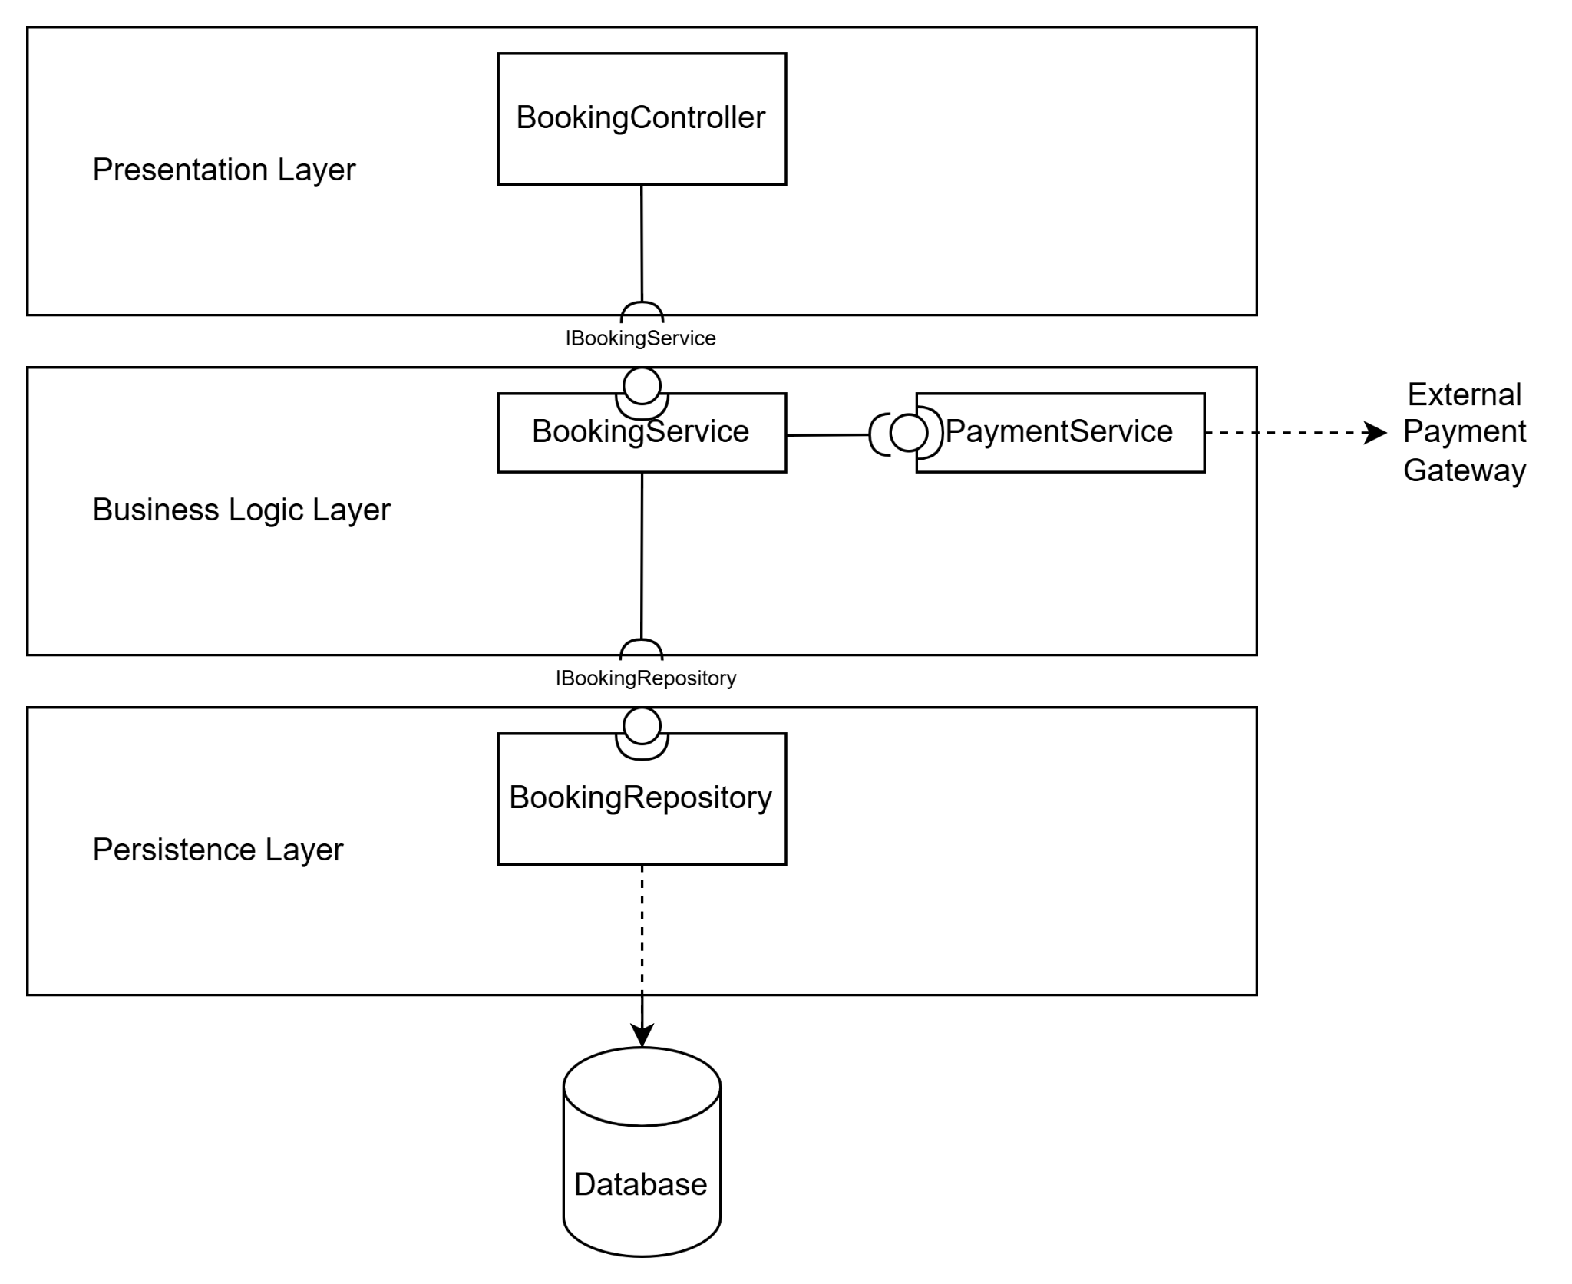

5. Conclusion & Reflection
The Layered Architecture pattern design in this lab directly addresses the Architecturally Significant Requirements (ASRs) identified in Lab 1:
- Modifiability (ASR-3): By separating the Presentation Layer (HTML/CSS) from the Business Logic Layer (Python), we ensure that changes to the user interface do not affect backend logic. Furthermore, encapsulating the Payment Gateway interaction within the PaymentService ensures that switching payment providers does not impact other parts of the system.
- Security (ASR-2): Authorization and validation logic are centralized in the Business Logic Layer. This ensures that even if a request bypasses the UI (e.g., via API tools), the core services (BookingService) still enforce security rules before accessing the Persistence Layer.

