PHENIKAA UNIVERSITY

PHENIKAA SCHOOL OF COMPUTING



COURSE: SOFTWARE ARCHITECTURE
HOTEL MANAGEMENT SYSTEM

INSTRUCTOR: Vũ Quang Dũng
GROUP 7: Nguyễn Hưng Thành (23010688 – K17 KTPM)
Trần Ngọc An (23010283 – K17-KTPM) Lê Mạnh Đức (23010208 – K17-KTPM)
Phạm Thế Thủy Hoàng (23010960 – K17-KTPM)
CREDIT CLASS: CSE703110-1-2-25(N01)

Ha Noi, December 6, 2025
Contents
1. Abstract/Summary 3
2. Lab Specific Section: I. UML Deployment Diagram 3
3. Lab Specific Section: II. Quality Attribute Analysis (Simplified ATAM) 4
3.1. Quality Attribute Scenarios 4
3.2. ATAM-style Evaluation for the Monolith 5
4. Conclusion & Reflection 5
1. Executive Summary
This project implements a Hotel Booking Management System that supports the end-to-end workflow of a real hotel: customers can browse rooms, create bookings, make payments, manage their wallet, and view booking history; receptionists can check guests in and out and manage service requests; administrators can manage rooms, services, staff, coupons, and reports. The system is architected using a layered architecture on top of Flask, with clear separation between controllers (HTTP layer), services (business logic), repositories (data access), and models (domain entities).
The backend lives under SRC/Arch and exposes REST-style JSON APIs (e.g. /api/bookings, /api/rooms, /api/auth/login, /api/wallet) through controller classes such as BookingController, RoomController, UserController, PaymentController, CouponController, CheckInController, StaffController, ReportController, and WalletController. These controllers rely on service classes (e.g. BookingService, RoomService, PaymentService, CouponService) that encapsulate business logic and call repository classes (e.g. BookingRepository, RoomRepository, CouponRepository) to access a MySQL database.
The frontend is implemented in SRC/UI as a set of HTML/CSS/JavaScript pages for different roles: public pages for browsing rooms, authentication pages for login and registration, user pages for dashboard, my bookings, payment, and wallet, and admin pages for room and staff management and reports. The final outcome is a working multi-role hotel management application where the architecture supports modifiability, maintainability, and basic security and scalability for small-to-medium usage.
2. Project Requirements & Goals
This section defines the scope and main architectural drivers of the Hotel Management System.
2.1 Core Functional Requirements
The primary entities that interact with the Hotel Management System are:
1. User
2. Administrator
3. Receptionist
These requirements define the specific behaviors and functions the system must provide.
- User Functional Requirements

ID | Requirement Name | Description | Priority
FR-01 | Room Search & Booking | The User must be able to search for rooms by date, type, and number of people, and complete the reservation online. | High
FR-02 | User Authentication | The User must be able to register and log in securely. | High
FR-03 | Booking Management | The User must be able to view, modify, or cancel their reservations. The system must store a full booking history. | High
FR-04 | Online Payment | The User must be able to make secure online payments for reservations and additional services (spa, dining). | High
FR-05 | Service Requests | The User must be able to request additional services (early check-in, late check-out, room service) during their stay. | Medium
FR-06 | Digital Wallet | The User must be able to view their wallet balance, top up the wallet with a specified amount, and pay for bookings and services using the internal wallet balance. | High
FR-07 | Coupon Application | The User must be able to apply valid promotional coupon codes during the booking or payment process to receive a discount (percentage or fixed amount). The system must validate coupon code, active status, and validity period. | Medium
- Receptionist Functional Requirements

ID | Requirement Name | Description | Priority
FR-08 | Check-in/Check-out Processing | The Receptionist must be able to process guest check-in and check-out, including verifying bookings. | High
FR-09 | Walk-in Booking | The Receptionist must be able to create new bookings for guests arriving directly at the counter (walk-in guests). | High
FR-10 | Room Assignment | The Receptionist must be able to assign specific rooms to bookings based on room status and guest preferences. | High
FR-11 | Guest Profile Management | The Receptionist must be able to view and update guest profile information. | Medium
FR-12 | Transaction & Activity History | The Receptionist must be able to view historical records of bookings, payments, service requests, and system activities. | High
FR-13 | Service Request Management | The Receptionist must be able to view the list of all service requests (e.g. room service, spa, dining) and update the status of each request (e.g. pending, in progress, completed). | High
FR-14 | Refund on Cancellation | When a User cancels a booking that was paid (in whole or in part) using the digital wallet, the system must automatically refund the corresponding amount to the User’s wallet and update the payment status (e.g. to “refunded”). Refund must only apply to eligible bookings (e.g. not yet checked in). | High
- Hotel Manager Functional Requirements (Administrator)

ID | Requirement Name | Description | Priority
FR-15 | Room Inventory Management | The Administrator must be able to perform full CRUD operations on the room catalog (add new rooms, update details, price) and manage room status (e.g., Under Maintenance). | High
FR-16 | Staff Management | The Administrator must be able to create and manage staff accounts, including assigning roles (e.g., Receptionist, Housekeeper). | High
FR-17 | Users Management | The Administrator must be able to see and manage users accounts. | High
FR-18 | Service Management | The Administrator must be able to update the catalog of hotel services (Spa, Dining menu) | Medium
FR-19 | Analytics & Reporting | The Administrator must have access to detailed reports on occupancy rates, revenue, and service performance. | Medium
3.2 Key Quality Attributes (Architectural Goals – Non-functional Requirements)
ID | Attribute | Description
NFR-01 | Modifiability | The system is organized into layers (controllers, services, repositories, models) so that new features such as new payment methods, extended reports, or additional service types can be added with minimal impact on existing logic.
NFR-02 | Maintainability | Code is grouped by responsibility (e.g. SRC/Arch/controllers, SRC/Arch/services, SRC/Arch/repository, SRC/Arch/models, SRC/Arch/views, SRC/Arch/middleware) providing clear entry points for debugging and enhancements.
NFR-03 | Reliability & Consistency | Booking and payment logic (in BookingService, BookingRepository, PaymentService, and related repositories) must avoid overbooking, maintain correct booking status transitions, and ensure payment records match wallet balances.
NFR-04 | Security | Authentication and role-based authorization are enforced via middleware (require_auth, require_admin, require_receptionist_or_admin, require_role) to secure sensitive endpoints such as booking, payment, wallet, and admin operations.
NFR-05 | Usability | The UI under SRC/UI is designed to be clear and role-oriented: customers see booking and payment pages; staff see check-in/check-out and service request screens; admins see management and reporting screens.
NFR-06 | Scalability | Although the current deployment is monolithic (single Flask app and a MySQL  database), the RESTful API design and separation of services/repositories allows future  scaling by splitting out services or deploying behind a load balancer.

3.3 Propose model of ASR

ASR ID | Quality Attribute | Statement | Impact
ASR-1 | Prevent Overbooking (NFR – Reliability & Consistency) | The system must ensure that a specific room cannot be booked by multiple users for overlapping date ranges. | This requirement directly shapes the design of BookingService and  BookingRepository. For example, BookingService uses RoomService and/or BookingRepository.find_available_rooms_by_date_range(...) which checks the database for existing bookings with overlapping check-in/check-out dates and excludes such rooms from the available list. The SQL query in BookingRepository filters out rooms whose bookings overlap in time and are not cancelled or checked_out, preventing double-booking at the data-access level.
ASR-2 | Secure Access to Financial Operations (NFR – Security & Integrity) | All wallet and payment-related operations must be performed only by authenticated users, and only on their own accounts or authorized resources.. | This requirement leads to the use of authentication middleware and role-based decorators around endpoints in app.py such as /api/payments, /api/wallet, /api/wallet/topup, and admin-only routes. PaymentService and WalletService must always validate the current user’s identity and ensure that wallet updates and payment records are tied to the correct user_id and booking_id, preventing unauthorized manipulation of balances or payments.

3.4 Use Case Modeling
3.4.1 Interface Specification and Development UC1 – Users.
UC-01: Login
ID and Name: | UC-01: Login
Create by: | Trần Ngọc An / Date created: 6/2/2026
Primary Actor: | User (any role: user / receptionist / administrator)
Description: | This use case allows a user to authenticate with username and password to access protected features such as booking, payment, wallet, and administrative functions (depending on role).
Trigger: | User selects “Login” and submits credentials.
Preconditions: | - The user has already registered (exists in the users table).  - The backend service is running and database connection is available.
Postconditions: | 1. Success  - The system returns user information (including user_id and role) to the client.  - The client stores the returned user_id and includes it in subsequent protected API calls via HTTP header: X-User-Id: <user_id>.  2. Failure  - No authenticated context is established; protected resources remain inaccessible.
Normal flow: | 1. User opens the login page in the UI.  2. User enters username and password.  3. User clicks “Login”.  4. Client sends POST /api/auth/login with { "username": "...", "password": "..." }.  5. System validates request format.  6. System authenticates user against MySQL credentials.  7. System returns user_id and role.  8. Client stores user_id and uses X-User-Id for protected requests.
Alternative Flows: | A1 – Missing credentials → 400.  A2 – Invalid username/password → 401/400 with message “Invalid username or password.”
Exceptions: | E1 – Database connection error → 500.
Priority: | High
Frequency of Use: | Very frequent (daily)
Business rules: | - Username and password are required fields.  - Only authenticated users can access endpoints protected by @require_auth.  - Authorization is role-based (RBAC) via middleware decorators:  - Administrator: full access to admin endpoints.  - Receptionist: access to receptionist endpoints (bookings list, check-in/out, etc.).  - User: access to own bookings, payments, wallet, and service requests.

UC-02: Register
ID and Name: | UC-02: Register
Create by: | Trần Ngọc An / Date created: 6/2/2026
Primary Actor: | User (any role: user / receptionist / administrator)
Description: | This use case allows a guest to create a new user account in the system.
Trigger: | Guest submits the registration form.
Preconditions: | None.
Postconditions: | 1. Success  - A new user record is created in the users table.  2. Failure  - No user record is created.
Normal flow: | 1. Guest opens the Register page.  2. Guest enters username, email, password, full_name, phone.  3. Client sends POST /api/users with JSON body.  4. System validates input data.  5. System saves the new user to MySQL.  6. System returns created user information to client.
Alternative Flows: | A1 – Missing/invalid fields  1. Guest submits missing required fields.  2. System returns 400 with validation error.
Exceptions: | E1 – Database error  - System returns 500 if database operation fails..
Priority: | High
Frequency of Use: | Medium
Business rules: | - Required fields must not be empty.  - Username/email should be unique (if enforced by DB/repository).

UC-03: Browse Rooms (List/Search/Detail)
ID and Name: | UC-03: Browse Rooms (List/Search/Detail)
Create by: | Trần Ngọc An / Date created: 6/2/2026
Primary Actor: | User
Description: | This use case allows browsing the room catalog: list rooms, search rooms, and view room detail
Trigger: | Actor opens Rooms page or Room Detail page.
Preconditions: | None (browsing rooms is optional_auth).
Postconditions: | Room list/detail is displayed to the actor.
Normal flow: | 1. Client requests room list via GET /api/rooms.  2. (Optional) Client searches via GET /api/rooms/search?room_type=...&status=....  3. Client views detail via GET /api/rooms/<room_id>.  4. If room has image_url, client loads image via GET /uploads/<path>.
Alternative Flows: | A1 – Room not found → 404 for GET /api/rooms/<room_id>.
Exceptions: | E1 – Database error → 500.
Priority: | High
Frequency of Use: | Very frequent
Business rules: | Current search endpoint filters by room_type and status.

UC-04: Create Booking (Reservation)
ID and Name: | UC-04: Create Booking (Reservation)
Create by: | Trần Ngọc An / Date created: 6/2/2026
Primary Actor: | User
Description: | This use case allows an authenticated user to create a booking for a room type and date range. The system checks availability, reserves a room, and persists the booking.
Trigger: | User confirms booking details in UI.
Preconditions: | - User is authenticated (X-User-Id is present).  - At least one room of selected type is available for the requested date range.
Postconditions: | - A booking record is created (status pending).  - A selected room is reserved (status reserved).
Normal flow: | 1. User enters guest_name, room_type, check_in_date (and optional check_out_date).  2. Client sends POST /api/bookings with required JSON and X-User-Id header.  3. System validates input and date rules.  4. System checks availability for the date range.  5. System selects a room and sets room status to reserved.  6. System saves booking to MySQL with status pending and room_id.  7. System returns created booking to client.
Alternative Flows: | A1 – No available rooms → 400 with message.  A2 – Invalid date format/past date → 400.
Exceptions: | E1 – Error reserving room or saving booking → 500 (room should be released if needed).
Priority: | High
Frequency of Use: | Frequent
Business rules: | Prevent overlapping bookings by date-range availability check.
UC-05: View My Bookings
ID and Name: | UC-05: View My Bookings
Create by: | Trần Ngọc An / Date created: 6/2/2026
Primary Actor: | User
Description: | This use case allows the user to view their booking history.
Trigger: | User opens “My Bookings”.
Preconditions: | - User authenticated (X-User-Id).
Postconditions: | - A list of user bookings is returned and displayed.
Normal flow: | 1. Client sends GET /api/bookings/my with X-User-Id.  2. System returns bookings for that user.
Alternative Flows: | A1 – User not found in request context → 404.
Exceptions: | E1 – Database error → 500.
Priority: | High
Frequency of Use: | Frequent
Business rules: | User can only view own bookings.

UC-06: Cancel Booking (Refund if applicable)
ID and Name: | UC-06: Cancel Booking (Refund if applicable)
Create by: | Trần Ngọc An / Date created: 6/2/2026
Primary Actor: | User
Description: | This use case allows a user to cancel a booking. The system releases the reserved room and may refund wallet payments and mark payments as refunded.
Trigger: | User selects “Cancel booking”.
Preconditions: | - User authenticated.  - Booking exists and is not checked_in/checked_out/cancelled.  - No check-in record exists for this booking.
Postconditions: | 1. Success  - Booking becomes cancelled.  - Reserved room becomes available (if applicable).  - Wallet refund may be applied (if paid by wallet).  2. Failure  - Booking remains unchanged.
Normal flow: | 1. Client sends DELETE /api/bookings/<booking_id> with X-User-Id.  2. System validates booking status and check-in constraints.  3. System releases reserved room if needed.  4. System cancels booking (status cancelled).  5. (Optional) System refunds wallet payment and updates payment status to refunded.  6. System returns success message.
Alternative Flows: | A1 – Booking already checked_in/checked_out → 400.  A2 – Check-in record exists → 400.
Exceptions: | E1 – Database error → 500.
Priority: | Medium
Frequency of Use: | Medium
Business rules: | Cannot cancel after check-in or if check-in record exists.

4. Architectural Design & Implementation
4.1 Architectural Pattern & Layers
The backend follows a layered architecture on top of Flask:
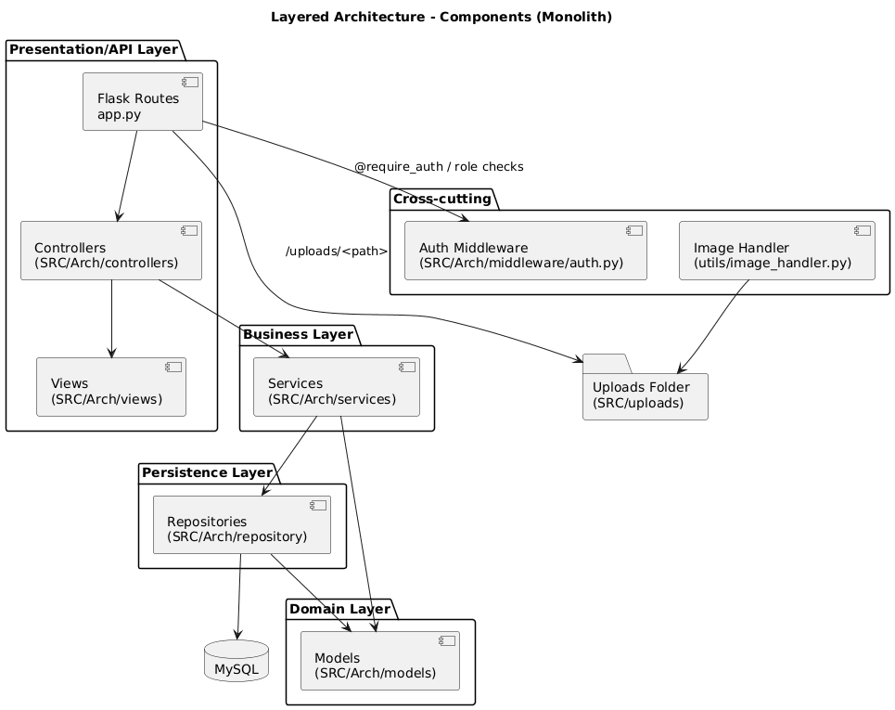
• Presentation/API Layer – Controllers (SRC/Arch/controllers)
- BookingController, RoomController, UserController, ServiceController,
PaymentController, CouponController, CheckInController, StaffController,
ReportController, WalletController.
- These classes receive HTTP requests (via routes defined in app.py), parse and
validate incoming JSON, call appropriate service methods, and use View classes
(e.g. BookingView) to format the JSON responses.

• Business Layer – Services (SRC/Arch/services)
- BookingService handles booking lifecycle: create_booking, update_booking,
cancel_booking, get_user_bookings. It validates input, checks dates, consults
RoomService for availability, interacts with RoomRepository to reserve rooms, and optionally triggers PaymentService for immediate payment.
- CouponService validates coupon creation and apply_coupon logic, enforcing rules on discount types, values, and validity dates.
- Additional services such as RoomService, PaymentService, CheckInService
(if present), ReportService, StaffService, UserService, and WalletService encapsulate domain logic for their respective areas.

• Data Access Layer – Repositories (SRC/Arch/repository)
- BookingRepository implements CRUD operations on the bookings table using
mysql.connector, with methods like save, find_by_id, find_all, find_by_user_id,
find_by_room_id, find_available_rooms_by_date_range, update, and delete.
The method find_available_rooms_by_date_range includes SQL logic to exclude rooms with overlapping active bookings.
- Similar repository classes exist for rooms, check-ins, coupons, payments,
service requests, staff, users, and wallets.

• Domain Model Layer – Models (SRC/Arch/models)
- Classes such as Booking, Room, User, Staff, Service, Coupon, CheckIn, Payment, Wallet, Report represent database entities in Python.
- Booking model instances are constructed from DB rows in BookingRepository._row_to_booking.

• Middleware and Utilities
- middleware/auth.py provides decorators (require_auth, require_admin,
require_receptionist_or_admin, require_role, optional_auth) that wrap endpoints
to enforce authentication and authorization.
- utils/image_handler.py handles image uploads for room images and returns file paths in SRC/uploads/rooms, which are later served by the /uploads route in app.py.

The frontend under SRC/UI is structured by roles and pages (admin, auth, public, user), and communicates with the backend via REST APIs using JavaScript.
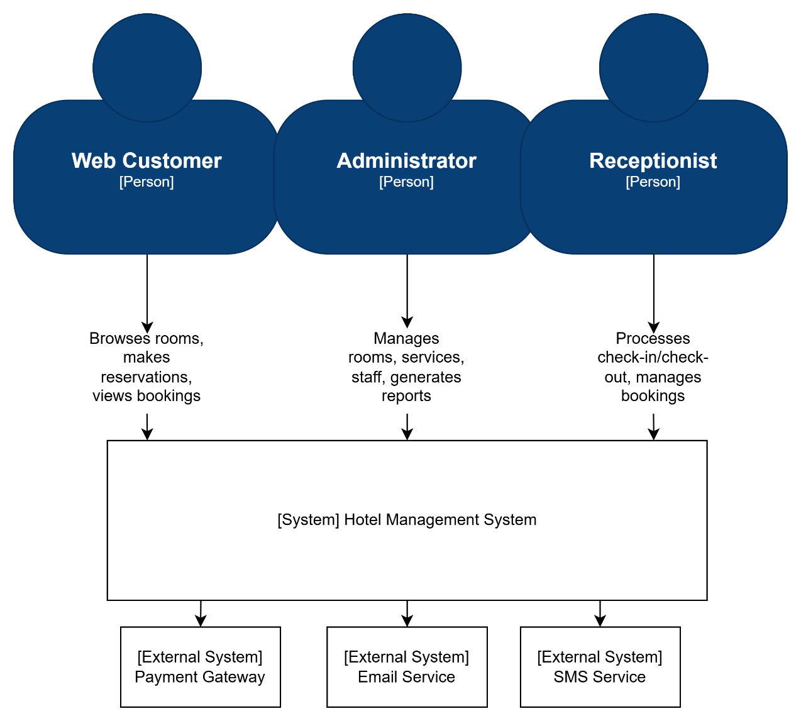
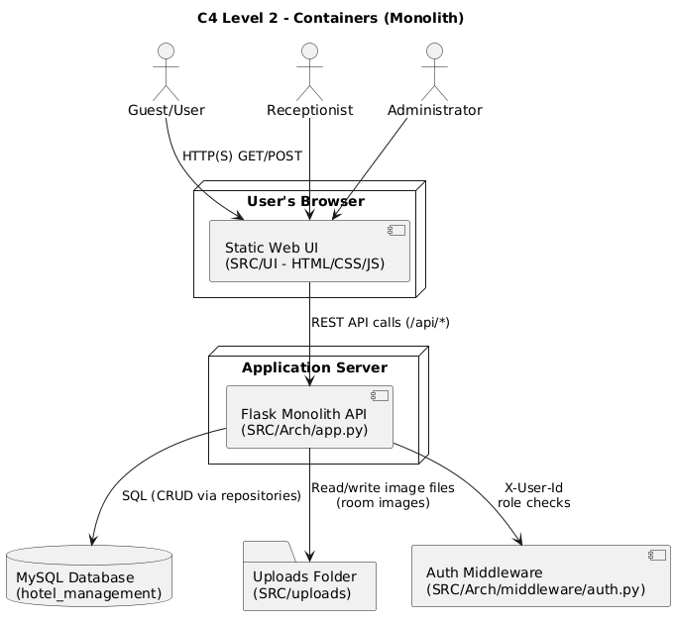
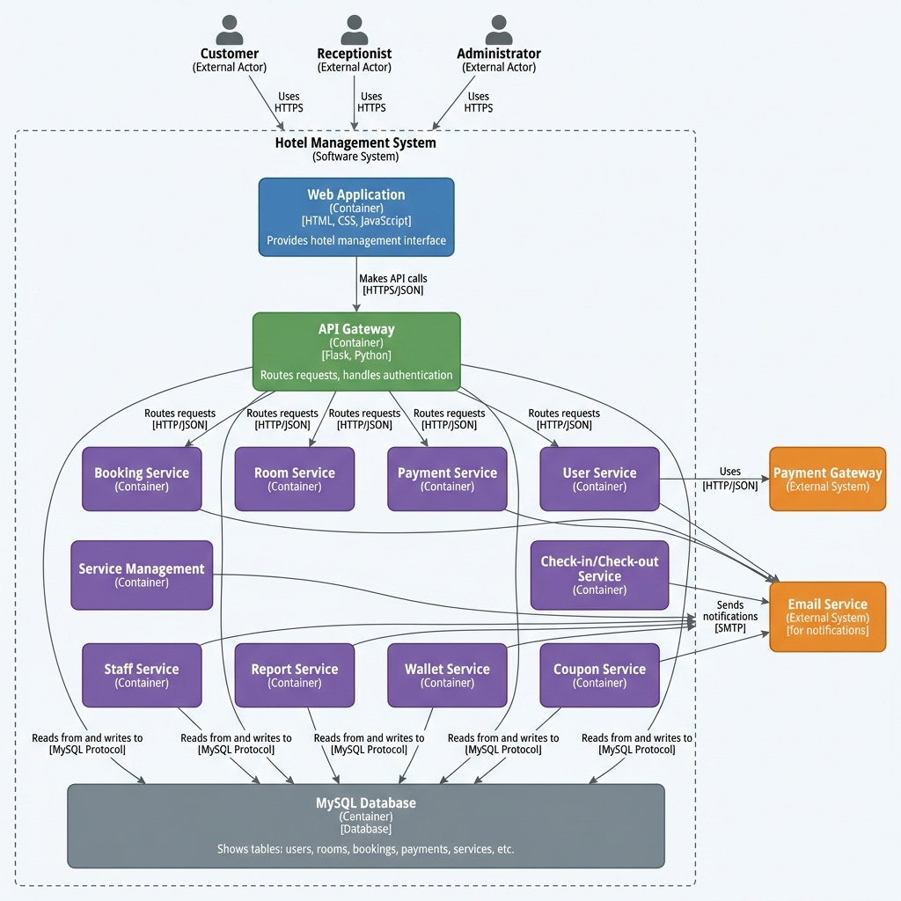
4.2 Technical Stack and Data Model
• Backend Framework: Flask (Python) – used to define routes in app.py and integrate controllers, services, and middleware.
• CORS: flask_cors.CORS configured to allow frontend (likely served from a different origin) to access /api/* and /uploads/*.
• Database: MySQL, configured via SRC/Arch/db_config.py. The DatabaseConfig class uses environment variables (DB_HOST, DB_PORT, DB_NAME, DB_USER, DB_PASSWORD) loaded from .env to create connections using mysql.connector.
• Data Access Pattern: Repositories use explicit SQL queries to interact with tables.
For example, BookingRepository.save inserts into bookings and returns a Booking object.
• Frontend: Static HTML/CSS/JS in SRC/UI (index.html, rooms.html, room-detail.html, auth/login.html, auth/register.html, user/dashboard.html, user/my-bookings.html, user/payment.html, user/wallet.html, admin/admin.html, admin/receptionist.html, etc.).
• Static & Uploaded Content: SRC/UI/images contains UI images; SRC/uploads/rooms stores uploaded room images. app.py serves uploaded files via the /uploads/<filename> route.

Data Model (excerpt based on code and schema hints):
• Room: id, room_number, room_type, price, status, capacity, image_url.
• Booking: id, user_id, guest_name, room_type, room_id, check_in_date,
check_out_date, total_price, status, created_at, updated_at.
• User: id, name, email, password_hash, role (user, receptionist, admin), etc.
• Payment: id, booking_id, user_id, amount, payment_method (cash, wallet, etc.),
status (pending, completed, refunded), created_at.
• Wallet: id, user_id, balance, created_at, updated_at.
• Coupon: id, code, discount_type (percentage/fixed_amount), discount_value,
valid_from, valid_to, is_active.
• CheckIn: id, booking_id, room_id, check_in_time, check_out_time, status.
• Report: id, type (revenue/occupancy/booking), parameters (e.g., date range),
generated_at, content/summary fields.
4.2.1 Data Relationships
ER Diagram
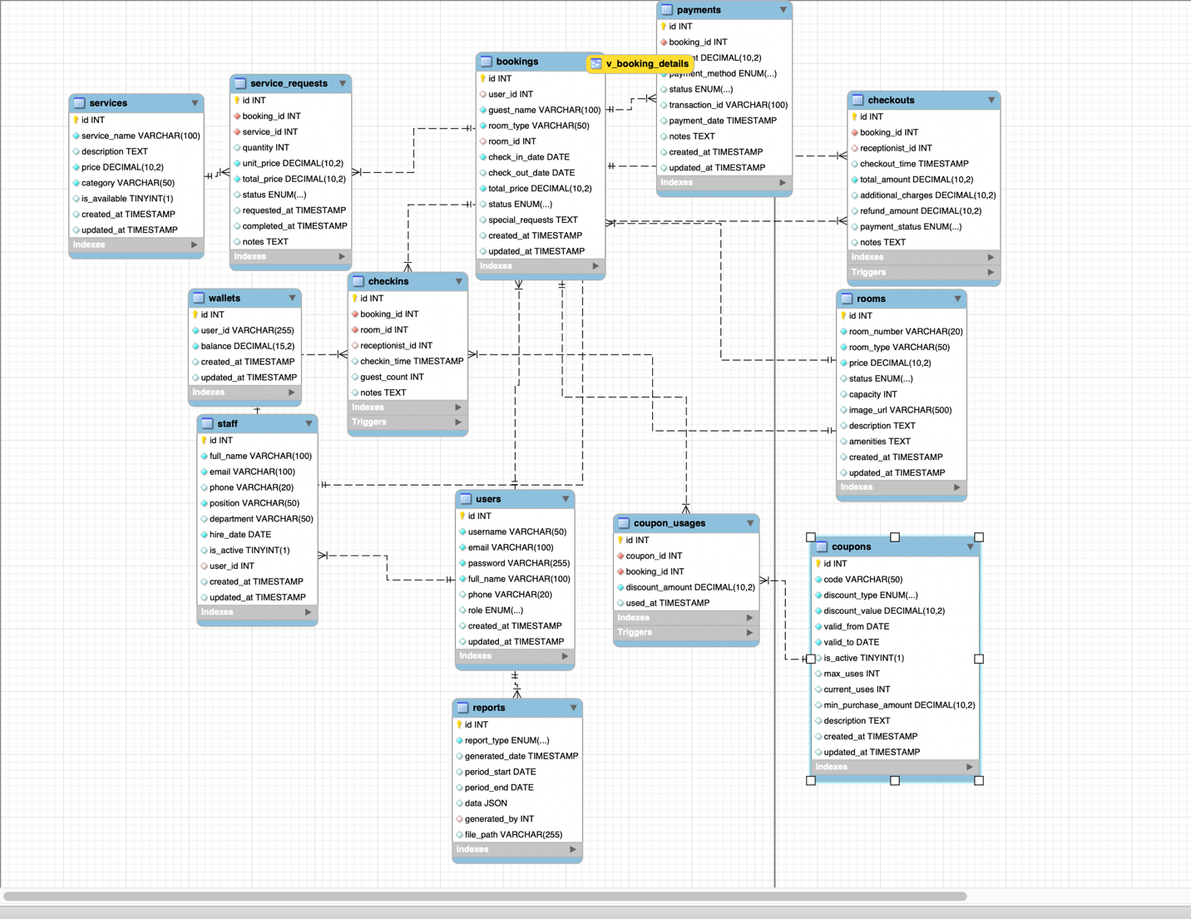
Users table:
ID | Data Object | Field name | Description | Unique? | Data type | Length | Req’d?
US1 | users | id | User auto-increment ID | Y | int | 11 | Y
US2 | users | username | Login ID | Y | varchar | 50 | Y
US3 | users | email | User's Email | Y | varchar | 100 | Y
US4 | users | password | Encrypted password | N | varchar | 255 | Y
US5 | users | full_name | User’s full name | N | varchar | 100 | Y
US6 | users | phone | User’s phone number | N | varchar | 20 | N
US7 | users | role | User role | N | enum | – | Y
US8 | users | created_at | Created at | N | timestamp | – | Y
US9 | users | updated_at | Updated at | N | timestamp | – | Y

Staff table:
ID | Data Object | Field name | Description | Unique? | Data type | Length | Req’d?
ST1 | staff | id | Staff ID | Y | int | 11 | Y
ST2 | staff | full_name | Staff’s full name | N | varchar | 100 | Y
ST3 | staff | email | User’s email | Y | varchar | 100 | Y
ST4 | staff | phone | Phone number | N | varchar | 20 | N
ST5 | staff | position | position | N | varchar | 50 | Y
ST6 | staff | department | department | N | varchar | 50 | N
ST7 | staff | hire_date | Hire date | N | date | – | Y
ST8 | staff | is_active | Working Status | N | boolean | – | Y
ST9 | staff | user_id | FK → users.id | N | int | 11 | N
ST10 | staff | created_at | Created at | N | timestamp | – | Y
ST11 | staff | updated_at | Updated at | N | timestamp | – | Y
Rooms staff:
ID | Data Object | Field name | Description | Unique? | Data type | Length | Req’d?
RM1 | rooms | id | Room ID | Y | int | 11 | Y
RM2 | rooms | room_number | Room number | Y | varchar | 20 | Y
RM3 | rooms | room_type | Room type | N | varchar | 50 | Y
RM4 | rooms | price | Room price | N | decimal | 10,2 | Y
RM5 | rooms | status | Room status | N | enum | – | Y
RM6 | rooms | capacity | Capacity | N | int | 11 | N
RM7 | rooms | image_url | Room’s picture | N | varchar | 500 | N
RM8 | rooms | description | Description | N | text | – | N
RM9 | rooms | amenities | amenities | N | text | – | N
RM10 | rooms | created_at | Created at | N | timestamp | – | Y
RM11 | rooms | updated_at | Updated at | N | timestamp | – | Y
Bookings table:
ID | Data Object | Field name | Description | Unique? | Data type | Length | Req’d?
BK1 | bookings | id | Booking ID | Y | int | 11 | Y
BK2 | bookings | user_id | FK → users.id | N | int | 11 | N
BK3 | bookings | guest_name | User’ name | N | varchar | 100 | Y
BK4 | bookings | room_type | Requested Room Type | N | varchar | 50 | Y
BK5 | bookings | room_id | FK → rooms.id | N | int | 11 | N
BK6 | bookings | check_in_date | Checkin date | N | date | – | Y
BK7 | bookings | check_out_date | Checkout date | N | date | – | N
BK8 | bookings | total_price | Total price | N | decimal | 10,2 | Y
BK9 | bookings | status | Booking status | N | enum | – | Y
BK10 | bookings | special_requests | Special requests | N | text | – | N
BK11 | bookings | created_at | Created at | N | timestamp | – | Y
BK12 | bookings | updated_at | Updated at | N | timestamp | – | Y
Payments table:
ID | Data Object | Field name | Description | Unique? | Data type | Length | Req’d?
PM1 | payments | id | Payment ID | Y | int | 11 | Y
PM2 | payments | booking_id | FK → bookings.id | N | int | 11 | Y
PM3 | payments | amount | amount | N | decimal | 10,2 | Y
PM4 | payments | payment_method | Payment method | N | enum | – | Y
PM5 | payments | status | status | N | enum | – | Y
PM6 | payments | transaction_id | Transaction ID | N | varchar | 100 | N
PM7 | payments | payment_date | Payment date | N | timestamp | – | N
PM8 | payments | notes | notes | N | text | – | N

Services table:
ID | Data Object | Field name | Description | Unique? | Data type | Length | Req’d?
SV1 | services | id | Services ID | Y | int | 11 | Y
SV2 | services | service_name | Service name | N | varchar | 100 | Y
SV3 | services | description | description | N | text | – | N
SV4 | services | price | price | N | decimal | 10,2 | Y
SV5 | services | category | category | N | varchar | 50 | Y
SV6 | services | is_available | Service status | N | boolean | – | Y
Service requests table:
ID | Data Object | Field name | Description | Unique? | Data type | Length | Req’d?
SR1 | service_requests | id | Service requests ID | Y | int | 11 | Y
SR2 | service_requests | booking_id | FK → bookings.id | N | int | 11 | Y
SR3 | service_requests | service_id | FK → services.id | N | int | 11 | Y
SR4 | service_requests | quantity | quantity | N | int | 11 | Y
SR5 | service_requests | unit_price | Unit price | N | decimal | 10,2 | Y
SR6 | service_requests | total_price | Total price | N | decimal | 10,2 | Y
SR7 | service_requests | status | service status | N | enum | – | Y
Coupons table:
ID | Data Object | Field name | Description | Unique? | Data type | Length | Req’d?
CP1 | coupons | id | Coupon ID | Y | int | 11 | Y
CP2 | coupons | code | Coupon code | Y | varchar | 50 | Y
CP3 | coupons | discount_type | coupons discount type | N | enum | – | Y
CP4 | coupons | discount_value | Coupons discount value | N | decimal | 10,2 | Y
CP5 | coupons | valid_from | Coupons valid from | N | date | – | Y
CP6 | coupons | valid_to | Coupons valid to | N | date | – | Y
CP7 | coupons | is_active | Coupons status | N | boolean | – | Y

Coupon usages table:
ID | Data Object | Field name | Description | Unique? | Data type | Length | Req’d?
CU1 | coupon_usages | id | Coupon usages ID | Y | int | 11 | Y
CU2 | coupon_usages | coupon_id | FK → coupons.id | N | int | 11 | Y
CU3 | coupon_usages | booking_id | FK → bookings.id | N | int | 11 | Y
CU4 | coupon_usages | discount_amount | Coupon usages discount amount | N | decimal | 10,2 | Y
CU5 | coupon_usages | used_at | Coupon usages used at | N | timestamp | – | Y
Checkins table:
ID | Data Object | Field name | Description | Unique? | Data type | Length | Req’d?
CI1 | checkins | id | check-in ID | Y | int | 11 | Y
CI2 | checkins | booking_id | FK → bookings.id | Y | int | 11 | Y
CI3 | checkins | room_id | FK → rooms.id | N | int | 11 | Y
CI4 | checkins | receptionist_id | FK → staff.id | N | int | 11 | N
CI5 | checkins | checkin_time | Checkin time | N | timestamp | – | Y
Checkouts table:
ID | Data Object | Field name | Description | Unique? | Data type | Length | Req’d?
CO1 | checkouts | id | Checkout ID | Y | int | 11 | Y
CO2 | checkouts | booking_id | FK → bookings.id | Y | int | 11 | Y
CO3 | checkouts | receptionist_id | FK → staff.id | N | int | 11 | N
CO4 | checkouts | checkout_time | Checkout time | N | timestamp | – | Y
CO5 | checkouts | total_amount | Total amount | N | decimal | 10,2 | Y
Wallets table:
ID | Data Object | Field name | Description | Unique? | Data type | Length | Req’d?
WL1 | wallets | id | Wallets ID | Y | int | 11 | Y
WL2 | wallets | user_id | FK → users.id | Y | int | 11 | Y
WL3 | wallets | balance | balance | N | decimal | 15,2 | Y

Reports table:
ID | Data Object | Field name | Description | Unique? | Data type | Length | Req’d?
RP1 | reports | id | Reports ID | Y | int | 11 | Y
RP2 | reports | report_type | Report type | N | enum | – | Y
RP3 | reports | generated_date | Generated date | N | timestamp | – | Y
RP4 | reports | period_start | Period start | N | date | – | N
RP5 | reports | period_end | Period end | N | date | – | N
RP6 | reports | data | Reports data | N | json | – | N
RP7 | reports | generated_by | FK → users.id | N | int | 11 | N
RP8 | reports | file_path | File path | N | varchar | 255 | N

4.2.2 Key State Models (Status Transitions)
Booking status (typical):
• pending → checked_in → checked_out
• pending → cancelled
Room status (typical):
• available → reserved → occupied → available (or dirty/maintenance depending on policy)
Payment status (typical):
• pending → completed → refunded (if cancellation/refund occurs)

4.2.3 API Endpoint Catalog (Core Contracts)
The following list documents the public API contracts of the monolith (grouped by domain).

Booking api:
Method | Endpoint | Auth | Role | Mô tả
POST | /api/bookings | Yes | user / receptionist / admin | Create booking
GET | /api/bookings/my | Yes | user / receptionist / admin | Get current user's bookings
GET | /api/bookings | Yes | receptionist / admin | Get all bookings
GET | /api/bookings/{booking_id} | Yes | user / receptionist / admin | Booking Details
PUT | /api/bookings/{booking_id} | Yes | receptionist / admin | Update Booking
DELETE | /api/bookings/{booking_id} | Yes | user / receptionist / admin | Cancel booking
ROOMS:
Method | Endpoint | Auth | Role | Mô tả
GET | /api/rooms | Optional | – | Room List
GET | /api/rooms/search | Optional | – | Filter Rooms by Type/Status
GET | /api/rooms/{room_id} | Optional | – | Room Details
POST | /api/rooms | Yes | admin | Create Room
PUT | /api/rooms/{room_id} | Yes | admin | Update room
DELETE | /api/rooms/{room_id} | Yes | admin | Delete room
POST | /api/rooms/assign | Yes | receptionist / admin | Assign Room
GET | /uploads/{filename} | Public | – | Return Image URL
AUTH & USERS:
Method | Endpoint | Auth | Role | Mô tả
POST | /api/auth/login | Public | – | Login
POST | /api/users | Public | – | Register
GET | /api/users | Yes | admin | User List
GET | /api/users/{user_id} | Yes | user / receptionist / admin | User Details
PUT | /api/users/{user_id}/profile | Yes | user / receptionist / admin | Update Profile
PUT | /api/users/{user_id} | Yes | admin | Admin Update User
DELETE | /api/users/{user_id} | Yes | admin | Delete User
SERVICES & SERVICE REQUESTS:
Method | Endpoint | Auth | Role | Mô tả
GET | /api/services | Optional | – | Service List
GET | /api/services/{service_id} | Optional | – | Service Details
POST | /api/services | Yes | admin | Create Service
PUT | /api/services/{service_id} | Yes | admin | Update Service
DELETE | /api/services/{service_id} | Yes | admin | Delete Service
POST | /api/services/request | Yes | user / receptionist / admin | Create Service Request
GET | /api/service-requests | Yes | receptionist / admin | Danh sách yêu cầu
GET | /api/service-requests/{request_id} | Yes | receptionist / admin | Request List
PUT | /api/service-requests/{request_id} | Yes | receptionist / admin | Request Details
PAYMENTS:
Method | Endpoint | Auth | Role | Mô tả
POST | /api/payments | Yes | user / receptionist / admin | payments
GET | /api/payments | Yes | receptionist / admin | Transaction History
GET | /api/payments/{payment_id} | Yes | user / receptionist / admin | Payment Details
GET | /api/bookings/{booking_id}/payments | Yes | user / receptionist / admin | Payment by Booking
COUPONS:
Method | Endpoint | Auth | Role | Mô tả
POST | /api/coupons | Yes | admin | Create coupon
GET | /api/coupons/{coupon_id} | Optional | – | Coupon detail
POST | /api/coupons/apply | Yes | user / receptionist / admin | Apply coupon
CHECK-IN / CHECK-OUT:
Method | Endpoint | Auth | Role | Mô tả
POST | /api/checkins | Yes | receptionist / admin | Check-in
POST | /api/checkouts | Yes | receptionist / admin | Check-out
GET | /api/checkins/{checkin_id} | Yes | receptionist / admin | check-in detail
GET | /api/checkouts/summary/{booking_id} | Yes | user / receptionist / admin | Checkout Summary
WALLET:
Method | Endpoint | Auth | Role | Mô tả
GET | /api/wallet | Yes | user / receptionist / admin | wallet
POST | /api/wallet/topup | Yes | user / receptionist / admin | Top-up Wallet
STAFF:
Method | Endpoint | Auth | Role | Mô tả
GET | /api/staff | Yes | admin | Staff list
POST | /api/staff | Yes | admin | Create staff
GET | /api/staff/{staff_id} | Yes | admin | Staff detail
PUT | /api/staff/{staff_id} | Yes | admin | Update staff
DELETE | /api/staff/{staff_id} | Yes | admin | Delete staff
REPORTS:
Method | Endpoint | Auth | Role | Mô tả
POST | /api/reports/revenue | Yes | admin | Revenue Report
POST | /api/reports/occupancy | Yes | admin | Occupancy Report
POST | /api/reports/booking | Yes | admin | Booking Report
GET | /api/reports/{report_id} | Yes | admin | Report detail
GET | /api/reports/type/{report_type} | Yes | admin | Report by Category

4.2.4 Authorization Matrix (Role-based Access Control Summary)
• Public (no auth): /api/auth/login, /api/users (register), /uploads/*
• Optional auth (guest can access): GET /api/rooms*, GET /api/services*, GET /api/coupons/<id>
• User: booking create/cancel/view own, payments by booking, wallet, request service, apply coupon
• Receptionist: booking list/update, assign room, check-in/check-out, manage service requests, payment list
• Administrator: all receptionist permissions + full CRUD for rooms/services/users/staff + reports + coupons

4.3 Implementation: Server-Side Logic (Flask Backend – Controllers/Services)

Example: Booking Creation Flow
1. The frontend (e.g., from rooms.html or room-detail.html) sends a POST request to
/api/bookings with JSON body containing:
- guest_name
- room_type
- check_in_date (and optionally check_out_date)
- optional total_price override
- optional payment_method and payment_amount
2. app.py defines the route:
- @app.route('/api/bookings', methods=['POST'])
@require_auth
def create_booking(): return booking_controller.create_booking()
3. BookingController.create_booking() reads request.json, obtains the current user from
request.current_user (set by the authentication middleware), and calls
BookingService.create_booking(...).
4. BookingService.create_booking() performs:
- Input validation (guest name, room type, dates).
- Date parsing and validation (no past check-in, check-out after check-in).
- Room availability check by calling RoomService.search_rooms(..., check_in_date,
check_out_date). This uses BookingRepository.find_available_rooms_by_date_range()
to exclude rooms with overlapping bookings.
- Room selection (first available) and status update to "reserved" via RoomRepository.
- Booking creation via BookingRepository.save(...) within a transaction.
- Optional payment processing by calling PaymentService.process_payment(...) if
payment details were provided. If payment fails, the service releases the room
and cancels the booking.
5. BookingController then uses BookingView.booking_created(booking) to format a
JSON response including booking details for the frontend.

Example: Booking Cancellation & Refund Flow
1. The frontend sends DELETE /api/bookings/<booking_id>, which is protected by
@require_auth in app.py.
2. BookingController.cancel_booking(booking_id) calls BookingService.cancel_booking.
3. BookingService.cancel_booking:
- Validates that the booking exists and is not already checked_in, checked_out,
or cancelled.
- Ensures there is no check-in record (via CheckInRepository).
- Releases the room by setting its status back to "available" if it was "reserved".
- Looks up completed payments for the booking through PaymentService and, if
applicable, refunds the amount to the user’s wallet and updates payment status
to "refunded".
- Updates booking status to "cancelled" via BookingRepository.delete (which sets
status = 'cancelled').
4. A descriptive message is returned to the client, including refund notes if any.

Example: Coupon Application Flow
1. The frontend sends POST /api/coupons/apply with a coupon code.
2. CouponController.apply_coupon() calls CouponService.apply_coupon(code).
3. CouponService.apply_coupon:
- Loads the coupon by code via CouponRepository.
- Validates that the coupon exists and is active.
- Checks current date against coupon.valid_from and coupon.valid_to, ensuring
the coupon is neither expired nor not yet valid.
- Returns coupon details to the controller, which then responds with discount
information so that frontend can adjust total price.

Example: Payment Processing Flow
1. Frontend sends POST /api/payments with JSON:
- booking_id, amount, payment_method (credit_card/cash/bank_transfer), optional user_id context.
2. PaymentController.process_payment delegates to PaymentService.process_payment(...).
3. PaymentService validates:
- amount > 0; payment_method in allowed methods; booking exists and not cancelled.
4. If wallet-based payment is used in the current design, the service checks wallet balance and deducts.
5. PaymentRepository saves payment record (status pending/completed).
6. Backend returns payment result to the frontend.

Example: Check-in Flow (Receptionist)
1. Receptionist selects a booking and calls POST /api/checkins (booking_id, receptionist_id, optional room_id).
2. CheckInController delegates to CheckInService.process_checkin(...).
3. Service validates booking exists, not already checked in, and room assignment matches booking.room_type.
4. Repository saves check-in record and service updates booking status to checked_in and room status to occupied.
5. Backend returns the check-in record.

Example: Check-out Flow (Receptionist)
1. Receptionist calls POST /api/checkouts with booking_id and checkout details.
2. CheckInService validates that a check-in exists for the booking.
3. Service calculates total checkout amount:
- room cost (booking.total_price) + additional services (service_requests total).
4. Repository saves checkout record; service updates booking status to checked_out and releases/updates room status.
5. Backend returns checkout result; user can view summary via GET /api/checkouts/summary/<booking_id>.

Example: Service Request Flow
1. User requests a service via POST /api/services/request (booking_id, service_id, quantity).
2. ServiceController delegates to ServiceService.create_service_request(...).
3. ServiceService validates booking exists and service exists, then creates service_requests record.
4. Receptionist/Admin can view and manage requests via:
- GET /api/service-requests, GET /api/service-requests/<id>, PUT /api/service-requests/<id>.

Example: Wallet Flow
1. User opens wallet page → GET /api/wallet.
2. WalletService returns wallet; if missing, creates one with balance 0.
3. User tops up → POST /api/wallet/topup with amount; system validates numeric and > 0, then updates balance.

4.3.1 Key Validation & Error Handling Strategy
Input validation is primarily implemented in the Service layer (e.g., BookingService, PaymentService, CouponService):
• Date validation: YYYY-MM-DD; check-in not in past; check-out after check-in.
• Money validation: amount > 0; discounts within valid ranges.
• State validation: cannot cancel/update after check-in; cannot checkout without check-in.
• Role validation: enforced by middleware decorators (401/403).

Error Response Strategy (high-level):
• 400 Bad Request: invalid input data, business rule violation
• 401 Unauthorized: authentication required / missing X-User-Id
• 403 Forbidden: role not permitted
• 404 Not Found: resource not found (booking/room/service/coupon/etc.)
• 500 Internal Server Error: database or unexpected server errors

4.3.2 Runtime/Deployment View (Monolith)
• The monolith runs as a single Flask process (default: 127.0.0.1:5000).
• The MySQL database is a separate process/service configured by environment variables in .env.
• UI files under SRC/UI are static and call APIs under /api/* via JavaScript (fetch).
• Uploaded images are stored under SRC/uploads and served through /uploads/<path>.

4.4 Implementation: Client-Side Logic (Web UI – HTML/CSS/JS)

The UI in SRC/UI is separated by role and page:
• Public & User pages:
- index.html: homepage introducing the hotel and quick access to room browsing.
- public/rooms.html and public/room-detail.html: room list and details pages.
- user/dashboard.html: user overview, showing relevant booking and wallet info.
- user/my-bookings.html: history and status of user’s bookings.
- user/payment.html: payment UI for a specific booking.
- user/wallet.html: wallet balance, top-up form, and transaction history view
(if implemented).

• Authentication pages:
- auth/login.html and auth/register.html: forms that send login/registration
requests to /api/auth/login and /api/users.

• Staff & Admin pages:
- admin/admin.html: admin dashboard for managing rooms, staff, services, coupons,
and viewing reports.
- admin/receptionist.html: interface tailored to receptionist tasks like
managing arrivals, check-ins, check-outs, and service requests.
- admin/admin-messages.html: page for internal messages or notifications.

JavaScript files (SRC/UI/js):
• api.js: centralizes AJAX/fetch calls to backend APIs; likely wraps GET/POST/PUT/DELETE
requests for rooms, bookings, payments, coupons, wallet, etc.
• auth.js: handles storing auth tokens, sending login/register forms, and updating
the UI based on user authentication state.
• admin.js and receptionist.js: contain logic to populate admin/receptionist tables,
call backend endpoints (/api/rooms, /api/service-requests, /api/staff, /api/reports),
and react to user actions (create room, accept service request, etc.).
• script.js and language.js: implement shared UI functionalities (menu behavior,
language switching), while admin-messages.js and chat.js support additional
user/admin communication features.

6. Conclusion & Reflection

This project successfully implements a multi-role Hotel Booking Management System using a layered Flask backend and a static HTML/CSS/JavaScript frontend. The layered structure with controllers, services, repositories, and models has proven effective in separating concerns, making it easier to reason about booking, payment, and reporting flows. The system satisfies the main functional requirements (room browsing, booking, payment, check-in/check-out, wallet, coupons, services, reporting) and achieves key architectural goals such as modifiability, maintainability, and basic security.

6.1 Lessons Learned
• Value of Clear Layering: Explicit separation between controllers, services, and
repositories significantly reduced coupling. When business rules changed (e.g.,
new validation for booking dates or coupon constraints), modifications could be
localized mainly in the service layer.
• Handling Data Consistency: Implementing correct booking and payment flows required careful handling of transactions and state transitions (pending, paid, cancelled, checked_in, checked_out). The repository methods and service logic had to be designed to avoid partial updates (e.g., reserving a room but failing to create a booking).
• Security & Roles: Introducing middleware-based decorators for authentication and role-based access control made it easier to secure endpoints consistently across
the application. This pattern helped enforce that only appropriate roles can perform sensitive operations like managing rooms, staff, or viewing reports.
• Integration with a Real Database: Working with MySQL and explicit SQL queries (instead of an ORM) provided deeper understanding of SQL, transactions, and how to map between relational tables and Python objects.

6.2 Future Improvements
1. Strengthen Authentication & Authorization:
- Adopt a more robust token-based authentication mechanism (e.g., JWT) with secure storage on the client and token refresh logic.
- Enhance password policies, add account lockout after repeated failed logins,
and introduce audit logging for security-sensitive operations.

2. Enhance Reporting:
- Extend ReportService and related repositories to produce richer analytics such as revenue by room type, monthly/seasonal trends, average length of stay, and service usage statistics.
- Provide export options (CSV/PDF) and more visual dashboards in the admin UI.

3. Improve Scalability & Deployment:
- Containerize the application (Docker), use environment-specific configurations,
and deploy on a cloud platform.
- Introduce a reverse proxy/load balancer and, if necessary, separate the booking,
payment, and reporting domains into independently scalable services.

4. UX & UI Enhancements:
- Improve responsiveness and interactivity of the frontend, potentially integrating
a modern frontend framework for complex admin views.
- Add user notifications (email or in-app) for booking confirmation, payment
receipts, and check-in reminders.

5. Logging, Monitoring & Error Handling:
- Implement structured logging and monitoring (e.g., using a logging framework and a dashboard) to quickly detect issues in production.
- Standardize error responses across controllers to provide consistent feedback to
frontend developers and end users.

