PHENIKAA UNIVERSITY

PHENIKAA SCHOOL OF COMPUTING



COURSE: SOFTWARE ARCHITECTURE
Lab 1: Elicitation and Modeling Requirements for Hotel Management System

INSTRUCTOR: Vũ Quang Dũng
GROUP 7: Nguyễn Hưng Thành (23010688 – K17 KTPM)
Trần Ngọc An (23010283 – K17-KTPM) Lê Mạnh Đức (23010208 – K17-KTPM)
Phạm Thế Thủy Hoàng (23010960 – K17-KTPM)
CREDIT CLASS: CSE703110-1-2-25(N01)

Ha Noi, December 6, 2025
Contents
1. Abstract/Summary 3
2. Lab Specific Section: I. Requirements Elicitation & Modeling 3
2.1. Software Requirements Specifications (SRS) 3
2.1.1. Functional Requirements (FRs) 3
2.1.2. Non-Functional Requirements (NFRs) 5
2.1.3. Architecturally Significant Requirements (ASRs) 5
2.2. Modeling Artifact: UML Use Case Diagram 6
3. Architectural Design 7
3.1. The Problem Statement 7
3.2. Impact of ASRs on Layered Architecture 7
4. Conclusion & Reflection 8

1. Abstract/Summary
The Hotel Management System project aims to develop a comprehensive platform for managing reservations, staff, rooms, check-ins/check-outs, and hotel services. This first lab focuses on requirements elicitation and modeling.
We have documented Functional Requirements, Non-Functional Requirements, and Architecturally Significant Requirements (ASRs) in a structured format. The system's core behavior is formally modeled using UML Use Case Diagrams, clearly defining system boundaries, external actors, and key behavioral relationships. This foundation establishes the scope and critical architectural drivers that will be addressed in subsequent labs, specifically the Layered Architecture design in Lab 2.

2. Lab Specific Section: I. Requirements Elicitation & Modeling
The primary entities that interact with the Hotel Management System are:
1. User
2. Administrator
3. Payment gateway
4. Receptionist

2.1. Software Requirements Specifications (SRS)
The following tables document the elicited requirements, which collectively form the basis for the Hotel Management System design.

2.1.1. Functional Requirements (FRs)
These requirements define the specific behaviors and functions the system must provide.
- User Functional Requirements

ID | Requirement Name | Description | Priority
FR-01 | Room Search & Booking | The User must be able to search for rooms by date, type, and number of people, and complete the reservation online. | High
FR-02 | User Authentication | The User must be able to register and log in securely, including password recovery. | High
FR-03 | Booking Management | The User must be able to view, modify, or cancel their reservations. The system must store a full booking history. | High
FR-04 | Online Payment | The User must be able to make secure online payments for reservations and additional services (spa, dining). | High
FR-05 | Service Requests | The User must be able to request additional services (early check-in, late check-out, room service) during their stay. | Medium
- Receptionist Functional Requirements

ID | Requirement Name | Description | Priority
FR-06 | Check-in/Check-out Processing | The Receptionist must be able to process guest check-in and check-out, including verifying bookings and issuing keys. | High
FR-07 | Walk-in Booking | The Receptionist must be able to create new bookings for guests arriving directly at the counter (walk-in guests). | High
FR-08 | Room Assignment | The Receptionist must be able to assign specific rooms to bookings based on room status and guest preferences. | High
FR-09 | Guest Profile Management | The Receptionist must be able to view and update guest profile information. | Medium
FR-10 | Payment Collection | The Receptionist must be able to collect payments at the counter (cash/card) and issue invoices. | High
- Hotel Manager Functional Requirements (Administrator)

ID | Requirement Name | Description | Priority
FR-11 | Room Inventory Management | The Administrator must be able to perform full CRUD operations on the room catalog (add new rooms, update details, price) and manage room status (e.g., Under Maintenance). | High
FR-12 | Staff Management | The Administrator must be able to create and manage staff accounts, including assigning roles (e.g., Receptionist, Housekeeper) and resetting passwords. | High
FR-13 | Service Management | The Administrator must be able to update the catalog of hotel services (Spa, Dining menu) | Medium
FR-14 | Analytics & Reporting | The Administrator must have access to detailed reports on occupancy rates, revenue, and service performance. | Medium

2.1.2. Non-Functional Requirements (NFRs)
ID | Attribute | Description | Impact
NFR-01 | Performance (Latency) | The system must respond to room search queries within 2.0 seconds under normal load. | High
NFR-02 | Security  (Integrity) | All users' data must be transmitted via HTTPS. Credit card details must not be stored in the database but processed directly via the Payment Gateway (PCI-DSS compliance). | Critical
NFR-03 | Reliability  (Availability) | The online booking system must maintain a minimum uptime of 99.9% to ensure users can book rooms 24/7. | Critical
These requirements specify criteria that can be used to judge the operation of the system, not specific functions.

2.1.3. Architecturally Significant Requirements (ASRs)
These are the non-functional requirements that have the most profound influence on the system's architecture, driving the selection of patterns.

ASR ID | Quality Attribute | Requirement Statement | Architectural Rationale
ASR-1 | Scalability | The architecture must support a sudden increase in traffic from 100 to 1,000 concurrent users during peak holiday seasons. | This drives the Python backend towards a stateless design, allowing for horizontal scaling and effective load balancing in future deployment stages. Note: Currently, the system is implemented as a monolithic Layered Architecture. The transition to Microservices Architecture (as designed in Lab 4) will address this scalability requirement more effectively by allowing independent scaling of high-demand services (e.g., Room Search) without scaling the entire application.
ASR-2 | Security | All access to administration functionalities (FR-11, FR-12, FR-13, FR-14) must be restricted to authenticated administrators via secure session/token validation. | This necessitates a dedicated Security Middleware/Component located in the Business Logic layer to enforce access control before requests reach the data. This ensures all administrative operations (room management, staff management, services, reporting) are fully protected regardless of request origin (UI or API).
ASR-3 | Modifiability | Updates to the Presentation Layer must not require changes to the Business Logic or Persistence layers. | Enforces the principle of Separation of Concerns. The architecture must strictly separate the Presentation Layer from the Business Layer, ensuring UI changes do not break core functionality.

2.2. Modeling Artifact: UML Use Case Diagram
The UML Use Case Diagram below models the functional scope of the Hotel Management System.
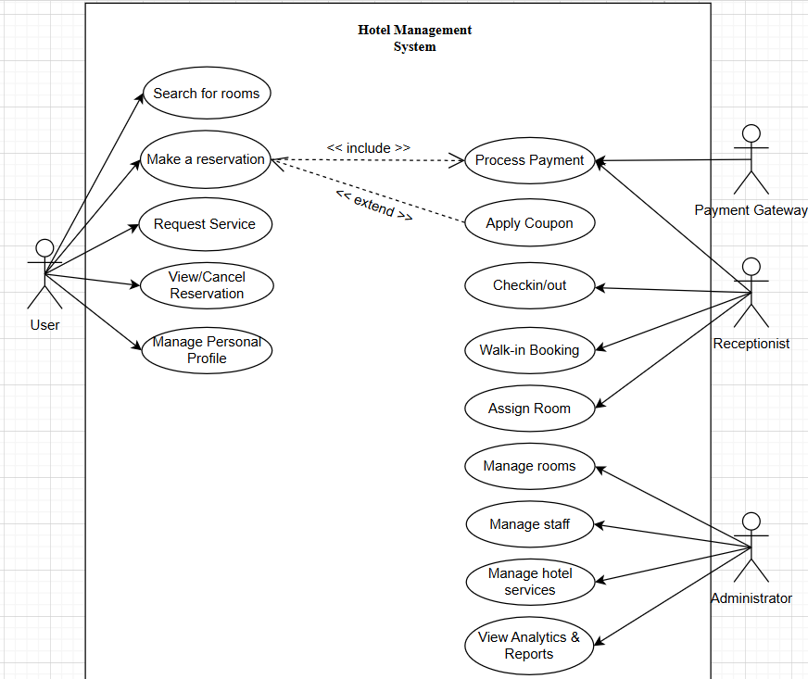

- Actors: The system interacts with four primary actors: User, Admin (Administrator), Receptionist and Payment Gateway.
- System Boundary: The box delineates the scope of the Hotel Management System.
- User Interactions: Interacts with the system to search for rooms, make reservations, and manage their personal profile.
- Administrator Interactions: Responsible for managing hotel resources (rooms, staff, services, view analytics and reports).
- Payment Gateway Interactions: Validates credit card information and processes financial transactions when prompted by the system during the reservation process. It returns the transaction status (Success/Failure) to the Hotel Management System.
- Receptionist Interactions: Handles the daily operations at the front desk, including checking guests in and out, verifying bookings, and receiving direct payments if applicable.

3. Architectural Design

3.1. The Problem Statement
The problem is to design an architecture that satisfies the core requirements while enforcing separation of concerns. The Layered Architecture pattern is chosen as the first structural approach to address the Modifiability and Security ASRs. This fits the chosen technology stack (Python Web Frameworks) well.

3.2. Impact of ASRs on Layered Architecture
- ASR-3 (Modifiability) Layered Structure: ASR-3 demands that the Presentation (HTML/CSS) be isolated from the Logic. The Layered Architecture supports this by defining distinct layers. This means the Business Logic Layer (Python services) can be modified without impacting the Presentation Layer (HTML templates), and vice versa. Interaction with the Payment Gateway should be encapsulated within a specific module in the Business Logic Layer. This ensures that switching payment providers (e.g., from Stripe to PayPal) does not affect the Frontend or other backend services.
- ASR-2 (Security) Business Logic Layer: ASR-2 requires rigorous authorization for Administrator tasks. In the Layered Architecture, this logic is enforced in the Business Logic Layer. This ensures that security checks are applied to core services (e.g., RoomService), protecting them regardless of whether the request comes from the web UI or an API call

4. Conclusion & Reflection
The requirements elicitation phase for the Hotel Management System successfully defined the project scope through detailed Functional and Non-Functional Requirements. The UML Use Case Diagram provides a clear visual model of user interactions. The identified ASRs—especially those relating to Modifiability (Separation of HTML/CSS from Python) and Security—directly necessitate the adoption of a structured pattern like the Layered Architecture for the subsequent design phase (Lab 2) behaviors.

