PHENIKAA UNIVERSITY

PHENIKAA SCHOOL OF COMPUTING



COURSE: SOFTWARE ARCHITECTURE
HOTEL MANAGEMENT SYSTEM

INSTRUCTOR: Vũ Quang Dũng
GROUP 7: Trần Ngọc An (23010283 – K17-KTPM)
Lê Mạnh Đức (23010208 – K17-KTPM)
Nguyễn Hưng Thành (23010688 – K17 KTPM)
Phạm Thế Thủy Hoàng (23010960 – K17-KTPM)
CREDIT CLASS: CSE703110-1-2-25(N01)

Ha Noi, December 6, 2025
Contents
1. Executive Summary 2
2. Project Requirements & Goals 3
2.1 Core Functional Requirements 3
2.2 Key Quality Attributes (Architectural Goals – Non-functional Requirements) 6
2.3 Propose model of ASR 7
2.4 Use Case Modeling 12
2.4.1 Interface Specification and Development UC1 – Users. 13
2.4.2 Interface Specification and Development UC2 – Receptionist. 22
2.4.3 Interface Specification and Development UC3 – Administrator. 29
2.4.4 Description of Layers 33
3. Architectural Design & Implementation 34
3.1 Architectural Pattern & Layers 34
3.2 Technical Stack and Data Model 42
3.2.1 Data Relationships 43
3.2.2 Key State Models (Status Transitions) 49
3.2.3 API Endpoint Catalog (Core Contracts) 51
3.2.4 Authorization Matrix (Role-based Access Control Summary) 53
3.3 Implementation: Server-Side Logic (Flask Backend – Controllers/Services) 54
3.3.1 Key Validation & Error Handling Strategy 56
3.3.2 Runtime/Deployment View 57
3.4 Implementation: Client-Side Logic (Web UI – HTML/CSS/JS) 58
4. Testing & Verification 58
4.1 Unit Testing 59
4.2 Integration Testing 60
4.3 Verification Proof: Booking – Payment – Check-in Flow 62
5. Conclusion & Reflection 66
5.1 Lessons Learned 66
5.2 Future Improvements 66

1. Executive Summary
This project implements a Hotel Booking Management System that supports the end-to-end workflow of a real hotel: customers can browse rooms, create bookings, make payments, manage their wallet, and view booking history; receptionists can check guests in and out and manage service requests; administrators can manage rooms, services, staff, coupons, and reports. The system is architected using a layered architecture on top of Flask, with clear separation between controllers (HTTP layer), services (business logic), repositories (data access), and models (domain entities).
The backend lives under SRC/Arch and exposes REST-style JSON APIs (e.g. /api/bookings, /api/rooms, /api/auth/login, /api/wallet) through controller classes such as booking_controller.py, room_controller.py, user_controller.py, payment_controller.py, coupon_controller.py, checkin_controller.py, staff_controller.py, report_controller.py, and wallet_controller.py. These controllers rely on service classes (e.g. booking_service.py, room_service.py, payment_service.py, coupon_service.py) that encapsulate business logic and call repository classes (e.g. booking_repository.py, room_repository.py, coupon_repository.py) to access a MySQL database.
The frontend is implemented in SRC/UI as a set of HTML/CSS/JS pages for different roles: public pages for browsing rooms, authentication pages for login and registration, user pages for dashboard, my bookings, payment, and wallet, and admin pages for room and staff management and reports. The final outcome is a working multi-role hotel management application where the architecture supports modifiability, maintainability, and basic security and scalability for small-to-medium usage.

2. Project Requirements & Goals

2.1 Core Functional Requirements
The primary entities that interact with the Hotel Management System are:
1. User
2. Administrator
3. Receptionist
These requirements define the specific behaviors and functions the system must provide.
- User Functional Requirements

ID | Requirement Name | Description | Priority
FR-01 | Room Search & Booking | The User must be able to browse/search rooms by type and status, and complete a reservation online. Availability by date range is validated during booking creation (check-in/check-out overlap prevention). | High
FR-02 | User Authentication | The User must be able to register and log in securely. | High
FR-03 | Booking Management | The User must be able to view and cancel their reservations. The system must store a full booking history, while operational booking updates (e.g., status adjustments) are handled by receptionist/administrator roles. | High
FR-04 | Online Payment | The User must be able to make secure online payments for reservations and additional services (spa, dining). | High
FR-05 | Service Requests | The User must be able to request additional services during their stay. | Medium
FR-06 | Digital Wallet | The User must be able to view their wallet balance, top up the wallet with a specified amount, and pay for bookings and services using the internal wallet balance. | High
FR-07 | Coupon Application | The User must be able to apply valid promotional coupon codes during the booking or payment process to receive a discount (percentage or fixed amount). The system must validate coupon code, active status, and validity period. | Medium
FR-08 | Contact with receptionist/admin | The User must be able to contact the receptionist or administrator (e.g., via the Contact/Support pages) to request services or ask for more information about rooms. | Medium
- Receptionist Functional Requirements

ID | Requirement Name | Description | Priority
FR-09 | Check-in/Check-out Processing | The Receptionist must be able to process guest check-in and check-out, including verifying bookings. | High
FR-10 | Walk-in Booking | The Receptionist must be able to confirm bookings for guests arriving directly at the counter. | High
FR-11 | Room Assignment | The Receptionist must be able to assign rooms to bookings based on room status and guest preferences. | High
FR-12 | Transaction & Activity History | The Receptionist must be able to view historical records of bookings, payments, service requests, and system activities. | High
FR-13 | Service Request Management | The Receptionist must be able to view the list of all service requests (e.g. room service, spa, dining) and update the status of each request (e.g. pending, in progress, completed). | High
FR-14 | Refund on Cancellation | When a User cancels a booking that was paid (in whole or in part) using the digital wallet, the system must automatically refund the corresponding amount to the User’s wallet and update the payment status (e.g. to “refunded”). Refund must only apply to eligible bookings (e.g. not yet checked in). | High
FR-15 | Contact with guest | The Receptionist must be able to reply to guest questions and messages through the contact/support channels. | High
- Hotel Manager Functional Requirements (Administrator)

ID | Requirement Name | Description | Priority
FR-16 | Room Inventory Management | The Administrator must be able to perform full CRUD operations on the room catalog (add new rooms, update details, price) and manage room status (e.g., Under Maintenance). | High
FR-17 | Staff Management | The Administrator must be able to create and manage staff accounts, including assigning roles (e.g., Receptionist, Housekeeper). | High
FR-18 | Users Management | The Administrator must be able to see and manage users accounts. | High
FR-19 | Service Management | The Administrator must be able to update the catalog of hotel services (Spa, Dining menu) | Medium
FR-20 | Analytics & Reporting | The Administrator must have access to detailed reports on occupancy rates, revenue, and service performance. | Medium

2.2 Key Quality Attributes (Architectural Goals – Non-functional Requirements)
ID | Attribute | Description
NFR-01 | Modifiability | The system is organized into layers (controllers, services, repositories, models) so that new features such as new payment methods, extended reports, or additional service types can be added with minimal impact on existing logic.
NFR-02 | Maintainability | Code is grouped by responsibility (e.g. SRC/Arch/controllers, SRC/Arch/services, SRC/Arch/repository, SRC/Arch/models, SRC/Arch/views, SRC/Arch/middleware) providing clear entry points for debugging and enhancements.
NFR-03 | Reliability & Consistency | Booking and payment logic (in booking_service.py, booking_repository.py, payment_service.py, and related repositories) must avoid overbooking, maintain correct booking status transitions, and ensure payment records match wallet balances.
NFR-04 | Security | Authentication and role-based authorization are enforced via middleware (require_auth, require_admin, require_receptionist_or_admin, require_role) to secure sensitive endpoints such as booking, payment, wallet, and admin operations.
NFR-05 | Usability | The UI under SRC/UI is designed to be clear and role-oriented: customers see booking and payment pages; staff see check-in/check-out and service request screens; admins see management and reporting screens.
NFR-06 | Scalability | Although the current deployment is monolithic (single Flask app and a MySQL database), the RESTful API design and separation of services/repositories allows future scaling by splitting out services or deploying behind a load balancer.
NFR-07 | Performance | The architecture utilizes direct function calls between layers (Controller → Service → Repository) eliminating internal network hops. Database queries are optimized with indexing.

2.3 Propose model of ASR

ASR ID | Quality Attribute | Statement | Impact
ASR-1 | Prevent Overbooking (NFR – Reliability & Consistency) | The system must ensure that a specific room cannot be booked by multiple users for overlapping date ranges. | This requirement directly shapes the design of booking_service.py and booking_repository.py. For example, booking_service.py uses room_service.py which checks the database for existing bookings with overlapping check-in/check-out dates and excludes such rooms from the available list. The SQL query in booking_repository.py filters out rooms whose bookings overlap in time and are not cancelled or checked_out, preventing double-booking at the data-access level.
ASR-2 | Secure Access to Financial Operations (NFR – Security & Integrity) | All wallet and payment-related operations must be performed only by authenticated users, and only on their own accounts or authorized resources.. | This requirement leads to the use of authentication middleware and role-based decorators around endpoints in app.py such as /api/payments, /api/wallet, /api/wallet/topup, and admin-only routes. payment_service.py and wallet_service.py must always validate the current user’s identity and ensure that wallet updates and payment records are tied to the correct user_id and booking_id, preventing unauthorized manipulation of balances or payments.
ASR-3 | Layered Modifiability (NFR – Modifiability) | New business rules (e.g., coupon rules, booking constraints, new payment methods) must be implemented primarily in the Service layer without changing the REST endpoints and without spreading SQL into controllers. | This requirement is implemented by the layered structure in SRC/Arch: controllers parse HTTP input and delegate to services; services encapsulate business logic; repositories encapsulate SQL. This reduces change impact and keeps changes localized.
ASR-4 | Maintainable Code Organization & Clear Entry Points (NFR – Maintainability) | The codebase must be organized by responsibility so developers can quickly locate where to add validations, debug failures, or extend features. | This requirement is satisfied by the directory structure and separation of concerns: SRC/Arch/controllers (HTTP), SRC/Arch/services (business rules), SRC/Arch/repository (SQL), SRC/Arch/models (entities), SRC/Arch/views (JSON formatting), SRC/Arch/middleware (RBAC), SRC/Arch/utils (utilities). For example, auth issues are investigated in middleware/auth.py; booking logic in services/booking_service.py; SQL overlap logic in repository/booking_repository.py.
ASR-5 | Consistent Error Responses Across APIs (NFR – Reliability & Maintainability) | All endpoints must return consistent JSON error payloads and appropriate HTTP status codes so the frontend can handle failures uniformly. | This requirement is reflected by controller + view patterns: controllers catch ValueError and return view.error_response(message, status) with 400/401/403/404, while unexpected errors map to 500. The UI-side API wrapper (SRC/UI/js/api.js) expects JSON errors and handles 401 by clearing currentUser. This reduces frontend complexity and improves reliability.
ASR-6 | Query Performance for Search and Availability (NFR – Performance) | Room search and date-range availability checks must remain responsive under typical loads by relying on indexed queries for common filters (room_type, status, date range). | This requirement is supported by database indexes defined in Design/database_schema.sql, such as indexes on rooms(room_type, status) and bookings(check_in_date, check_out_date), plus booking/payment indexes for lookups. The availability query in booking_repository.py/ BookingRepository.find_available_rooms_by_date_range(...) is designed to leverage these indexes to filter rooms and exclude overlapping bookings efficiently.
ASR-7 | Stateless API for Horizontal Scaling (NFR – Scalability) | The backend APIs should remain largely stateless so the monolith can be replicated behind a load balancer in the future (without server-side session affinity requirements). | This requirement is supported by the REST-style API and header-based identity propagation (X-User-Id) combined with database persistence. Since user context is derived from each request header via middleware, the Flask process can be scaled out by running multiple instances as long as they share the same MySQL database and upload storage strategy.
Architectural tactics:
ASR-1:
- Enforce room availability checks at the service layer (BookingService and RoomService) before creating or updating a booking.
- Use a single SQL overlap query in booking_repository.py/BookingRepository.find_available_rooms_by_date_range(...) to centralize consistency checks and execute them inside a database transaction.
ASR-2:
- Apply authentication and role-based authorization middleware (require_auth, require_admin, require_receptionist_or_admin) on all financial endpoints before business logic is executed.
- Validate user identity and resource ownership inside PaymentService and WalletService by checking user_id against booking_id and wallet records before updating balances or payment status.
ASR-3:
- Enforce a strict layering rule (Controller → Service → Repository → Database) where controllers are thin HTTP adapters and all business rules live in services.
- Isolate SQL access in repository classes so that new or changed rules are implemented by extending services without modifying controllers or duplicating SQL.
ASR-4:
- Organize files by technical responsibility (controllers, services, repositories, models, views, middleware, utils) rather than by pages, so each concern has a clear “home”.
- Use consistent naming and domain slices (e.g., booking_controller.py, booking_service.py, booking_repository.py, booking.py, booking_view.py) to make navigation and change‑impact analysis straightforward.
ASR-5:
- Centralize error formatting in view classes (e.g., BookingView.error_response) so controllers always return structured JSON with HTTP status codes.
- Use a convention where services raise ValueError for business rule violations and controllers catch them to map to 4xx responses, while unexpected exceptions propagate to generic 500 handlers.
ASR-6:
- Create database indexes on frequently filtered columns (e.g., rooms.room_type, rooms.status, bookings.check_in_date, bookings.check_out_date, and foreign keys used by booking and payment queries).
- Use a dedicated availability query in BookingRepository.find_available_rooms_by_date_range(...) that performs filtering in the database instead of loading all rooms into memory.
ASR-7:
- Keep the Flask API stateless by deriving user context from each request’s X-User-Id header and persisting all long‑lived state in MySQL and uploads storage rather than in server‑side sessions.
- Design REST endpoints so that multiple Flask processes behind a load balancer can handle requests interchangeably as long as they share the same database and uploads directory.

2.4 Use Case Modeling
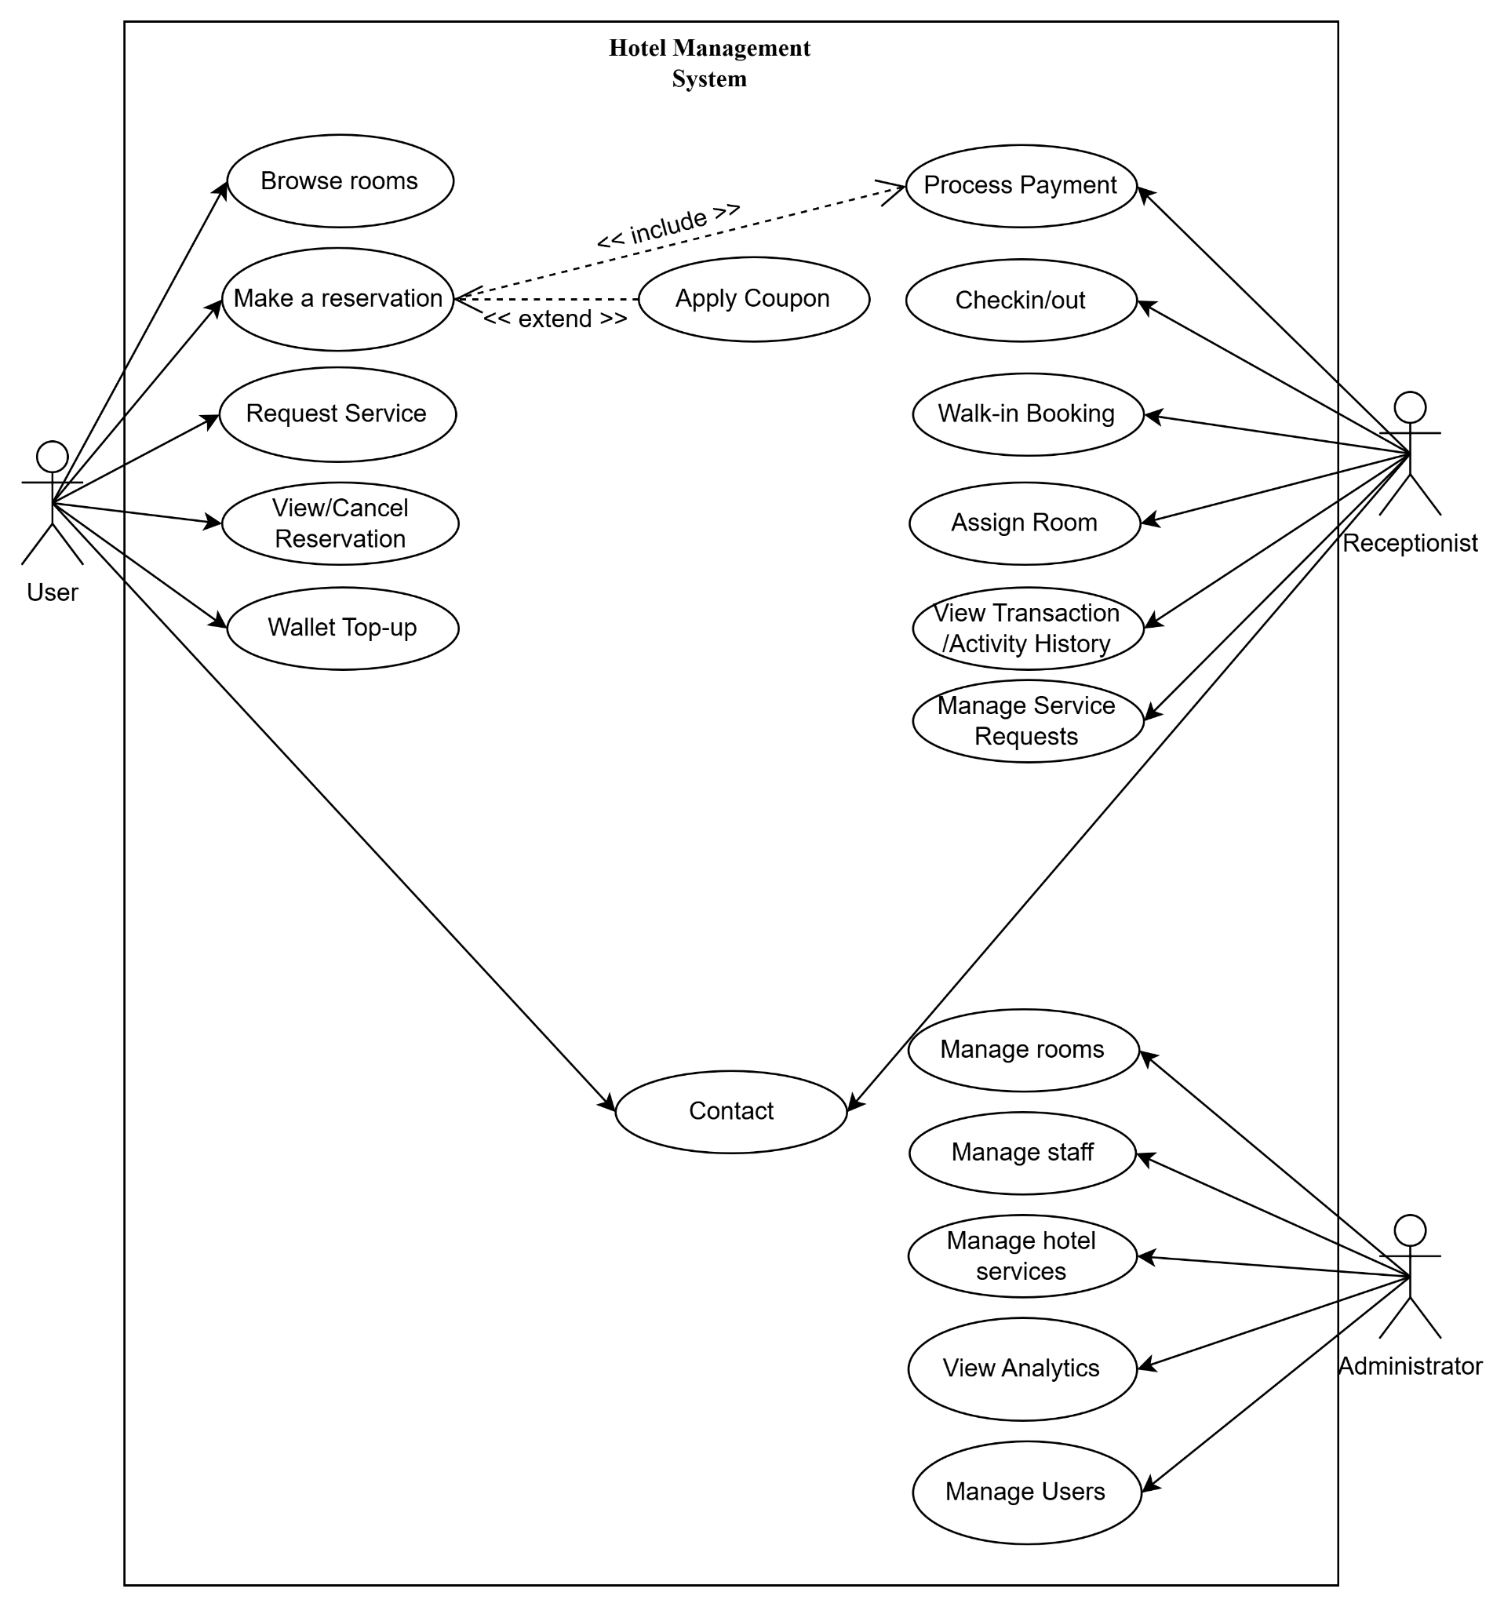

Figure 1: Use case diagram
The use case diagram describes the functional scope of the hotel management system through three main user groups and their use cases, all inside the system boundary labelled “Hotel Management System”.
Roles and functional groups
- User – left: self-service actions: browse rooms, make a reservation, request service, view/cancel reservation, and wallet top-up. Making a reservation always includes payment (Process Payment – include) and can optionally apply a discount (Apply Coupon – extend).
- Receptionist – top right: daily operations: direct payment (Process Payment), check-in/check-out (Checkin/out), walk-in booking (Walk-in Booking), assign room (Assign Room), view transaction and activity history (View Transaction/Activity History), and manage service requests (Manage Service Requests).
- Administrator – bottom right: configuration and master data: manage rooms (Manage rooms), manage staff (Manage staff), manage hotel services (Manage hotel services), view analytics (View Analytics), and manage users (Manage Users).
Overall, the diagram clarifies functional scope per role, the include/extend relationships around reservation, and the separation between self-service (guest), operations (receptionist), and configuration (administrator), making it suitable for system architecture analysis and design.

2.4.1 Interface Specification and Development UC1 – Users.
UC-01: Login
ID and Name: | UC-01: Login
Create by: | Nguyễn Hưng Thành / Date created: 6/2/2026
Primary Actor: | User (any role: user / receptionist / administrator)
Description: | This use case allows a user to authenticate with username and password to access protected features such as booking, payment, wallet, and administrative functions (depending on role).
Trigger: | User selects “Login” and submits credentials.
Preconditions: | - The user has already registered (exists in the users table).  - The backend service is running and database connection is available.
Postconditions: | 1. Success  - The system returns user information (including user_id and role) to the client.  - The client stores the returned user_id and includes it in subsequent protected API calls via HTTP header: X-User-Id: <user_id>.  2. Failure  - No authenticated context is established; protected resources remain inaccessible.
Normal flow: | 1. User opens the login page in the UI.  2. User enters username and password.  3. User clicks “Login”.  4. Client sends POST /api/auth/login with { "username": "...", "password": "..." }.  5. System validates request format.  6. System authenticates users against MySQL credentials.  7. System returns user_id and role.  8. Client stores user_id and uses X-User-Id for protected requests.
Alternative Flows: | A1 – Missing credentials → 400.  A2 – Invalid username/password → 401/400 with message “Invalid username or password.”
Exceptions: | E1 – Database connection error → 500.
Priority: | High
Frequency of Use: | Very frequent (daily)
Business rules: | - Username and password are required fields.  - Only authenticated users can access endpoints protected by @require_auth.  - Authorization is role-based (RBAC) via middleware decorators:  - Administrator: full access to admin endpoints.  - Receptionist: access to receptionist endpoints (bookings list, check-in/out, etc.).  - User: access to own bookings, payments, wallet, and service requests.

UC-02: Register
ID and Name: | UC-02: Register
Create by: | Nguyễn Hưng Thành / Date created: 6/2/2026
Primary Actor: | User (any role: user / receptionist / administrator)
Description: | This use case allows a guest to create a new user account in the system.
Trigger: | Guest submits the registration form.
Preconditions: | None.
Postconditions: | 1. Success  - A new user record is created in the users table.  2. Failure  - No user record is created.
Normal flow: | 1. Guest opens the Register page.  2. Guest enters username, email, password, full_name, phone.  3. Client sends POST /api/users with JSON body.  4. System validates input data.  5. System saves the new user to MySQL.  6. System returns created user information to client.
Alternative Flows: | A1 – Missing/invalid fields  1. Guest submits missing required fields.  2. System returns 400 with validation error.
Exceptions: | E1 – Database error  - System returns 500 if database operation fails..
Priority: | High
Frequency of Use: | Medium
Business rules: | - Required fields must not be empty.  - Username/email should be unique (if enforced by DB/repository).

UC-03: Browse Rooms (List/Search/Detail)
ID and Name: | UC-03: Browse Rooms (List/Search/Detail)
Create by: | Nguyễn Hưng Thành / Date created: 6/2/2026
Primary Actor: | User
Description: | This use case allows browsing the room catalog: list rooms, search rooms, and view room detail
Trigger: | Actor opens Rooms page or Room Detail page.
Preconditions: | None (browsing rooms is optional_auth).
Postconditions: | Room list/detail is displayed to the actor.
Normal flow: | 1. Client requests a room list via GET /api/rooms.  2. (Optional) Client searches via GET /api/rooms/search?room_type=...&status=....  3. Client views detail via GET /api/rooms/<room_id>.  4. If a room has an image_url, the client loads the image via GET /uploads/<path>.
Alternative Flows: | A1 – Room not found → 404 for GET /api/rooms/<room_id>.
Exceptions: | E1 – Database error → 500.
Priority: | High
Frequency of Use: | Very frequent
Business rules: | Current search endpoint filters by room_type and status.

UC-04: Create Booking (Reservation)
ID and Name: | UC-04: Create Booking (Reservation)
Create by: | Nguyễn Hưng Thành / Date created: 6/2/2026
Primary Actor: | User
Description: | This use case allows an authenticated user to create a booking for a room type and date range. The system checks availability, reserves a room, and persists the booking.
Trigger: | The user confirms booking details in the UI.
Preconditions: | - User is authenticated (X-User-Id is present).  - At least one room of selected type is available for the requested date range.
Postconditions: | - A booking record is created (status pending).  - A selected room is reserved (status reserved).
Normal flow: | 1. User enters guest_name, room_type, check_in_date (and optional check_out_date).  2. Client sends POST /api/bookings with required JSON and X-User-Id header.  3. System validates input and date rules.  4. System checks availability for the date range.  5. System selects a room and sets room status to reserved.  6. System saves booking to MySQL with status pending and room_id.  7. The system returns the created booking to the client.
Alternative Flows: | A1 – No available rooms → 400 with message.  A2 – Invalid date format/past date → 400.
Exceptions: | E1 – Error reserving room or saving booking → 500 (room should be released if needed).
Priority: | High
Frequency of Use: | Frequent
Business rules: | Prevent overlapping bookings by date-range availability check.

UC-05: View My Bookings
ID and Name: | UC-05: View My Bookings
Create by: | Nguyễn Hưng Thành / Date created: 6/2/2026
Primary Actor: | User
Description: | This use case allows the user to view their booking history.
Trigger: | User opens “My Bookings”.
Preconditions: | - User authenticated (X-User-Id).
Postconditions: | - A list of user bookings is returned and displayed.
Normal flow: | 1. Client sends GET /api/bookings/my with X-User-Id.  2. System returns bookings for that user.
Alternative Flows: | A1 – User not found in request context → 404.
Exceptions: | E1 – Database error → 500.
Priority: | High
Frequency of Use: | Frequent
Business rules: | Users can only view their own bookings.

UC-06: Cancel Booking (Refund if applicable)

ID and Name: | UC-06: Cancel Booking (Refund if applicable)
Create by: | Nguyễn Hưng Thành / Date created: 6/2/2026
Primary Actor: | User
Description: | This use case allows a user to cancel a booking. The system releases the reserved room and may refund wallet payments and mark payments as refunded.
Trigger: | User selects “Cancel booking”.
Preconditions: | - User authenticated.  - Booking exists and is not checked_in/checked_out/cancelled.  - No check-in record exists for this booking.
Postconditions: | 1. Success  - Booking becomes cancelled.  - Reserved room becomes available (if applicable).  - Wallet refund may be applied (if paid by wallet).  2. Failure  - Booking remains unchanged.
Normal flow: | 1. Client sends DELETE /api/bookings/<booking_id> with X-User-Id.  2. The system validates booking status and check-in constraints.  3. The system releases reserved rooms if needed.  4. System cancels booking (status cancelled).  5. (Optional) System refunds wallet payment and updates payment status to refunded.  6. The system returns a success message.
Alternative Flows: | A1 – Booking already checked_in/checked_out → 400.  A2 – Check-in record exists → 400.
Exceptions: | E1 – Database error → 500.
Priority: | Medium
Frequency of Use: | Medium
Business rules: | Cannot cancel after check-in or if check-in record exists.

UC-07: Wallet Top-up

ID and Name: | UC-07: Wallet Top-up
Create by: | Nguyễn Hưng Thành / Date created: 6/2/2026
Primary Actor: | User
Description: | This use case allows a user to add money to their internal wallet.
Trigger: | User submits a top-up amount.
Preconditions: | - User authenticated.
Postconditions: | 1. Success  - Wallet balance increases by the amount.  2. Failure  - Wallet balance unchanged.
Normal flow: | 1. Client sends POST /api/wallet/topup with { "amount": ... } and X-User-Id.  2. System validates amount > 0 and numeric.  3. System updates wallet balance in MySQL.  4. System returns updated wallet.
Alternative Flows: | A1 – amount invalid/<=0 → 400.
Exceptions: | E1 – Database error → 500.
Priority: | Medium
Frequency of Use: | Medium
Business rules: | Amount must be numeric and > 0.

UC-08: View Wallet Balance

ID and Name: | UC-08: View Wallet Balance
Create by: | Nguyễn Hưng Thành / Date created: 6/2/2026
Primary Actor: | User
Description: | This use case allows an authenticated user to view wallet balance. If wallet does not exist, it is auto-created.
Trigger: | User opens Wallet page.
Preconditions: | - User authenticated (X-User-Id).
Postconditions: | 1. Success  - Wallet object (balance) is returned to the client.  2. Failure  - Wallet is not returned.
Normal flow: | 1. Client sends GET /api/wallet with X-User-Id.  2. System finds wallet by user_id; if missing, creates wallet with balance 0.  3. System returns wallet object.
Alternative Flows: | A1 – Missing authentication header → 401.
Exceptions: | E1 – Database error → 500.
Priority: | Medium
Frequency of Use: | Medium
Business rules: | - Wallet belongs to the authenticated user only.

UC-09: Process Payment

ID and Name: | UC-09: Process Payment
Create by: | Nguyễn Hưng Thành / Date created: 6/2/2026
Primary Actor: | User
Description: | This use case allows an authenticated user to pay for a booking using supported methods (wallet, cash, bank_transfer, credit_card) and records a payment transaction.
Trigger: | User clicks “Pay” on the payment page for a booking.
Preconditions: | - User authenticated (X-User-Id).  - Booking exists and is not cancelled.
Postconditions: | 1. Success  - A payment record is created (status completed).  - If payment_method = wallet, wallet balance is deducted accordingly.  2. Failure  - No completed payment is recorded; wallet balance unchanged.
Normal flow: | 1. Client sends POST /api/payments with { booking_id, amount, payment_method, optional transaction_id } and X-User-Id.  2. System validates amount > 0, payment_method is allowed, and booking exists.  3. If wallet payment: system checks balance and deducts.  4. System saves payment in MySQL and returns payment result.
Alternative Flows: | A1 – Invalid amount/method → 400.  A2 – Wallet insufficient balance → 400.  A3 – Booking not found → 404/400.
Exceptions: | E1 – Database error → 500.
Priority: | High
Frequency of Use: | Frequent
Business rules: | - Payment must be tied to booking_id and user_id (from X-User-Id context).

UC-10: Apply Coupon

ID and Name: | UC-10: Apply Coupon
Create by: | Nguyễn Hưng Thành / Date created: 6/2/2026
Primary Actor: | User
Description: | This use case validates a coupon code and returns coupon details so the frontend can compute the discount for booking/payment.
Trigger: | User enters a coupon code and clicks “Apply”.
Preconditions: | - User authenticated (X-User-Id).  - Coupon exists in database.
Postconditions: | 1. Success  - Coupon details are returned (discount_type, discount_value, validity).  2. Failure  - Coupon is rejected with a validation error.
Normal flow: | 1. Client sends POST /api/coupons/apply with { code } and X-User-Id.  2. System loads coupon by code and validates: active status + valid date range.  3. System returns coupon information to the client.
Alternative Flows: | A1 – Coupon code not found → 400.  A2 – Coupon inactive/expired/not yet valid → 400.
Exceptions: | E1 – Database error → 500.
Priority: | Medium
Frequency of Use: | Medium
Business rules: | - Coupon must be active and within valid_from/valid_to.

UC-11: Service Request

ID and Name: | UC-11: Service Request
Create by: | Nguyễn Hưng Thành / Date created: 6/2/2026
Primary Actor: | User
Description: | This use case allows an authenticated user to request additional hotel services during a stay (e.g., dining, laundry) for a booking.
Trigger: | User selects a service and submits a request.
Preconditions: | - User authenticated (X-User-Id).  - Booking exists.  - Service exists and is available.
Postconditions: | 1. Success  - A service_requests record is created with status pending.  2. Failure  - No service request is created.
Normal flow: | 1. Client sends POST /api/services/request with { booking_id, service_id, quantity } and X-User-Id.  2. System validates booking and service existence and quantity > 0.  3. System creates the service request in MySQL and returns the created request.
Alternative Flows: | A1 – Invalid quantity or missing fields → 400.  A2 – Booking/service not found → 404/400.
Exceptions: | E1 – Database error → 500.
Priority: | Medium
Frequency of Use: | Medium
Business rules: | - Service request is linked to a booking and may be included in checkout total.

UC-12: Contact with Receptionist/Admin

ID and Name: | UC-12: Contact with Receptionist/Admin
Create by: | Nguyễn Hưng Thành / Date created: 6/2/2026
Primary Actor: | User
Description: | This use case allows a user to contact the receptionist or administrator (e.g., to request services or ask for more information about rooms) via the Contact/Support pages. Messages are exchanged through the in-app chat UI , conversation state is stored client-side (e.g., localStorage) in the current implementation.
Trigger: | User opens the Contact page and sends a message.
Preconditions: | - User authenticated (X-User-Id).
Postconditions: | 1. Success  - User’s message is stored and visible to staff in the admin-messages view.  2. Failure  - Message is not delivered or not visible (e.g., client-side storage full).
Normal flow: | 1. User navigates to Contact/Support  2. User types a message in the chat input and submits.  3. Client stores the message and updates the UI.  4. Receptionist/Admin can view and reply.
Alternative Flows: | A1 – User not logged in: some implementations may still allow sending a message with a guest identifier.
Exceptions: | E1 – Client-side storage failure → message may not persist.
Priority: | Medium
Frequency of Use: | Medium
Business rules: | - Contact is implemented as client-side chat; no backend API is required for the current design.

2.4.2 Interface Specification and Development UC2 – Receptionist.
UC-13: View All Bookings

ID and Name: | UC-13: View All Bookings
Create by: | Nguyễn Hưng Thành / Date created: 6/2/2026
Primary Actor: | Receptionist
Description: | This use case allows receptionists to view all bookings for daily operations.
Trigger: | Receptionist opens booking management screen.
Preconditions: | - Receptionist authenticated and has receptionist/admin role.
Postconditions: | - System returns the booking list.
Normal flow: | 1. Client sends GET /api/bookings with X-User-Id.  2. System authorizes role (receptionist/admin).  3. System returns bookings.
Alternative Flows: | A1 – Access denied (wrong role) → 403.
Exceptions: | E1 – Database error → 500.
Priority: | High
Frequency of Use: | Frequent
Business rules: | - Only receptionist/admin can access this endpoint.

UC-14: Walk-in Booking

ID and Name: | UC-14: Walk-in Booking
Create by: | Nguyễn Hưng Thành / Date created: 6/2/2026
Primary Actor: | Receptionist
Description: | This use case allows receptionists to confirm a booking for walk-in guests at the counter.
Trigger: | Receptionist enters guest information and booking details.
Preconditions: | - Receptionist authenticated.  - At least one room is available for the requested dates and room_type.
Postconditions: | 1. Success  - A booking is created (status pending) and a room is reserved.  2. Failure  - Booking is not created.
Normal flow: | 1. Receptionist inputs guest_name, room_type, check_in_date, optional check_out_date.  2. Client sends POST /api/bookings with booking JSON and X-User-Id (receptionist).  3. System validates input and checks availability (date-range overlap prevention).  4. System reserves a room and saves booking in MySQL.
Alternative Flows: | A1 – No available rooms → 400.  A2 – Invalid dates → 400.
Exceptions: | E1 – Database error → 500.
Priority: | High
Frequency of Use: | Medium
Business rules: | - Walk-in booking uses the same booking creation logic as online booking.

UC-15: Assign Room to Booking

ID and Name: | UC-15: Assign Room to Booking
Create by: | Nguyễn Hưng Thành / Date created: 6/2/2026
Primary Actor: | Receptionist
Description: | This use case allows receptionists to assign a room to a booking.
Trigger: | Receptionist selects a booking and assigns a room.
Preconditions: | - Receptionist authenticated.  - Booking exists.  - Room exists and is not occupied.
Postconditions: | - Booking is updated with room_id.  - Room status may be updated based on rules.
Normal flow: | 1. Receptionist chooses booking_id and room_id.  2. Client sends POST /api/rooms/assign with { room_id, booking_id } and X-User-Id.  3. System validates room and booking.  4. System updates booking and room state.  5. System returns assigned room info.
Alternative Flows: | A1 – Room not found or occupied → 400/404.  A2 – Booking not found → 404.
Exceptions: | E1 – Database error → 500.
Priority: | High
Frequency of Use: | Medium
Business rules: | - Cannot assign an occupied room.

UC-16: Process Check-in

ID and Name: | UC-16: Process Check-in
Create by: | Nguyễn Hưng Thành / Date created: 6/2/2026
Primary Actor: | Receptionist
Description: | This use case allows receptionists to check in a guest for a booking and create a check-in record.
Trigger: | Receptionist confirms check-in for a booking.
Preconditions: | - Receptionist authenticated.  - Booking exists.  - Booking not already checked in; no existing check-in record.
Postconditions: | - Check-in record is created in MySQL.  - Booking and room statuses are updated accordingly.
Normal flow: | 1. Receptionist inputs booking_id (and optional room_id).  2. Client sends POST /api/checkins with JSON body and X-User-Id.  3. System validates booking and receptionist role.  4. System creates check-in record.  5. System updates booking status to checked_in and room status to occupied.  6. System returns check-in information.
Alternative Flows: | A1 – Existing check-in already exists → 400.  A2 – No available room for booking type → 400.
Exceptions: | E1 – Database error → 500.
Priority: | High
Frequency of Use: | Frequent
Business rules: | - A booking can be checked in only once.

UC-17: Process Check-out

ID and Name: | UC-17: Process Check-out
Create by: | Nguyễn Hưng Thành / Date created: 6/2/2026
Primary Actor: | Receptionist
Description: | This use case allows receptionists to check out a guest, calculate total charges (room + services), and create a checkout record.
Trigger: | Receptionist confirms checkout for a booking.
Preconditions: | - Receptionist authenticated.  - A check-in exists for the booking.
Postconditions: | 1. Success  - Checkout record is created.  - Booking status becomes checked_out and room status becomes available.  2. Failure  - No checkout record is created; states unchanged.
Normal flow: | 1. Receptionist requests summary via GET /api/checkouts/summary/<booking_id>.  2. System calculates total (booking.total_price + service_requests totals).  3. Receptionist sends POST /api/checkouts with { booking_id, total_amount, receptionist_id, optional checkout_time }.  4. System validates check-in exists and saves checkout record; updates booking/room status.
Alternative Flows: | A1 – No check-in exists → 400.
Exceptions: | E1 – Database error → 500.
Priority: | High
Frequency of Use: | Frequent
Business rules: | - Cannot check out without a prior check-in.

UC-18: View Transaction & Activity History

ID and Name: | UC-18: View Transaction & Activity History
Create by: | Nguyễn Hưng Thành / Date created: 6/2/2026
Primary Actor: | Receptionist
Description: | This use case allows receptionists to view historical records of bookings, payments, and service requests for operations and auditing.
Trigger: | Receptionist opens history dashboards (bookings, payments, service requests).
Preconditions: | - Receptionist authenticated with receptionist/admin role.
Postconditions: | - Lists are returned for display.
Normal flow: | 1. Receptionist views bookings via GET /api/bookings.  2. Receptionist views payments via GET /api/payments.  3. Receptionist views service requests via GET /api/service-requests.
Alternative Flows: | A1 – Access denied → 403.
Exceptions: | E1 – Database error → 500.
Priority: | High
Frequency of Use: | Frequent
Business rules: | - Only receptionist/admin can access global histories.

UC-19: Manage Service Requests

ID and Name: | UC-19: Manage Service Requests
Create by: | Nguyễn Hưng Thành / Date created: 6/2/2026
Primary Actor: | Receptionist
Description: | This use case allows receptionists to view all service requests and update each request status (pending, in_progress, completed, cancelled).
Trigger: | Receptionist selects a service request and updates its status.
Preconditions: | - Receptionist authenticated with receptionist/admin role.
Postconditions: | 1. Success  - Service request status is updated in MySQL.  2. Failure  - Status unchanged.
Normal flow: | 1. Receptionist loads all requests via GET /api/service-requests.  2. Receptionist selects a request and sends PUT /api/service-requests/<request_id> with { status, optional notes }.  3. System validates status and updates the record; returns updated request.
Alternative Flows: | A1 – Invalid status → 400.  A2 – Request not found → 404.
Exceptions: | E1 – Database error → 500.
Priority: | High
Frequency of Use: | Frequent
Business rules: | - Status must be one of: pending, in_progress, completed, cancelled.

UC-20: Contact with Guest

ID and Name: | UC-20: Contact with Guest
Create by: | Nguyễn Hưng Thành / Date created: 6/2/2026
Primary Actor: | Receptionist
Description: | This use case allows the receptionist or administrator to view guest messages and reply to them through the contact/support channels. Staff use the admin-messages page to see conversations and send replies; messages are stored client-side (e.g., localStorage) and synced so the guest can see replies when they reopen the Contact page.
Trigger: | Receptionist/Admin opens the Contact/Messages management page (admin-messages.html) and replies to a guest.
Preconditions: | - Receptionist or Admin is authenticated (X-User-Id with role receptionist or administrator).  - At least one guest has sent a message (stored in chat data).
Postconditions: | 1. Success  - Staff reply is stored and associated with the guest conversation; guest can see it when viewing the chat.  2. Failure  - Reply is not stored or not visible to guest (e.g., client-side error).
Normal flow: | 1. Staff opens admin-messages.html and selects a guest/conversation from the list.  2. Staff views the message history (messages loaded from localStorage).  3. Staff types a reply and submits; client appends the message to the conversation and updates localStorage.  4. Guest can see the reply when they next open the Contact page or refresh the chat.
Alternative Flows: | A1 – No conversations yet → empty state is shown.
Exceptions: | E1 – Client-side storage or script error → reply may not persist.
Priority: | High
Frequency of Use: | Frequent
Business rules: | - Implemented in SRC/UI; no backend API; data is stored in browser localStorage.

2.4.3 Interface Specification and Development UC3 – Administrator.
UC-21: Manage Rooms (CRUD)

ID and Name: | UC-21: Manage Rooms (CRUD)
Create by: | Nguyễn Hưng Thành / Date created: 6/2/2026
Primary Actor: | Administrator
Description: | This use case allows administrators to create, update, and delete rooms, including changing room status and managing room capacity and images.
Trigger: | Admin performs room management operations from admin UI.
Preconditions: | Admin authenticated with administrator role.
Postconditions: | 1. Success  - Room records are created/updated/deleted in MySQL.  2. Failure  - No changes are applied.
Normal flow: | 1. Admin creates a room via POST /api/rooms.  2. Admin updates room fields via PUT /api/rooms/<room_id>.  3. Admin deletes a room via DELETE /api/rooms/<room_id>.
Alternative Flows: | A1 – Cannot delete room with check-in history → 400.  A2 – Invalid room data (price <= 0, capacity <= 0) → 400.
Exceptions: | E1 – Database error → 500.
Priority: | High
Frequency of Use: | Medium
Business rules: | - Only administrator can create/update/delete rooms.  - Room price must be positive; capacity (if provided) must be positive.

UC-22: View Analytics

ID and Name: | UC-22: View Analytics
Create by: | Nguyễn Hưng Thành / Date created: 6/2/2026
Primary Actor: | Administrator
Description: | This use case allows administrators to view analytics (revenue, occupancy, booking) and store them.
Trigger: | Admin requests a report for a given period.
Preconditions: | - Admin authenticated with administrator role.
Postconditions: | 1. Success  - A report record is created and stored in reports table.  2. Failure  - No report is stored.
Normal flow: | 1. Admin requests revenue report via POST /api/reports/revenue (with optional dates).  2. System aggregates payment/booking data.  3. System saves report and returns report object.  4. Admin may repeat for occupancy and booking reports.
Alternative Flows: | A1 – Invalid date range input → 400.
Exceptions: | E1 – Database error during aggregation/save → 500.
Priority: | Medium
Frequency of Use: | Medium
Business rules: | - Only administrator can generate reports.

UC-23: Manage Staff Accounts (CRUD)

ID and Name: | UC-23: Manage Staff Accounts (CRUD)
Create by: | Nguyễn Hưng Thành / Date created: 6/2/2026
Primary Actor: | Administrator
Description: | This use case allows administrators to create, update, and delete staff records.
Trigger: | Admin performs staff management operations from admin UI.
Preconditions: | - Admin authenticated with administrator role.
Postconditions: | 1. Success  - Staff records are created/updated/deleted in MySQL.  2. Failure  - No changes are applied.
Normal flow: | 1. Admin creates staff via POST /api/staff.  2. Admin updates staff via PUT /api/staff/<staff_id>.  3. Admin deletes staff via DELETE /api/staff/<staff_id>.
Alternative Flows: | A1 – Invalid staff data (missing full_name/email, invalid email format) → 400.
Exceptions: | E1 – Database error → 500.
Priority: | High
Frequency of Use: | Medium
Business rules: | - Staff email must be unique.

UC-24: Manage Users Accounts (CRUD)

ID and Name: | UC-24: Manage Users Accounts (CRUD)
Create by: | Nguyễn Hưng Thành / Date created: 6/2/2026
Primary Actor: | Administrator
Description: | This use case allows administrators to list, update, and delete user accounts.
Trigger: | Admin performs user management from admin UI.
Preconditions: | - Admin authenticated with administrator role.
Postconditions: | 1. Success  - User records are updated/deleted in MySQL.  2. Failure  - No changes are applied.
Normal flow: | 1. Admin lists users via GET /api/users.  2. Admin updates a user via PUT /api/users/<user_id>.  3. Admin deletes a user via DELETE /api/users/<user_id>.
Alternative Flows: | A1 – User not found → 404.  A2 – Invalid update data (duplicate email/invalid role) → 400.
Exceptions: | E1 – Database error → 500.
Priority: | High
Frequency of Use: | Medium
Business rules: | - Only admin can manage users list and roles.

UC-25: Manage Services (CRUD)

ID and Name: | UC-25: Manage Services (CRUD)
Create by: | Nguyễn Hưng Thành / Date created: 6/2/2026
Primary Actor: | Administrator
Description: | This use case allows administrators to create, update, and delete hotel services (spa, dining, laundry, etc.).
Trigger: | Admin updates the service catalog.
Preconditions: | - Admin authenticated with administrator role.
Postconditions: | 1. Success  - Service catalog is updated in MySQL.  2. Failure  - No changes are applied.
Normal flow: | 1. Admin creates a service via POST /api/services.  2. Admin updates a service via PUT /api/services/<service_id>.  3. Admin deletes a service via DELETE /api/services/<service_id>.
Alternative Flows: | A1 – Invalid service data (price <= 0) → 400.
Exceptions: | E1 – Database error → 500.
Priority: | Medium
Frequency of Use: | Medium
Business rules: | - Service price must be positive.

2.4.4 Description of Layers

Layer | Purpose/Responsibility | Output/Artifact
1. Presentation Layer (UI) | Handles HTTP requests, user authentication, session management, and renders the user interface. It ensures the separation of the frontend (HTML/CSS) from the backend logic. | Controllers (e.g., room_controller.py, booking_controller.py,...), Templates (HTML views), Views (JSON), HTML/CSS/JS in SRC/UI.
2. Business Logic Layer (Service) | Contains the core business rules, validation logic, and transaction management. It orchestrates data access and handles integrations with external systems (like the internal payment). | Services (e.g., booking_service.py, payment_service.py, room_service.py,...).
3. Persistence Layer (Data Access) | Responsible for mapping business objects to database entities and executing CRUD (Create, Read, Update, Delete) operations. It abstracts the database queries from the business logic. | Repositories/DAOs (e.g., booking_repository.py, room_repository.py,...).
4. Data Layer | The physical database storage system where all application data is persisted. | Database Schema (MySQL), Tables (users, rooms, bookings, payments, wallets, …).

3. Architectural Design & Implementation

3.1 Architectural Pattern & Layers
The backend follows a layered architecture on top of Flask:

- Presentation/API Layer – Controllers (SRC/Arch/controllers): booking_controller.py, room_controller.py, user_controller.py, service_controller.py, payment_controller.py, coupon_controller.py, checkin_controller.py, staff_controller.py, report_controller.py, wallet_controller.py.

These classes receive HTTP requests (via routes defined in app.py), parse and validate incoming JSON, call appropriate service methods, and use View classes (e.g. booking_view.py) to format the JSON responses.

- Business Layer – Services (SRC/Arch/services):
- booking_service.py handles booking lifecycle: create_booking, update_booking, cancel_booking, get_user_bookings. It validates input, checks dates, consults room_service.py for availability, interacts with room_repository.py to reserve rooms, and optionally triggers payment_service.py for immediate payment.
- coupon_service.py validates coupon creation and apply_coupon logic, enforcing rules on discount types, values, and validity dates.
- Additional services such as room_service.py, payment_service.py, checkin_service.py (if present), report_service.py, staff_service.py, user_service.py, and wallet_service.py encapsulate domain logic for their respective areas.

- Data Access Layer – Repositories (SRC/Arch/repository):
- booking_repository.py implements CRUD operations on the bookings table using mysql.connector, with methods like save, find_by_id, find_all, find_by_user_id, find_by_room_id, find_available_rooms_by_date_range, update, and delete. The method find_available_rooms_by_date_range includes SQL logic to exclude rooms with overlapping active bookings.
- Similar repository classes exist for rooms, check-ins, coupons, payments, service requests, staff, users, and wallets.

- Domain Model Layer – Models (SRC/Arch/models)
- Classes such as booking.py, room.py, user.py, staff.py, service.py, coupon.py, checkin.py, payment.py, wallet.py, report.py represent database entities in Python.
- Booking model instances are constructed from DB rows in booking_repository.py/BookingRepository._row_to_booking.

- Middleware and Utilities
- middleware/auth.py provides decorators (require_auth, require_admin, require_receptionist_or_admin, require_role, optional_auth) that wrap endpoints to enforce authentication and authorization.
- utils/image_handler.py handles image uploads for room images and returns file paths in SRC/uploads/rooms, which are later served by the /uploads route in app.py.

The frontend under SRC/UI is structured by roles and pages (admin, auth, public, user), and communicates with the backend via REST APIs using JavaScript.
C4 Level 1
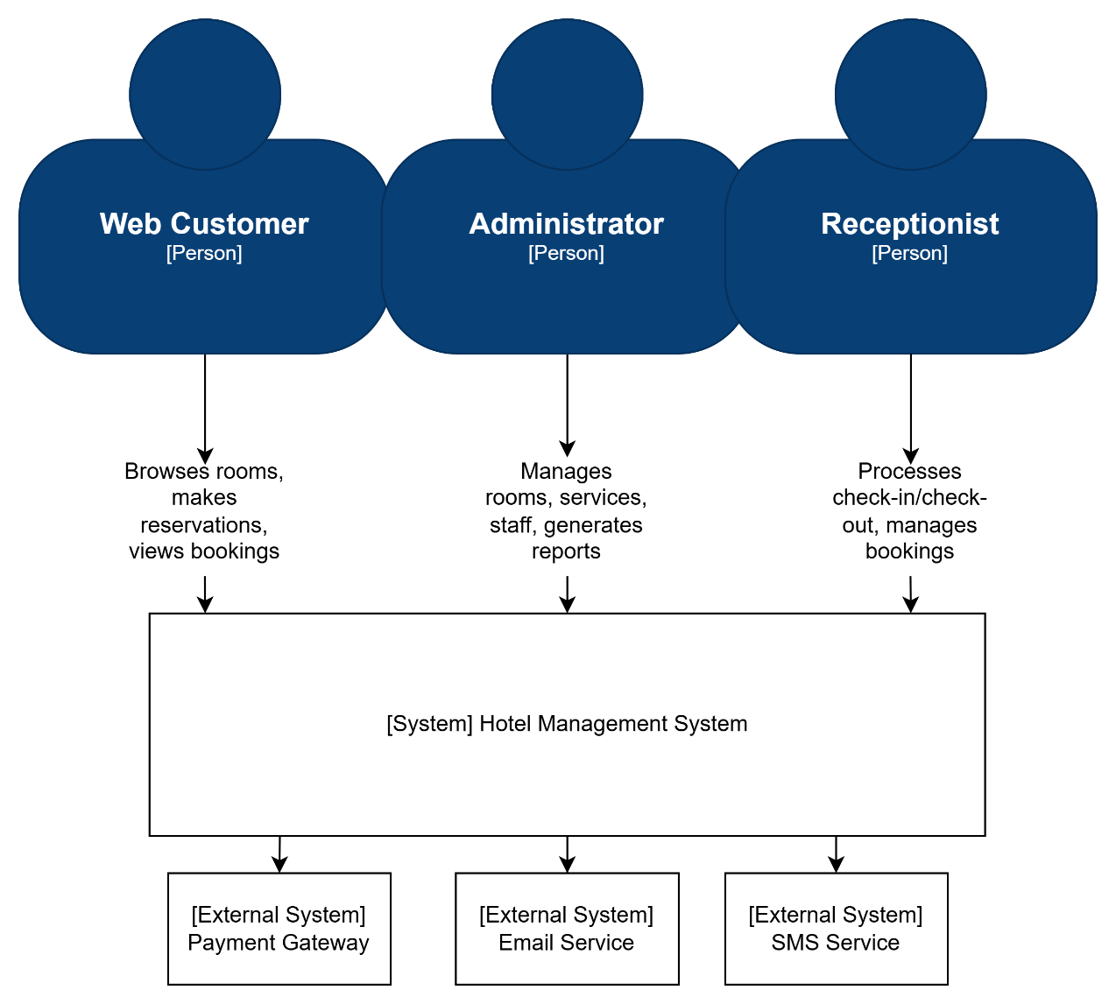

Figure 2: C4 lv 1 Diagram
At the center of the model is the Hotel Management System, a single Flask-based monolithic backend with a static web UI. Around this system boundary are three primary human actors:
- Web Customer: browses rooms, creates and manages bookings, performs payments, manages wallet balance, and submits service requests or contact messages.
- Receptionist: manages daily hotel operations such as check-in/check-out, walk‑in bookings, room assignment, and monitoring of transactions and service requests.
- Administrator: manages room inventory, services, staff accounts, user accounts, and analytical reports.
All interactions from these actors go through the web browser UI into the monolithic backend, which in turn persists state in a single MySQL database. External services such as third‑party payment gateways or email providers are considered future integrations but are not part of the current implementation.
C4 Level 2 - Container Diagram
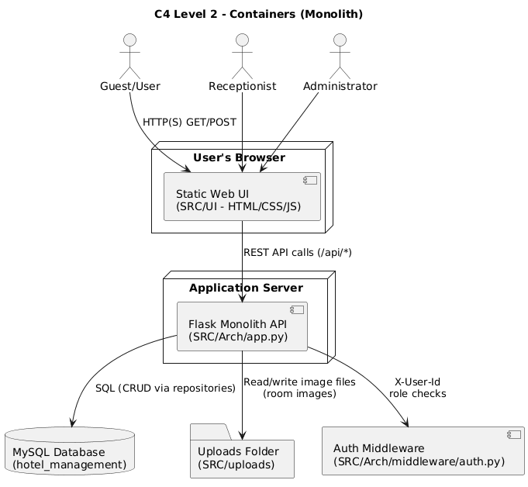

Figure 3: C4 lv 2 - Container Diagram
At the container level, the Hotel Management System is decomposed into three main containers:
- Web Browser (Static Web UI – SRC/UI): HTML/CSS/JavaScript pages grouped by role (public, auth, user, admin, receptionist). JavaScript (notably api.js) calls backend APIs under /api/ and renders booking, wallet, payment, and management screens.
- Flask Monolith API (SRC/Arch): a single Flask application (app.py) exposing REST‑style JSON endpoints for rooms, bookings, payments, coupons, wallet, service requests, staff, reports, and authentication. It implements all business rules and orchestrates database access.
- MySQL Database: the relational store for users, rooms, bookings, payments, wallets, coupons, service requests, staff, and reports, configured via SRC/Arch/db_config.py.
Static file storage for uploaded room images (SRC/uploads/rooms) is also modeled as an infrastructure container, served via the /uploads/<filename> route from the Flask monolith. The browser communicates only with the Flask API and /uploads/; the API is the single integration point to MySQL and the uploads storage.
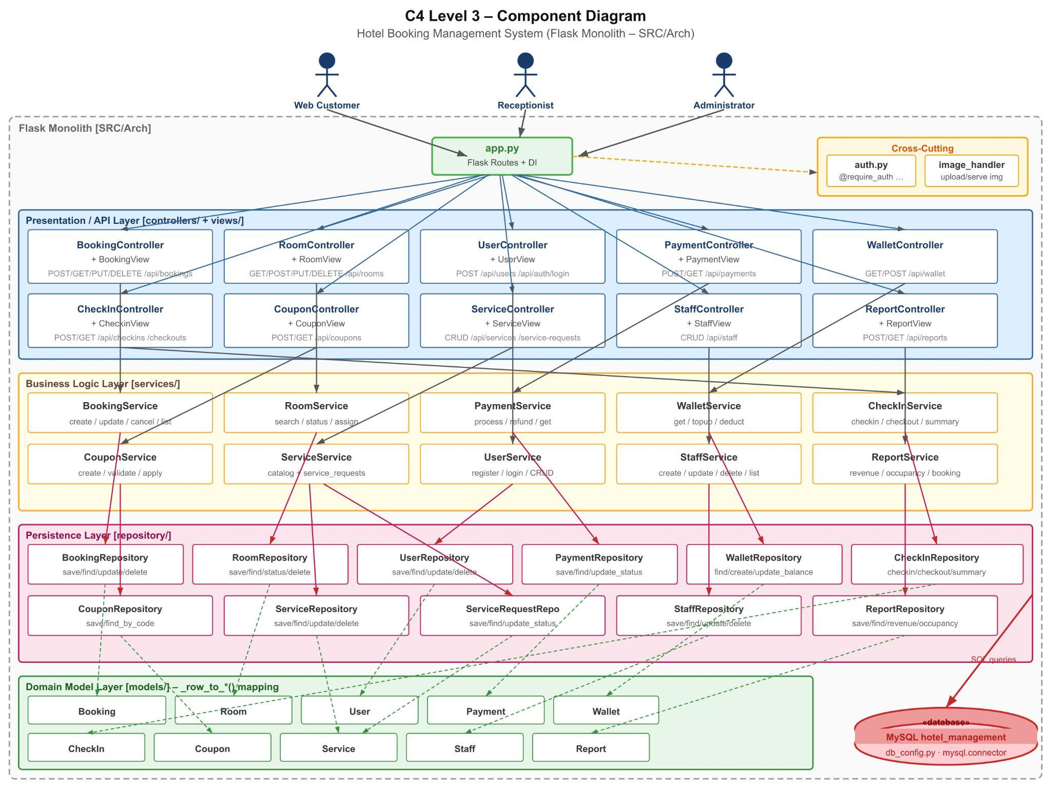
C4 Level 3 - Components Diagram

Figure 4: C4 lv 3 - Components Diagram

Inside the Flask monolith, the main components are organized into layers:
- Routing / Entry Point: app.py defines Flask routes and wires them to controller methods. It also applies authentication/authorization decorators from middleware/auth.py.
- Controllers (SRC/Arch/controllers): one controller per domain (e.g., booking_controller.py, room_controller.py, user_controller.py, payment_controller.py, coupon_controller.py, checkin_controller.py, staff_controller.py, report_controller.py, wallet_controller.py, service_controller.py). Controllers parse HTTP requests, perform basic validation, and delegate to services.
- Views (SRC/Arch/views): view classes (e.g., booking_view.py, room_view.py, payment_view.py) format domain objects and errors into consistent JSON responses.
- Services (SRC/Arch/services): business‑logic components such as booking_service.py, room_service.py, payment_service.py, wallet_service.py, coupon_service.py, service_service.py, checkin_service.py, staff_service.py, report_service.py, and user_service.py. They implement booking lifecycle, availability checks, payment and refund rules, wallet updates, coupon validation, reporting, and staff/user/service management.
- Repositories (SRC/Arch/repository): data‑access components (booking_repository.py, room_repository.py, user_repository.py, payment_repository.py, wallet_repository.py, coupon_repository.py, service_repository.py, service_request_repository.py, staff_repository.py, checkin_repository.py, report_repository.py) wrapping SQL queries against MySQL.
- Domain Models (SRC/Arch/models): entity classes such as booking.py, room.py, user.py, staff.py, service.py, coupon.py, checkin.py, payment.py, wallet.py, and report.py.
- Cross‑cutting components: authentication/authorization middleware in middleware/auth.py (decorators like require_auth, require_admin, require_receptionist_or_admin) and the image upload handler in utils/image_handler.py used by room management.

C4 Level 4 - Code view Diagram
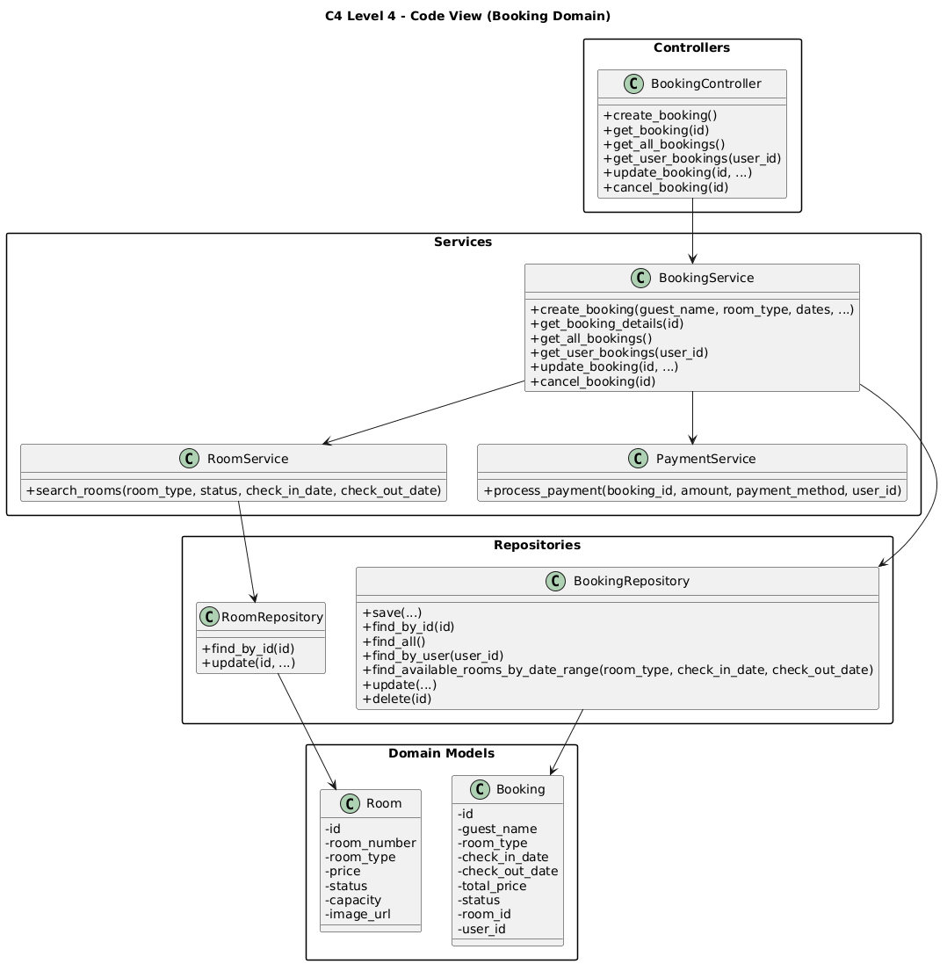
Figure 5: C4 lv 4 - Code view booking domain Diagram
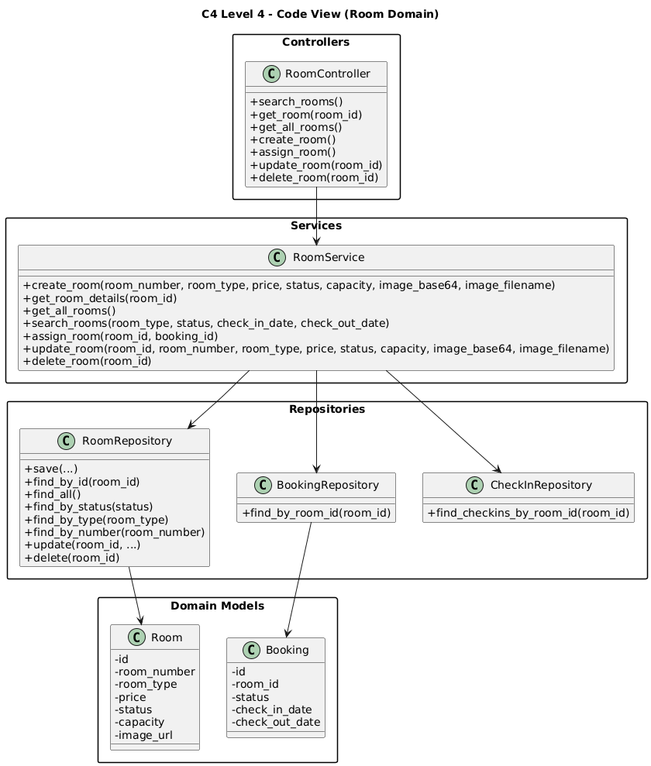
Figure 6: C4 lv 4 - Code view room domain Diagram

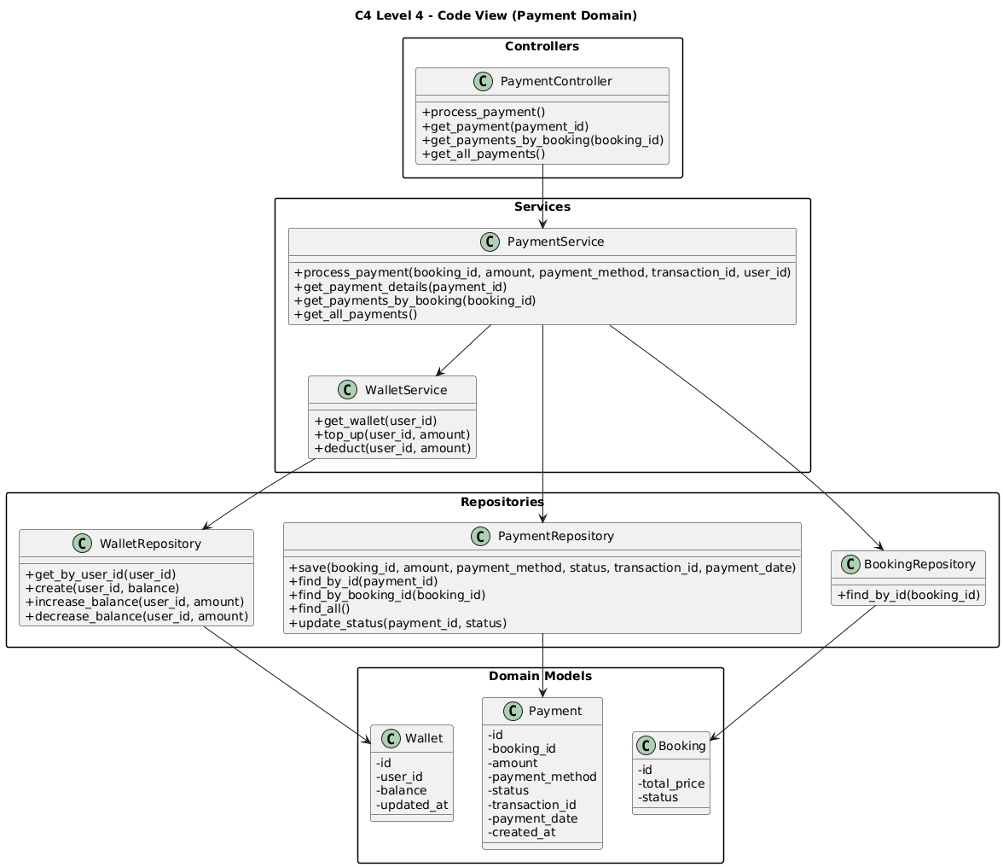

Figure 7: C4 lv 4 - Code view payment domain Diagram
At the code level, each component family is realized by a consistent set of Python modules and classes:
- Routes and composition: SRC/Arch/app.py imports all controllers, registers Flask routes (e.g., /api/bookings, /api/rooms, /api/payments), and applies middleware decorators. This file is the concrete entry point shown in the code‑level diagram.
- Domain slices: for each domain (booking, room, payment, wallet, coupon, service requests, staff, reports, users, check‑in/out) there is a cohesive group of modules following the pattern: controllers/<domain>_controller.py ↔ services/<domain>_service.py ↔ repository/<domain>_repository.py ↔ models/<Domain>.py ↔ views/<domain>_view.py. For example, booking_controller.py, booking_service.py, booking_repository.py, booking.py, and booking_view.py together implement the booking slice.
- Infrastructure code: db_config.py configures MySQL connections; middleware/auth.py implements authentication and RBAC; utils/image_handler.py handles file uploads; SRC/UI/js/api.js encapsulates frontend HTTP calls to the backend.

This code‑level perspective makes it clear how the high‑level C4 components map directly to concrete packages, modules, and classes in the repository, and supports the architectural goals described in the ASRs (modifiability, maintainability, performance, and security).

3.2 Technical Stack and Data Model
Technical Stack:
- Backend Framework: Flask (Python) – used to define routes in app.py and integrate controllers, services, and middleware.
- CORS: flask_cors.CORS configured to allow frontend (likely served from a different origin) to access /api/ and /uploads/.
- Database: MySQL, configured via SRC/Arch/db_config.py. The DatabaseConfig class uses environment variables (DB_HOST, DB_PORT, DB_NAME, DB_USER, DB_PASSWORD) loaded from .env to create connections using mysql.connector.
- Data Access Pattern: Repositories use explicit SQL queries to interact with tables. For example, BookingRepository.save inserts into bookings and returns a Booking object.
- Frontend: Static HTML/CSS/JS in SRC/UI (index.html, rooms.html, room-detail.html, auth/login.html, auth/register.html, user/dashboard.html, user/my-bookings.html, user/payment.html, user/wallet.html, admin/admin.html, admin/receptionist.html, etc.).
- Static & Uploaded Content: SRC/UI/images contains UI images; SRC/uploads/rooms stores uploaded room images. app.py serves uploaded files via the /uploads/<path:filename> route (e.g., /uploads/rooms/<image>.jpg)..

Data Model:
- Room: id, room_number, room_type, price, status, capacity, image_url.
- Booking: id, user_id, guest_name, room_type, room_id, check_in_date, check_out_date, total_price, status, created_at, updated_at.
- User: id, name, email, password_hash, role (user, receptionist, admin), etc.
- Payment: id, booking_id, user_id, amount, payment_method (cash, wallet, etc.), status (pending, completed, refunded), created_at.
- Wallet: id, user_id, balance, created_at, updated_at.
- Coupon: id, code, discount_type (percentage/fixed_amount), discount_value, valid_from, valid_to, is_active.
- CheckIn: id, booking_id, room_id, check_in_time, check_out_time, status.
- Report: id, type (revenue/occupancy/booking), parameters (e.g., date range), generated_at, content/summary fields.

3.2.1 Data Relationships
ER Diagram

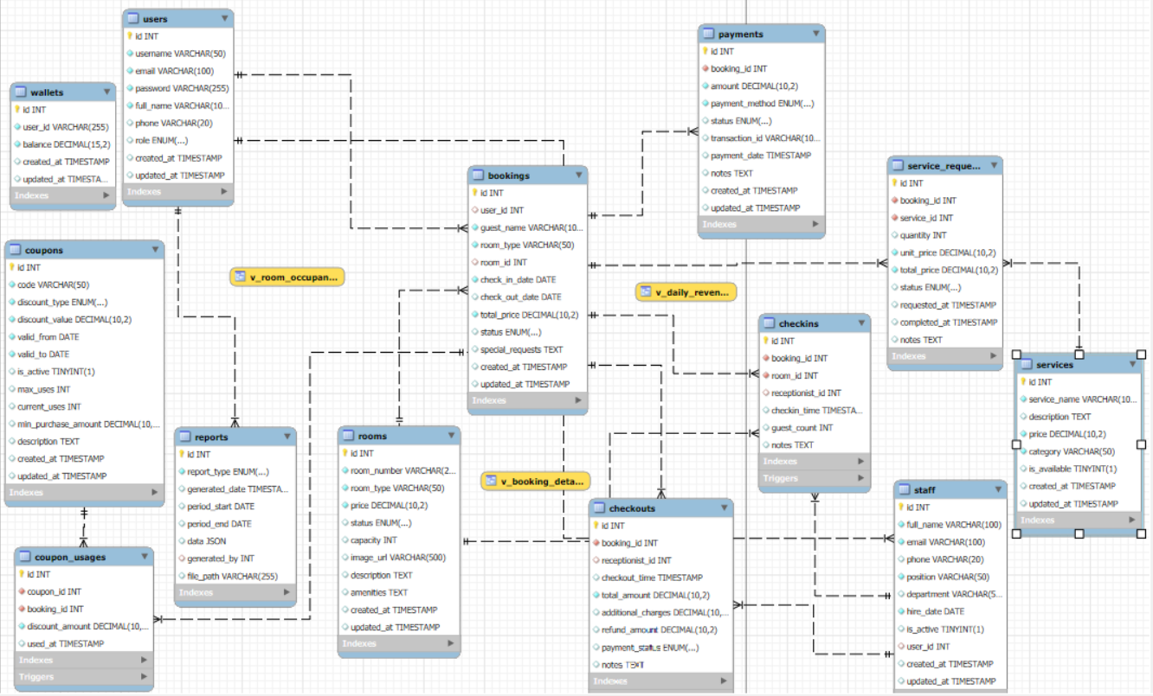

Figure 8: ER Diagram

Users table:
ID | Data Object | Field name | Description | Unique? | Data type | Length | Req’d?
US1 | users | id | User auto-increment ID | Y | int | 11 | Y
US2 | users | username | Login ID | Y | varchar | 50 | Y
US3 | users | email | User's Email | Y | varchar | 100 | Y
US4 | users | password | Encrypted password | N | varchar | 255 | Y
US5 | users | full_name | User’s full name | N | varchar | 100 | Y
US6 | users | phone | User’s phone number | N | varchar | 20 | N
US7 | users | role | User role | N | enum | – | Y
US8 | users | created_at | Created at | N | timestamp | – | Y
US9 | users | updated_at | Updated at | N | timestamp | – | Y

Staff table:
ID | Data Object | Field name | Description | Unique? | Data type | Length | Req’d?
ST1 | staff | id | Staff ID | Y | int | 11 | Y
ST2 | staff | full_name | Staff’s full name | N | varchar | 100 | Y
ST3 | staff | email | User’s email | Y | varchar | 100 | Y
ST4 | staff | phone | Phone number | N | varchar | 20 | N
ST5 | staff | position | position | N | varchar | 50 | Y
ST6 | staff | department | department | N | varchar | 50 | N
ST7 | staff | hire_date | Hire date | N | date | – | Y
ST8 | staff | is_active | Working Status | N | boolean | – | Y
ST9 | staff | user_id | FK → users.id | N | int | 11 | N
ST10 | staff | created_at | Created at | N | timestamp | – | Y
ST11 | staff | updated_at | Updated at | N | timestamp | – | Y

Rooms table:
ID | Data Object | Field name | Description | Unique? | Data type | Length | Req’d?
RM1 | rooms | id | Room ID | Y | int | 11 | Y
RM2 | rooms | room_number | Room number | Y | varchar | 20 | Y
RM3 | rooms | room_type | Room type | N | varchar | 50 | Y
RM4 | rooms | price | Room price | N | decimal | 10,2 | Y
RM5 | rooms | status | Room status | N | enum | – | Y
RM6 | rooms | capacity | Capacity | N | int | 11 | N
RM7 | rooms | image_url | Room’s picture | N | varchar | 500 | N
RM8 | rooms | description | Description | N | text | – | N
RM9 | rooms | amenities | amenities | N | text | – | N
RM10 | rooms | created_at | Created at | N | timestamp | – | Y
RM11 | rooms | updated_at | Updated at | N | timestamp | – | Y

Bookings table:
ID | Data Object | Field name | Description | Unique? | Data type | Length | Req’d?
BK1 | bookings | id | Booking ID | Y | int | 11 | Y
BK2 | bookings | user_id | FK → users.id | N | int | 11 | N
BK3 | bookings | guest_name | User’ name | N | varchar | 100 | Y
BK4 | bookings | room_type | Requested Room Type | N | varchar | 50 | Y
BK5 | bookings | room_id | FK → rooms.id | N | int | 11 | N
BK6 | bookings | check_in_date | Checkin date | N | date | – | Y
BK7 | bookings | check_out_date | Checkout date | N | date | – | N
BK8 | bookings | total_price | Total price | N | decimal | 10,2 | Y
BK9 | bookings | status | Booking status | N | enum | – | Y
BK10 | bookings | special_requests | Special requests | N | text | – | N
BK11 | bookings | created_at | Created at | N | timestamp | – | Y
BK12 | bookings | updated_at | Updated at | N | timestamp | – | Y

Payments table:
ID | Data Object | Field name | Description | Unique? | Data type | Length | Req’d?
PM1 | payments | id | Payment ID | Y | int | 11 | Y
PM2 | payments | booking_id | FK → bookings.id | N | int | 11 | Y
PM3 | payments | amount | amount | N | decimal | 10,2 | Y
PM4 | payments | payment_method | Payment method | N | enum | – | Y
PM5 | payments | status | status | N | enum | – | Y
PM6 | payments | transaction_id | Transaction ID | N | varchar | 100 | N
PM7 | payments | payment_date | Payment date | N | timestamp | – | N
PM8 | payments | notes | notes | N | text | – | N

Services table:
ID | Data Object | Field name | Description | Unique? | Data type | Length | Req’d?
SV1 | services | id | Services ID | Y | int | 11 | Y
SV2 | services | service_name | Service name | N | varchar | 100 | Y
SV3 | services | description | description | N | text | – | N
SV4 | services | price | price | N | decimal | 10,2 | Y
SV5 | services | category | category | N | varchar | 50 | Y
SV6 | services | is_available | Service status | N | boolean | – | Y

Service requests table:
ID | Data Object | Field name | Description | Unique? | Data type | Length | Req’d?
SR1 | service_requests | id | Service requests ID | Y | int | 11 | Y
SR2 | service_requests | booking_id | FK → bookings.id | N | int | 11 | Y
SR3 | service_requests | service_id | FK → services.id | N | int | 11 | Y
SR4 | service_requests | quantity | quantity | N | int | 11 | Y
SR5 | service_requests | unit_price | Unit price | N | decimal | 10,2 | Y
SR6 | service_requests | total_price | Total price | N | decimal | 10,2 | Y
SR7 | service_requests | status | service status | N | enum | – | Y

Coupons table:
ID | Data Object | Field name | Description | Unique? | Data type | Length | Req’d?
CP1 | coupons | id | Coupon ID | Y | int | 11 | Y
CP2 | coupons | code | Coupon code | Y | varchar | 50 | Y
CP3 | coupons | discount_type | coupons discount type | N | enum | – | Y
CP4 | coupons | discount_value | Coupons discount value | N | decimal | 10,2 | Y
CP5 | coupons | valid_from | Coupons valid from | N | date | – | Y
CP6 | coupons | valid_to | Coupons valid to | N | date | – | Y
CP7 | coupons | is_active | Coupons status | N | boolean | – | Y

Coupon usages table:
ID | Data Object | Field name | Description | Unique? | Data type | Length | Req’d?
CU1 | coupon_usages | id | Coupon usages ID | Y | int | 11 | Y
CU2 | coupon_usages | coupon_id | FK → coupons.id | N | int | 11 | Y
CU3 | coupon_usages | booking_id | FK → bookings.id | N | int | 11 | Y
CU4 | coupon_usages | discount_amount | Coupon usages discount amount | N | decimal | 10,2 | Y
CU5 | coupon_usages | used_at | Coupon usages used at | N | timestamp | – | Y

Checkins table:
ID | Data Object | Field name | Description | Unique? | Data type | Length | Req’d?
CI1 | checkins | id | check-in ID | Y | int | 11 | Y
CI2 | checkins | booking_id | FK → bookings.id | Y | int | 11 | Y
CI3 | checkins | room_id | FK → rooms.id | N | int | 11 | Y
CI4 | checkins | receptionist_id | FK → staff.id | N | int | 11 | N
CI5 | checkins | checkin_time | Checkin time | N | timestamp | – | Y

Checkouts table:
ID | Data Object | Field name | Description | Unique? | Data type | Length | Req’d?
CO1 | checkouts | id | Checkout ID | Y | int | 11 | Y
CO2 | checkouts | booking_id | FK → bookings.id | Y | int | 11 | Y
CO3 | checkouts | receptionist_id | FK → staff.id | N | int | 11 | N
CO4 | checkouts | checkout_time | Checkout time | N | timestamp | – | Y
CO5 | checkouts | total_amount | Total amount | N | decimal | 10,2 | Y

Wallets table:
ID | Data Object | Field name | Description | Unique? | Data type | Length | Req’d?
WL1 | wallets | id | Wallets ID | Y | int | 11 | Y
WL2 | wallets | user_id | FK → users.id | Y | int | 11 | Y
WL3 | wallets | balance | balance | N | decimal | 15,2 | Y

Reports table:
ID | Data Object | Field name | Description | Unique? | Data type | Length | Req’d?
RP1 | reports | id | Reports ID | Y | int | 11 | Y
RP2 | reports | report_type | Report type | N | enum | – | Y
RP3 | reports | generated_date | Generated date | N | timestamp | – | Y
RP4 | reports | period_start | Period start | N | date | – | N
RP5 | reports | period_end | Period end | N | date | – | N
RP6 | reports | data | Reports data | N | json | – | N
RP7 | reports | generated_by | FK → users.id | N | int | 11 | N
RP8 | reports | file_path | File path | N | varchar | 255 | N

3.2.2 Key State Models (Status Transitions)
Booking status (typical):
• pending → checked_in → checked_out
• pending → cancelled
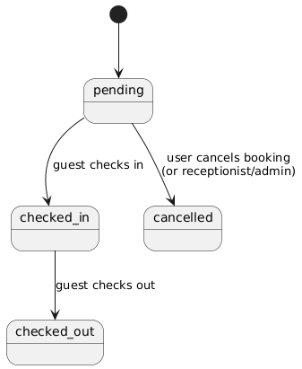

Figure 9: Key state booking status
Room status (typical):
• available → reserved → occupied → available (or dirty/maintenance depending on policy)
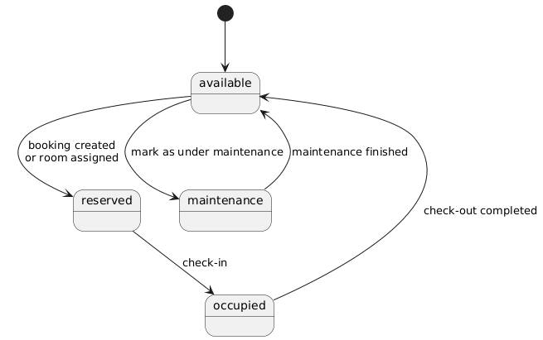

Figure 10: Key state room status
Payment status (typical):
• pending → completed → refunded (if cancellation/refund occurs)
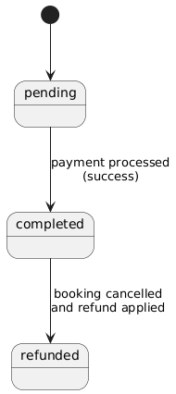
Figure 11: Key state payment status

3.2.3 API Endpoint Catalog (Core Contracts)
The following list documents the public API contracts of the monolith (grouped by domain).

Booking api:
Method | Endpoint | Auth | Role | Describe
POST | /api/bookings | Yes | user / receptionist / admin | Create booking
GET | /api/bookings/my | Yes | user / receptionist / admin | Get current user's bookings
GET | /api/bookings | Yes | receptionist / admin | Get all bookings
GET | /api/bookings/{booking_id} | Yes | user / receptionist / admin | Booking Details
PUT | /api/bookings/{booking_id} | Yes | receptionist / admin | Update Booking
DELETE | /api/bookings/{booking_id} | Yes | user / receptionist / admin | Cancel booking

Rooms api:
Method | Endpoint | Auth | Role | Describe
GET | /api/rooms | Optional | – | Room List
GET | /api/rooms/search | Optional | – | Filter Rooms by Type/Status
GET | /api/rooms/{room_id} | Optional | – | Room Details
POST | /api/rooms | Yes | admin | Create Room
PUT | /api/rooms/{room_id} | Yes | admin | Update room
DELETE | /api/rooms/{room_id} | Yes | admin | Delete room
POST | /api/rooms/assign | Yes | receptionist / admin | Assign Room
GET | /uploads/{filename} | Public | – | Return Image URL

Auth & User api:
Method | Endpoint | Auth | Role | Describe
POST | /api/auth/login | Public | – | Login
POST | /api/users | Public | – | Register
GET | /api/users | Yes | admin | User List
GET | /api/users/{user_id} | Yes | user / receptionist / admin | User Details
PUT | /api/users/{user_id}/profile | Yes | user / receptionist / admin | Update Profile
PUT | /api/users/{user_id} | Yes | admin | Admin Update User
DELETE | /api/users/{user_id} | Yes | admin | Delete User

Services & Service requests:
Method | Endpoint | Auth | Role | Describe
GET | /api/services | Optional | – | Service List
GET | /api/services/{service_id} | Optional | – | Service Details
POST | /api/services | Yes | admin | Create Service
PUT | /api/services/{service_id} | Yes | admin | Update Service
DELETE | /api/services/{service_id} | Yes | admin | Delete Service
POST | /api/services/request | Yes | user / receptionist / admin | Create Service Request
GET | /api/service-requests | Yes | receptionist / admin | Service requests  list
GET | /api/service-requests/{request_id} | Yes | receptionist / admin | Request List
PUT | /api/service-requests/{request_id} | Yes | receptionist / admin | Request Details

Payments:
Method | Endpoint | Auth | Role | Describe
POST | /api/payments | Yes | user / receptionist / admin | Payments
GET | /api/payments | Yes | receptionist / admin | Transaction History
GET | /api/payments/{payment_id} | Yes | user / receptionist / admin | Payment Details
GET | /api/bookings/{booking_id}/payments | Yes | user / receptionist / admin | Payment by Booking

Coupons:
Method | Endpoint | Auth | Role | Describe
POST | /api/coupons | Yes | admin | Create coupon
GET | /api/coupons/{coupon_id} | Optional | – | Coupon detail
POST | /api/coupons/apply | Yes | user / receptionist / admin | Apply coupon

Check out:
Method | Endpoint | Auth | Role | Describe
POST | /api/checkins | Yes | receptionist / admin | Check-in
POST | /api/checkouts | Yes | receptionist / admin | Check-out
GET | /api/checkins/{checkin_id} | Yes | receptionist / admin | check-in detail
GET | /api/checkouts/summary/  {booking_id} | Yes | user / receptionist / admin | Checkout Summary
Wallet:
Method | Endpoint | Auth | Role | Describe
GET | /api/wallet | Yes | user / receptionist / admin | wallet
POST | /api/wallet/topup | Yes | user / receptionist / admin | Top-up Wallet
Staff:
Method | Endpoint | Auth | Role | Describe
GET | /api/staff | Yes | admin | Staff list
POST | /api/staff | Yes | admin | Create staff
GET | /api/staff/{staff_id} | Yes | admin | Staff detail
PUT | /api/staff/{staff_id} | Yes | admin | Update staff
DELETE | /api/staff/{staff_id} | Yes | admin | Delete staff
Reports:
Method | Endpoint | Auth | Role | Describe
POST | /api/reports/revenue | Yes | admin | Revenue Report
POST | /api/reports/occupancy | Yes | admin | Occupancy Report
POST | /api/reports/booking | Yes | admin | Booking Report
GET | /api/reports/{report_id} | Yes | admin | Report detail
GET | /api/reports/type/{report_type} | Yes | admin | Report by Category

3.2.4 Authorization Matrix (Role-based Access Control Summary)
- Public (no auth): /api/auth/login, /api/users (register), /uploads/*
- Optional auth (guest can access): GET /api/rooms*, GET /api/services*, GET /api/coupons/<id>
- User: booking create/cancel/view own, payments by booking, wallet, request service, apply coupon
- Receptionist: booking list/update, assign room, check-in/check-out, manage service requests, payment list
- Administrator: all receptionist permissions + full CRUD for rooms/services/users/staff + reports + coupons

3.3 Implementation: Server-Side Logic (Flask Backend – Controllers/Services)
Example: Booking Creation Flow
1. The frontend (e.g., from rooms.html or room-detail.html) sends a POST request to /api/bookings with JSON body containing:
- guest_name
- room_type
- check_in_date (and optionally check_out_date)
- optional total_price override
- optional payment_method and payment_amount
2. app.py defines the route:
- @app.route('/api/bookings', methods=['POST']) @require_auth def create_booking(): return booking_controller.create_booking()
3. BookingController.create_booking() reads request.json, obtains the current user from request.current_user (set by the authentication middleware), and calls BookingService.create_booking(...).
4. BookingService.create_booking() performs:
- Input validation (guest name, room type, dates).
- Date parsing and validation (no past check-in, check-out after check-in).
- Room availability check by calling RoomService.search_rooms(..., check_in_date, check_out_date). This uses BookingRepository.find_available_rooms_by_date_range() to exclude rooms with overlapping bookings.
- Room selection (first available) and status update to "reserved" via RoomRepository.
- Booking creation via BookingRepository.save(...) within a transaction.
- Optional payment processing by calling PaymentService.process_payment(...) if payment details were provided. If payment fails, the service releases the room and cancels the booking.
5. BookingController then uses BookingView.booking_created(booking) to format a JSON response including booking details for the frontend.

Example: Booking Cancellation & Refund Flow
1. The frontend sends DELETE /api/bookings/<booking_id>, which is protected by
@require_auth in app.py.
2. BookingController.cancel_booking(booking_id) calls BookingService.cancel_booking.
3. BookingService.cancel_booking:
- Validates that the booking exists and is not already checked_in, checked_out,
or cancelled.
- Ensures there is no check-in record (via CheckInRepository).
- Releases the room by setting its status back to "available" if it was "reserved".
- Looks up completed payments for the booking through PaymentService and, if
applicable, refunds the amount to the user’s wallet and updates payment status
to "refunded".
- Updates booking status to "cancelled" via BookingRepository.delete (which sets
status = 'cancelled').
4. A descriptive message is returned to the client, including refund notes if any.

Example: Coupon Application Flow
1. The frontend sends POST /api/coupons/apply with a coupon code.
2. CouponController.apply_coupon() calls CouponService.apply_coupon(code).
3. CouponService.apply_coupon:
- Loads the coupon by code via CouponRepository.
- Validates that the coupon exists and is active.
- Checks current date against coupon.valid_from and coupon.valid_to, ensuring
The coupon is neither expired nor not yet valid.
- Returns coupon details to the controller, which then responds with discount
information so that frontend can adjust the total price.

Example: Payment Processing Flow
1. Frontend sends POST /api/payments with JSON:
- booking_id, amount, payment_method (credit_card/cash/bank_transfer), optional user_id context.
2. PaymentController.process_payment delegates to PaymentService.process_payment(...).
3. PaymentService validates:
- amount > 0; payment_method in allowed methods; booking exists and not cancelled.
4. If wallet-based payment is used in the current design, the service checks wallet balance and deducts.
5. PaymentRepository saves payment records (status pending/completed).
6. Backend returns payment result to the frontend.

Example: Check-in Flow (Receptionist)
1. The receptionist selects a booking and calls POST /api/checkins (booking_id, receptionist_id, optional room_id).
2. CheckInController delegates to CheckInService.process_checkin(...).
3. Service validates booking exists, not already checked in, and room assignment matches booking.room_type.
4. Repository saves check-in records and service updates booking status to checked_in and room status to occupied.
5. Backend returns the check-in record.

Example: Check-out Flow (Receptionist)
1. The receptionist calls POST /api/checkouts with booking_id and checkout details.
2. CheckInService validates that a check-in exists for the booking.
3. Service calculates total checkout amount:
- room cost (booking.total_price) + additional services (service_requests total).
4. Repository saves checkout record; service updates booking status to checked_out and releases/updates room status.
5. Backend returns checkout result; user can view summary via GET /api/checkouts/summary/<booking_id>.

Example: Service Request Flow
1. User requests a service via POST /api/services/request (booking_id, service_id, quantity).
2. ServiceController delegates to ServiceService.create_service_request(...).
3. ServiceService validates booking exists and service exists, then creates service_requests record.
4. Receptionist/Admin can view and manage requests via:
- GET /api/service-requests, GET /api/service-requests/<id>, PUT /api/service-requests/<id>.

Example: Wallet Flow
1. User opens wallet page → GET /api/wallet.
2. WalletService returns wallet; if missing, creates one with balance 0.
3. User tops up → POST /api/wallet/topup with amount; system validates numeric and > 0, then updates balance.

3.3.1 Key Validation & Error Handling Strategy
Input validation is primarily implemented in the Service layer (e.g., BookingService, PaymentService, CouponService):
• Date validation: YYYY-MM-DD; check-in not in past; check-out after check-in.
• Money validation: amount > 0; discounts within valid ranges.
• State validation: cannot cancel/update after check-in; cannot checkout without check-in.
• Role validation: enforced by middleware decorators (401/403).

Error Response Strategy (high-level):
• 400 Bad Request: invalid input data, business rule violation
• 401 Unauthorized: authentication required / missing X-User-Id
• 403 Forbidden: role not permitted
• 404 Not Found: resource not found (booking/room/service/coupon/etc.)
• 500 Internal Server Error: database or unexpected server errors

3.3.2 Runtime/Deployment View
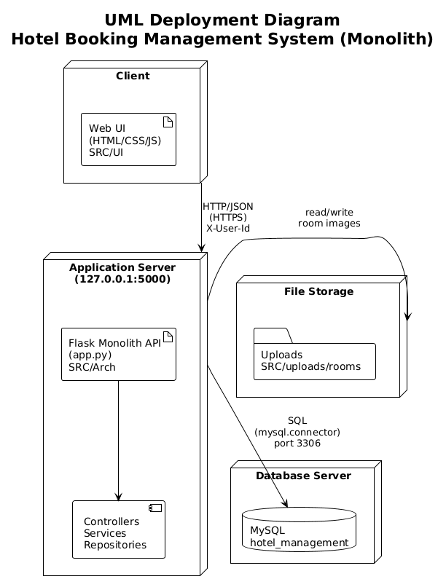
Figure 12: Deployment View
• The monolith runs as a single Flask process (default: 127.0.0.1:5000).
• The MySQL database is a separate process/service configured by environment variables in .env.
• UI files under SRC/UI are static and call APIs under /api/* via JavaScript (fetch).
• Uploaded images are stored under SRC/uploads and served through /uploads/<path>.

3.4 Implementation: Client-Side Logic (Web UI – HTML/CSS/JS)
The UI in SRC/UI is separated by role and page:
• Public & User pages:
- index.html: homepage introducing the hotel and quick access to room browsing.
- public/rooms.html and public/room-detail.html: room list and details pages.
- user/dashboard.html: user overview, showing relevant booking and wallet info.
- user/my-bookings.html: history and status of user’s bookings.
- user/payment.html: payment UI for a specific booking.
- user/wallet.html: wallet balance, top-up form, and transaction history view
(if implemented).

• Authentication pages:
- auth/login.html and auth/register.html: forms that send login/registration
requests to /api/auth/login and /api/users.

• Staff & Admin pages:
- admin/admin.html: admin dashboard for managing rooms, staff, services, coupons, and viewing reports.
- admin/receptionist.html: interface tailored to receptionist tasks like
managing arrivals, check-ins, check-outs, and service requests.
- admin/admin-messages.html: page for internal messages or notifications.

JavaScript files (SRC/UI/js):
• api.js: centralizes AJAX/fetch calls to backend APIs; likely wraps GET/POST/PUT/DELETE requests for rooms, bookings, payments, coupons, wallet, etc.
• auth.js: handles storing auth tokens, sending login/register forms, and updating
the UI based on user authentication state.
• admin.js and receptionist.js: contain logic to populate admin/receptionist tables,
call backend endpoints (/api/rooms, /api/service-requests, /api/staff, /api/reports),
and react to user actions (create room, accept service request, etc.).
• script.js and language.js: implement shared UI functionalities (menu behavior,
language switching), while admin-messages.js and chat.js support additional
user/admin communication features.

4. Testing & Verification
The main goal of testing is to ensure that:
- Booking and room availability logic works correctly (no overbooking).
- Payments and wallet operations are consistent with booking states.
- Authentication and authorization are enforced for protected endpoints.
- The frontend can interact smoothly with the backend APIs and present correct data.

4.1 Unit Testing
Unit tests verify individual components (functions, methods, or classes) in isolation, usually with dependencies mocked or stubbed. In this project, unit testing focuses on the business and data-access layers so that validation rules, state transitions, and data mapping behave as specified without requiring a live database or HTTP server.

- Service layer: booking_service.py, coupon_service.py, payment_service.py, wallet_service.py, and other services are tested for core logic—e.g. date overlap validation, coupon validity and discount calculation, wallet balance checks before payment, and refund amount computation on cancellation. Dependencies such as repositories are mocked so that tests are fast and deterministic.
- Repository layer: Repository methods (e.g. booking_repository.py/BookingRepository.find_available_rooms_by_date_range, WalletRepository.update_balance) can be unit-tested with an in-memory SQLite database or with mocks of the database connection to assert correct SQL behaviour and mapping from rows to domain models.
- Validation and helpers: Input validation (date ranges, positive amounts, required fields) and utility functions (e.g. in utils or middleware) are covered by unit tests to prevent invalid data from propagating to the database or API responses.

Tools such as pytest or unittest can be used, with pytest fixtures for shared setup and mocks (e.g. unittest.mock or pytest-mock) for repository and external dependencies.

Example unit tests:

1. BookingService – reject past check-in dates
def test_create_booking_rejects_past_check_in_date():
service = BookingService()
past_date = "2020-01-01"
with pytest.raises(ValueError):
service.create_booking(
guest_name="Alice",
room_type="standard",
check_in_date=past_date,
total_price=100.0,
)

2. BookingRepository – mapping database row to Booking model
def test_row_to_booking_maps_row_correctly():
repo = BookingRepository()
row = {
"id": 42,
"guest_name": "Bob",
"room_type": "deluxe",
"check_in_date": date(2026, 2, 10),
"check_out_date": date(2026, 2, 12),
"total_price": 300.0,
"status": "pending",
"room_id": 7,
"user_id": 5,
}
booking = repo._row_to_booking(row)
assert booking.id == "42"
assert booking.room_id == 7
assert booking.user_id == 5

3. PaymentService – prevent double payment
def test_process_payment_rejects_when_fully_paid(monkeypatch):
service = PaymentService()
# Fake repositories to avoid real DB
monkeypatch.setattr(service, "booking_repo", FakeBookingRepo(total_price=100.0))
monkeypatch.setattr(service, "repo", FakePaymentRepo(existing_amount=100.0))
with pytest.raises(ValueError):
service.process_payment(booking_id=1, amount=50.0, payment_method="cash")

4.2 Integration Testing
Integration tests verify that multiple components work together correctly—for example, API endpoints with the real (or test) database, or controller → service → repository flows. They ensure that the contracts between layers are respected and that end-to-end behaviour within the backend is consistent.

- API + database: Key flows are tested by sending HTTP requests to the Flask app (e.g. using Flask test client) against a dedicated MySQL database or an in-memory SQLite instance. Examples include: POST /api/bookings creates a booking and updates room availability; POST /api/payments correctly deducts wallet balance and updates booking status; GET /api/rooms returns only available rooms for the given date range.
- Authentication and authorization: Endpoints protected by require_auth, require_admin, or require_receptionist_or_admin are tested with valid and invalid X-User-Id headers (and optionally role) to confirm that forbidden access returns 401/403 and that allowed roles succeed.
- Cross-layer flows: Integration tests cover scenarios such as create booking → process payment → check-in → check-out, and cancel booking → refund to wallet, ensuring that service and repository interactions and transaction boundaries behave correctly under a single application context.

These tests may use the same Flask application factory and a test configuration that points to a test database, with cleanup (e.g. transaction rollback or truncated tables) between tests to avoid side effects.

Example integration tests:

1. Booking API + room availability
def test_create_booking_reserves_room(client, db):
# Arrange: seed one available room of type "standard" in the test DB
room_id = seed_room(db, room_type="standard", status="available")
payload = {
"guest_name": "Alice",
"room_type": "standard",
"check_in_date": "2026-02-10",
"check_out_date": "2026-02-12"
}
# Act: call POST /api/bookings via Flask test client
response = client.post("/api/bookings", json=payload, headers={"X-User-Id": "1"})
# Assert: booking is created and room status becomes 'reserved'
assert response.status_code == 200
data = response.get_json()
assert data["booking"]["room_id"] == room_id
assert get_room(db, room_id).status == "reserved"

2. Payment API + wallet deduction
def test_wallet_payment_deducts_balance(client, db, wallet_factory):
wallet = wallet_factory(user_id="1", balance=500.0)
booking_id = seed_booking(db, user_id="1", total_price=200.0)
payload = {
"booking_id": booking_id,
"amount": 200.0,
"payment_method": "cash"
}
response = client.post("/api/payments", json=payload, headers={"X-User-Id": "1"})
assert response.status_code == 200
updated_wallet = get_wallet(db, "1")
assert updated_wallet.balance == wallet.balance - 200.0

3. Authorization on admin endpoint
def test_normal_user_cannot_access_admin_rooms(client, db):
# User without admin role tries to access admin-only rooms endpoint
response = client.post("/api/rooms", json={}, headers={"X-User-Id": "normal-user"})
# Expect 403 Forbidden returned by require_admin middleware
assert response.status_code == 403

4.3 Verification Proof: Booking – Payment – Check-in Flow
Test Scenario: A user successfully books a room, pays using wallet, and is checked in and later checked out by a receptionist.

Step | Action | Expected Result | Actual Result | Status
1 | User registers and logs in via UI | User account is created and authenticated | OK | Pass
2 | User browses rooms and selects room type and date range | Available rooms are displayed | OK | Pass
3 | User confirms booking (POST /api/bookings) | Booking is created with pending status and assigned room_id | OK | Pass
4 | User opens payment page and pays via wallet | Wallet balance is verified, payment is processed, booking status updated to paid | OK | Pass
5 | Receptionist views upcoming arrivals and performs check-in | Check-in record is created, room status is updated | OK | Pass
6 | Receptionist performs check-out at end of stay | Check-out summary is generated, room is released | OK | Pass
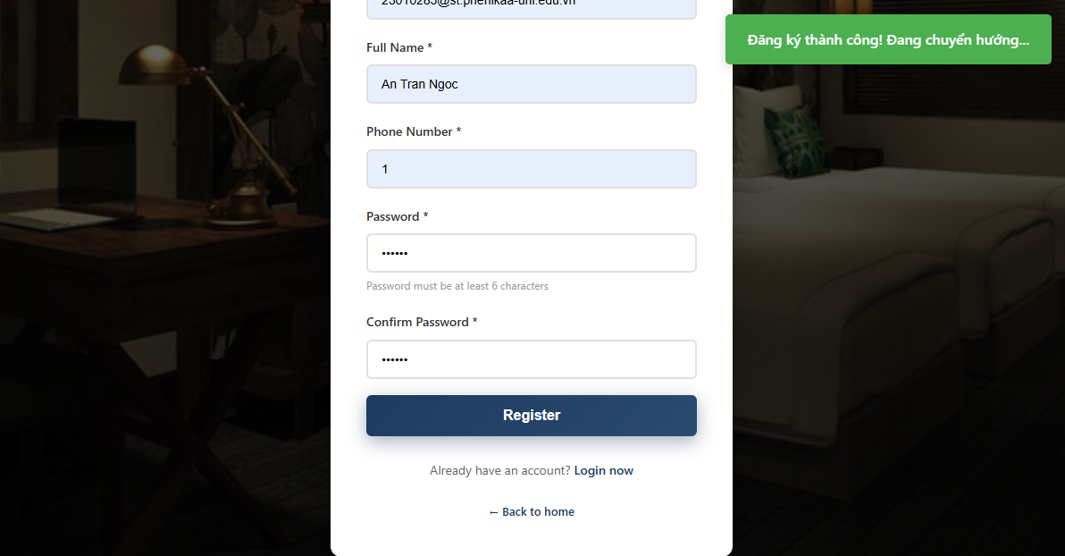
Figure 13: Register completed
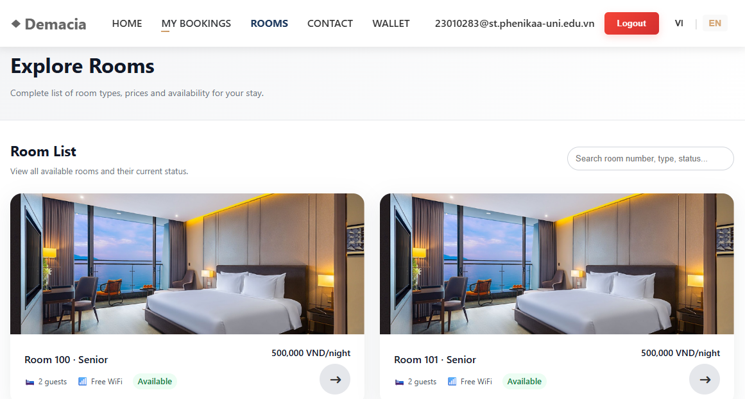
Figure 14: Search rooms
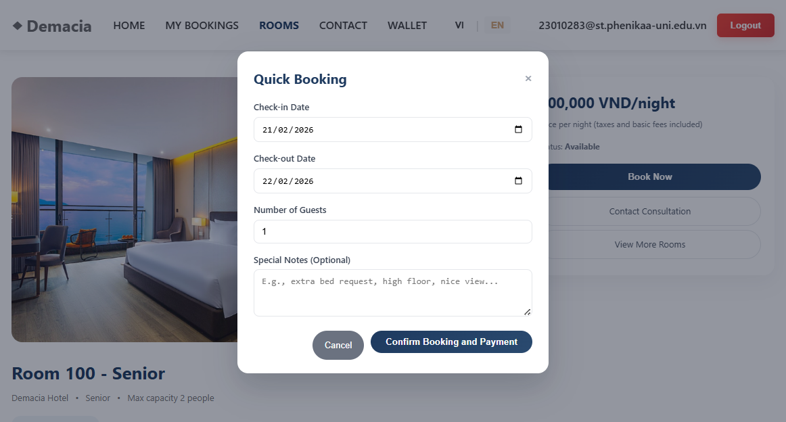
Figure 15: Booking
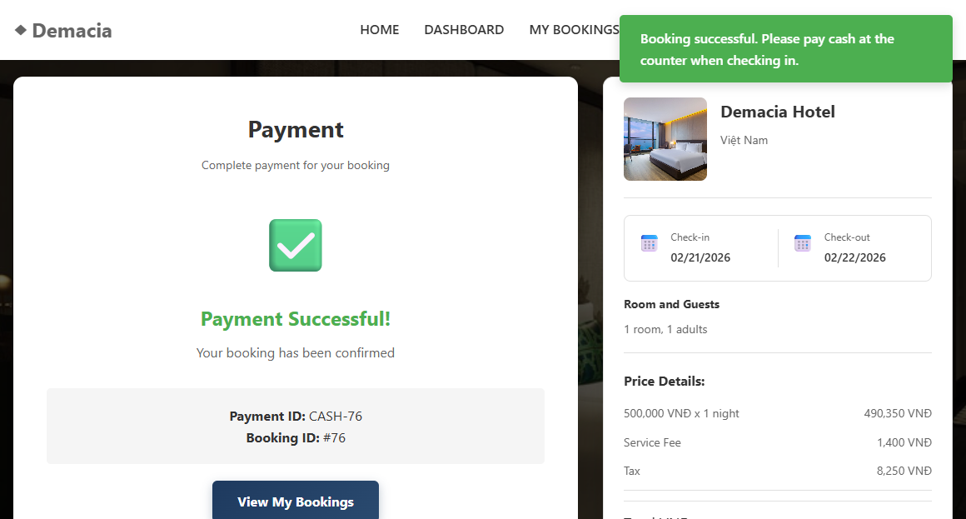
Figure 16: Payment completed
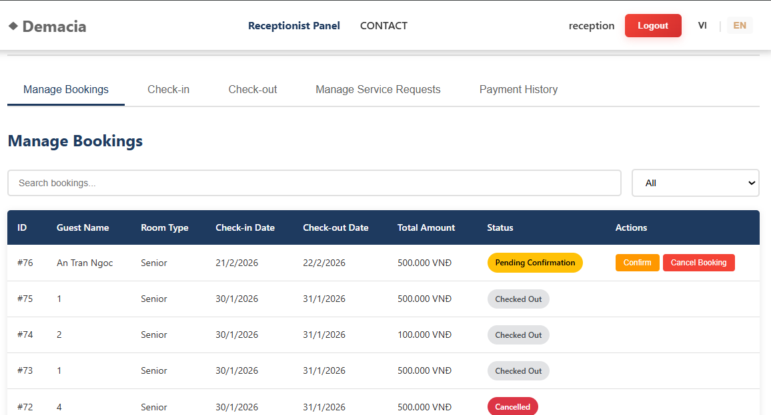
Figure 17: Manage bookings
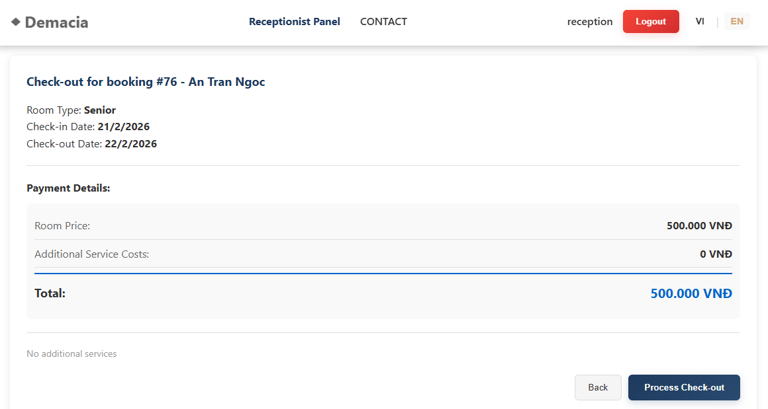
Figure 18: Checkout
Additional tests include:
- Attempting to book the same room and date range twice, which should fail due to the SQL overlap logic in BookingRepository.find_available_rooms_by_date_range.
- Attempting to access admin endpoints as a normal user, which should be blocked by require_admin or require_receptionist_or_admin middleware.
- Applying expired or inactive coupons, which should be rejected by CouponService.
- Verifying that cancellation triggers appropriate room release and, if applicable, wallet refunds, and that booking status is updated to 'cancelled'.

5. Conclusion & Reflection
This project successfully implements a multi-role Hotel Booking Management System using a layered Flask backend and a static HTML/CSS/JavaScript frontend. The layered structure with controllers, services, repositories, and models has proven effective in separating concerns, making it easier to reason about booking, payment, and reporting flows. The system satisfies the main functional requirements (room browsing, booking, payment, check-in/check-out, wallet, coupons, services, reporting) and achieves key architectural goals such as modifiability, maintainability, and basic security.

5.1 Lessons Learned
Value of Clear Layering: Explicit separation between controllers, services, and repositories significantly reduced coupling. When business rules changed (e.g.,
new validation for booking dates or coupon constraints), modifications could be
localized mainly in the service layer.
Handling Data Consistency: Implementing correct booking and payment flows required careful handling of transactions and state transitions (pending, paid, cancelled, checked_in, checked_out). The repository methods and service logic had to be designed to avoid partial updates (e.g., reserving a room but failing to create a booking).
Security & Roles: Introducing middleware-based decorators for authentication and role-based access control made it easier to secure endpoints consistently across
the application. This pattern helped enforce that only appropriate roles can perform sensitive operations like managing rooms, staff, or viewing reports.
Integration with a Real Database: Working with MySQL and explicit SQL queries (instead of an ORM) provided deeper understanding of SQL, transactions, and how to map between relational tables and Python objects.

5.2 Future Improvements
1. Strengthen Authentication & Authorization:
- Adopt a more robust token-based authentication mechanism (e.g., JWT) with secure storage on the client and token refresh logic.
- Enhance password policies, add account lockout after repeated failed logins,
and introduce audit logging for security-sensitive operations.
2. Enhance Reporting:
- Extend ReportService and related repositories to produce richer analytics such as revenue by room type, monthly/seasonal trends, average length of stay, and service usage statistics.
- Provide export options (CSV/PDF) and more visual dashboards in the admin UI.
3. Improve Scalability & Deployment:
- Containerize the application (Docker), use environment-specific configurations,
and deploy on a cloud platform.
- Introduce a reverse proxy/load balancer and, if necessary, separate the booking, payment, and reporting domains into independently scalable services.
4. UX & UI Enhancements:
- Improve responsiveness and interactivity of the frontend, potentially integrating a modern frontend framework for complex admin views.
- Add user notifications (email or in-app) for booking confirmation, payment receipts, and check-in reminders.
5. Logging, Monitoring & Error Handling:
- Implement structured logging and monitoring (e.g., using a logging framework and a dashboard) to quickly detect issues in production.
- Standardize error responses across controllers to provide consistent feedback to Frontend developers and end users.

