PHENIKAA UNIVERSITY

PHENIKAA SCHOOL OF COMPUTING



COURSE: SOFTWARE ARCHITECTURE
Lab Report 4: Microservices Decomposition & Communication

INSTRUCTOR: Vũ Quang Dũng
GROUP 7: Nguyễn Hưng Thành (23010688 – K17 KTPM)
Trần Ngọc An (23010283 – K17-KTPM) Lê Mạnh Đức (23010208 – K17-KTPM)
Phạm Thế Thủy Hoàng (23010960 – K17-KTPM)
CREDIT CLASS: CSE703110-1-2-25(N01)

Ha Noi, December 6, 2025
Contents
1. Abstract/Summary 3
2. Lab Specific Section: I. Decomposition by Business Capability 3
2.1. Identified Microservices and Data Ownership 3
3. Lab Specific Section: II. Defining Service Contracts (APIs) 3
3.1. Room Service API Contract 3
3.2. Booking Service API Contract 4
3.3. User Service API Contract 4
3.4. Payment Service API Contract 5
3.5. Hotel Service API Contract. 5
3.6. Coupon Service API Contract. 5
3.7. CheckIn Service API Contract. 5
3.8. Staff Service API Contract. 6
3.9. Report Service API Contract. 6
4. Lab Specific Section: III. C4 Model 6
5. Conclusion & Reflection 9

1. Abstract/Summary
This lab transitions the Hotel Management System from the monolithic Layered Architecture designed in Lab 3 to a Microservices Architecture. The primary goal is to address the Scalability (ASR-1) identified in Lab 1 , which the monolith failed to handle efficiently. By decomposing the system into independent services, we ensure that high-demand components like "Room Search" can scale autonomously without wasting resources on underutilized administrative tools.

2. Lab Specific Section: I. Decomposition by Business Capability
We have shifted from technical layers (Controller, Service, Repository) to services organized around business domains. This ensures High Cohesion and Low Coupling.

2.1. Identified Microservices and Data Ownership
Each service owns its own process and database; no cross-service database access is permitted.
Business Capability | Proposed Microservice | Data Owned (Entities)
Room Catalog Management | Room Service | Room Details, Room Types, Pricing, Status
User & Staff Management User Service | User Service | User Profiles, Authentication Credentials, Roles
Reservation Fulfillment | Booking Service | Booking Headers, Reservation Line Items, Status
Service Management | Hotel Service | Service Catalog (Spa, Dining), Guest Requests
Payment Processing | Payment Service | Payment Transactions, Payment Methods, Transaction History
Promotion Management | Coupon Service | Coupon Codes, Discount Rules, Validation Rules
Guest Operations | CheckIn Service | CheckIn Records, CheckOut Records, Guest Status
Human Resources | Staff Service | Staff Profiles, Staff Assignments, Department Information
Analytics & Reporting | Report Service | Generated Reports, Report Templates, Historical Data

3. Lab Specific Section: II. Defining Service Contracts (APIs)
The service contract is the stable, public RESTful interface that allows services to integrate without knowing internal implementation details.

3.1. Room Service API Contract
This contract provides the stable interface for the Booking Service (Consumer) to interact with Room Service (Producer).
Endpoint | HTTP Method | Description | Data Returned
/api/rooms | GET | List rooms based on criteria | List of Room Summary objects
/api/rooms | POST | Create a new room | Created Room object
/api/rooms/search | GET | Search rooms by type and status | List of matching Room objects
/api/rooms/{id} | GET | Retrieve full details of a single room | Full Room object (Price, Desc, Status)
/api/rooms/{id} | PUT | Update room information | Updated Room object
/api/rooms/{id} | DELETE | Delete a room | Success message
/api/rooms/assign | POST | Assign room to a booking | Assigned Room object

3.2. Booking Service API Contract
This contract provides the interface for managing reservations and bookings.
Endpoint | HTTP Method | Description | Data Returned
/api/bookings | POST | Create a new booking | Created Booking object
/api/bookings | GET | Get all bookings | Booking objects
/api/bookings/{id} | GET | Retrieve booking | Full Booking object
/api/bookings/{id} | PUT | Update booking information | Updated Booking object
/api/bookings/{id} | DELETE | Cancel a booking | Success message

3.3. User Service API Contract
This contract handles user authentication and profile management.
Endpoint | HTTP Method | Description | Data Returned
/api/users | POST | Create a new user (Register) | Created User object
/api/users/{id} | GET | Retrieve user details | Full User object
/api/users/{id}/profile | PUT | Update user profile | Updated User object
/api/auth/login | POST | Authenticate user credentials | User object with authentication token

3.4. Payment Service API Contract
This contract manages payment processing and transaction history.
Endpoint | HTTP Method | Description | Data Returned
/api/payments | POST | Process a payment | Payment Transaction object
/api/payments/{id} | GET | Retrieve payment details | Full Payment object
/api/users/{id}/profile | GET | Get all payments for a booking | List of Payment objects

3.5. Hotel Service API Contract.
This contract manages hotel services like Spa, Dining, and other amenities.
Endpoint | HTTP Method | Description | Data Returned
/api/services | GET | Get all available services | List of Service objects
/api/services | POST | Create a new service | Created Service object
/api/services/{id} | GET | Retrieve service details | Full Service object
/api/services/request | POST | Request a service for a guest | Service Request confirmation

3.6. Coupon Service API Contract.
This contract handles discount codes and promotional offers.
Endpoint | HTTP Method | Description | Data Returned
/api/coupons | POST | Create a new coupon | Created Coupon object
/api/coupons/{id} | GET | Retrieve coupon details | Full Coupon object
/api/coupons/apply | POST | Apply coupon code to booking | Applied Coupon with discount calculation

3.7. CheckIn Service API Contract.
This contract manages guest check-in and check-out operations.
Endpoint | HTTP Method | Description | Data Returned
/api/checkins | POST | Process guest check-in | CheckIn Record object
/api/checkouts | POST | Process guest check-out | CheckOut Record object
/api/checkins/{id} | GET | Retrieve check-in details | Full CheckIn object

3.8. Staff Service API Contract.
This contract manages staff information and assignments.
Endpoint | HTTP Method | Description | Data Returned
/api/staff | GET | Get all staff members | List of Staff objects
/api/staff | POST | Create a new staff member | Created Staff object
/api/staff/{id} | GET | Retrieve staff details | Full Staff object
/api/staff/{id} | PUT | Update staff information | Updated Staff object

3.9. Report Service API Contract.
This contract generates various analytical reports for management.
Endpoint | HTTP Method | Description | Data Returned
/api/reports/revenue | POST | Generate revenue report | Report object with revenue data
/api/reports/occupancy | POST | Generate occupancy report | Report object with occupancy statistics
/api/reports/booking | POST | Generate booking report | Report object with booking analytics
/api/reports/{id} | GET | Retrieve generated report | Full Report object
/api/reports/type/{type} | GET | Get reports by type | List of Report objects

4. Lab Specific Section: III. C4 Model
The C4 Model Level 1 diagram illustrates the high-level boundary of the Hotel Management System and its interactions with external entities.
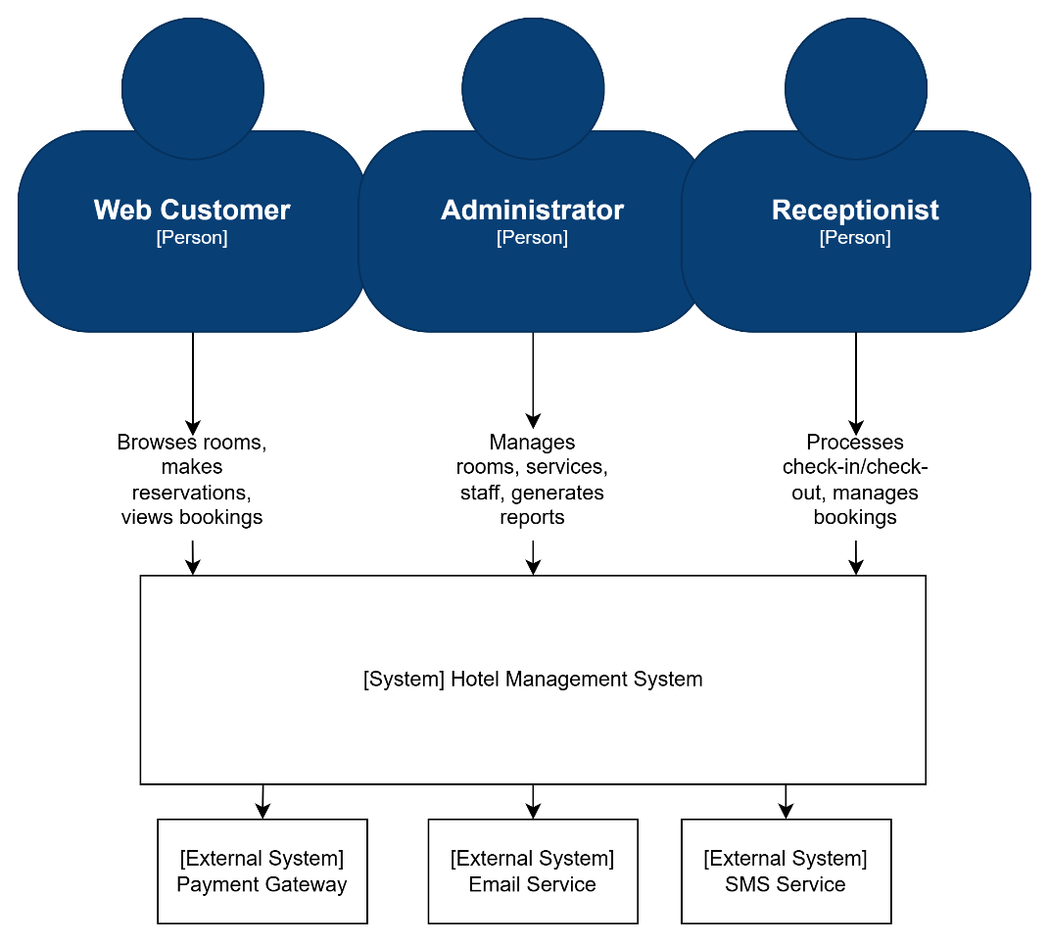

At the center of the model is the [System] Hotel Management System, which represents the entire microservices platform as a unified whole.

Surrounding this boundary are three primary human actors:
- Web Customer: Browsers the hotel website, searches for available rooms, makes reservations, and manages their bookings.
- Administrator: Manages the hotel catalog (rooms, services), staff members, and generates analytical reports.
- Receptionist: Processes guest check-in and check-out operations, manages room assignments, and handles booking modifications

The system also maintains critical interfaces with external systems:
- Payment Gateway: Processes payment transactions synchronously to ensure immediate transaction confirmation
- Email Service: Sends booking confirmations, check-in reminders, and other notifications asynchronously to avoid blocking core business operations
- SMS Service (Optional): Sends SMS notifications for booking confirmations and important updates
Communication Strategy:
Interaction | Service/Component | Communication Type | Rationale
User Login | API Gateway → User Service | Synchronous (HTTP) | Immediate response required for authentication
Room Search | Web Customer → Room Service | Synchronous (HTTP) | Need real-time room availability
Booking Creation | Booking Service → Room Service | Synchronous (HTTP) | Must verify room availability before booking
Payment Processing | Payment Service → Payment Gateway | Synchronous (HTTP) | Real-time transaction confirmation required
Booking Confirmation Email | Booking Service → Email Service | Asynchronous (Message Queue) | Email delivery should not block booking completion
Check-in Notification | CheckIn Service → Email Service | Asynchronous (Message Queue) | Non-blocking notification
Report Generation | Report Service → Booking/Payment Services | Asynchronous (Message Queue) | Reports can be generated in background
Coupon Validation | Booking Service → Coupon Service | Synchronous (HTTP) | Need immediate discount calculation

The communication strategy distinguishes between synchronous interactions (for immediate needs like authentication, room availability, and payment processing) and asynchronous interactions (for non-critical operations like email notifications and report generation).

5. Conclusion & Reflection
Transitioning to microservices gains Fault Isolation; for example, a crash in the Hotel Service (Spa/Dining) does not stop the User Service from functioning. However, we trade development simplicity for Operational Complexity, such as the need for an API Gateway and Distributed Transactions (Saga Pattern) to maintain data integrity.

