Review: Project DevAI’s StarCraft AI Template

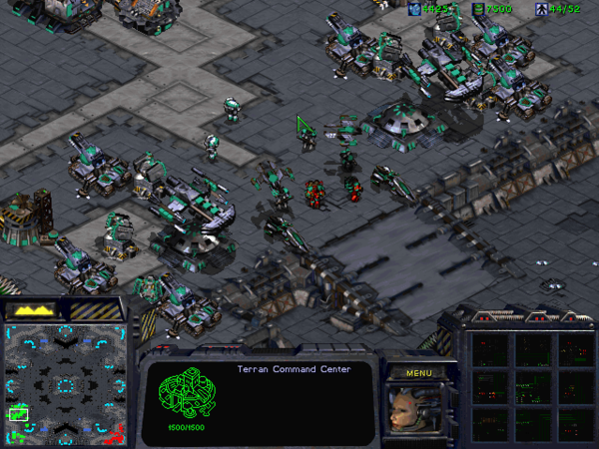

Most people, even programmers, struggle to grasp the ins and outs of artificial intelligence. After all, creating computer programs that can think for themselves is a tough task for a species that sometimes forgets whether or not they turned their oven off when they left the house. Programmers, indeed, have the upper hand in that if they learn basic artificial intelligence concepts, they can strengthen their understanding through implementing these concepts in their own programs. If only, then, there were clear and entertaining ways that programmers could learn artificial intelligence without too much furious rubbing between their own brain cells. Project DevAI capitalizes on our fascination with artificial intelligence and the average programmer’s desire to transform the abstract into the concrete by demonstrating to them how it works. The Project DevAI API is implemented through the use of StarCraft, a popular video game, by allowing the programmer to interact with their API and see how their code animates and changes the landscape of the game. They have also developed an example artificial intelligence program that exemplifies how people can use their API to learn artificial intelligence in a hands-on way. Sponsored by a professor who specializes in artificial intelligence, I am pleased to announce that for those of us who are mystified and fascinated by this subject and are interested in how to create their own, the Project DevAI attempts, and mostly succeeds, to bridge the gap.

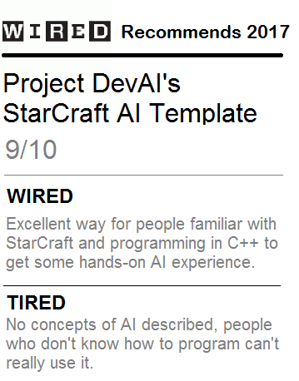

In terms of understanding artificial intelligence in a programmatic context, I like what Project DevAI offers. If you are familiar with C++ or object-oriented programming, it can be easy to peruse their documentation and see how to use their methods. However, the use of StarCraft can be perplexing to some of us who have never played it. Luckily, since the Project DevAI API encompasses such a small subset of the StarCraft environment, our learning curve can be easy to overcome. But still, the assumption that a programmer interested in learning artificial intelligence should already know StarCraft could be offensive to some circles.

If you are a non-programmer and you want to understand some artificial intelligence concepts, you’re totally out of luck with the Project DevAI. This happens to be one of the project’s weaknesses. The intended audience of Project DevAI is perhaps a somewhat small subset of all people who might want to learn some things about artificial intelligence. It makes no attempt to market itself as anything but a module for and by developers, and those who hear C++ and become overwhelmed with abject confusion (I used to be one too- consider joining the support group) benefit from this product in no discernible way.

For people who hear artificial intelligence and think of Alan Turing, this may be a great product for you. It’s well-documented, it’s fun to tinker around with, and the results of tinkering are obvious and fun to observe. For people who hear artificial intelligence and think of the movie *I, Robot*, this product may be of no use to you. Maybe in future updates the Project DevAI team could bring up text windows describing the artificial intelligence concept at play when the user is watching the development team’s example artificial intelligence program. But for now, this programmer is satisfied with what the Project DevAI has allowed me to chew on.