
CoolFly Dream · 第 2 号品牌片
First Light
脚本 v09 · 面向美国用户
项目 | 内容
时长 | 约 45 秒（4 段生成 11 + 11 + 10 + 10 秒，加 3 秒整屏橙色 logo 卡；当前样片合成版约 48 秒）
画幅 | 16:9，1920×1080 主版本；9:16 竖版之后再做
语言 | 画面文字一律英文；全片没有台词和旁白
生成 | 即梦 Seedance 2.5 样片模式（480p）→ 满意后在画布上直出 1080p
日期 | 2026-10-21

1. 一句话故事
周六凌晨，他从崖顶牧场的机库里推出 Dream，从停机坪起飞，贴着加州 1 号公路的海岸飞行，从拱桥下穿过，然后降落在崖顶草地上，和等着他吃早餐的妻子、女儿团聚。女儿坐进了驾驶座，抬头望着天空。
时间线是一个早晨（凌晨 → 日出 → 早上），和 Dream Pro 40 分钟的续航对得上：一次早晨飞行，飞完就到。
段 | 时长 | 全片时间 | 内容 | 情绪
1 · TAKEOFF | 11 s | 0–11 s | 机库、检查、戴头盔、起飞、俯冲出崖边 | 仪式感 → 爆发
2 · THE COAST | 11 s | 11–22 s | 贴海追飞、大笑、穿桥、张手慢动作、脚下的海 | 速度 → 喘息 → 自由
3 · HOME | 10 s | 22–32 s | 远处降落、女儿跑来、戴头盔、仰望天空 | 温暖
4 · FINALE | 10 s | 32–42 s | 咖啡、一家人、Dream 细节、定版远景 | 回味 → 品牌
logo 卡 | 3 s | 42–45 s | 整屏 CoolFly 橙 + 黑色 logo | —

2. 从美国用户的心理出发
看片的人：美国的高收入人群，35–55 岁，男女都有；住在海边、山里或郊区，车库里已经有 Porsche、Rivian 或者一辆皮卡；喜欢户外，是新科技的早期用户。他们不缺车，缺的是没人做过的体验，和属于自己的时间。

五个判断
- 「开阔的路」是美国人最深的自由神话。片子要说的是：开阔的路，变成了开阔的天空。所以海岸拍成加州 1 号公路的样子：混凝土拱桥、金色草坡、公路上慢慢开着的车。
- 想要，来自「它就住在我家」。起飞地点是自家牧场的开放式机库，Dream 停在门外的起降圈上，而不是工业机库。
- 美国人对「飞行汽车」先怀疑，再心动。所以要让人觉得一切在掌控之中：起飞前用手检查螺旋桨、安全带咔嗒一声、全程单手握杆；只飞过开阔的海岸和海面，高度不超过约 20 米，不飞过人群和车流。
- 情绪要看得见。头盔用透明面罩，看得到他的大笑；张开手迎风的慢动作；透过镂空踏板看到脚下的海浪。
- 爽完之后，要有一个和人分享的落点。Dream 是单座，分享发生在落地以后：女儿坐进驾驶座（飞行器关机，不会飞），抬头看天，爸爸看着她笑。「这个梦，会传下去」，不写出来，靠画面说。

3. 节奏设计（快慢切换）
参考 Xiaomi「长镜头蓄势 → 连续快切 → 突然停住」和 Eletre「微距慢、飞驰快」，再用一个停得最久的英雄远景收尾。
全片时间 | 段 | 节奏 | 镜头长度 | 声音
0–6 s | 1 | 慢：推门、检查、戴头盔，仪式感 | 1.6–2.4 s | 门轨、脚步、咔嗒
6–11 s | 1 | 爆发：螺旋桨、手、气流三个快切 → 起飞 → 俯冲 | 0.5–0.7 s | 电机声突然响起
11–17 s | 2 | 快：追飞、擦身而过、甩镜、穿桥 | 0.4–1.8 s | 风、浪、桥下回声
17–19.8 s | 2 | 慢动作喘息：镜头沿手臂移到张开的手 | 2.6 s | 只剩风声和呼吸
19.8–22 s | 2 | 再快：脚下的海浪，拉起 | 0.8–1.4 s | 声音猛地恢复
22–32 s | 3 | 慢、温柔：降落、女儿跑来、戴头盔 | 1.4–2.6 s | 草地、风、笑声
32–35.6 s | 4 | 慢：咖啡、一家人、环绕 Dream | 1.6–2.0 s | 安静
35.6–37.1 s | 4 | 三个快拍：机臂、电机、整流罩 | 0.5 s | 配乐踩点
37.1–42 s | 4 | 定版静止：全片最长的镜头 | 约 4.9 s | 只剩风声，配乐收尾
42–45 s | 卡 | 整屏橙色 + 黑色 logo | 3 s | 最后一拍

4. 段与段之间的衔接
每段分开生成时，模型不知道上一段最后一帧长什么样，接缝处的角度、大小和光线就会跳变。v09 的做法是：按顺序生成，把上一段样片的最后一帧截下来，作为下一段的第一帧参考图，并要求开头的运镜沿同一方向、以同样速度继续。
接缝 | 上一段结尾 → 下一段开头 | 「桥」
1 → 2 | FPV 俯冲、倾斜的地平线 → 同一个画面 | 同一个 FPV 运镜继续，1 秒内把地平线转平
2 → 3 | Dream 后上方的俯拍 → 同一个画面 | 同一个下降运镜继续，穿过野花落到草地高度，露出家人
3 → 4 | 女儿仰头，镜头摇进明亮的天空 → 同一片天空 | 用天空做桥：从天空摇下来，落到放咖啡杯的手上；笑声延续到早餐桌，做声音桥
4 → 卡 | 定版远景静止 | 硬切整屏橙色 logo 卡（参考 Eletre 的整屏品牌黄）
段内规则：切点两边的运动方向一致、速度相近，切在动作上。后期在接缝前后各补 4–6 帧速度渐变，配乐跨过接缝不断开。

5. 资产
标签 | 内容
@char_pilot4 | 主演：美国男性，30 多岁，深棕短发，灰绿眼睛；黑色飞行服，左胸小号、背后大号 CoolFly logo；黑色头盔配透明面罩
@char_pilot3 | 主演不戴头盔的脸（摘下头盔后用）
@char_family | 妻子（30 多岁，米色针织衫、深色牛仔裤）和 8 岁女儿（雀斑、浅色牛仔外套、深蓝打底裤）
@prop_dream2 | Dream 三视图（去掉编号 05，整流罩只有橙色和两条白色条纹）
@loc_hangar_us | 崖顶牧场的开放式机库：两扇大推拉门、停机坪和白色起降圈
@loc_coast_us | 加州 1 号公路式海岸：混凝土拱桥、金色草坡、海雾
@loc_breakfast | 崖顶草地上的早餐桌（亚麻桌布、咖啡壶），崖下是海雾；不出现汽车
@p1_end / @p2_end / @p3_end | 上一段样片的最后一帧，作为下一段的第一帧

6.1 第 1 段 · TAKEOFF · 起飞（11 秒，全片 0–11 s）
说明：沿用 v08 样片（V8P1），不重跑。
参考图：@char_pilot4 · @prop_dream · @loc_hangar_us

分镜
画面（样片截图） | 时间 | 内容 | 节奏
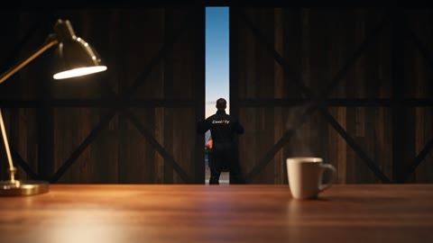 | 0.0–2.4 s | 机库里，他把咖啡放在工作台上，推开巨大的推拉门；门板扫过整个画面（前景遮挡），晨光涌进来，露出停在起降圈上的 Dream 和大海。 | 慢
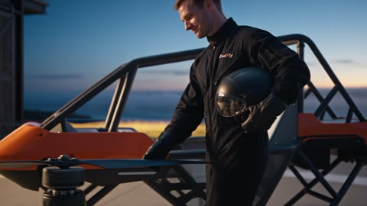 | 2.4–4.0 s | 室外横移跟拍：他绕着 Dream 走，用手套划过螺旋桨做起飞前检查；转身时背后的 CoolFly logo 清楚。切在他坐进座椅的动作上。 | 慢
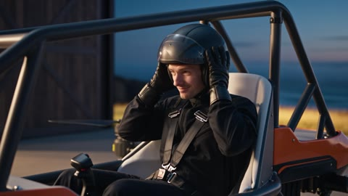 | 4.0–6.2 s | 85mm 环绕：扣上安全带 → 从腿上拿起头盔 → 完整戴上 → 扣下巴带 → 放下透明面罩。 | 慢
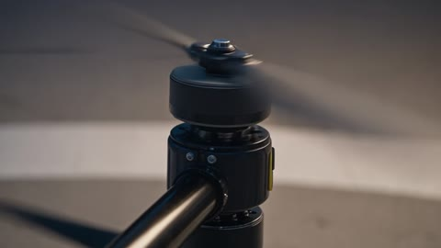 | 6.2–6.8 s | 微距：螺旋桨猛地转起来，变成半透明的圆盘。 | 快
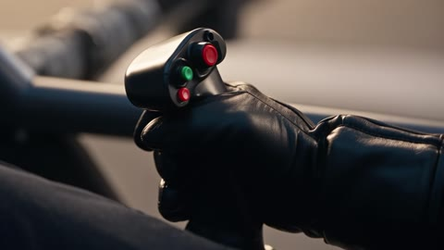 | 6.8–7.3 s | 微距：戴手套的手把操纵杆往前推。 | 快
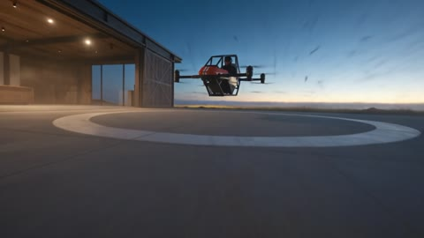 | 7.3–8.0 s | 贴地：下洗气流把尘土和草吹成一圈，扑向镜头。 | 快
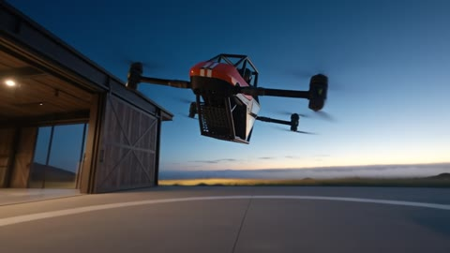 | 8.0–9.4 s | 低机位升降：Dream 从起降圈平稳垂直起飞，机库在背后亮着灯。 | 中
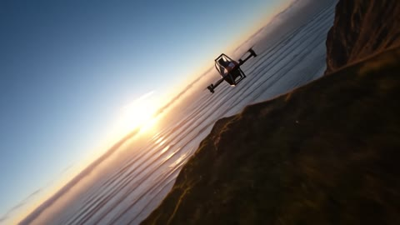 | 9.4–11.0 s | 机腹从镜头正上方掠过；镜头翻转 180° 跟上去，像 FPV 一样俯冲出崖边，贴着海面追向朝阳。 | 快

英文提示词（提交给即梦的原文）
提交前，提示词里的 @名字会换成画布节点。
An 11-second live-action commercial opening, 16:9, the blue hour before dawn at a clifftop ranch on the California coast. A man slides open the huge door of his private hangar; the CoolFly Dream already stands outside on the landing circle of the apron; he checks it by hand, sits and puts on his helmet in a slow, deliberate ritual — then the rhythm explodes: rapid close-ups of the propellers, the grip and the downwash, the aircraft lifts off the apron, sweeps over the camera, and the camera spins round and dives after it off the cliff edge toward the sunrise. Slow build, then a burst of fast cuts. The camera never stops moving.

REFERENCES
@prop_dream — the aircraft. Take every detail of shape, livery, arms, motors and propellers; ignore its grey studio backdrop.
@char_pilot4 — the pilot. Take his face, hair, flight suit with both CoolFly wordmarks, gloves and the black helmet with the perfectly clear visor; ignore the grey backdrop and the sheet layout.
@loc_hangar_us — the hangar and apron: the long dark timber-and-steel hangar on the left with its two huge sliding doors, the warm-lit interior with the walnut workbench and brass lamp, the concrete apron with the large white landing circle, the golden grass, the cliff edge and the Pacific on the right. The plate shows the doors open and the circle empty; in this clip the doors start closed and the aircraft stands in the centre of the circle.

LOOK
High-end automotive commercial, clean modern digital cinema, 24–100mm lenses including macro, deep clean blacks, crisp detail. Deep blue pre-dawn light outside, warm lamplight spilling from the hangar, the first gold on the horizon growing by the end; the aircraft's orange is the strongest colour in every shot. RHYTHM: 0.0–6.2s is slow and deliberate — long, smooth, weighted camera moves; 6.2–11.0s explodes into fast cuts of 0.5–0.7s and hard, accelerating moves. The camera is always moving; no locked-off shots.

CHARACTERS
The pilot — an American man in his mid-30s, short dark-brown hair, light stubble, grey-green eyes, real skin. Calm, competent, quietly excited. He never speaks and never looks into the lens. He carries the helmet in his hand until he puts it on in the 4.0–6.2s shot; after that the clear visor is down and his face stays clearly visible through it.

SUIT RULE
Matte black one-piece flight suit exactly as @char_pilot4: the CoolFly wordmark printed small on the left chest and large across the upper back, 'Cool' in off-white and 'Fly' in orange, the same slanted stencil letters, never misspelled, mirrored or redesigned. These two prints are the only text allowed in the clip.

AIRCRAFT RULE
Exactly one CoolFly Dream, identical to @prop_dream in every frame: orange glossy front fairing with two white vertical stripes and the number 05, dark-grey tubular steel roll cage with an arched roof, white bucket seat with harness, four carbon-fibre arms in an X layout, a coaxial pair of black motors at each arm tip (one above, one below) with two-blade carbon propellers, eight propellers in total, open perforated steel floor. Never redesigned, never round, spherical or hexagonal; no extra or missing parts; no added logos or text. Its small status lights are tiny and soft and never light up the aircraft or the ground. It stands outside on the landing circle the whole time and takes off from there, never inside the hangar. Propellers are still until 6.2s; after that they are translucent spinning discs. It never flies higher than about 20 metres above the ground or the water.

WHERE EVERYTHING IS — fixed for the whole clip
From the apron looking toward the sea: the hangar on the left with its sliding doors; the aircraft in the centre of the white landing circle on the apron, nose toward the ocean; the golden grass, the cliff edge and the Pacific on the right and ahead. Inside the hangar, the workbench and lamp on its left wall.

SHOTS
0.0–2.4s — THE VERY FIRST FRAME OF THE CLIP IS THIS: inside the dark hangar, low, looking at the closed sliding doors, a thin line of blue dawn light along their edge. At 0.3s the pilot sets a steaming coffee mug down on the workbench in the near foreground, then grips a door handle and slides one huge door open; the camera dollies slowly forward behind him as the door panel glides across the whole frame — a natural foreground wipe — and deep blue dawn floods in, revealing the apron, the aircraft standing on the landing circle and the ocean beyond. SLOW. BACKGROUND: the door, then the apron and the sea.

2.4–4.0s — outside on the apron, 50mm, a slow lateral dolly at chest height alongside the pilot as he walks around the parked aircraft, helmet in his left hand, face fully visible, a faint private smile, the CoolFly wordmark on his left chest. He runs his gloved right hand slowly along the leading edge of a still carbon propeller blade; at 3.4s the large CoolFly wordmark across his back is readable as he turns to the seat; at 3.8s he swings down into the seat — cut on that movement at 4.0s. SLOW. BACKGROUND: the warm open hangar behind, the ocean.

4.0–6.2s — 85mm, one continuous slow orbit of about 60 degrees around the seated pilot, never stopping. At 4.2s he clicks the harness buckle; at 4.5s he lifts the helmet from his lap with both hands, raises it above his head and at 5.0s pulls it down over his head in one clear, visible motion; at 5.5s he fastens the chin strap; at 5.9s he lowers the perfectly clear visor; through it his eyes look ahead at the sea, focused, the corner of his mouth lifting. SLOW. BACKGROUND: the hangar glow, the deep blue sky.

6.2–6.8s — FAST: 100mm macro on a coaxial motor pair as the two-blade propeller snaps into motion and blurs into a translucent disc, the camera whipping past it.

6.8–7.3s — FAST: 100mm macro of his gloved right hand pushing the control grip forward, the camera rushing in.

7.3–8.0s — FAST: ground level at the edge of the landing circle, the camera sliding fast; the downwash blasts a ring of dust and grass outward across the concrete toward the lens.

8.0–9.4s — 35mm low wide from the apron, the camera craning up fast as the aircraft lifts smoothly and vertically off the circle to about 4 metres between 8.1s and 9.2s, perfectly level, the pilot visible in the seat, the hangar glowing behind.

9.4–11.0s — FAST: the aircraft surges forward directly over the camera, its belly and open perforated floor sweeping across the lens at 9.6s; the camera tilts over and spins 180 degrees to follow in one continuous move, then dives off the cliff edge after it like an FPV drone, dropping toward the sea and chasing it low over the water toward the first gold of sunrise, accelerating. The clip ends mid-chase, the camera still moving fast.

SOUND
No music: the score is added in post. Diegetic sound only: dawn wind and distant surf; the soft knock of the mug on wood at 0.3s; the heavy rumble of the sliding door on its rail 0.6–2.2s; footsteps on concrete from 2.4s; a gloved hand brushing carbon at 3.0s; seat and harness sounds at 3.8s; a crisp buckle click at 4.2s; helmet shell and strap sounds 5.0–5.5s; a visor click at 5.9s; then a sudden sharp motor whine at 6.2s, a grip click at 6.8s, a blast of downwash at 7.3s, a deep rotor roar from 8.1s, a huge rotor pass overhead at 9.6s, then wind and surf rushing as the camera dives. No dialogue, voices, narrator, stings or added whooshes.

KEEP CONSISTENT
- The clip opens inside the dark hangar on the closed doors, never on a close-up of the aircraft.
- The aircraft stands outside on the landing circle and takes off from there; it never flies inside the hangar or through a door.
- Rhythm: slow until 6.2s, then fast cuts at 6.8s, 7.3s and 8.0s, then the climb and the dive.
- The camera never stops; no locked-off shots.
- The helmet is in his hand until 4.5s and goes on only in the 4.0–6.2s orbit, in one clear visible motion; it never simply appears on his head.
- Exactly one aircraft, identical to @prop_dream; eight propellers; its status lights never glow on the aircraft or the ground.
- Exactly one pilot, identical to @char_pilot4, both CoolFly wordmarks; after 5.9s the clear visor is down; he is in the seat in every shot after 4.0s.
- The aircraft never flies higher than about 20 metres; no birds, no clouds below it.
- Colour stays rich and clean, never washed out.
- Apart from the two CoolFly wordmarks on the suit, no subtitles, on-screen text, other logos or watermarks.

6.2 第 2 段 · THE COAST · 海岸（11 秒，全片 11–22 s）
说明：第一帧 = 第 1 段最后一帧（@p1_end），按顺序生成。
参考图：@p1_end · @char_pilot4 · @prop_dream2 · @loc_coast_us

分镜
画面（样片截图） | 时间 | 内容 | 节奏
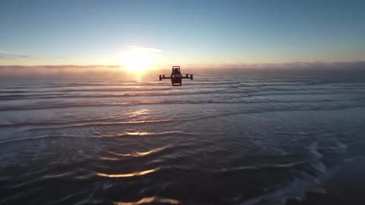 | 0.0–1.6 s | 接着第 1 段的俯冲继续：同样倾斜的地平线、同样的太阳位置；1 秒内地平线转平，FPV 加速追近 Dream。 | 快
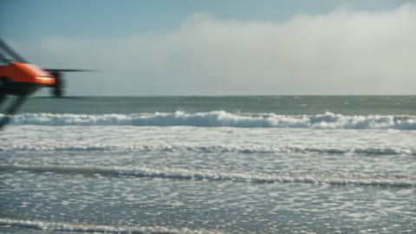 | 1.6–2.4 s | 贴着水面拍，Dream 从镜头旁呼啸而过，溅起水雾。切在掠过的瞬间。 | 快
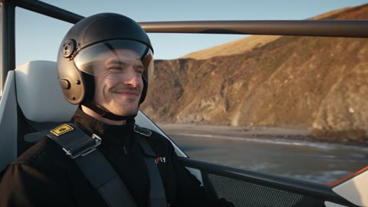 | 2.4–4.0 s | 50mm 在驾驶舱斜前方同步跟拍：透过透明面罩，他从专注变成咧嘴大笑。他看向前方，镜头顺着他的视线甩出去。 | 快
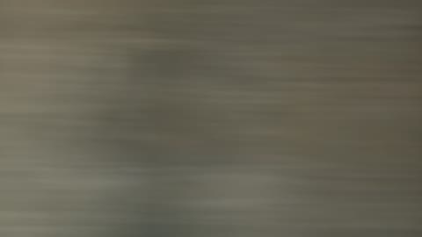 | 4.0–4.4 s | 甩镜：一道带动态模糊的横扫。 | 快
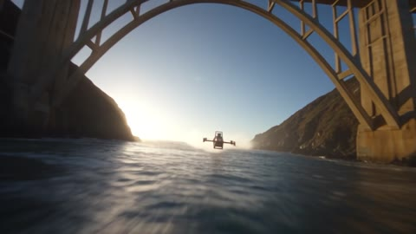 | 4.4–6.2 s | 甩镜落在峡谷口：巨大的混凝土拱桥压在画面上方，Dream 贴着海面从桥下穿过，冲出桥的阴影进入阳光，光晕扫过镜头。 | 快
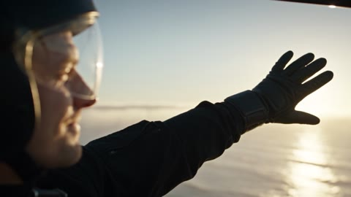 | 6.2–8.8 s | 升格慢动作：镜头从他的侧脸出发，沿着伸出去的左臂一路移到张开的手；手占满大半个画面，风吹得手套和袖子发抖，阳光从指缝里闪过；最后手指慢慢握拢。右手一直握着操纵杆。声音只剩风和呼吸。 | 慢动作
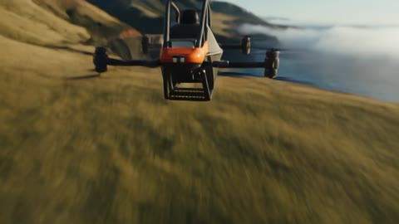 | 8.8–9.6 s | 速度猛地恢复：镜头越过防滚架顶部往下看，靴子踩在镂空踏板上，十几米下面的海浪飞快掠过。 | 快
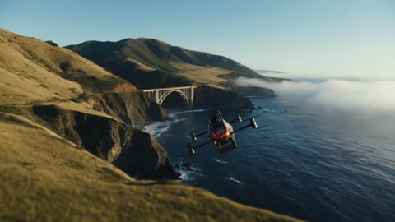 | 9.6–11.0 s | 镜头拉出驾驶舱，升到 Dream 的后上方；Dream 转向崖顶的绿色草地，开始下降。 | 中

英文提示词（提交给即梦的原文）
提交前，提示词里的 @名字会换成画布节点。
An 11-second live-action commercial flight sequence, 16:9, sunrise on the Big Sur coast of California. It continues the previous clip without a break: it opens on exactly the previous clip's last frame, mid-dive, and the same FPV move carries on. The aircraft races the swells, the pilot grins, the camera whips to the towering arch bridge and flies under it with him, bursts into sunlight, then in slow motion travels out along his arm to his open hand in the wind; real speed snaps back, the camera looks down through the cage at the sea beneath his boots, then rises high behind the aircraft as it banks toward a green clifftop meadow and starts to descend. Rhythm: fast, one slow-motion breath, fast again. The camera never stops moving.

REFERENCES
@p1_end — the last frame of the previous clip. THE VERY FIRST FRAME OF THIS CLIP IS EXACTLY THIS IMAGE: same framing, same tilted horizon, same light, same position and size of the aircraft.
@prop_dream2 — the aircraft. Every detail of shape, livery, arms, motors and propellers; ignore the grey backdrop.
@char_pilot4 — the pilot: face, suit with both CoolFly wordmarks, gloves, the black helmet with the perfectly clear visor down; his face is visible through the visor.
@loc_coast_us — the coastline: golden-grass hills, dark cliffs, the concrete arch bridge carrying the coastal highway high above a canyon mouth, the ocean. Take the geography and light; camera heights here are lower, as written per shot.

LOOK
High-end automotive commercial, clean modern digital cinema, 16–85mm lenses. Low warm sunlight, long shadows on the golden hills, deep blue Pacific, white surf, soft morning mist in the canyon mouths; the light direction stays exactly as in @p1_end for the whole clip; the aircraft's orange is the strongest colour. The camera is always moving with real speed, weight and inertia; across every cut the direction of motion continues and the camera speed is similar on both sides. RHYTHM: 0.0–6.2s fast (shots of 0.4–1.6s); 6.2–8.8s a smooth speed ramp into slow motion, the one quiet breath of the film; 8.8–11.0s back to full speed. No locked-off shots.

CHARACTERS
The pilot — the same American man as @char_pilot4, seated and harnessed, right hand always on the control grip, clear visor down, his face and eyes clearly visible through it. Focus turning into pure, open joy. Never speaks, never looks into the lens.

AIRCRAFT RULE
Exactly one CoolFly Dream, identical to @prop_dream2 in every frame: plain glossy orange front fairing with two white vertical stripes, dark-grey tubular roll cage with an arched roof, white seat, four carbon arms in an X layout, coaxial motor pairs at each tip, eight two-blade carbon propellers spinning as translucent discs the whole time, open perforated steel floor. No numbers, letters, logos or text anywhere on the aircraft. Never redesigned, never round, spherical or hexagonal; no extra or missing parts; nothing on it glows. The pilot is visible in the seat in every shot. It always flies between about 10 and 20 metres above the water, never higher.

WHERE EVERYTHING IS — fixed for the whole clip
Looking north along the coast: the hills, cliffs, the coastal highway and the arch bridge are on the left (land side); the open Pacific is on the right. The aircraft always flies north over the water, never over people or traffic. At the end it banks right toward a green clifftop meadow ahead.

SHOTS
0.0–1.6s — THE VERY FIRST FRAME OF THE CLIP IS EXACTLY @p1_end: the FPV camera diving low over the sea behind the small aircraft, the horizon tilted. The same move continues at the same speed and direction without a break: the FPV rolls the horizon level by 1.0s while it accelerates and closes in behind the aircraft, three metres above the swells, foam rushing under the lens. FAST.

1.6–2.4s — FAST, cut on movement: a camera skimming just above the water; the aircraft roars past close beside the lens from left to right, spray kicking up.

2.4–4.0s — 50mm, the camera tracking just ahead of the cockpit at front three-quarter, travelling with it. Through the perfectly clear visor his face is clearly visible: at 2.7s his focus breaks into a wide, open grin and he shakes his head once, delighted. At 3.7s he looks ahead toward the coast and the camera whip-pans right along his gaze.

4.0–4.4s — FAST: the whip pan, a motion-blurred swish across the coast, continuing to the right.

4.4–6.2s — the whip lands: low over the water at the canyon mouth, the huge concrete arch bridge towering ahead across the top of the frame, its deck far above. The aircraft flies toward it just above the water and the camera follows close behind; at 5.1s both pass under the arch, the bridge's shadow sweeping over the lens; at 5.9s they burst out of the shadow into bright sunlight that flares across the lens.

6.2–8.8s — SLOW MOTION: the action ramps smoothly into slow motion. 85mm, the camera starts close on the pilot's left profile through the clear visor, calm and overjoyed. At 6.4s he lifts his left arm out beside the cage; the camera travels slowly out along his arm, past the elbow, to his open hand: by 7.6s the gloved hand fills most of the frame, fingers spread wide, the wind rippling the glove and the sleeve, sunlight flickering between the fingers, the coast streaming past behind as soft flowing light. At 8.6s his fingers close slowly. His right hand stays on the control grip, out of frame.

8.8–9.6s — FAST: real speed snaps back; the camera whips up over the arched roof of the roll cage and looks straight down between his knees: his black boots on the open perforated steel floor, and through its holes the sunlit swells and white foam stream past about 15 metres below.

9.6–11.0s — the camera pulls straight up and back out of the cage, rising high above and behind the aircraft as it banks gently to the right toward a green clifftop meadow ahead and begins to descend toward it; the camera follows it down. The clip ends with the camera high behind the descending aircraft, the aircraft in the lower centre of frame, the green meadow and the cliff edge ahead.

SOUND
No music: the score is added in post. Diegetic sound only: wind and rushing water continuing from the previous clip; the rotor roar rising and falling; a close rotor pass at 2.0s; the natural air rush of the whip pan at 4.0s; the rotor booming under the bridge at 5.1s, opening out into bright wind at 5.9s; during the slow motion 6.2–8.8s everything drops to a low, soft rush of wind over the glove and his calm breathing; full sound slams back at 8.8s with the hiss of waves below; the rotor note dropping as it descends from 9.6s. No dialogue, voices, narrator, stings or added whooshes.

KEEP CONSISTENT
- The first frame is exactly @p1_end and the FPV move continues from it without a break, never a new composition.
- Rhythm: fast to 6.2s, one smooth slow-motion breath 6.2–8.8s with the open hand filling the frame, full speed again from 8.8s.
- The camera never stops; across every cut the direction of motion continues and the speed is similar.
- Exactly one aircraft, identical to @prop_dream2, eight spinning propellers; no numbers or text on it; the pilot is in the seat in every shot.
- It always flies about 10–20 metres above the water, far below the bridge deck; no clouds below it, no birds anywhere.
- His right hand stays on the control grip the whole time; only the left hand opens to the wind.
- The clear visor is down in every frame; no dark or mirrored visor.
- Land on the left, ocean on the right; it flies north and banks right toward the meadow at the end.
- Colour stays rich and punchy, never washed out.
- Apart from the two CoolFly wordmarks on the suit, no subtitles, on-screen text, other logos or watermarks.

6.3 第 3 段 · HOME · 回家（10 秒，全片 22–32 s）
说明：第一帧 = 第 2 段最后一帧（@p2_end）。
参考图：@p2_end · @char_pilot4 · @char_pilot3 · @char_family · @prop_dream2 · @loc_breakfast

分镜
画面（样片截图） | 时间 | 内容 | 节奏
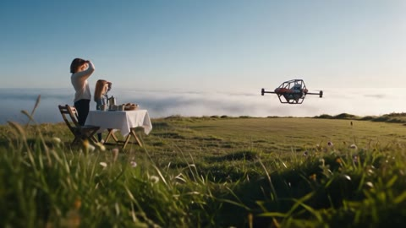 | 0.0–2.6 s | 接着第 2 段的下降运镜继续：镜头跟着 Dream 往下降，穿过草地边缘的野花落到草地高度，露出左边早餐桌旁抬头张望的妻子和女儿；Dream 在草地远端降落，离她们至少 40 米。 | 慢
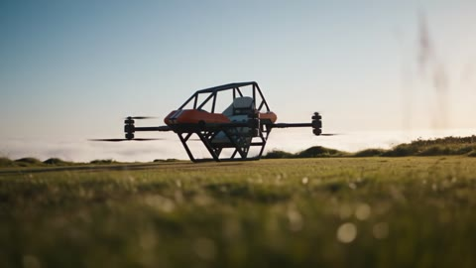 | 2.6–4.0 s | 低机位滑向 Dream：草被吹平，螺旋桨慢下来，完全停住。这时没有任何人在旁边。 | 慢
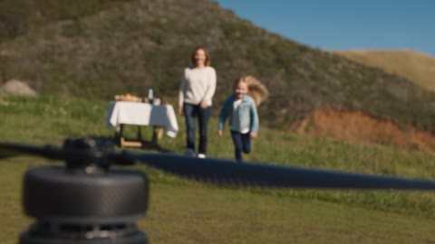 | 4.0–5.6 s | 前景是静止的螺旋桨；螺旋桨停稳以后女儿才跑过来，焦点从桨叶移到她身上，妈妈在后面慢慢走。 | 慢
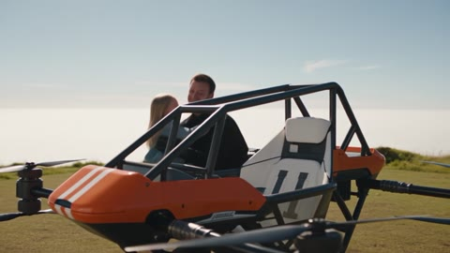 | 5.6–7.6 s | 环绕驾驶舱：他摘下头盔，头发被风吹乱，笑着；女儿跑到跟前，他把她抱进座椅。切在她落进座椅的动作上。 | 中
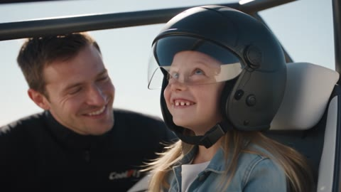 | 7.6–10.0 s | 他把大一号的头盔戴到女儿头上，她咯咯笑；焦点移到爸爸的笑脸；女儿仰头看天，镜头跟着她的视线往上摇，明亮的晨空和柔和的光晕铺满画面。 | 慢

英文提示词（提交给即梦的原文）
提交前，提示词里的 @名字会换成画布节点。
A 10-second live-action commercial scene, 16:9, a clear sunny morning on a wide clifftop meadow on the California coast. It continues the previous clip without a break: it opens on exactly the previous clip's last frame, high behind the descending aircraft, and the same descending camera move carries on down to the meadow, revealing his wife and young daughter waiting by a breakfast table. The aircraft lands far away at the other end of the meadow, at least 40 metres from them; the propellers stop completely; only then does the daughter run across the grass. He takes off his helmet, lifts her into the seat and sets the too-big helmet on her head; he watches her and smiles; she tilts her head back to look at the sky and the camera follows her gaze up into the bright morning sky. The aircraft stays switched off on the ground.

REFERENCES
@p2_end — the last frame of the previous clip. THE VERY FIRST FRAME OF THIS CLIP IS EXACTLY THIS IMAGE.
@prop_dream2 — the aircraft; every detail; ignore the grey backdrop.
@char_pilot4 — the pilot in his suit with both CoolFly wordmarks, gloves and the black helmet with the perfectly clear visor.
@char_pilot3 — the pilot's face and hair without a helmet, seen after he takes the helmet off at 5.8s; ignore the grey backdrop.
@char_family — his wife (shoulder-length light-brown hair, cream knit sweater, dark jeans) and their 8-year-old daughter (long sandy-blonde hair, freckles, light denim jacket, white T-shirt, navy leggings, white sneakers); ignore the grey backdrop and the sheet layout.
@loc_breakfast — the clifftop meadow: the breakfast table on the left, the long open meadow stretching away to the right; the aircraft lands at the far end of that open meadow.

LOOK
High-end lifestyle commercial, clean modern digital cinema, 24–85mm lenses, shallow depth of field. Warm golden morning sun, long soft shadows, morning mist lying low over the ocean beyond the cliff edge, clear blue sky, wild flowers; the aircraft's orange is the strongest colour. Natural light only. The camera is always moving, gently — one continuous descending crane at the start, then slides, slow orbits and motivated focus pulls; across every cut the motion continues. Warm and tender. No locked-off shots.

CHARACTERS
The pilot — the same American man as @char_pilot3 and @char_pilot4. Glowing, a little windswept, a quiet proud smile. Never speaks, never looks into the lens.
The wife — as @char_family. Relaxed, amused, warm. She stays by the table until the propellers have stopped, then walks slowly across.
The daughter — as @char_family, 8 years old. Bursting with excitement, she stays at her mother's side until the propellers have stopped, then runs across the meadow; in the seat she goes still with wonder.
No one speaks; only the girl laughs.

AIRCRAFT RULE
Exactly one CoolFly Dream, identical to @prop_dream2 in every frame, eight two-blade carbon propellers, plain orange fairing with two white stripes, no numbers, letters or text anywhere on it. It descends to the far end of the meadow and lands at 2.4s, at least 40 metres from the table; the motors are switched off at once and the propellers are completely still by 3.8s; it never moves or lifts again. The girl only sits in it on the ground. Never redesigned, never round or hexagonal, nothing on it glows. The pilot is in the seat until he climbs out.

WHERE EVERYTHING IS — fixed for the whole clip
The breakfast table with the white linen cloth, coffee pot and mugs is on the left near the meadow's edge; the wife and the daughter stand beside it; the long open meadow runs away to the right; the aircraft lands at its far end, at least 40 metres from the table, nose toward the ocean. No vehicles, no other people.

SHOTS
0.0–2.6s — THE VERY FIRST FRAME OF THE CLIP IS EXACTLY @p2_end: the camera high behind the descending aircraft, the green meadow and the cliff edge ahead. The same descending move continues without a break: the camera follows the aircraft down and keeps sinking, down through the tops of tall wild-flower stems at the meadow's edge to grass level; as it lands it reveals, on the left, the breakfast table with the wife and the daughter beside it, shading their eyes and looking up. The aircraft continues to the far end of the meadow on the right and settles on the grass at 2.4s, small and far away. BACKGROUND: the long meadow, the cliff edge, the ocean.

2.6–4.0s — 50mm, the camera slides low over the grass toward the far end of the meadow, continuing the same direction; the grass around the parked aircraft flattens in a ring; the propellers slow from discs to visible blades and are completely still by 3.8s. Nobody is near it.

4.0–5.6s — 50mm close on a still carbon propeller blade in sharp focus in the foreground, the camera drifting slowly sideways; at 4.2s, far away across the meadow, the daughter breaks away from her mother and runs toward the aircraft, and the focus pulls from the blade to her as she runs closer, hair flying; the wife follows slowly.

5.6–7.6s — 50mm, a slow orbit around the cockpit. At 5.8s the pilot pulls his helmet off, his short dark-brown hair messed by the wind, his face the same man as @char_pilot3, grinning. The daughter arrives at 6.3s, breathless and laughing; he lifts her by the waist and swings her up into the white seat — cut on that movement as she lands in the seat at 7.6s.

7.6–10.0s — 85mm, front three-quarter on the daughter in the seat, a slow push-in. At 7.8s he sets the big helmet on her head; it is far too big and tilts to one side; at 8.1s she giggles and pushes it straight with both hands; at 8.5s the focus pulls to his face beside her: he watches her and smiles. At 9.0s she tilts her head back and looks up at the sky with shining eyes, and the camera follows her gaze, tilting up past the top of her helmet into the bright morning sky; by 9.8s soft bright blue sky with a gentle warm sun flare fills the whole frame, every edge and corner. The clip ends on the bright sky.

SOUND
No music: the score is added in post. Diegetic sound only: wind continuing from the previous clip; the rotor descending; a soft touchdown at 2.4s; motor spin-down whine 2.4–3.8s, then silence from the aircraft; meadow wind and birdsong; the girl's quick footsteps in the grass from 4.2s; helmet strap sounds at 5.8s; her breathless laugh at 6.3s; a delighted giggle at 8.1s that keeps ringing softly as the camera rises into the sky. No dialogue, words, narrator, stings or added whooshes.

KEEP CONSISTENT
- The first frame is exactly @p2_end and the descending move continues from it without a break, down to grass level.
- The aircraft lands at least 40 metres from the table; nobody is near it until the propellers are completely still at 3.8s; the girl starts running only at 4.2s.
- Exactly one aircraft, identical to @prop_dream2; no numbers or text on it; switched off and still from 3.8s; it never lifts or moves again; the girl never flies.
- The pilot's face matches @char_pilot3 after the helmet comes off.
- Exactly three people: the pilot, the wife, the daughter; no one else, no vehicles, no birds near the aircraft.
- The clip ends with the camera tilted up into the bright sky filling the whole frame.
- Warm, rich colour, never washed out.
- Apart from the two CoolFly wordmarks on the suit, no subtitles, on-screen text, other logos or watermarks.

6.4 第 4 段 · FINALE · 收尾 · 定版（10 秒，全片 32–42 s）
说明：第一帧 = 第 3 段最后一帧（@p3_end）。定版镜头模型只给了约 1.8 秒，样片里后期放慢到约 4.7 秒。
参考图：@p3_end · @char_pilot3 · @char_pilot4 · @char_family · @prop_dream2 · @loc_breakfast

分镜
画面（样片截图） | 时间 | 内容 | 节奏
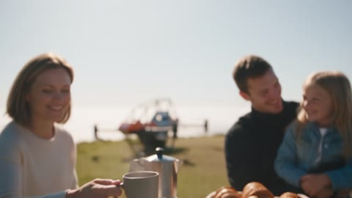 | 0.0–2.0 s | 从同一片天空往下摇：妻子的手把冒着热气的咖啡杯放在亚麻桌布上（呼应片头），焦点移开，露出一家人在早餐桌旁笑着，远处停着橙色的 Dream。 | 慢
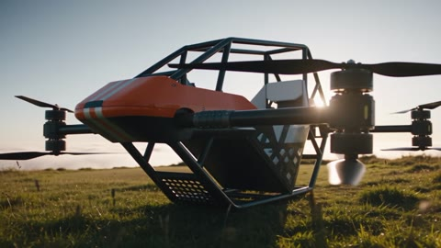 | 2.0–3.6 s | 低机位慢慢环绕停着的 Dream，逆光从防滚架里透过来。 | 慢
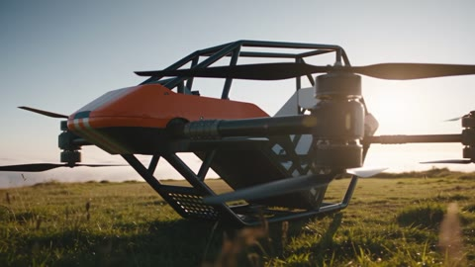 | 3.6–4.1 s | 微距：碳纤维机臂的纹理。 | 快
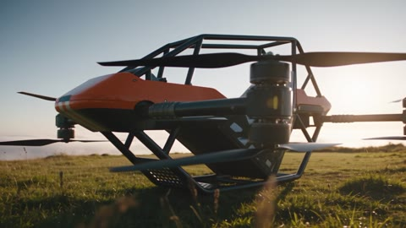 | 4.1–4.6 s | 微距：黑色共轴电机和静止的螺旋桨。 | 快
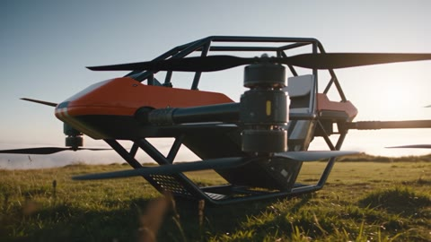 | 4.6–5.1 s | 微距：橙色整流罩的弧线和两条白色条纹（不出现编号）。 | 快
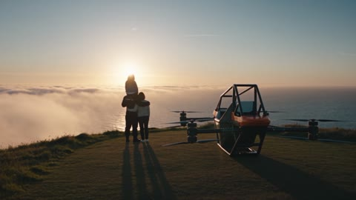 | 5.1–10.0 s | 定版英雄远景：Dream 停在崖边，一家人背对镜头站在旁边看海和朝阳，女儿骑在爸爸肩上；构图对称，上方三分之一留给文字；几乎静止。 | 静止

英文提示词（提交给即梦的原文）
提交前，提示词里的 @名字会换成画布节点。
A 10-second live-action commercial finale, 16:9, the same sunny clifftop morning, a little later. It continues the previous clip without a break: it opens on exactly the previous clip's last frame, the bright morning sky, and the camera tilts and cranes down out of the sky to a coffee mug being set down on the breakfast table, revealing the family laughing together at breakfast with the Dream parked far away on the meadow; a slow orbit around the parked aircraft, three quick macro beats of its details, and then the stillest, longest shot of the film: the family standing beside the Dream at the cliff edge, seen from behind, looking out at the ocean and the sun, held for five seconds with open sky above for the title.

REFERENCES
@p3_end — the last frame of the previous clip. THE VERY FIRST FRAME OF THIS CLIP IS EXACTLY THIS IMAGE.
@prop_dream2 — the aircraft; every detail of shape, livery, carbon arms, coaxial motors and propellers; ignore the grey backdrop.
@char_pilot3 — the pilot without a helmet, still in his black flight suit with the CoolFly wordmarks (as @char_pilot4).
@char_pilot4 — the flight suit and both CoolFly wordmarks.
@char_family — his wife and their 8-year-old daughter, exactly as their sheet.
@loc_breakfast — the clifftop meadow with the breakfast table on the left, the long open meadow to the right and the cliff edge above the ocean.

LOOK
High-end automotive commercial finale, clean modern digital cinema, 35–100mm lenses including macro, shallow depth of field. Warm low golden sun, a soft natural sheen on the orange clear coat, real carbon weave, morning mist on the ocean beyond the cliff edge. Natural light only; nothing on the aircraft glows. RHYTHM: slow 0.0–3.6s, three quick beats 3.6–5.1s, then complete stillness 5.1–10.0s — the calm after the energy, like the held final shot of a car commercial. The camera keeps only a barely perceptible drift in the final shot; no handheld shake.

CHARACTERS
The pilot — the same American man as @char_pilot3, no helmet, black flight suit, relaxed, laughing with his family. Never looks into the lens.
The wife and the daughter — as @char_family, happy and relaxed.
No one speaks.

AIRCRAFT RULE
Exactly one CoolFly Dream, identical to @prop_dream2 in every frame, parked and switched off on the grass near the cliff edge at the far end of the meadow, at least 40 metres from the table, nose toward the ocean; all eight propellers are completely still; it never moves. Plain glossy orange front fairing with two white vertical stripes, dark-grey tubular roll cage, white seat, four carbon arms, coaxial motor pairs. No numbers, letters, logos or text anywhere on the aircraft. Never redesigned.

SHOTS
0.0–2.0s — THE VERY FIRST FRAME OF THE CLIP IS EXACTLY @p3_end: the bright morning sky with a gentle sun flare filling the frame. The camera tilts and cranes down out of the sky in one smooth move; at 0.9s the wife's hand sets a steaming ceramic coffee mug down on the white linen tablecloth in the near foreground; the focus pulls to reveal the family at the breakfast table — the pilot laughing, the daughter on his knee, the wife sitting down beside them — and, far behind them at the end of the meadow, the parked orange Dream in the golden light. SLOW.

2.0–3.6s — 35mm low, a slow orbit around the parked aircraft on the grass, from its front three-quarter toward its side, the low sun flaring softly through the roll cage and rimming the arms, the grass moving in the breeze. SLOW.

3.6–4.1s — QUICK: 100mm macro gliding along a carbon-fibre arm, the real weave catching the light.

4.1–4.6s — QUICK: 100mm macro sliding over the black coaxial motor pair and a still two-blade propeller.

4.6–5.1s — QUICK: 100mm macro gliding along the curve of the plain orange fairing and its two white stripes, the sky reflected in the clear coat; no numbers or text.

5.1–10.0s — THE FINAL HERO SHOT, STILL, lasting the full 4.9 seconds: a wide 35mm from low behind, a calm symmetrical composition. The parked Dream stands at the cliff edge in the right half of frame, seen from behind, nose to the ocean, its arms and still propellers in silhouette, a warm rim of sunlight along the roll cage. Beside it on the left, the family stands with their backs to camera looking out to sea: the pilot with his daughter riding on his shoulders, the wife leaning against him. Beyond them the glittering ocean, the morning mist and the low sun just above the horizon at the centre. The upper third of the frame is open, clean sky. The camera pushes in so slowly that it is almost still; nobody moves except the girl's hair and the grass in the wind. The clip ends on this held frame at 10.0s.

SOUND
No music: the score is added in post. Diegetic sound only: the girl's giggle continuing from the previous clip and melting into the family's quiet laughter at the table, no words; the soft knock of the mug on the table at 0.9s; meadow wind, distant surf and birdsong; in the final shot only a soft wind and the far surf. No dialogue, words, narrator, stings or added whooshes.

KEEP CONSISTENT
- The first frame is exactly @p3_end and the camera tilts down out of that sky without a break.
- The aircraft is parked, switched off and completely still near the cliff edge, at least 40 metres from the table; it never moves.
- Exactly one aircraft, identical to @prop_dream2; eight still propellers; no numbers, letters or text anywhere on it.
- Exactly three people; no one else, no vehicles.
- The final shot from 5.1s is the stillest and longest shot: composed, symmetrical, open sky in the upper third, held for the full 4.9 seconds to 10.0s.
- Warm, rich colour, never washed out.
- Apart from the CoolFly wordmarks on the suit, no subtitles, on-screen text, other logos or watermarks.

7. 后期
- 配乐：Seed Music，在 6 秒（起飞爆发）、17 秒（慢动作）、19.8 秒（恢复）、35.6 秒（三个快拍）和 37.1 秒（定版）几处踩点。
- 数据小字（英文，只用已确认的参数）：第 2 段叠 100 km/h，第 3 段叠 40 min，第 4 段叠 Dream Pro / Dream ST 参数。
- 定版文字：约 38.5 秒在天空位置淡入产品名「Dream」；标语那一行先空着，等 slogan 定了再加。
- 结尾卡：42 秒硬切到整屏 CoolFly 橙色，配黑色 logo，3 秒。
- 响度统一到 −14 LUFS，输出 16:9 母版。

产品参数（画面上只能出现这些数据）
 | Dream Pro | Dream ST
续航（载一位 70 kg 驾驶员） | 40 分钟 | 16 分钟
最高速度 | 100 km/h | 100 km/h
载重 | 120 kg | 95 kg

8. 待定事项
- 四段样片确认后，在网页画布上直出 1080p：约 2,688 积分，今天剩 2,507，最后一段可能要明天出。
- 加州海岸面朝西，日出在陆地一侧；现在片中的太阳在海平面上，更像日落。要不要把故事时间改成傍晚，待定。
- Slogan 待定；定下以后再考虑旁白或文字。

