NOTE: Use of internet is not permitted, calculators are permitted and your answers must include worked solutions. If you require extra sheet(s) please write your name and student number at the top of each additional sheet.

**Objective**

Complete exam questions d, e, and f below

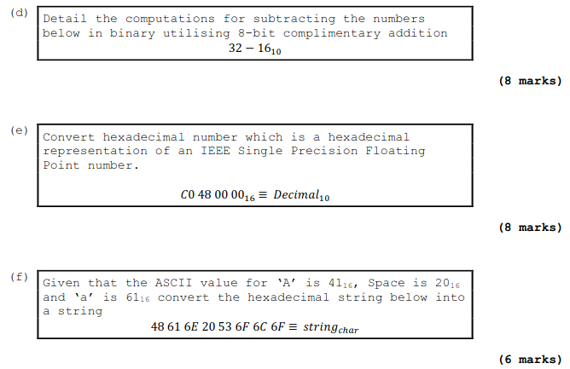

Hand up this practical report at the end of session and ensure it has been checked

|  |  |  |  |
| --- | --- | --- | --- |
| **Student Name** | **David Darigan** | **Student Number** | **C00263218** |
| **Date** | **10th November 2021** | **Checked** |  |
| **Group** | **A / B** |  | **A** |