PART 2:

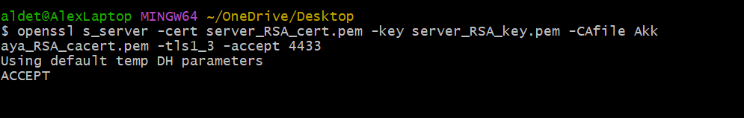

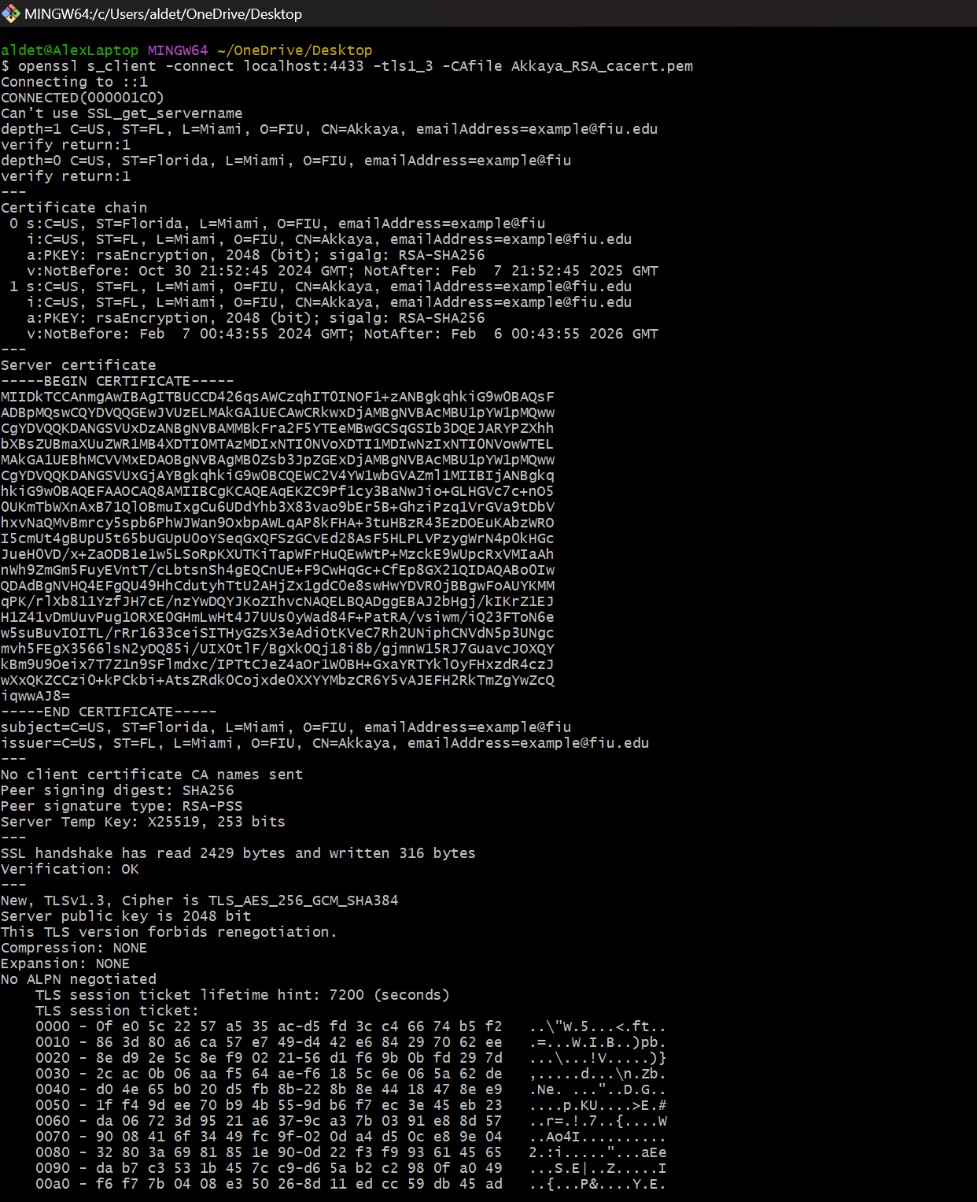
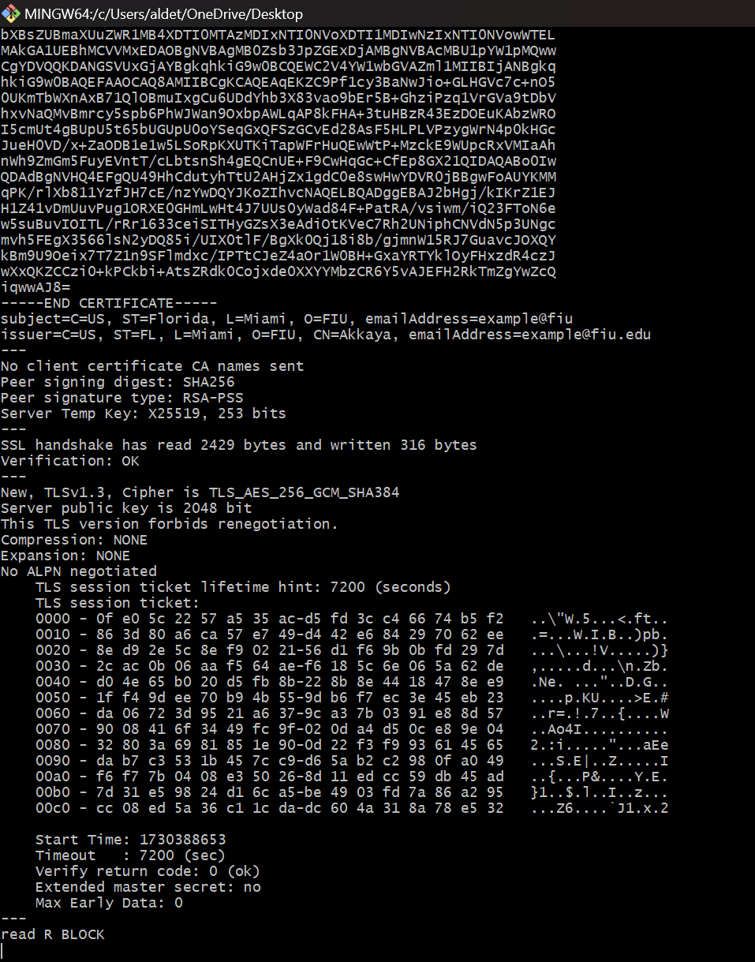

After running the command to view all the available cipher suites, were you
able to find the cipher suite shown in the client’s output? Provide the name
of the used cipher suite.
- Yes, I was able to find the cipher suite shown in the client’s output. The name of it is TLS_AES_256_GCM_SHA384.

ANSWER the following:
• Based on the filtered packets, which version of TLS is being used?
- Version 1.2 is being used.
▪ How can you find the TLS version?
- You can see it in the Transport Later Security frame under Handshake Protocol.
▪ Find the used cipher suite for this communication in the filtered packets.
Hint (It’s in the Client Hello packet). Expand everything in the Transport
Layer Security frame in Wireshark. Once you find it, provide a screenshot.
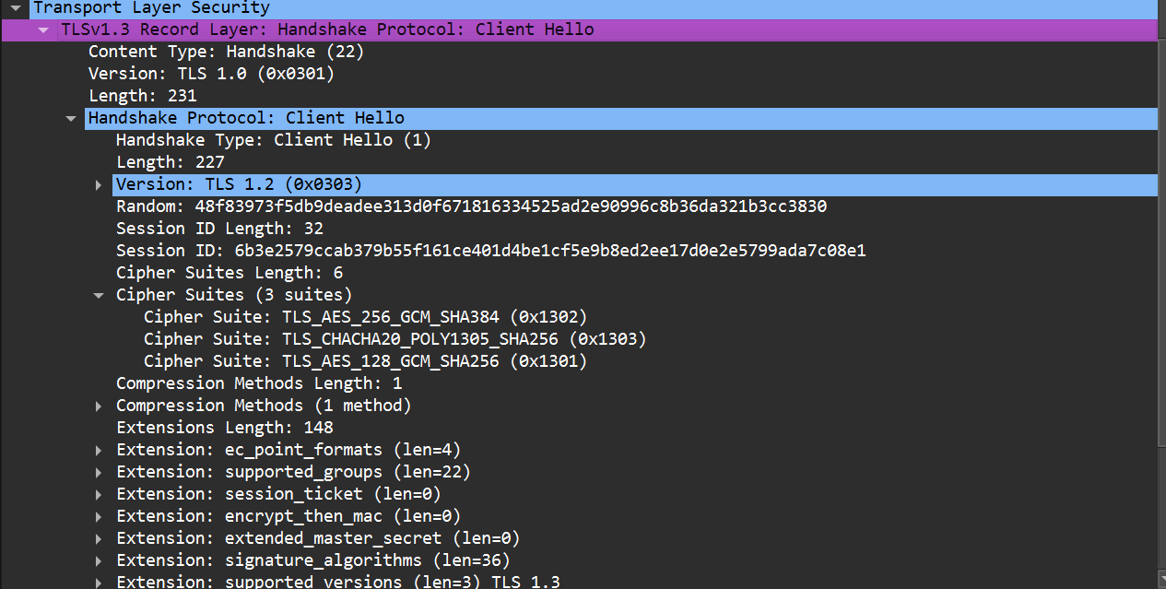

PART 3:
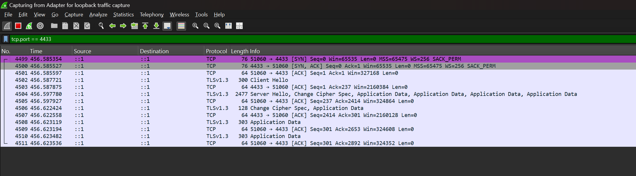

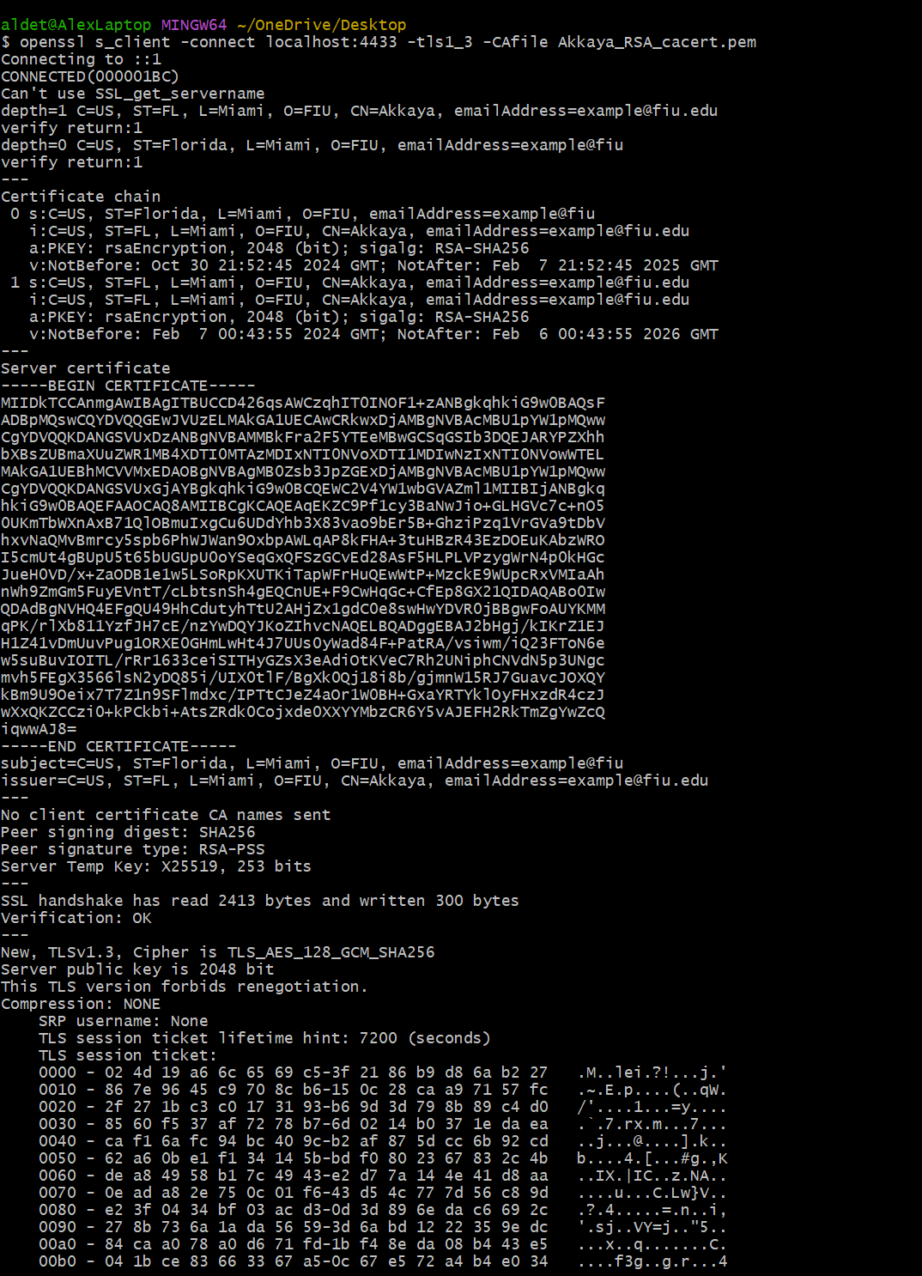
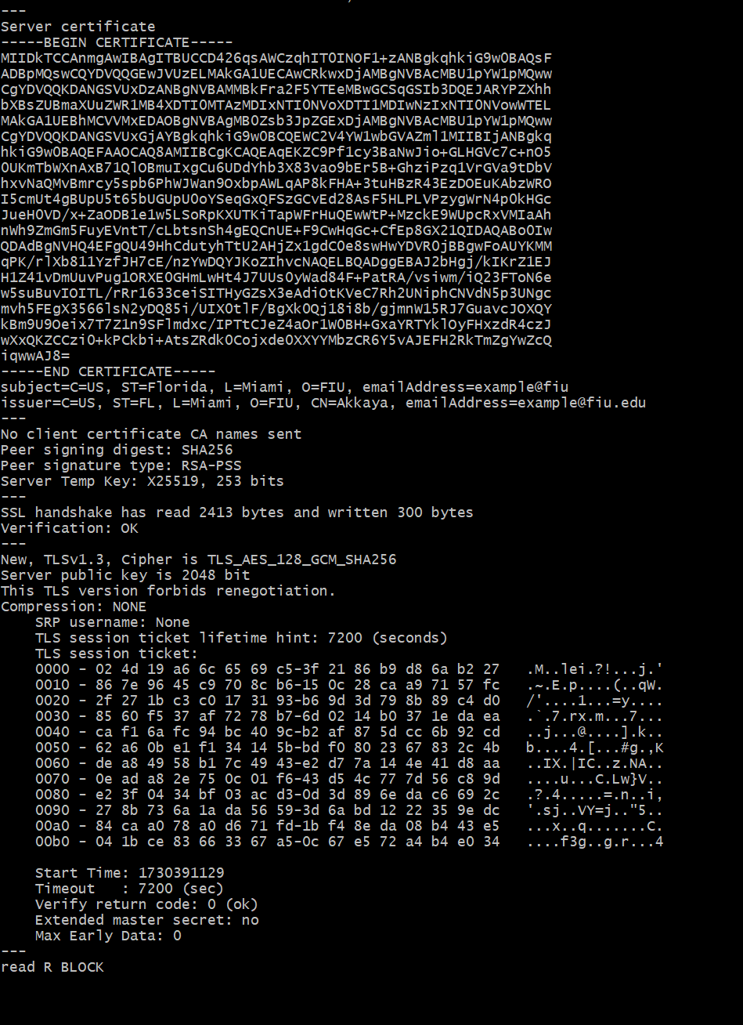
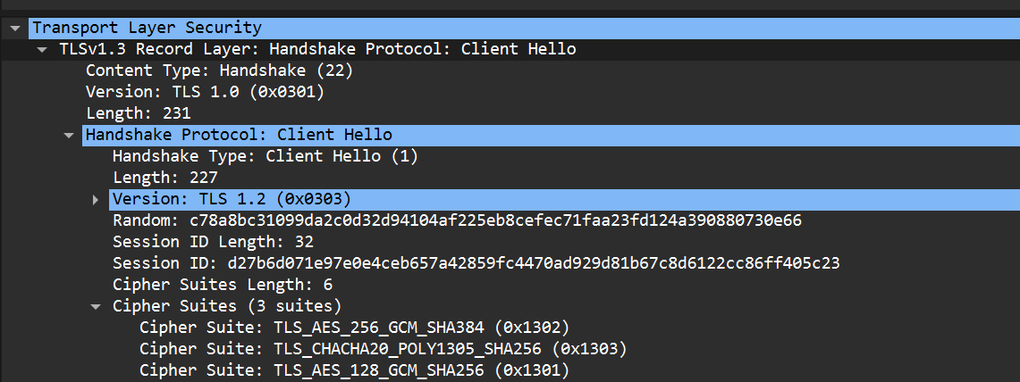

Which TLS version is being used?
- Version 1.2.

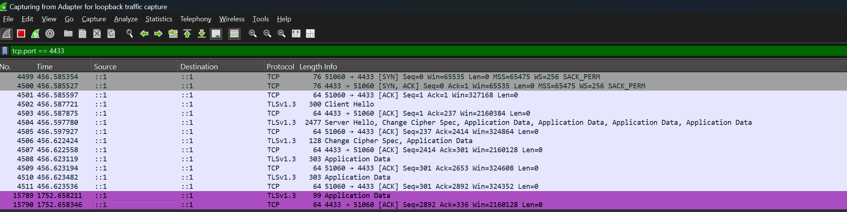

Can you see the Hello World in the payload in the new packets? Is it
encrypted?
- I cannot see the Hello World in the payload. It seems to be encrypted.

