Part 1 Screenshots:

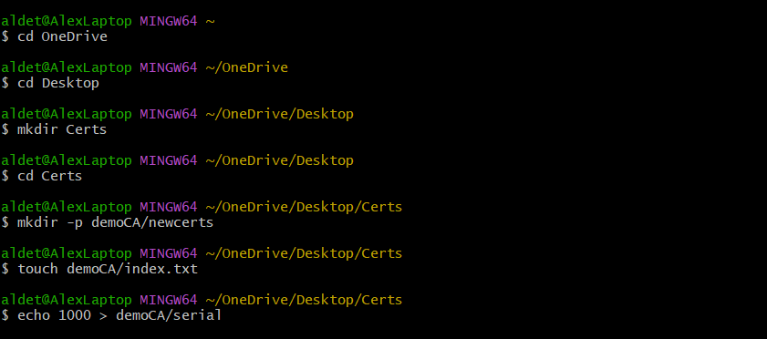

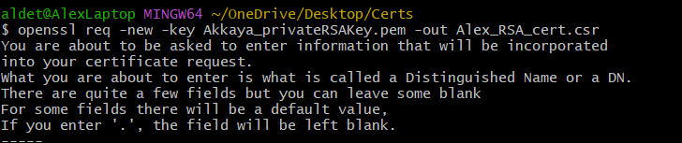

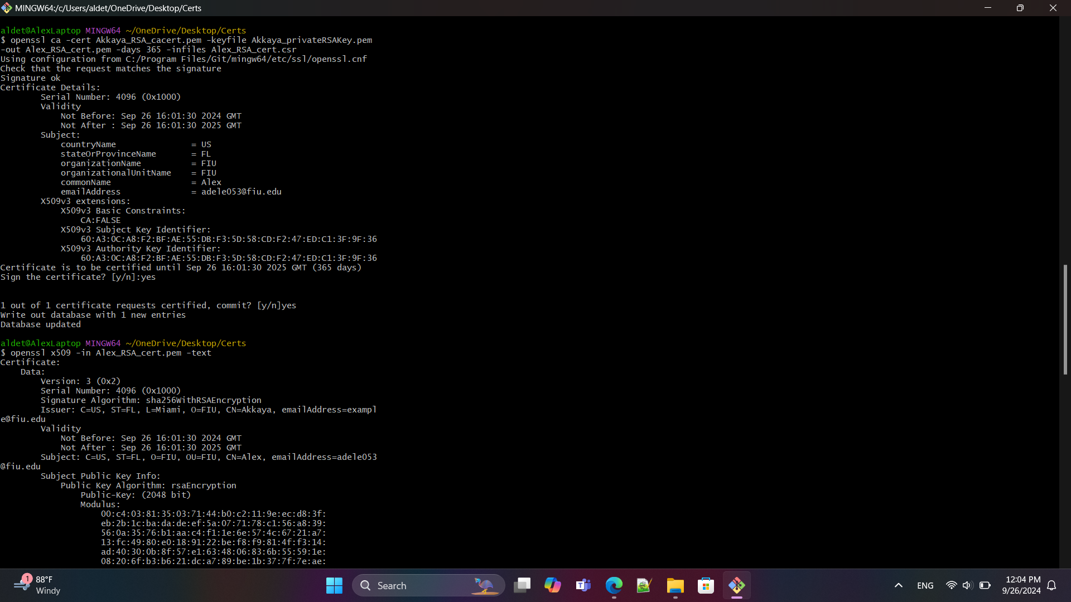

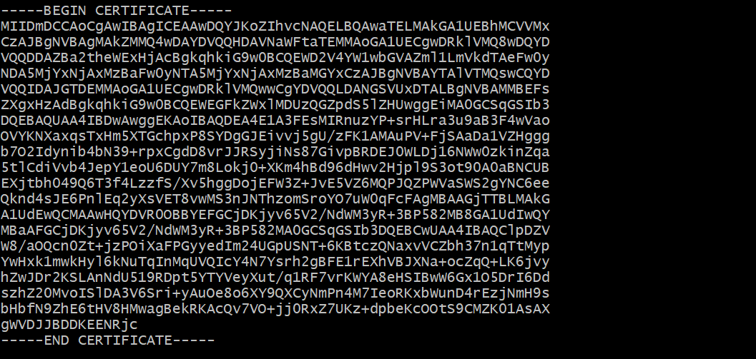

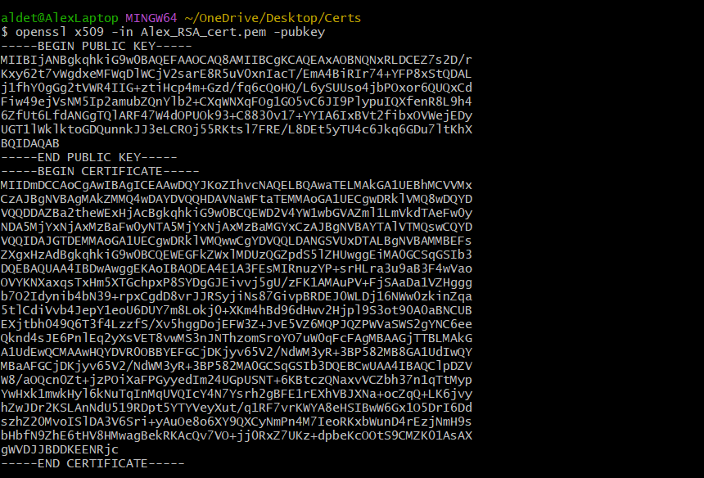
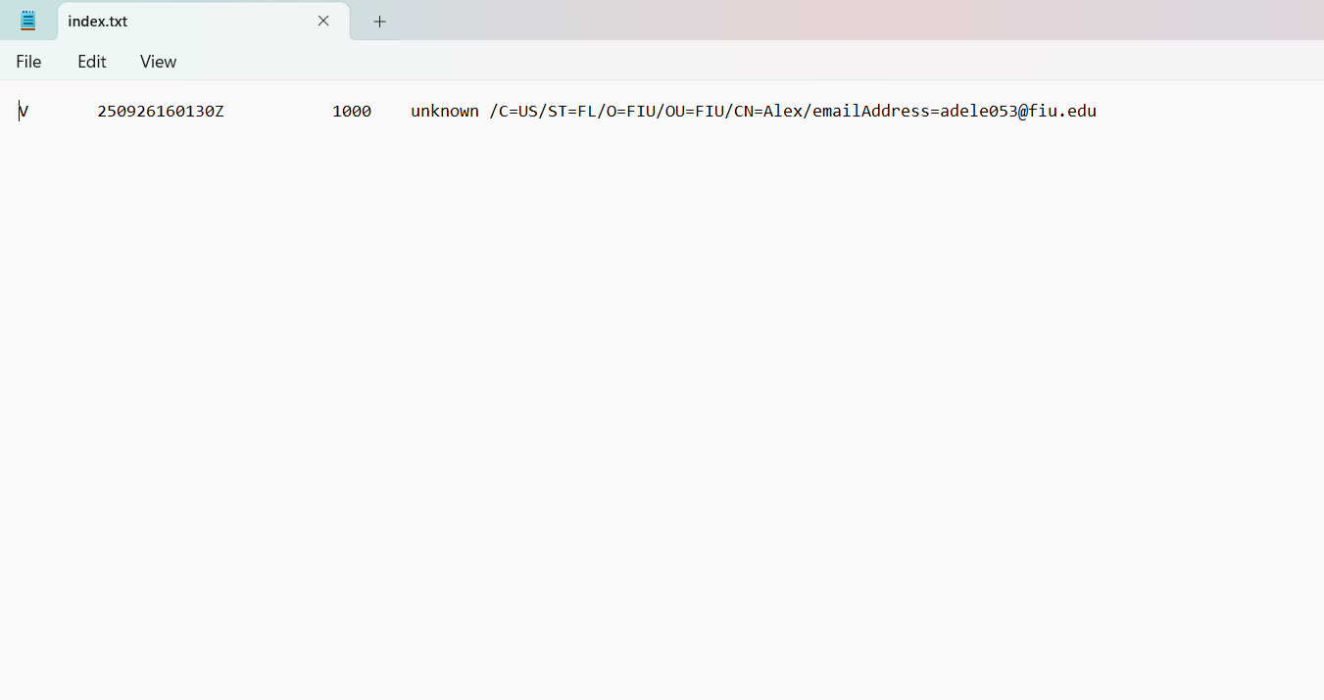

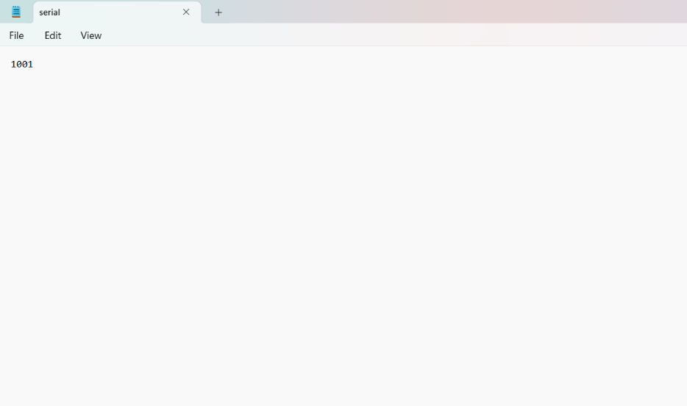

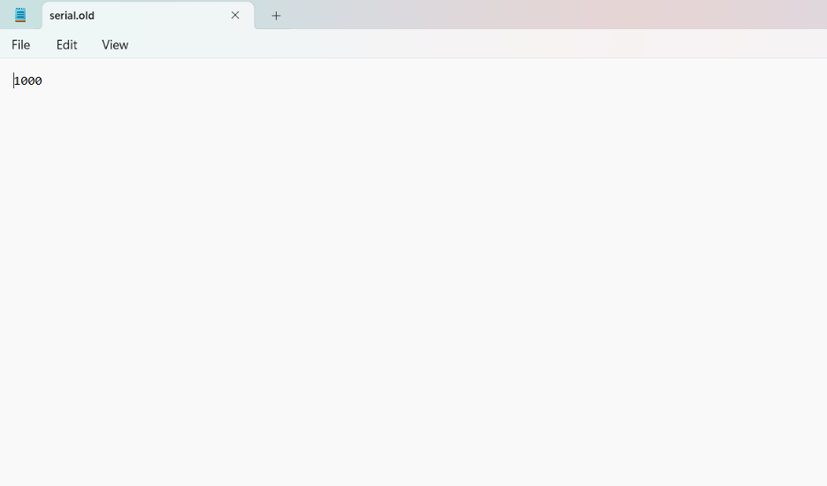

Part 2 Screenshots:

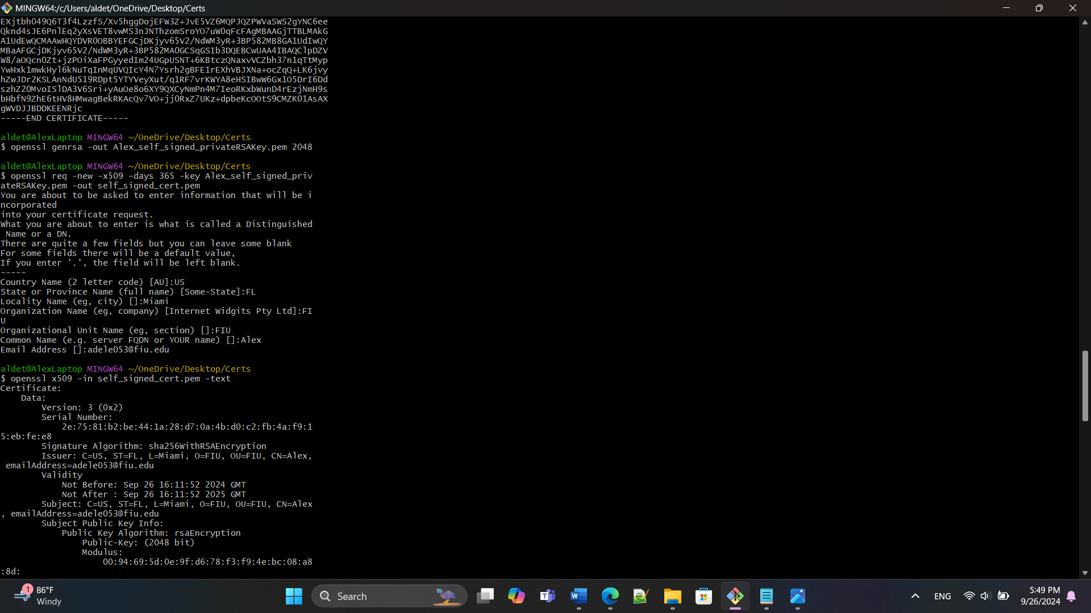
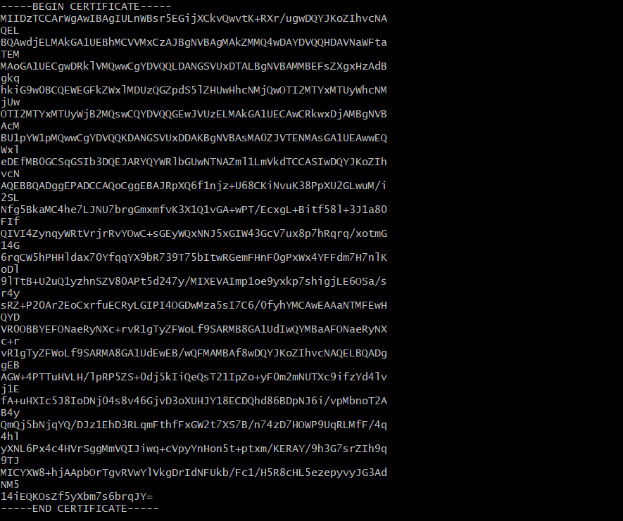

Questions:
- What makes a self-signed certificate different from a certificate that is
signed through a CA and what is the part that was not used in the self-
signed certificate?
- With a self-signed certificate, the answers you input are not compared to anything unlike with a CA-signed certificate. Additionally, a self-signed certificate only vouches for itself while a CA-signed certificate validates the entity that is requesting the certificate and is signed by a third party. The part that was not used in the self-signed certificate was the one asking for ‘extra’ attributes, including a challenge password and optional company name.

- What is the main difference when comparing self_signed_cert.pem and
Your_Name_RSA_cert.pem. (hint: use openssl x509 -in cert.pem -text)
- The main difference when comparing both is the difference in serial number.

