**Handout-1**

**Q1. Demonstrate the concept of data binding using ng-model and ng-bind directives**

**Q2. Demonstrate the concept of data binding using ng-init directives and expressions for binding data and displaying the data**

**Q3. Demonstrate the use and scope of ng-app directive**

**Q4. Develop a "hello world" program with AngularJS which shows the model, view and controller parts of an AngularJS app.**

**Q5.Demonstrate ng-model directive for one way binding and two-way binding**

**Q6. Demonstrate the use of ng-init directive to initialize an array an use ng-repeat to display the same.**

**Q7. Develop an HTML and Angular JS code to display cost calculator**

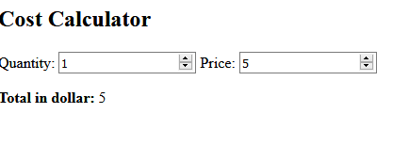

**Q8. Write a Angular JS application to display(** Firstname, lastname( as object properties)Marks: (as an array element)

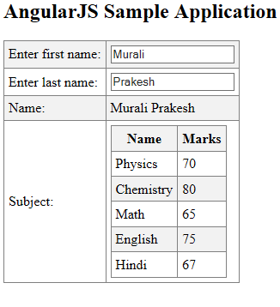

Q6.Demonstrate angular JS expressions to display

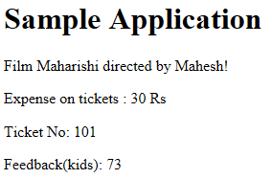

<html>

<head>

<title>AngularJS Expressions</title>

</head>

<body>

<h1>Sample Application</h1>

<div ng-app = "" ng-init = "quantity = 1;cost = 30; student =

{filmname:'Maharishi',directorname:'Mahesh',Ticketno:101};feedback = [80,90,75,73,60]">

<p> Film {{student.filmname + " directed by " + student.directorname}}!</p>

<p>Expense on tickets : {{cost * quantity}} Rs</p>

<p>Ticket No: {{student.Ticketno}}</p>

<p>Feedback(kids): {{feedback[3]}}</p>

</div>

<script src = "https://ajax.googleapis.com/ajax/libs/angularjs/1.3.14/angular.min.js">

</script>

</body>

</html>

Q7.Demonstrate the use of filters to display first five students from total of 10 students ordered by their names.(actor)

Q8.Develop an Angular JS form with following validations

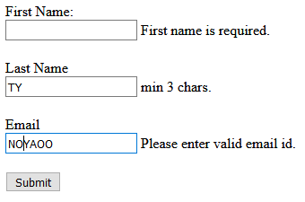

<!DOCTYPE html>

<html>

<head>

<script src="https://ajax.googleapis.com/ajax/libs/angularjs/1.3.16/angular.min.js"></script>

</head>

<body ng-app >

<form name="studentForm" novalidate>

<label for="firstName">First Name: </label> <br />

<input type="text" name="firstName" ng-model="student.firstName" ng-required="true" />

<span ng-show="studentForm.firstName.$touched && studentForm.firstName.$error.required">First name is required.</span><br /><br />

<label for="lastName">Last Name</label><br />

<input type="text" name="lastName" ng-minlength="3" ng-maxlength="10" ng-model="student.lastName" />

<span ng-show="studentForm.lastName.$touched && studentForm.lastName.$error.minlength">min 3 chars.</span>

<span ng-show="studentForm.lastName.$touched && studentForm.lastName.$error.maxlength">Max 10 chars.</span><br /><br />

<label for="dob">Email</label><br />

<input type="email" id="email" ng-model="student.email" name="email" />

<span ng-show="studentForm.email.$touched && studentForm.email.$error.email">Please enter valid email id.</span><br /><br />

<input type="submit" value="Submit" />

</form>

</body>

</html>