Lab Report

1. Github repo: <https://github.com/jaycelmarie/CC>

Hello World Output

Index of Website

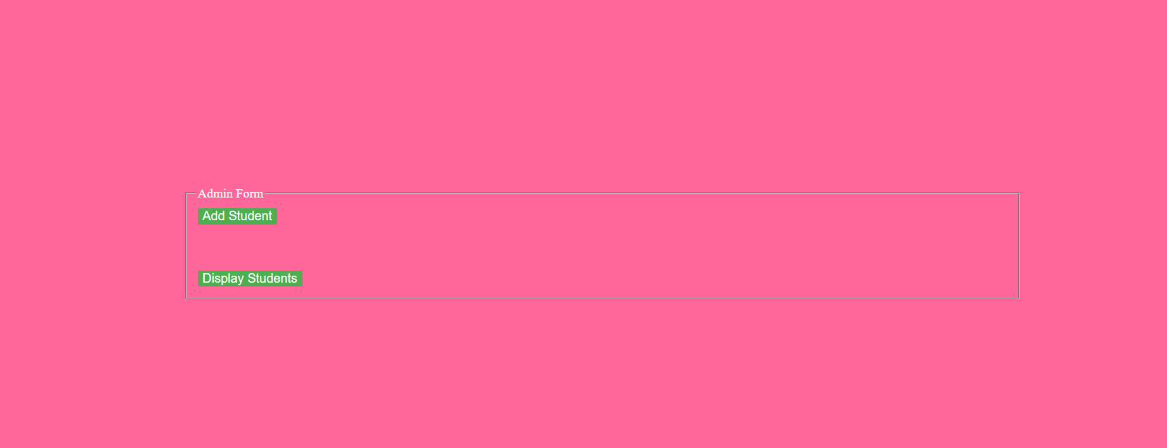

Add Student + Form for creativity

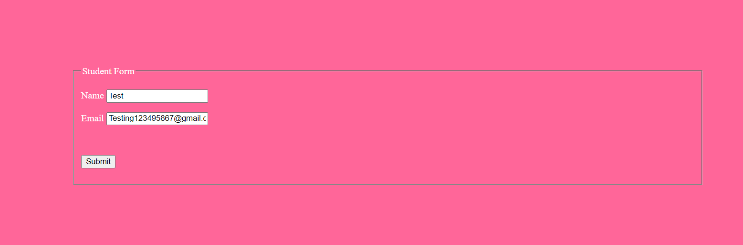



Display Students



1. What I found most difficult in this weeks lab was figuring out how to deploy the application as I wasn’t sure if we needed to go use DevOps for it. I have watched youtube tutorials to get an idea of how to approach this week’s lab. After figuring out how to approach this after talking to my fellow classmates, everything was fine.

It didn’t take long to figure out what to do next after going through the initial process. The github examples helped a lot.