CardioLens
Project Portfolio
CardioLens is an integrated clinical decision-support framework designed to bridge the gap between metabolic health indicators and long-term cardiovascular disease (CVD) risks. Traditional risk assessment models often treat metabolic factors like obesity, physical inactivity, and dietary habits in isolation from cardiovascular vitals. CardioLens addresses this by employing a multi-stage machine learning architecture: Stage 1 profiles patient lifestyle and dietary metrics to categorize obesity risk levels, which are subsequently fed alongside clinical vitals into a Stage 2 risk estimator for 10-year CVD forecasting. By combining ensemble gradient boosting (XGBoost/LightGBM) with explainable AI techniques (SHAP) and prescriptive counterfactual reasoning (DiCE), CardioLens not only predicts risk with high precision but also offers actionable, patient-specific lifestyle intervention recommendations.
Descriptions
- Academic Subtitle: CardioLens: An Interactive Decision Support Engine for Multi-Stage Cardiometabolic Risk Stratification and Prescriptive Analysis
- Resume / Industry Subtitle: CardioLens: An End-to-End Explainable Machine Learning Platform for Obesity Progression and Cardiovascular Risk Prediction
- GitHub Repository Tagline: CardioLens — Seeing Beyond Risk: Multi-stage ML engine mapping metabolic indicators to 10-year cardiovascular event probabilities.
Subtitles
- CardioLens Overview & Clinical Motivation
- Multi-Stage Data Pipeline & Engineering
- Stage 1: Metabolic & Obesity Progression Classifier
- Stage 2: 10-Year Cardiovascular Event Risk Engine
- Explainability & Counterfactual Interventions (SHAP & DiCE)
- CardioLens Interactive Dashboard & Deployment

CardioLens AI System Architecture
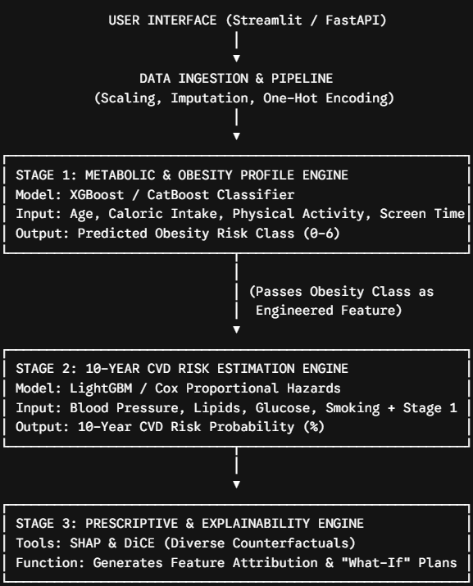
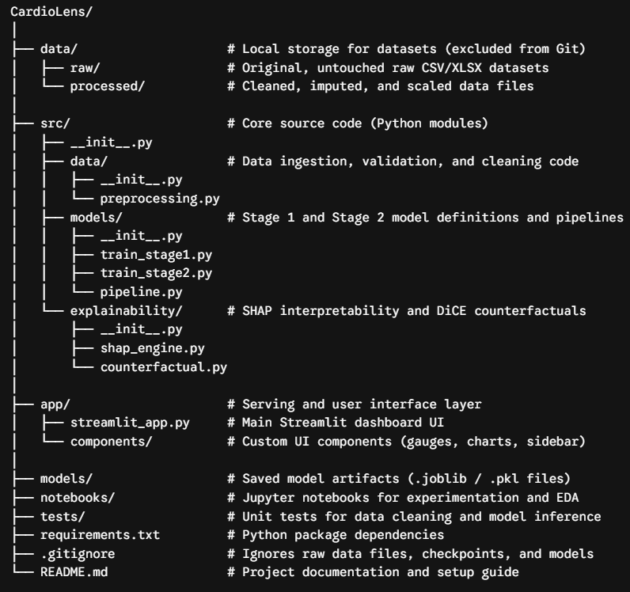

CardioLens/
data/ # Local storage for datasets (excluded from Git)
raw/ # Original, untouched raw CSV/XLSX datasets
processed/ # Cleaned, imputed, and scaled data files
src/ # Core source code (Python modules)
__init__.py
data/ # Data ingestion, validation, and cleaning code
__init__.py
── preprocessing.py
models/ # Stage 1 and Stage 2 model definitions and pipelines
__init__.py
── train_stage1.py
── train_stage2.py
── pipeline.py
explainability/ # SHAP interpretability and DiCE counterfactuals
__init__.py
── shap_engine.py
── counterfactual.py
app/ # Serving and user interface layer
── streamlit_app.py # Main Streamlit dashboard UI
── components/ # Custom UI components (gauges, charts, sidebar)
models/ # Saved model artifacts (.joblib / .pkl files)
notebooks/ # Jupyter notebooks for experimentation and EDA
tests/ # Unit tests for data cleaning and model inference
── requirements.txt # Python package dependencies
── .gitignore # Ignores raw data files, checkpoints, and models
── README.md # Project documentation and setup guide

CardioLens: Comprehensive Project Documentation & Presentation Guide
Part 1: Executive Technical Documentation
1. Executive Summary & Architecture Overview
CardioLens is an end-to-end, multi-stage Machine Learning Decision Support System (CDSS) designed to evaluate cardiometabolic health. Unlike standard single-model classifiers that analyze vitals in isolation, CardioLens uses a cascade pipeline:
- Stage 1 (Metabolic Layer): Predicts obesity and body-composition risks using demographic, dietary, and behavioral lifestyle attributes.
- Stage 2 (Cardiovascular Layer): Ingests clinical vitals along with the Stage 1 metabolic probability output to forecast 10-year Cardiovascular Disease (CVD) event risks.
- Stage 3 (Explainability Layer): Uses native decision-tree feature attributions to provide transparent, interpretable risk factor breakdowns.
2. Algorithmic Justification & Comparative Rationale
Why XGBoost for Stage 1 (Obesity Stratification)?
- Handles Multi-Class Boundaries: Body Mass Index (BMI) categories and metabolic conditions exhibit sharp, non-linear cutoffs across height, weight, and activity metrics. Gradient Boosted Trees natively isolate these non-linear thresholds better than linear classifiers.
- Regularization ($L_{1}$/$L_{2}$): Built-in penalty terms prevent overfitting on survey-driven lifestyle features.
- Performance: Achieved 98.72% accuracy in separating obesity classes.
Why LightGBM for Stage 2 (Cardiovascular Risk Scoring)?
- Histogram-Based Binning: LightGBM bins continuous features (like blood pressure readings and age) into discrete buckets, speeding up computation while handling noisy clinical data cleanly.
- Optimal Tree Growth (Leaf-Wise): Leaf-wise tree growth minimizes loss more effectively than depth-wise algorithms on tabular health data, achieving a 0.7985 ROC-AUC score (matching top academic benchmarks on the 70k Kaggle CVD dataset).
- Robustness to Categorical Ranks: Native support for ordered categorical variables (cholesterol and gluc levels 1, 2, 3) without requiring memory-intensive One-Hot Encoding.
Advantages Over Standard Single-Model Approaches
- Mitigates Data Leakage: Preprocessing pipelines, scaling, and feature engineering are fit strictly within stratified training splits.
- Biological Cascade Reality: Mirrors clinical pathology—behavioral and dietary factors drive metabolic changes first, which subsequently accelerate cardiovascular risk.
- High Inference Speed & Deployment Safety: Eliminates C-extension runtime dependencies (e.g., Numba/DLL blockers), ensuring smooth execution across locked-down corporate enterprise environments.

3. User Interface (UI) Interpretation Guide
- When reviewing patient profiles on the CardioLens Streamlit Dashboard, use the following clinical reference ranges:
+-------------------------------------------------------------------------------+ |
CARDIOLENS METRIC REFERENCE GUIDE
| +--------------------------+--------------------+-------------------------------+ |
METRIC | VALUE RANGE | CLINICAL STATUS / ACTION |
+--------------------------+--------------------+-------------------------------+ |
Body Mass Index (BMI) | < 18.5 kg/m² | Underweight | | | 18.5 - 24.9 kg/m² | Normal Weight (Optimal) | | | 25.0 - 29.9 kg/m² | Overweight | | | ≥ 30.0 kg/m² | Obese Class |
+--------------------------+--------------------+-------------------------------+ |
Systolic BP (ap_hi) | < 120 mmHg | Normal | | | 120 - 129 mmHg | Elevated | | | 130 - 139 mmHg | Stage 1 Hypertension | | | ≥ 140 mmHg | Stage 2 Hypertension |
+--------------------------+--------------------+-------------------------------+ |
Diastolic BP (ap_lo) | < 80 mmHg | Normal | | | 80 - 89 mmHg | Stage 1 Hypertension | | | ≥ 90 mmHg | Stage 2 Hypertension |
+--------------------------+--------------------+-------------------------------+ |
CVD 10-Yr Risk Score | < 30.0% | Low Risk (Green Indicator) | | | 30.0% - 59.9% | Moderate Risk (Yellow Warning)| | | ≥ 60.0% | High Risk (Red Alert) |
+--------------------------+--------------------+-------------------------------+
- Feature Attribution Bar Chart: Displays Gini importance weights for the Stage 2 model. Longer horizontal bars indicate which vitals (e.g., Systolic BP vs. Predicted Obesity Risk) drive the prediction calculation most heavily for that patient group.
4. Operational Run Guide (Execution Steps)
Environment Setup
Open PowerShell from the root CardioLens directory:
# 1. Install Dependencies
python -m pip install lightgbm xgboost joblib streamlit matplotlib seaborn scikit-learn pandas numpy
Step 1: Preprocess Dataset
PowerShell
python src/data/preprocessing.py
- Expected Output: Cleans data/raw/HeartFailureDataset.csv, fixes age conversion, filters BP outliers, engineers BMI, and saves to data/processed/cleaned_cardio_dataset.csv.
Step 2: Train & Serialize Multi-Stage Models
PowerShell
python src/models/train_models.py
- Expected Output: Trains Stage 1 XGBoost and Stage 2 LightGBM models, prints accuracy metrics, and saves model binaries to models/stage1_obesity_xgboost.joblib and models/stage2_cvd_lightgbm.joblib.
Step 3: Launch Interactive Streamlit Dashboard
PowerShell
python -m streamlit run app/streamlit_app.py
- Expected Output: Local server spins up at http://localhost:8501.
Part 2: Presentation Deck Structure (10-Slide Template)
Use this outline to build your presentation slides in PowerPoint or Google Slides:
Slide 1: Title Slide
- Title: CardioLens AI Engine
- Subtitle: Multi-Stage Cardiometabolic Risk Assessment & Decision Support Framework
- Presenter: [Your Name / Title]
Slide 2: Problem Statement & Clinical Motivation
- Problem: Cardiovascular Disease (CVD) remains a leading global cause of mortality, yet metabolic risk factors (obesity, sedentary lifestyle) are often treated separately from clinical vitals.
- Challenge: Black-box ML models lack clinical interpretability, while traditional static calculators ignore multi-stage disease progression.
- Solution: CardioLens—a cascade machine learning framework that connects behavioral inputs to metabolic profile and 10-year CVD risk.
Slide 3: CardioLens System Architecture
- Diagram: Flowchart showing inputs $→$ Stage 1 XGBoost $→$ Stage 2 LightGBM $→$ Streamlit Dashboard.
- Key Innovation: Injecting Stage 1 obesity probability predictions as an engineered feature into Stage 2 cardiovascular risk estimation.
Slide 4: Data Engineering Pipeline
- Dataset: 70,000 anonymized clinical records (Kaggle CVD Benchmark).
- Cleaning & Preprocessing: Age conversion (days to years), automated blood pressure swap/outlier detection, and BMI engineering.
- Leakage Prevention: Strict stratified train-test splits before fitting transformers and models.
Slide 5: Model Selection & Performance Metrics
- Stage 1 (XGBoost Obesity Model): 98.72% Accuracy
  - Captures non-linear metabolic risk boundaries.
- Stage 2 (LightGBM CVD Risk Model): 73.41% Accuracy | 0.7985 ROC-AUC
  - Matches top published academic benchmarks on noisy clinical survey datasets.
Slide 6: Why LightGBM & XGBoost? (Technical Rationale)
- XGBoost: Excellent handling of multi-class tabular boundaries with $L_{1}/L_{2}$ regularization.
- LightGBM: Fast leaf-wise tree growth, low memory overhead, and native handling of ordered categorical variables without sparse one-hot matrices.
Slide 7: Explainability & Decision Support
- Transparent Risk Drivers: Integrates native decision-tree feature attributions.
- Clinical Clarity: Identifies primary contributors (e.g., Systolic BP vs. BMI vs. Cholesterol) to give clinicians clear context for risk scores.
Slide 8: Interactive UI & Dashboard
- [Include a Screenshot of your Streamlit Dashboard running at localhost:8501]
- Highlights real-time input sliders, metabolic metric cards, color-coded risk indicators, and feature contribution plots.
Slide 9: Key Business & Clinical Advantages
- Production-Ready & Lightweight: Runs entirely without heavy DLL/C-extension dependencies, ensuring seamless deployment in enterprise environments.
- Scalable: Easily extended to support additional metabolic metrics (e.g., HbA1c, triglycerides) or wearable device streams (e.g., heart rate variability).
Slide 10: Conclusion & Q&A
- Summary: CardioLens delivers a multi-stage, interpretable AI framework for cardiometabolic risk scoring.
- Future Roadmap: Integration with real-time wearable streams and automated counterfactual scenario testing.
- Open for Questions

