# Instruction

## 1. Configuration

### 1.1 Bayesian Optimization

命令：pip install bayesian-optimization==0.6.0

### 1.2 Genetic Algorithm

命令：pip install gaft

Github : <https://github.com/PytLab/gaft>

There is a place you must modify it on your own sever.

In this package’s original file mpiutil.py:

(the path in my server: /usr/local/miniconda3/envs/dl/lib/python3.6/site-packages/gaft/mpiutil.py. If you do not find where it is, you can run the code first and see the error info)

Enter into this directory, and then use vim command to modify it.

At the bottom of this python file, you should add the statement at following location:

mpi = MPIUtil()

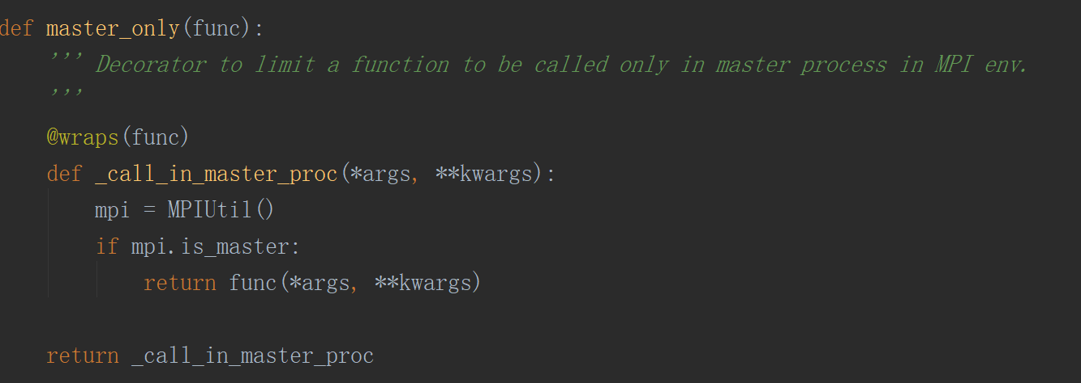

## 2. Run the code

两个超参数： **node_per_layer** and **num_layer**

两个PDE： **Burgers** and **Poisson**

### **2.1 主程序**

**BO：1_width_depth文件夹中的BO_dw.py；2_depth文件夹中的BO_depth.py；3_width文件夹中的BO_width.py. run_BO.py 是将BO搜索出来的每一个跑10次取均值。**

**GA：各个文件夹下的main.py**

**HB, RS：与BO类似**

### **2.2 调参**

#### **2.2.1 BO**

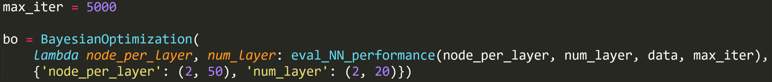

max_iter=5000

node_per_layer = [20,100]

num_layer = [5,10]

#### 2.2.2 GA

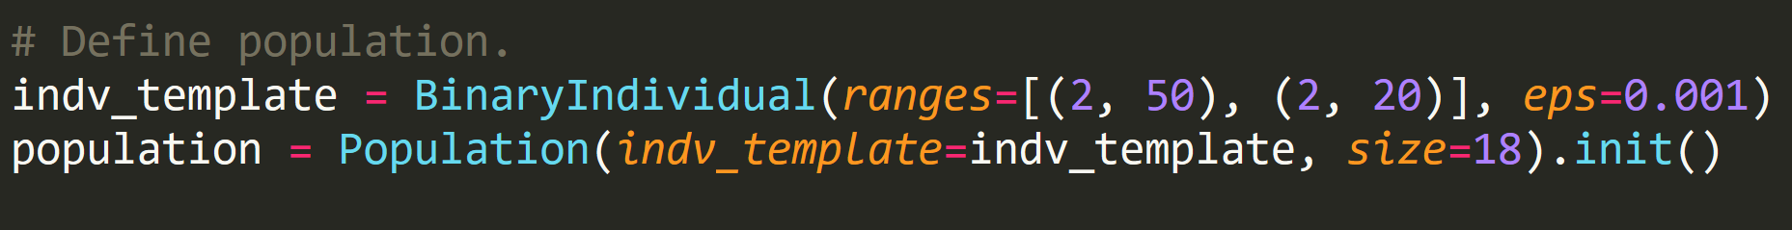

population size = 18 node_per_layer = [2,50] num_layer = [2,20]



generation = 5

#### 2.2.3 HB

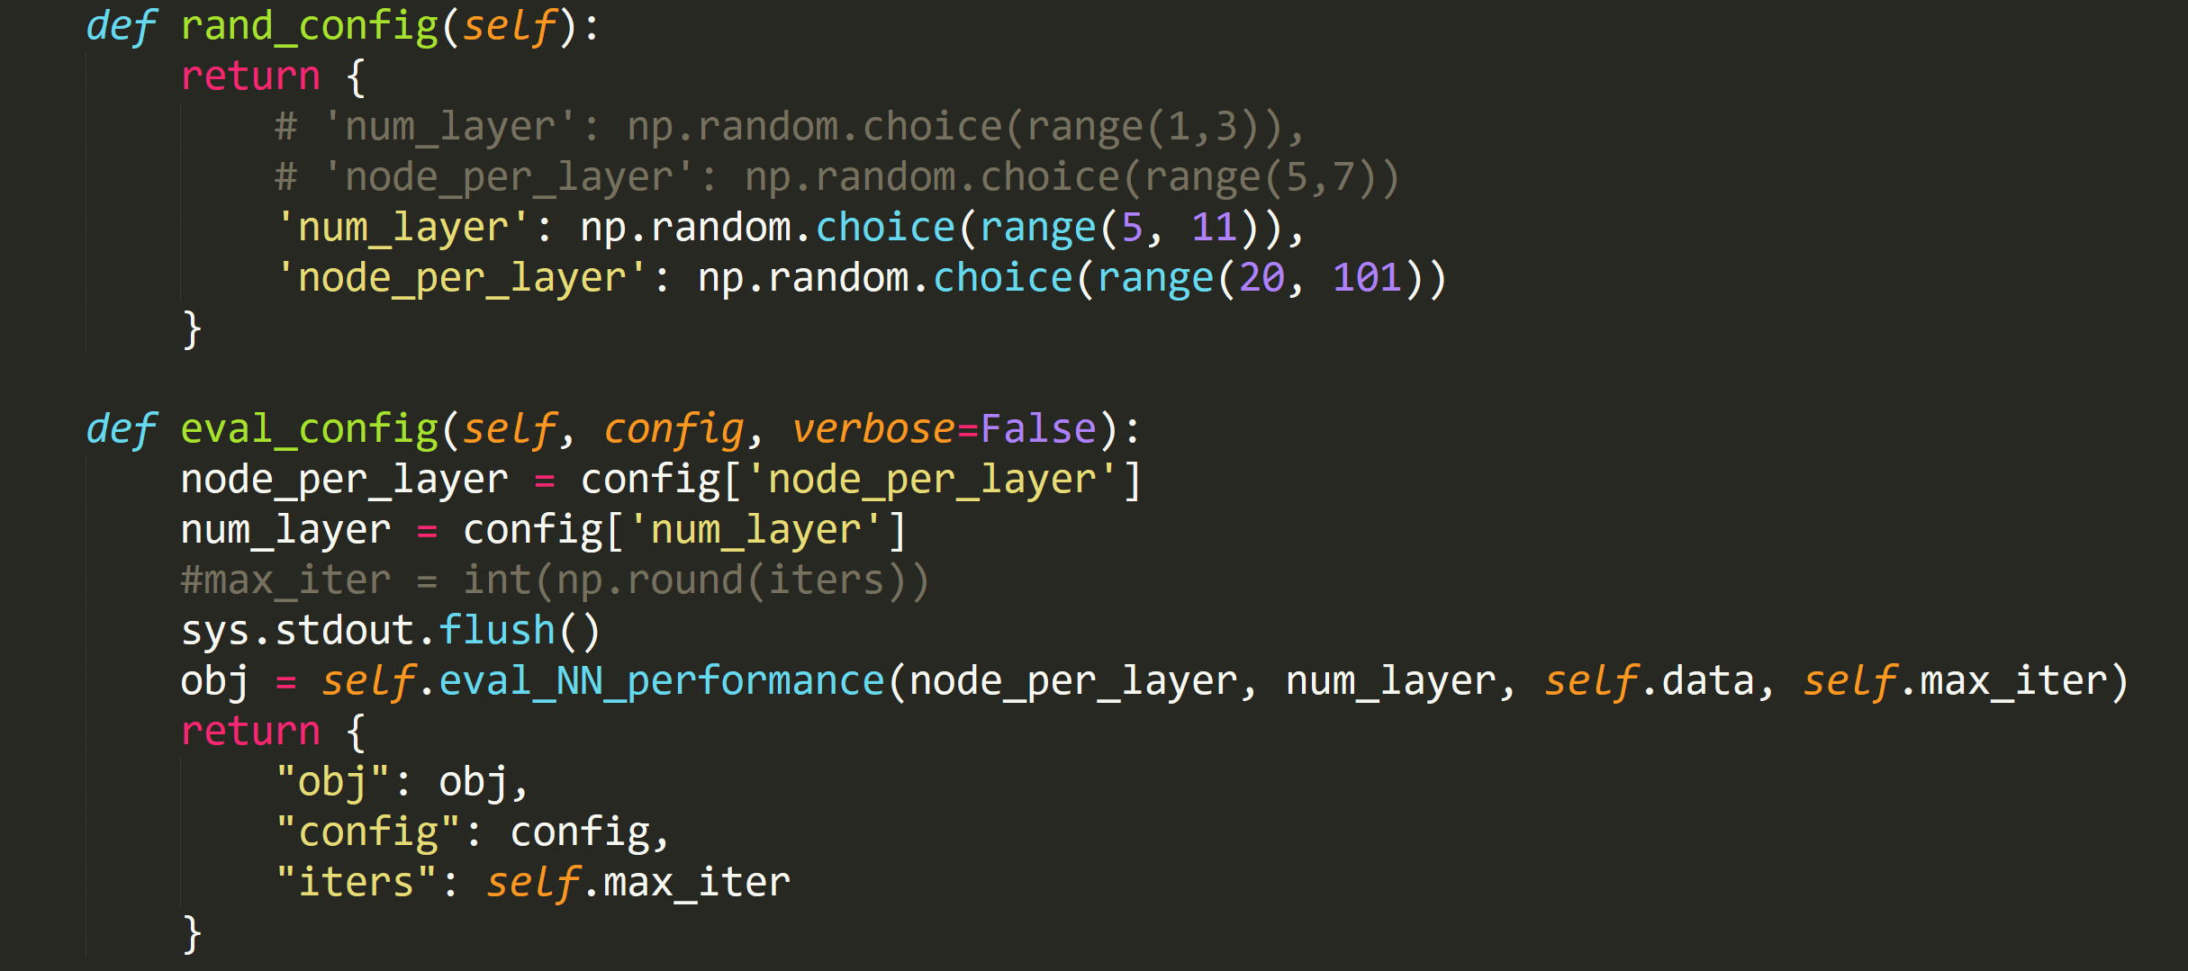

node_per_layer = [20,100]

num_layer = [5,10]

#### 2.2.4 RS

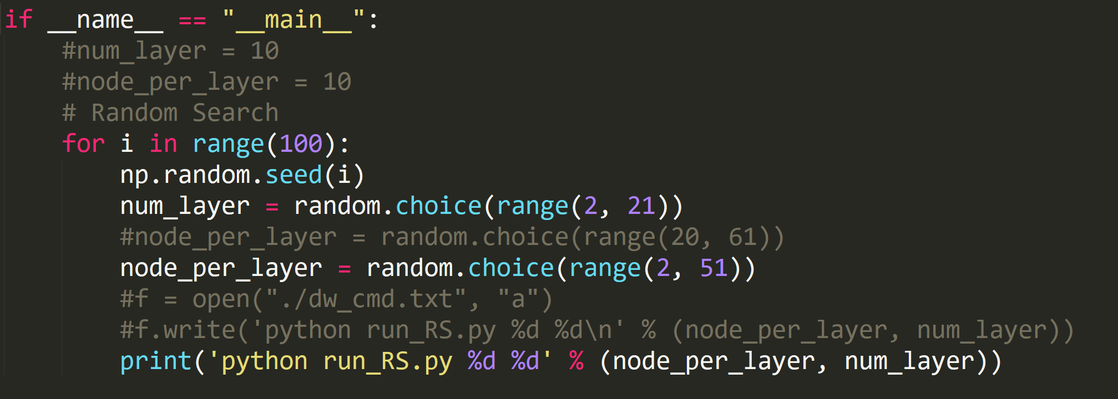

## 3. Draw the figure

**Take GA for example:**

### 3.1 1_width_depth



**process_data.py** ：将cluster反馈的结果汇总，生成最终画图的数据。

[node_per_layer,num_layer,mean,std]

**mean.py : 每个点对应的mean值**

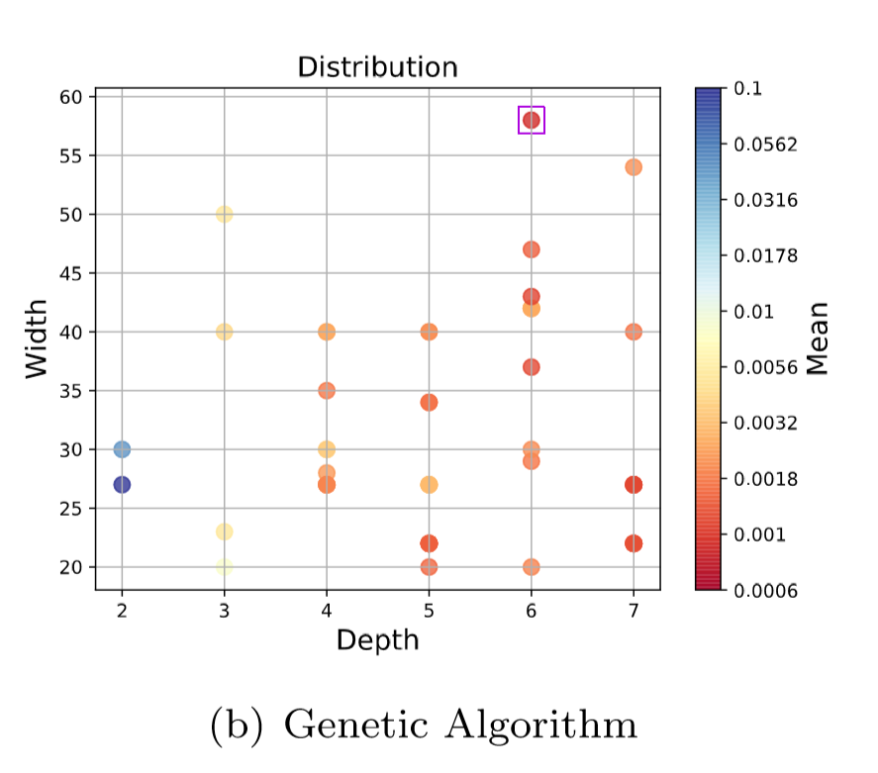

**std.py** : **每个点对应的std值**

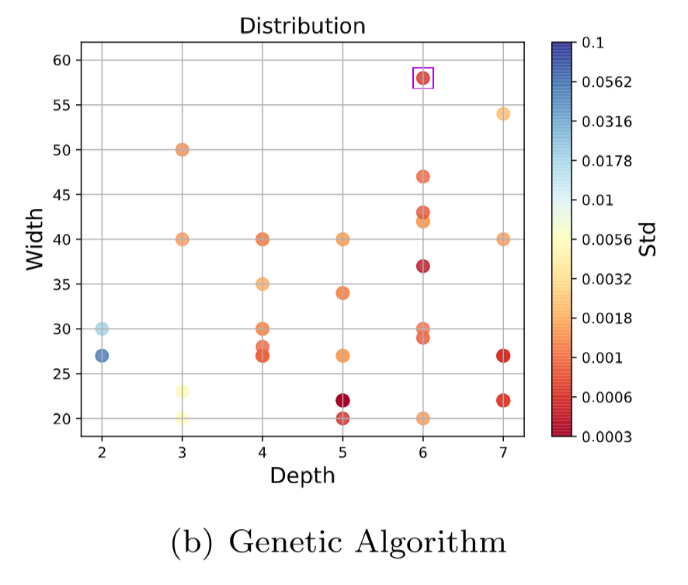

**mean_iter.py** : **每个点对应的iter，反映收敛程度**

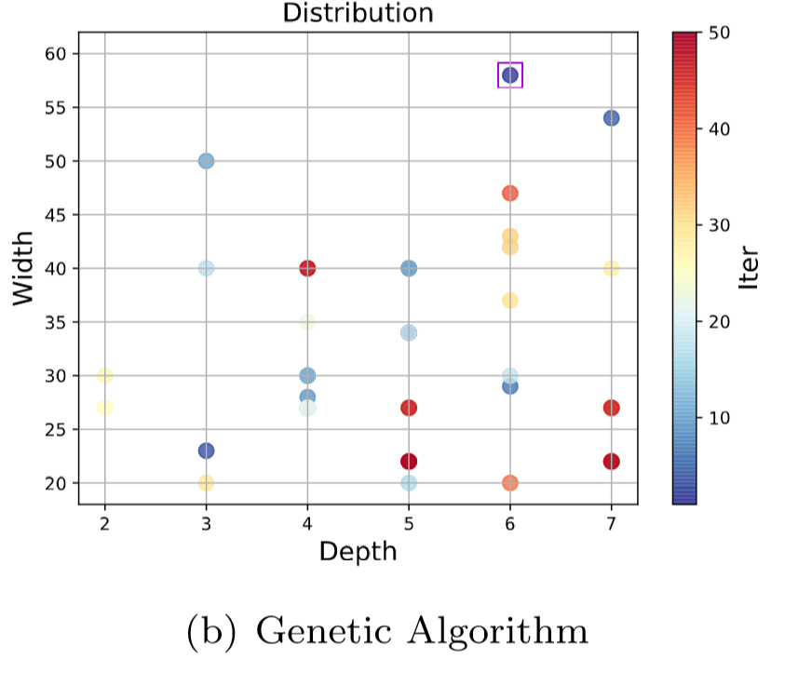

### 3.2 2_depth

**iter.py** :

Fix width to 10. 带紫色方框的点是最后收敛到的点。

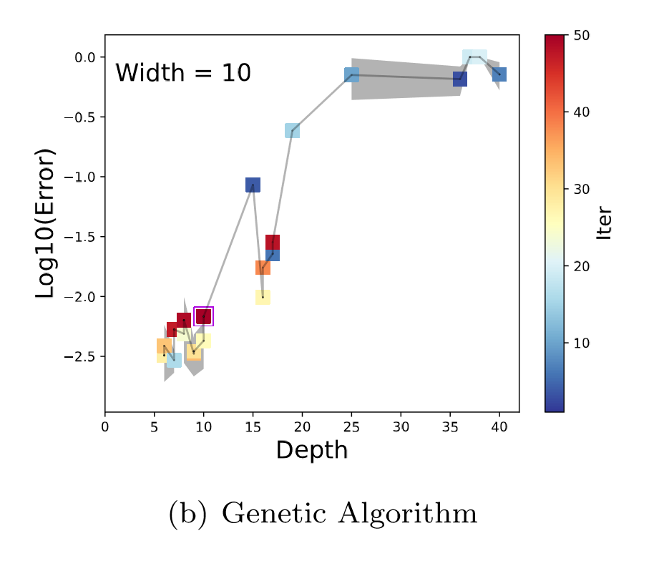

### 3.3 3_width

**iter.py** :

Fix depth to 10. 带紫色方框的点是最后收敛到的点。

