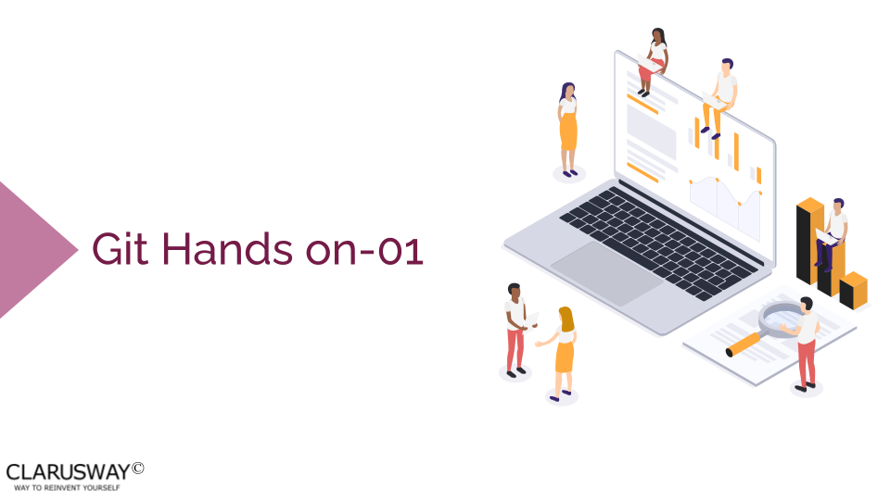

**Part 1:**

**1. Create a public repository in GitHub:**

* named python-project
* write a description of your repository
* add README.md file

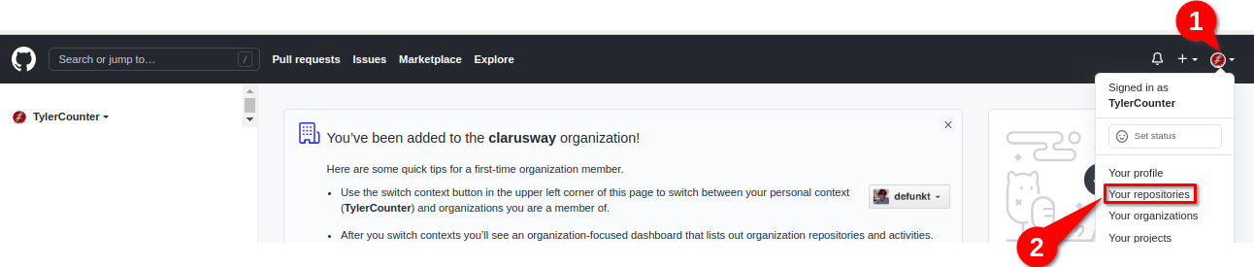

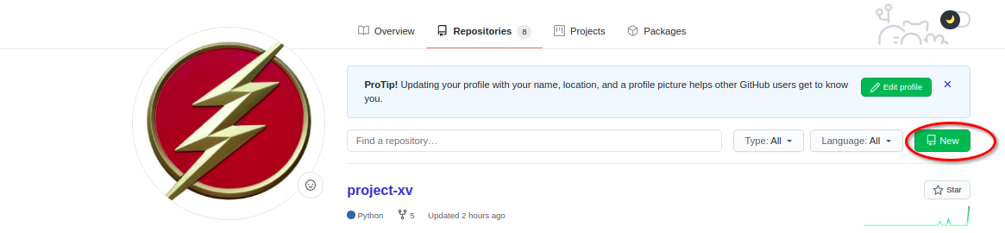

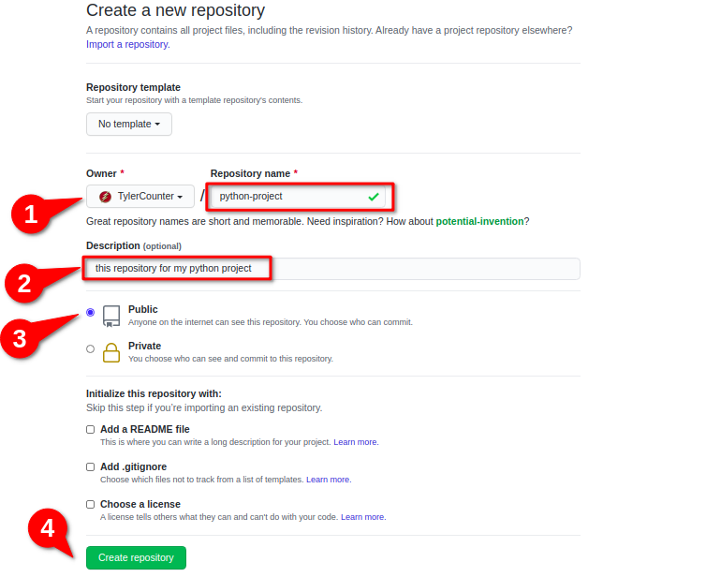

* After clicking the Create repository. GitHub creates a public repository and led you to the following page.

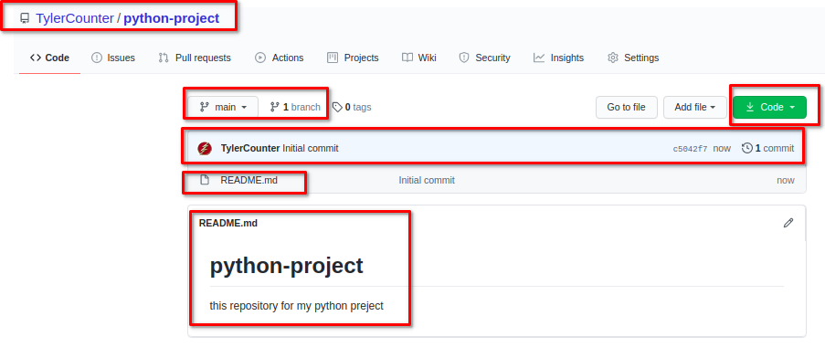

**Part 2:**

**2. Clone your remote repository to your computer:**

* Open your terminal (for Windows, run "Git Bash")
* Make a directory named git-lesson under the desktop directory and cd into it.

**mkdir git-lesson**

**cd git-lesson**

* Clone your remote repository (Syntax: git clone <remote-url> )
* Copy your remote repository URL

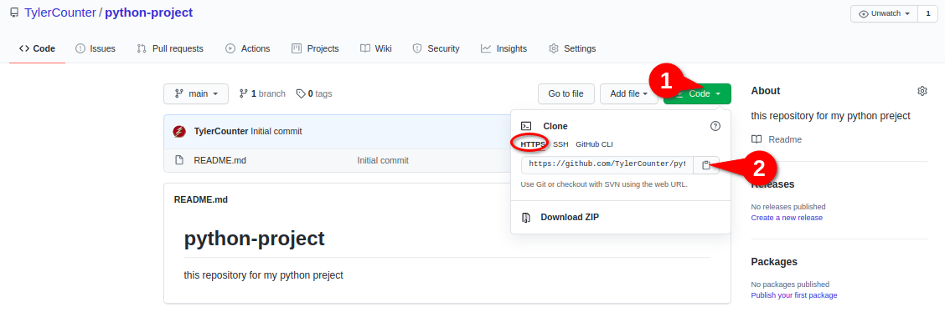

* run the following command

**git clone https://github.com/TylerCounter/python-project**[**.git**](https://github.com/TylerCounter/python-project.git) **(→ use your remote repo URL)**

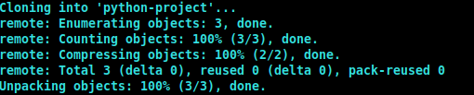

Output:

**-** See the current state of the project:

**git status**

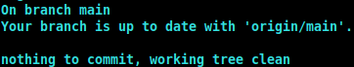

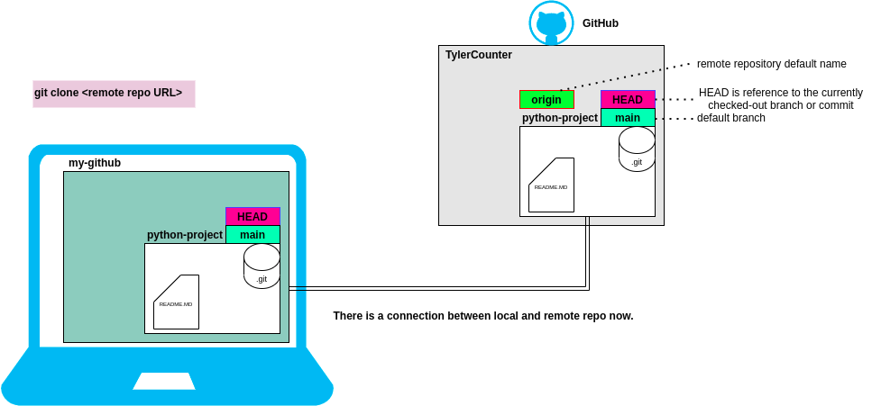

**Part 3:**

**-** Create a file named hello-world.py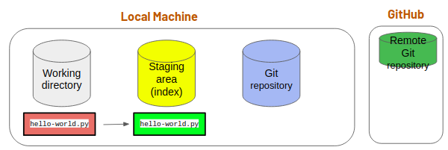

**touch hello-world.py**

**-** stage it

**git add hello-world.py**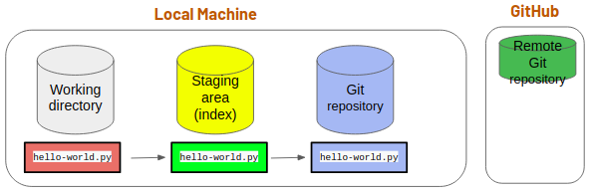

**-** store it in the local repository

**git commit -m “created hello-world.py”**

**-** open hello-world.py and add a line, then save and close.

**vim hello-world.py**

**-** check the status of the folder

**git status**

**-** store it to local repository, and check the state of the folder

**git commit -am “updated hello world.py”**

**git status**

* See the commit history

**git log**

**git log --pretty=oneline**

**git log --oneline**

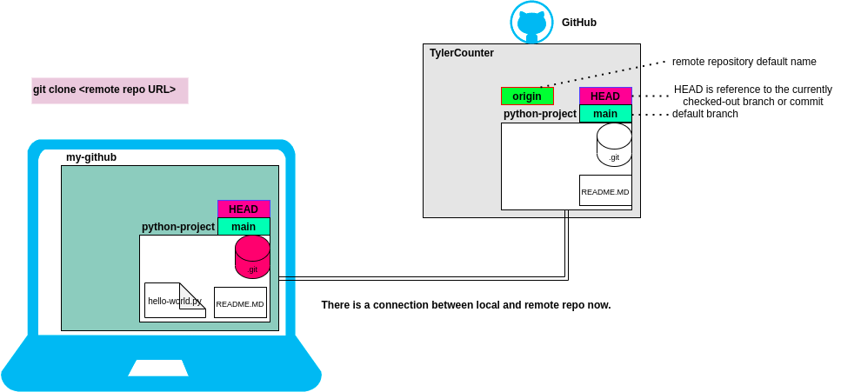

- Then send the changes to your remote repo.

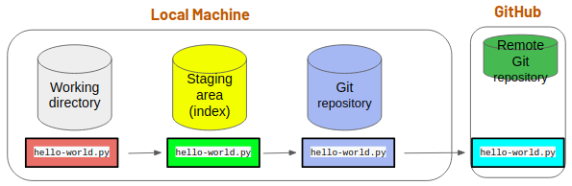

**git push**

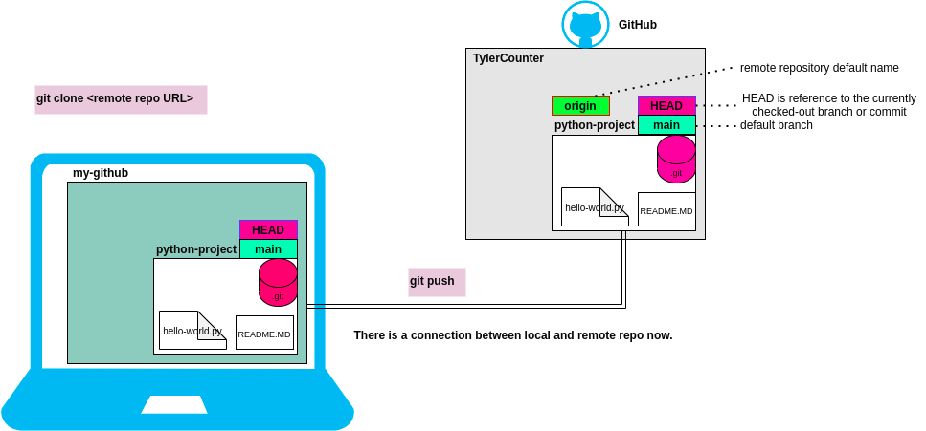

* Go to your GitHub account and see the changes:

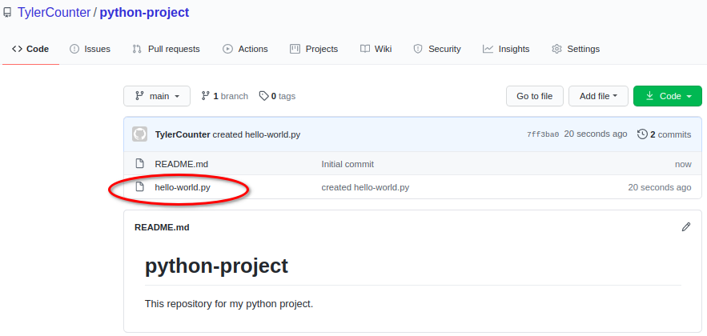

**Part 4:**

* Create a new file named index.html in the python-project repository by using GitHub.

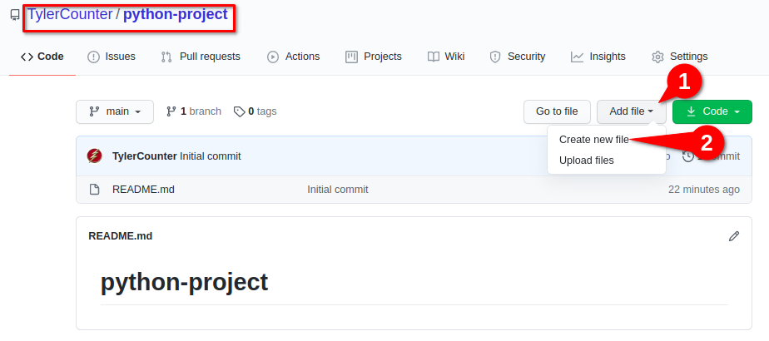

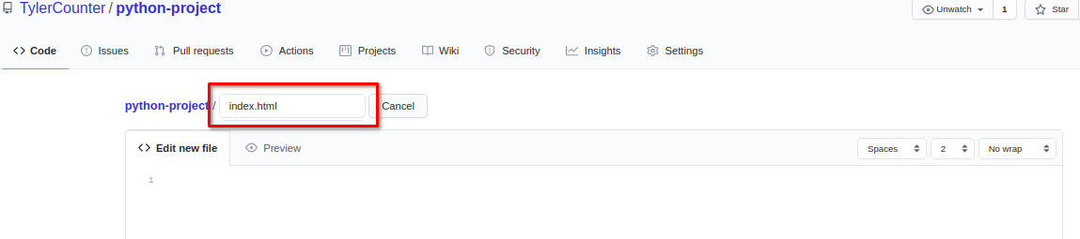

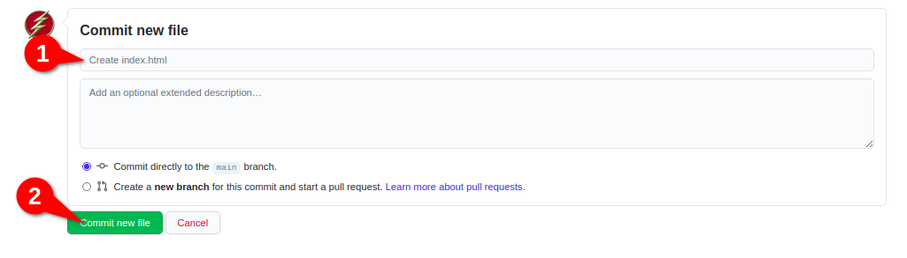

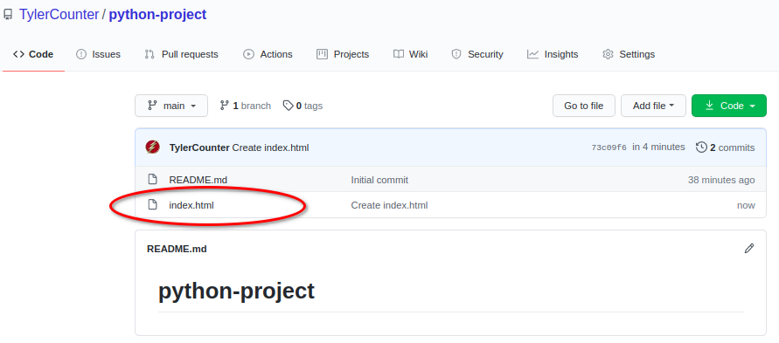

* The current state of our project:

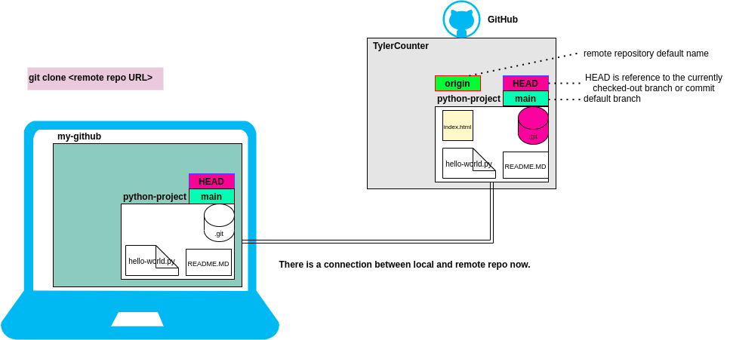

* At GitHub check the commits: (click commits)

You will see the three commits

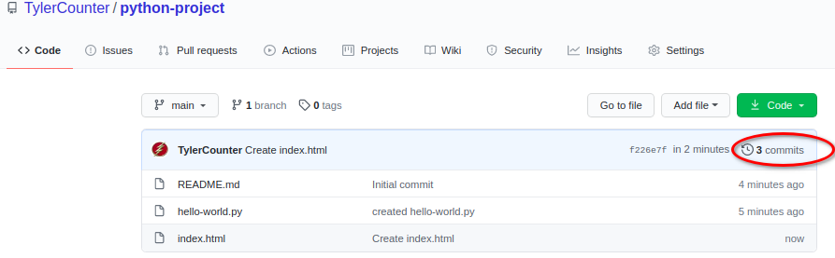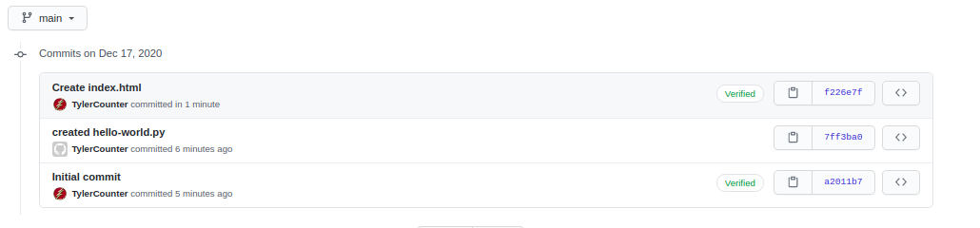

**Part 5:**

* Go to the terminal and see the commit history

**git log**

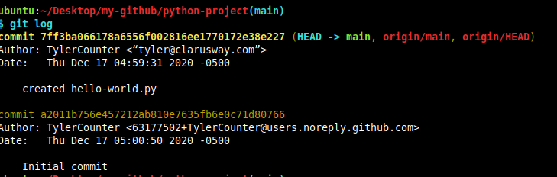

* Download the changes from the remote repository to your local repository

**git fetch**

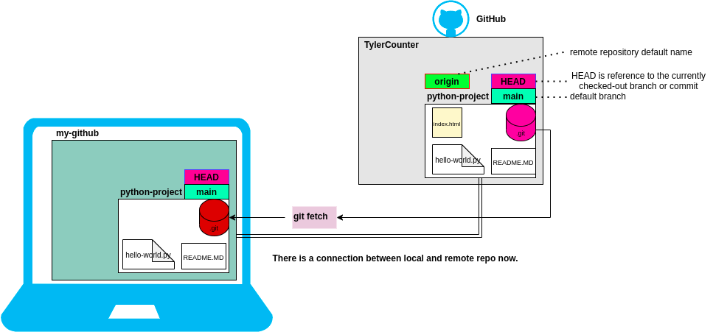

* See the changes in local repository

**git diff main origin/main**

* Combine main and origin/main

**git merge**

* Then list the files in your working directory

ls

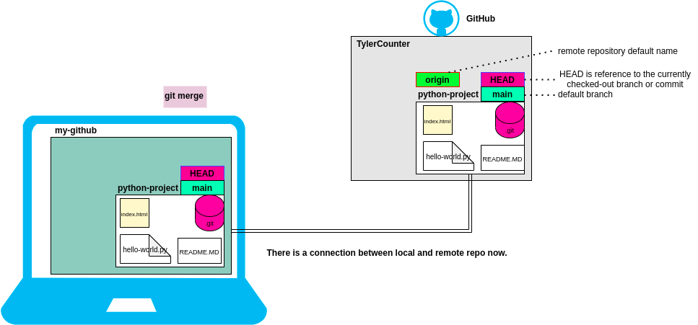

**Part 5:**

* At GitHub, create a new file named **test.txt**
* Download all changes to your computer

(terninal)

**git pull**  (that perform **git fetch** + **git merge** automatically)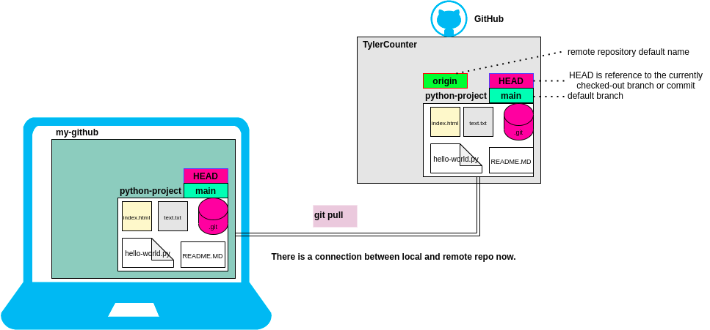

* See the commit history

git log --oneline

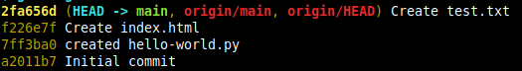

* Lets go the first commit, and see the changes in the working directory

**git checkout <commitID>**

* Switch the last commit again. (main)

**git checkout main**

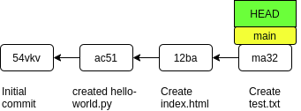

**Part 6:**

- Create a new branch named **front-end**

**git branch front-end**

- See branches

**git branch** (show local branchs)

**git branch -r** (show remote branchs)

**git branch -a** (show all local and remote branchs)

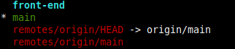

* Switch to **front-end** branch

**git checkout front-end**

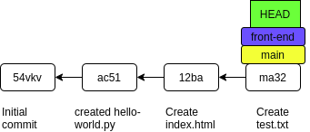

* List the files and check the status of the working directory

**ls**

**git status**

* Make some changes in the **test.txt** file, and check the status

**vim test.txt**

**git status**

* Store the changes to the repo and check the status

**git commit -am "added first line"**

**git status**

* Add another line to **test.txt** and store it to the local repo.

**vim test.txt**

**git commit -am "added second line**"

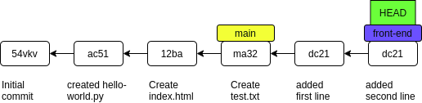

* Switch the main branch and see the content of the **test.txt**

git checkout main

cat text.txt

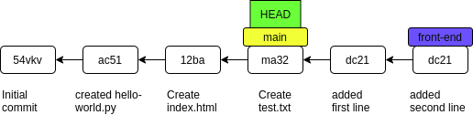

* Merge front-end branch to **main** branch.

git merge

cat test.tst

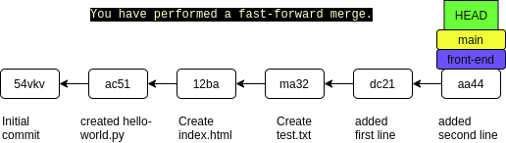

* Create a new branch named **back-end** and switch to it

git checkout -b back-end

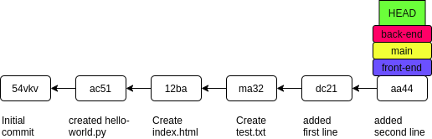

* Create a new file named **test2.txt** and store the changes to repo.

touch test2.txt

git add .

git commit -m “created text2.txt”

* Switch the main branch again

git checkout main

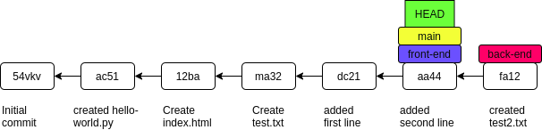

* Create a new file **test3.txt** and send the changes to local repo.

touch test3.txt

git add .

git commit -m “created text3.txt”

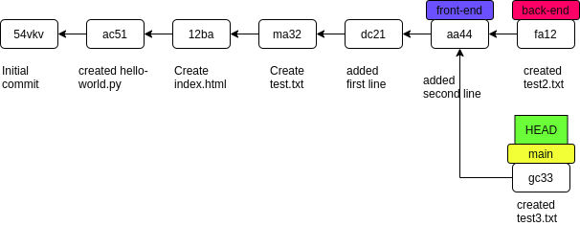

* Merge **main** branch with **back-end** branch

git merge back-end

**Part 7:**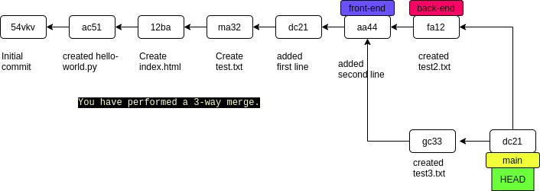

* Send the changes to the remote repository

git push

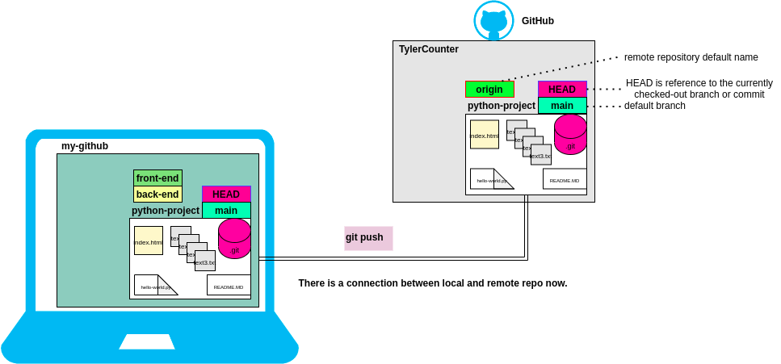

* Go and check the remote repository

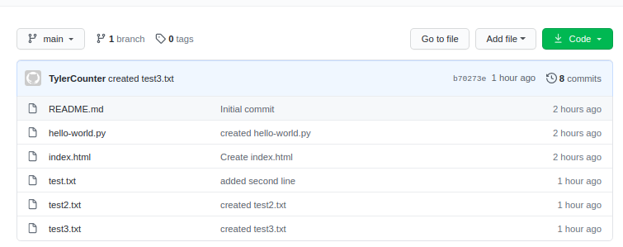

**Part 7:**

* Go to the terminal and delete the branches named **front-end** and **back-end**

**git branch -d front-end**

**git branch -D back-end**

* List the all branches

**git branch -a**

