INTERNSHIP REPORT

Student: I** A******** F********
University: Dunarea de Jos Galati
Coordinator: Dr. Ing. R*** B*****

Project Objectives and Approach

The main objective of this internship was to analyze a set of datasets and explore how machine learning could be applied to extract meaningful insights and build predictive models. Rather than following a fixed set of tasks, the project was exploratory in nature: together with my tutor, I tested different approaches, experimented with various techniques, and examined the data to identify trends, patterns, and potential relationships. The goal was to understand the datasets thoroughly and determine how they could be used to support practical decision-making through machine learning models.

Methodology

- Understanding the Field and Dataset Structure
- Reading about the field, FIO, and how write operations are simulated.
- Exploring the meaning of each column and its role in disk performance analysis.
Columns structure:
- Time (nanoseconds) – the timestamp or time taken for an operation, helps in analyzing temporal patterns.
- WIOPS (Write Operations Per Second) – measures the number of write operations performed per second; could be used as a performance metric.
- Latency (milliseconds) – measures the time delay for write operations; an important indicator of storage responsiveness.
- Dispatch Queue Size – represents the number of operations waiting to be processed; affects throughput and latency.
Determining potential target variables for predictive modeling.

2. Familiarization with Data Analysis Libraries
The second step of the project involved becoming proficient with key Python libraries commonly used for data analysis and visualization: NumPy, Pandas, and Matplotlib.
NumPy is a library designed for efficient numerical computations, providing support for multi-dimensional arrays, mathematical functions, and operations on large datasets. It is particularly useful for performing calculations quickly and handling structured numerical data.
Pandas is a data manipulation library that allows for easy reading, cleaning, and processing of structured datasets. With its powerful DataFrame structure, Pandas enables filtering, aggregation, and transformation of data in a flexible and intuitive way.
Matplotlib is a visualization library used to create plots, charts, and graphs. It helps in exploring the data visually, identifying patterns, trends, and outliers, and communicating findings effectively.
During this phase, I practiced basic operations such as reading datasets into Pandas, performing simple numerical calculations with NumPy, and plotting data distributions and trends with Matplotlib. This step laid the foundation for the later stages of data preprocessing, exploration, and modeling.

3. Data Cleaning and Outlier Detection
The third step focused on data cleaning, which is a crucial part of preparing datasets for analysis and machine learning. Cleaning ensures that the data is consistent, complete, and reliable, improving the quality of any subsequent analysis or modeling.
Two main tasks were performed during this phase:
- Handling Missing Values
Some rows in the datasets contained null or missing values in certain columns. These rows were identified and removed to ensure that the datasets only included complete and usable entries.
- Outlier Detection and Removal
Outliers are data points that deviate significantly from the majority of observations. They can distort analysis and negatively affect machine learning models.
To detect outliers, I applied the percentile method, which involves removing values below a certain lower percentile and above a certain upper percentile (e.g., below the 1st percentile or above the 99th percentile).
This approach helped to eliminate extreme values while retaining the bulk of the data, resulting in a cleaner and more representative dataset.
This step was essential for preparing the data for exploratory analysis and ensuring that machine learning models would be trained on accurate and meaningful information.

4. Regression Analysis and Trend Exploration
The fourth step involved exploring the relationships between the columns using regression analysis. Regression is a statistical technique used to model the relationship between a dependent variable (target) and one or more independent variables (features). In this project, the goal was to identify trends and understand how each column might relate to the others.
I applied polynomial regression, which extends linear regression by fitting a polynomial equation to the data, allowing it to capture nonlinear relationships. To determine the appropriate polynomial degree, I implemented a function that evaluated multiple degrees and selected the most suitable one. However, instead of choosing solely based on the best score, I introduced a tolerance threshold to avoid overfitting—a scenario where a model captures not only the underlying trend but also the noise in the dataset, leading to poor generalization on new data. For example, if multiple degrees produced very similar scores (difference less than 0.02), I chose the lowest degree to keep the model simple and efficient.
The regression analysis was performed individually for each dataset as well as for a combined global dataset, which merged all datasets together. This allowed me to compare regression coefficients and intercepts across datasets, revealing differences or similarities in trends and providing insight into how consistent the relationships between variables were.

5. Insights from Regression Analysis
Based on the plots and results from the regression analysis, it became clear that latency is generally dependent on WIOPS and dispatch queue size (QSize), which were considered as input variables in the models.
WIOPS (Write I/O Operations Per Second) represents the number of write operations issued to the storage system. This is an input parameter to the FIO tool during simulations and directly affects the workload intensity. Higher WIOPS generally increases the number of requests the system needs to handle, which can influence latency.
Dispatch Queue Size (QSize) indicates the number of operations waiting in the queue before being processed by the storage device. This value depends on both the workload (WIOPS) and the hardware characteristics of the storage device. Larger queue sizes can lead to increased latency if the disk cannot handle the queued requests efficiently, while very small queues might underutilize the hardware.
From this analysis, it is possible to see that latency is affected by a combination of workload and system capability. WIOPS defines how many operations the system is asked to perform, while dispatch queue size reflects how the system manages pending operations. Understanding these relationships is crucial for building a predictive model that can estimate latency based on the input parameters and potentially help optimize storage performance.
Additionally, examining the regression plots across individual datasets and the combined global dataset allowed for comparison of trends, highlighting differences or similarities in how latency responds to changes in WIOPS and queue size across different experimental conditions.

6. Time Series Analysis
Another step in the project involved exploring how the dataset values evolve over time. To achieve this, I performed time series analysis for each column in each dataset.
Time series refers to a sequence of data points collected or recorded at successive points in time, typically at uniform intervals. Analyzing data as a time series allows us to detect trends, seasonal patterns, or temporal dependencies that may exist within the dataset.
By plotting the time series of each column, I was able to observe trends and fluctuations over the course of the experiments. (See the Figure 3 down below the document.)
This analysis helped to:
Confirm that latency is an appropriate target variable for predictive modeling, as its variations are influenced by input parameters like WIOPS and dispatch queue size over time.
Identify any temporal patterns or anomalies that could affect model performance or provide additional insight into system behavior.
Performing time series analysis reinforced the understanding of relationships between variables and supported the decision to focus on latency as the main quantity to predict with machine learning models.

7. Machine Learning Modeling with XGBoost
To build a predictive model that also considers the temporal aspect of the data, I implemented a gradient boosting model using XGBoost (Extreme Gradient Boosting).
Gradient boosting is an ensemble learning technique where multiple weak learners, typically decision trees, are trained sequentially. Each new tree focuses on correcting the errors of the previous trees, gradually improving the overall predictive performance. This approach is particularly effective for capturing complex nonlinear relationships in data. XGBoost is a highly optimized implementation of gradient boosting that is widely used for structured data due to its speed, accuracy, and ability to handle missing values.
For more information regarding boosting and XGBoost, see the official documentation.
Helpful links:
https://aws.amazon.com/what-is/boosting/
https://xgboost.readthedocs.io/en/stable/

Incorporating Time via Lags
To account for the influence of previous time points, I included time lags as input features. A lag represents a previous observation in the dataset relative to the current time: for example, a lag of 5 corresponds to the value recorded 5 time steps before the current observation. By incorporating multiple lags, the model can learn temporal dependencies and trends in the data, improving predictive accuracy for latency.
I developed a function to determine the optimal number of lags to include. Rather than simply maximizing the model score, I balanced performance with complexity to avoid overfitting, selecting the lowest number of lags that produced a score within a small tolerance of the best score.
Model Inputs and Performance
I trained models using a global dataset, combining all individual datasets.
The main input features were time, dispatch queue size (QSize), and WIOPS.
I also tested reduced input combinations:
- Time + Dispatch
- Time + WIOPS
The results showed that dispatch queue size is the most influential variable, followed by WIOPS. Models trained with only time and dispatch achieved scores similar to those using all three features, while time and WIOPS alone resulted in significantly lower performance. (See Figure 4, for a plot example, down below the document.)
Evaluation with R² Score
I evaluated the models using the R² score, which measures the proportion of variance in the target variable that is explained by the model. The R² values ranged between 0.85 and 0.9, indicating a strong fit.
An R² of 1 would mean the model perfectly predicts all observed values without error.
An R² of 0 would mean the model does not explain any of the variability in the target variable, performing no better than simply predicting the mean.
The high R² values in this project confirm that the selected features and lags effectively capture the underlying patterns in latency.

Feature and Lag Importance
To better understand the model, I plotted the importance of each feature and lag (See Figure 5, down below the document), showing which variables contributed most to predicting latency. This analysis highlighted the critical role of dispatch queue size and recent time lags, confirming the findings from regression and time series analysis.

8. Integration into a Command-Line Tool (CLI)
To make the analyses and models accessible and user-friendly, I integrated all the work into a command-line interface (CLI). A CLI is a software interface that allows users to interact with a program by typing commands in a terminal or console, rather than using a graphical interface. This approach was chosen because it is lightweight, flexible, and allows users to quickly select options and execute different functionalities without navigating multiple menus.
The CLI provides three main functionalities, each allowing the user to select the files they are interested in for processing, as well as whether the files will be used for training or testing:
Regression Plotting
Users can generate 2D or 3D regression plots to explore relationships between columns. (See Figure 1 and Figure 2 down below the document.)
In 3D regression, the inputs used are dispatch queue size (QSize) and WIOPS, without including the time column.
Users can select which columns to analyze as inputs and targets, or rely on default selections based on the most interesting relationships identified during the analysis.
Time Series Plotting
This functionality allows users to plot time series for the four columns of interest.
Users can select the datasets to visualize, enabling exploration of temporal trends and variations across different experiments.
XGBoost Model Creation and Plotting
Users can train XGBoost models using the selected datasets and input columns.
The tool automatically handles the incorporation of time lags if desired.
After training, the tool plots predictions, feature importance, and lag importance for visual analysis.
Automatic Saving of Outputs
The CLI automatically saves all generated plots (regression, time series, XGBoost) and trained XGBoost models in a designated folder.
Each saved file includes a timestamp in its name, ensuring clear organization and preventing overwriting of previous results.
This CLI allows for flexible experimentation and makes it easy for users to explore different datasets, plot trends, and train predictive models with minimal manual setup. By centralizing all functionalities, the tool provides a consistent and efficient way to reproduce analyses and visualize results.

CLI Functionality Overview
The CLI provides a convenient way to interact with the project and perform all main analyses without manually running scripts. Users can select datasets, choose features, and generate outputs with just a few commands.

Here we can see the information message telling the user what functionalities he can use:
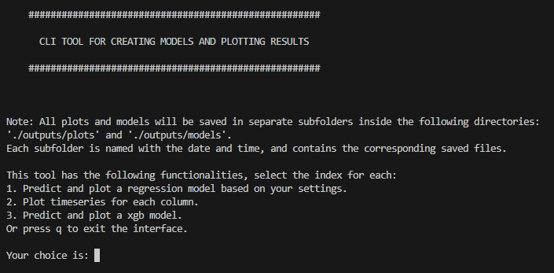

The user can choose a range of files for training and the rest will be considered as for testing:

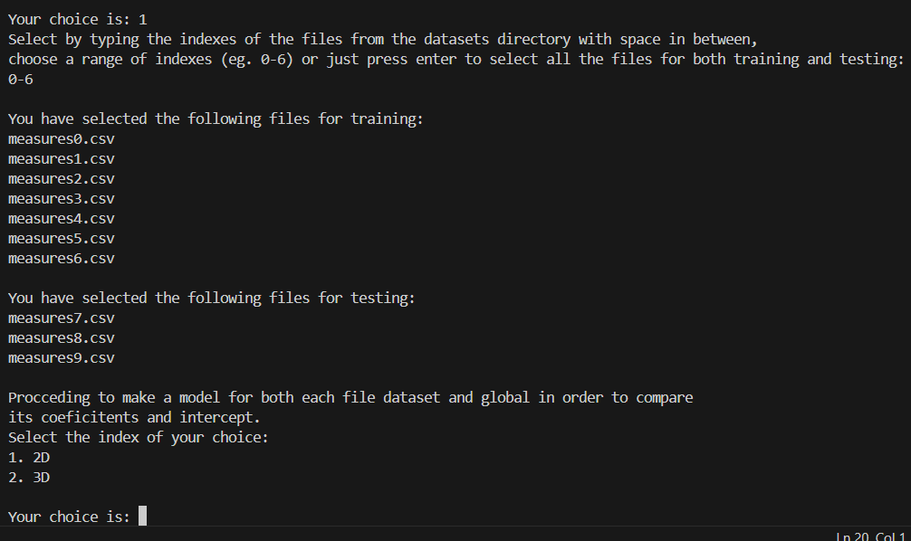

Here the rest of regression setting can be chosen, and the process is being executed:

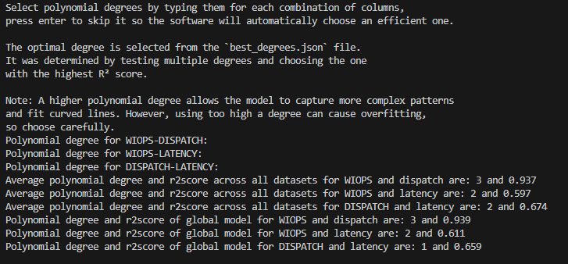

Here we can find the saved plots and models depending of which option we chose:

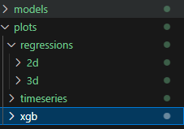

A new subdirectory will be created with current date and time where we can find all the plots or models within the previous shown directories:

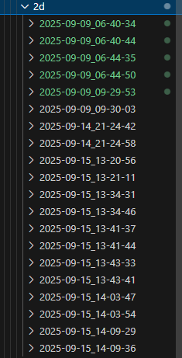

Figure 1: Example of a simple regression plot

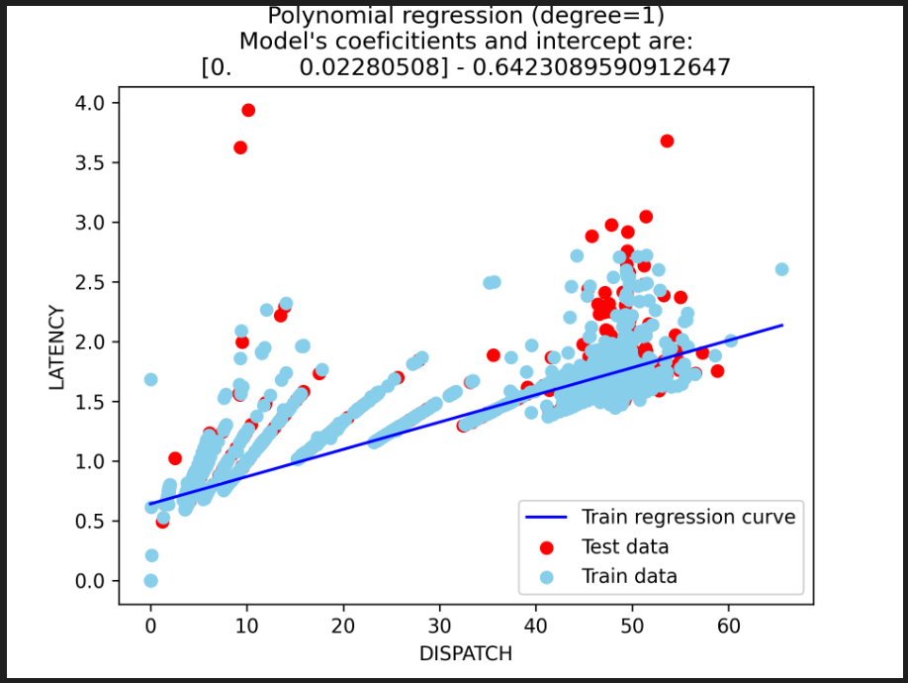

Figure 2: Example of a 3d regression plot

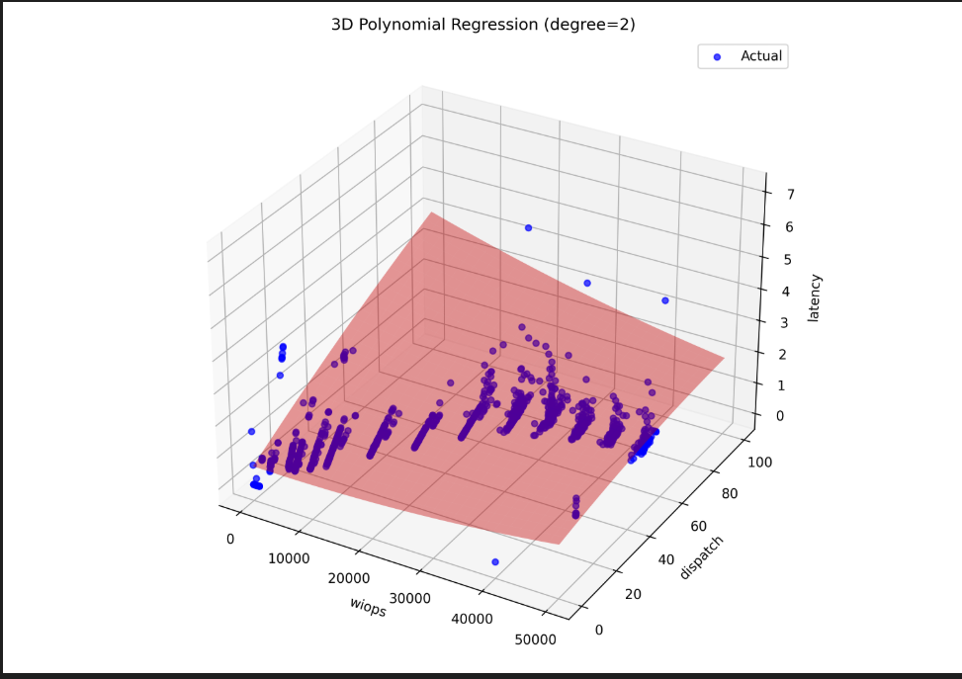

Figure 3: Exemple of a timeseries of latency column:

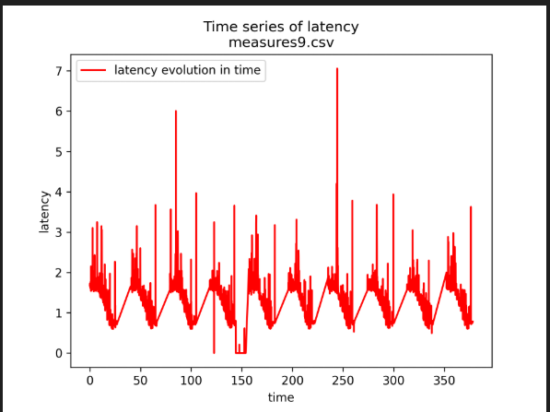

Figure 4: Example of xgb approach plot:

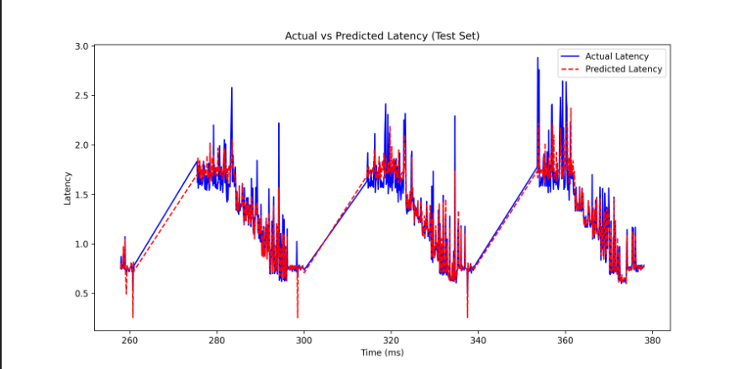

Figure 5: Importance of features for a xgb model:

