ORBIT Gen-1 RF Canceller User Manual

1. **Digital attenuator (SKY12343-364LF)**

The detailed datasheet of SKY12343-364LF can be found at <http://www.mouser.com/ds/2/472/201355C-39206.pdf>. Specifically, the serial addressable register map and the timing diagram are included below.

**Example**: If the desired attenuation word is 23(dec) = 0010111(bin) with address word 0(dec) = 000(bin), the register will have values [00000000|00010111](A7-D0). Then, these bits are written in an LSB first order at the rising edge of CLOCK.

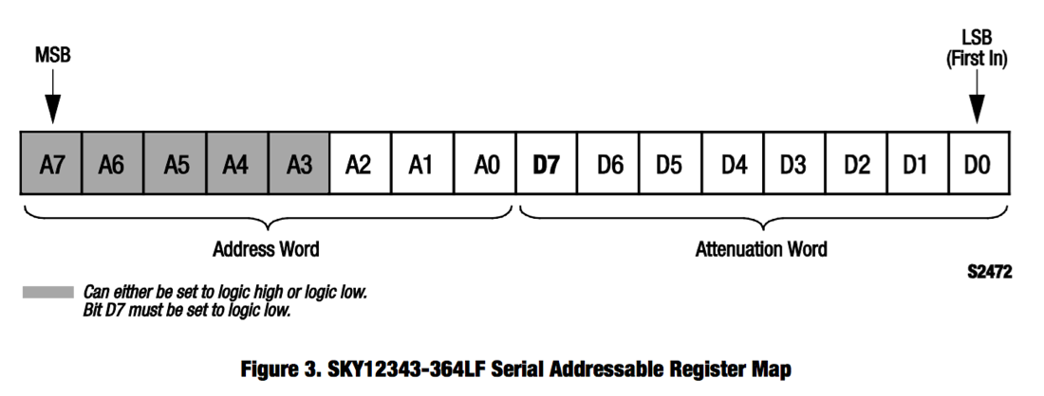

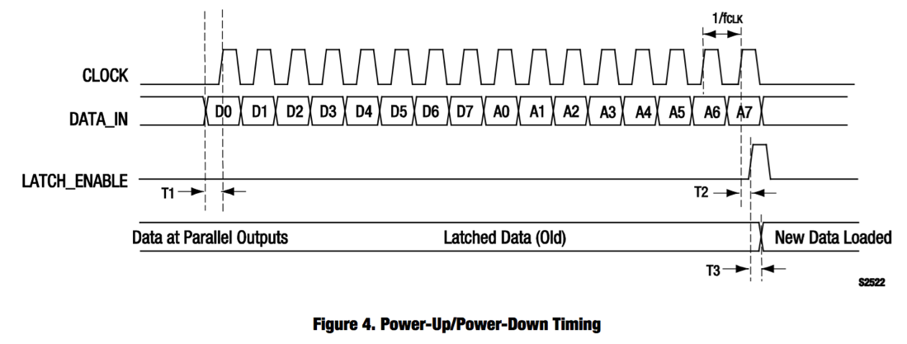

1. **Digital-to-Analog (DAC) Converter (TI DAC081S101)**

The detailed datasheet of DAC081S101 can be found at <http://www.ti.com/lit/ds/symlink/dac081s101.pdf>. Specifically, the input register map and the timing diagram are included below.

**Example**: If the desired input word is 23(dec) = 00010111(bin) with normal operation mode 00(bin), the register will have values [0000|00010111|0000](D15-D0). Then, these bits are written in an MSB first order at the falling edge of SCLK. Note that here, the difference compare with the digital attenuator operation is that (i) MSB first and (ii) each bit is written at the falling edge of SCLK.

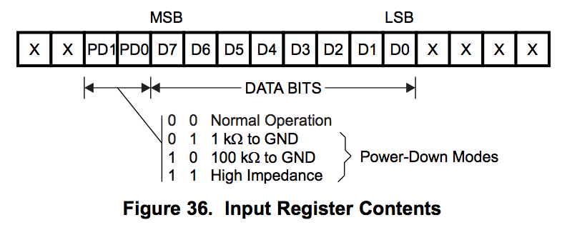

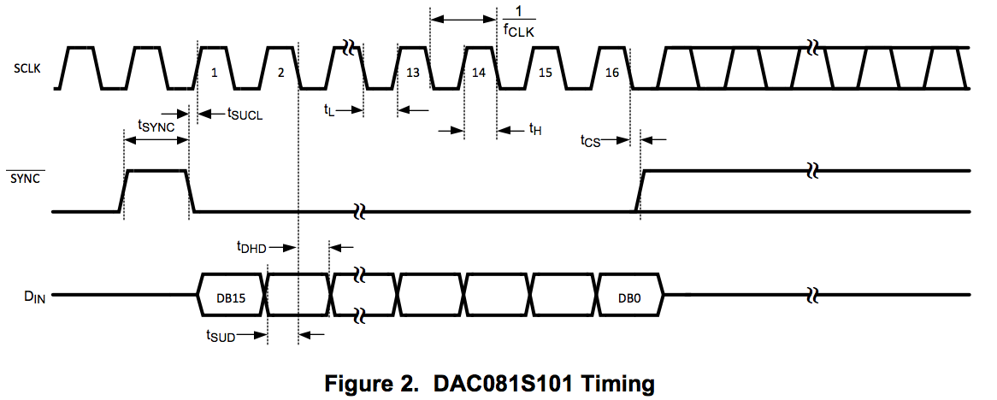

1. The SUB20 SPI Interface