**Acknowledgement**

We would like to express our deepest appreciation to Justin Thomson, Pramod Somashekar and Christina Gutierrez from Medidata Solution, who provided us the possibility to complete the changeling project.

We are highly indebted to them for their patient guidance and constant supervision as well as necessary information.

Further more, a gratitude we would like to give to Professor J.C. Franchitti, whose contribution in stimulating suggestions and encouragement, helped us to coordinate the project and well present our achievement.

**Information Technology Project**

**Further work**

* Include indexing in our project so as to make the traversal of all the graph nodes more faster
* Reduce execution time and memory usage to improve the efficiency



251 Mercer Street

New York, NY 10012-1185

http://cs.nyu.edu



**ODM Graph Database**



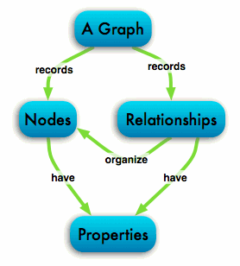

Team Members:

Jenson Thomas

Ashwathama Rajendran

Da Feng

Qi Yang

Instructor:

Justin Thomson