We detected Hand Washing activities using accelerometer data collected from a smart watch. We wanted to differentiate between hand washing and other activities using machine learning.

**Data Collection**

* Hand Washing Data: Collected accelerometer data for 20 hand washing instances.
* Non-Hand Washing Data: Collected 10 minutes of various other activities

**Preprocessing and Feature Extraction**

* Data Extraction: Used wada.jar to extract accelerometer data and convert it to CSV files.
* Segmentation: Divided the data into 1-second windows.
* Features Computed: For each window, calculated the mean and standard deviation for X, Y, and Z axes
* Labeling: Each window was labeled as either hand_wash or no_hand_wash.
* Feature File: Placed all features into features.csv.

**Classification**

Classifier: J48 Decision Tree (weka.classifiers.trees.J48) with default parameters.

Classifier Model (Decision Tree)

=== Run information ===

Scheme: weka.classifiers.trees.J48 -C 0.25 -M 2

Relation: wada

Instances: 933

Attributes: 7

Mean_X

Std_X

Mean_Y

Std_Y

Mean_Z

Std_Z

Activity

Test mode: 10-fold cross-validation

=== Classifier model (full training set) ===

## The decision tree generated by the classifier:

J48 pruned tree

------------------

Std_X <= 0.130164

| Mean_X <= -1.19669

| | Mean_Y <= -5.441734: no_hand_wash (2.0)

| | Mean_Y > -5.441734: hand_wash (12.0)

| Mean_X > -1.19669: no_hand_wash (63.0/2.0)

Std_X > 0.130164

| Mean_Z <= 8.557854

| | Mean_X <= -6.109754

| | | Mean_Y <= -1.758478

| | | | Std_Y <= 0.604376

| | | | | Mean_X <= -7.32905: hand_wash (17.0)

| | | | | Mean_X > -7.32905: no_hand_wash (2.0)

| | | | Std_Y > 0.604376

| | | | | Std_Z <= 9.121441

| | | | | | Mean_Y <= -3.114957: no_hand_wash (115.0/29.0)

| | | | | | Mean_Y > -3.114957

| | | | | | | Mean_X <= -10.631763

| | | | | | | | Std_X <= 4.3385: no_hand_wash (25.0/1.0)

| | | | | | | | Std_X > 4.3385

| | | | | | | | | Mean_Z <= -1.29652: hand_wash (14.0)

| | | | | | | | | Mean_Z > -1.29652: no_hand_wash (2.0)

| | | | | | | Mean_X > -10.631763

| | | | | | | | Std_Y <= 5.833649

| | | | | | | | | Mean_Z <= -2.520972: no_hand_wash (2.0)

| | | | | | | | | Mean_Z > -2.520972: hand_wash (21.0/1.0)

| | | | | | | | Std_Y > 5.833649: no_hand_wash (2.0)

| | | | | Std_Z > 9.121441

| | | | | | Std_Y <= 14.303921: hand_wash (16.0)

| | | | | | Std_Y > 14.303921: no_hand_wash (2.0)

| | | Mean_Y > -1.758478

| | | | Std_X <= 2.608086: hand_wash (50.0)

| | | | Std_X > 2.608086

| | | | | Std_Z <= 2.231247

| | | | | | Mean_Y <= -1.215591: no_hand_wash (5.0)

| | | | | | Mean_Y > -1.215591: hand_wash (2.0)

| | | | | Std_Z > 2.231247: hand_wash (46.0/3.0)

| | Mean_X > -6.109754

| | | Std_Y <= 0.660023

| | | | Mean_Y <= -9.12598: no_hand_wash (14.0/1.0)

| | | | Mean_Y > -9.12598

| | | | | Mean_Y <= 4.359362: hand_wash (33.0/10.0)

| | | | | Mean_Y > 4.359362: no_hand_wash (4.0)

| | | Std_Y > 0.660023: hand_wash (450.0/63.0)

| Mean_Z > 8.557854

| | Mean_X <= -2.484657: hand_wash (3.0)

| | Mean_X > -2.484657

| | | Std_Z <= 0.695515: no_hand_wash (22.0)

| | | Std_Z > 0.695515

| | | | Std_X <= 1.126352

| | | | | Mean_Z <= 9.048455: no_hand_wash (2.0)

| | | | | Mean_Z > 9.048455: hand_wash (3.0)

| | | | Std_X > 1.126352: no_hand_wash (4.0)

Number of Leaves : 27

Size of the tree : 53

Time taken to build model: 0.1 seconds

Decision tree visualization

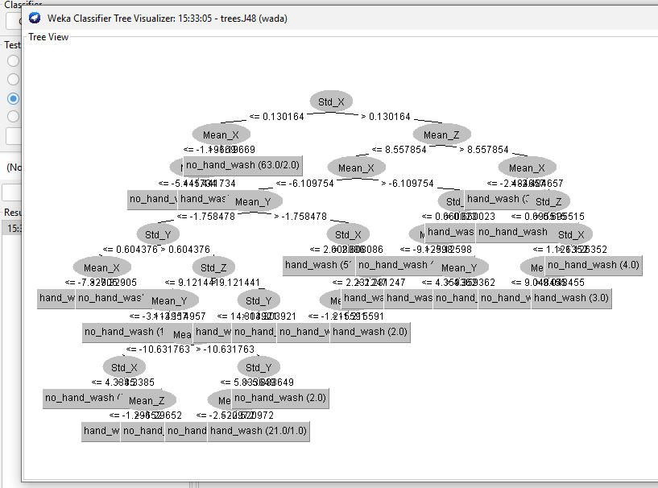

=== Stratified cross-validation ===

=== Summary ===

## Classification Accuracy:

Correctly Classified Instances 749 80.2787 %

Incorrectly Classified Instances 184 19.7213 %

Kappa statistic 0.5437

Mean absolute error 0.2384

Root mean squared error 0.3994

Relative absolute error 53.7126 %

Root relative squared error 84.7879 %

Total Number of Instances 933

=== Detailed Accuracy By Class ===

TP Rate FP Rate Precision Recall F-Measure MCC ROC Area PRC Area Class

0.878 0.348 0.835 0.878 0.856 0.545 0.811 0.852 hand_wash

0.652 0.122 0.727 0.652 0.687 0.545 0.811 0.688 no_hand_wash

Weighted Avg. 0.803 0.273 0.799 0.803 0.800 0.545 0.811 0.798

## Confusion Matrix:

=== Confusion Matrix ===

a b <-- classified as

547 76 | a = hand_wash

108 202 | b = no_hand_wash