**Part 1**

Previous data had instances. We have 1459 for this assignment after collection.

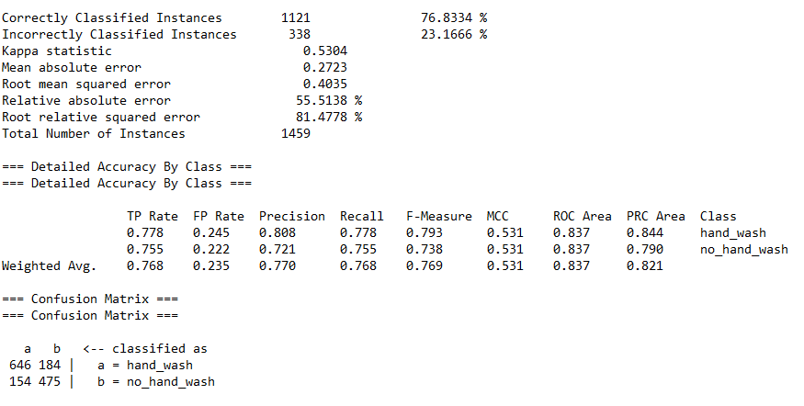

**Figure 1 Accuracy result for part 1**

The accuracy decreases to 76.83% comparing with 80.27% of assignment 1.

**Part 2**

Yes, accuracy improves as we increase the time slice.

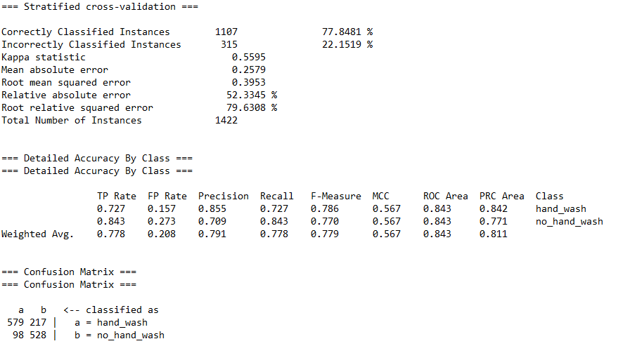

**Figure 2 Time slice =2**

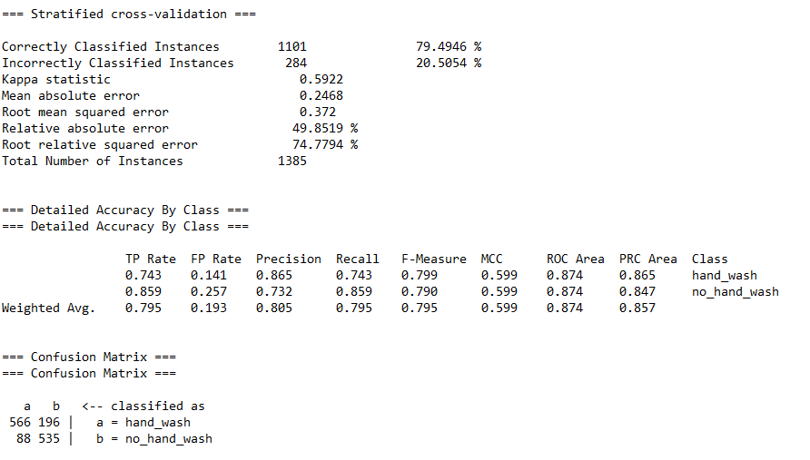

**Figure 3 Time slice =3**

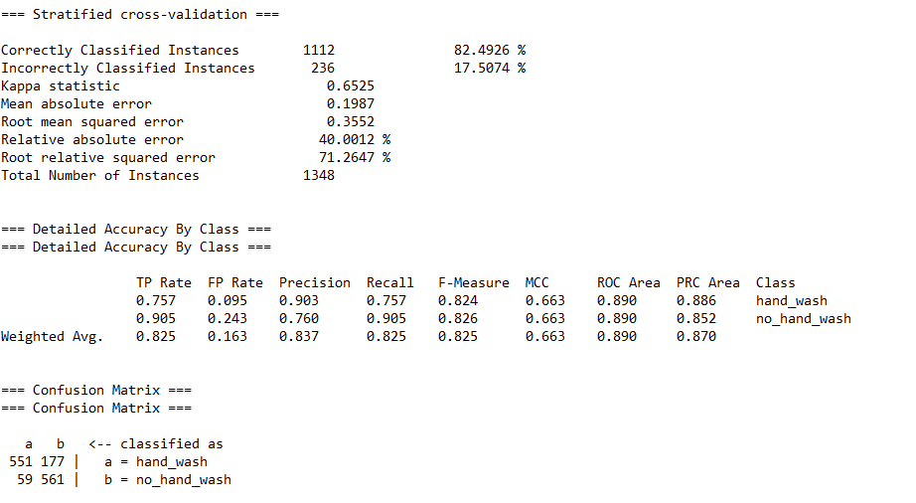

**Figure 4 Time slice = 4**

**Part 3**

The best time slice from part 2 is 4. The accuracy improves over part 1 but decreases in comparison with part 2, time slice=4.

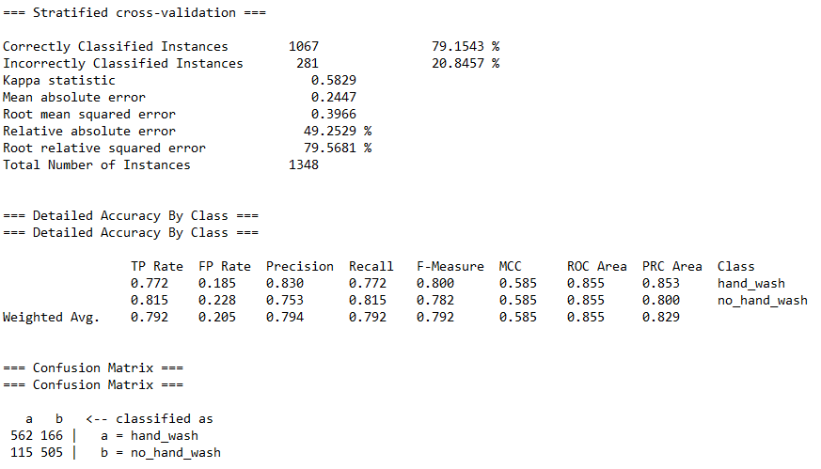

**Figure 5 Accuracy for part 3**

**Part 4**

The best time interval is 4.

We apply Sequential Feature Selection method and decision tree classifier.

**Table 1 Feature names and respective index**

|  |  |  |  |  |  |  |  |  |  |  |  |
| --- | --- | --- | --- | --- | --- | --- | --- | --- | --- | --- | --- |
| Mean X | Std X | Median X | RMS X | Mean Y | Std Y | Median Y | RMS Y | Mean Z | Std Z | Median Z | RMS Z |
| 0 | 1 | 2 | 3 | 4 | 5 | 6 | 7 | 8 | 9 | 10 | 11 |

The feature set is {8, 0, 6, 2}. The accuracy is 83.90% which is an improvement over part 3. The table shows how accuracy improves with feature selection. We stop and don’t add the next feature as the improvement is less than 1%.

**Table 2 Change in accuracy with each iteration of SFS for DT**

|  |  |  |
| --- | --- | --- |
| Iteration | Feature set | Accuracy (%) |
| 1 | {8} | 73.664 |
| 2 | {8, 0} | 78.264 |
| 3 | {8, 0, 6} | 81.157 |
| **4** | **{8, 0, 6, 2}** | **83.902** |
| 5 | {8, 0, 6, 2, 10} | 84.569 |

**Part 5**

When classifier: Random Forest

**Table 3 Change in accuracy with each iteration of SFS for Random Forest**

|  |  |  |
| --- | --- | --- |
| Iteration | Feature set | Accuracy (%) |
| 1 | {2} | 68.249 |
| 2 | {2, 10} | 81.750 |
| 3 | {2, 10, 6} | 86.646 |
| **4** | **{**2, 10, 6, 1**}** | **88.724** |
| 5 | {2, 10, 6, 1, 9} | 89.614 |

Classifier: SVM (weka.classifiers.functions.SMO)

**Table 4 Change in accuracy with each iteration of SFS for SVM**

|  |  |  |
| --- | --- | --- |
| Iteration | Feature set | Accuracy (%) |
| 1 | {8} | 70.919 |
| **2** | **{8, 5}** | **73.071** |
| 3 | {8, 5, 0} | 73.813 |

The accuracy improves as a feature is selected. We stop when improvement in accuracy is less than 1%.

Out of the three classifiers, random forest is the best. It also takes the most time to execute.

* Feature File: Placed all 12 features into features.csv.