**Attribute Helper**

When installed, the **Attribute Helper** command is added to the Tools tab, in the Part, Assembly, Drawing, Presentation, and iFeatures ribbons, as shown below.

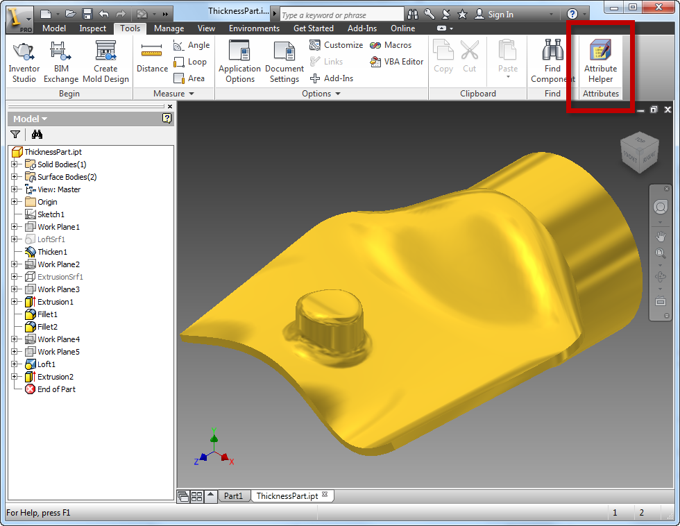

Running the **Attribute Helper** command displays the dialog below.

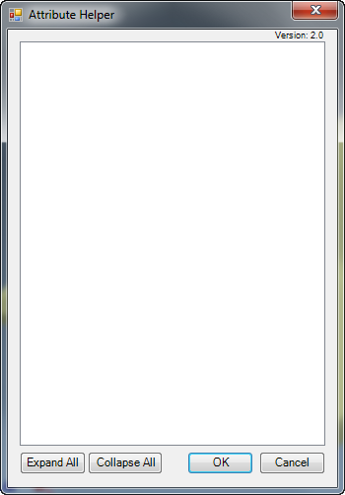

The dialog lists all of the entities that have any attributes associated with them. In the example above there aren’t any attributes in the part so the dialog is empty. You can use the **Attribute Helper** utility to add an attribute set by selecting and right-clicking any entity that supports attributes, while the **Attribute Helper** dialog is displayed. In the example below a face was right-clicked to display the context menu where the **Add Attribute Set** command is. Clicking this command will display a dialog where you can specify the name of the set, as shown below.

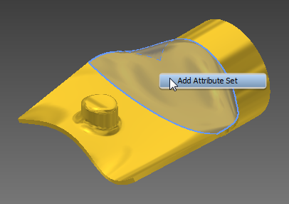 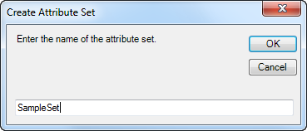

Once the attribute set is added, the dialog is updated to show the entity and associated attribute set, as shown below. Clicking on the entity (Face in this case) will highlight the associated entity in the graphics window.

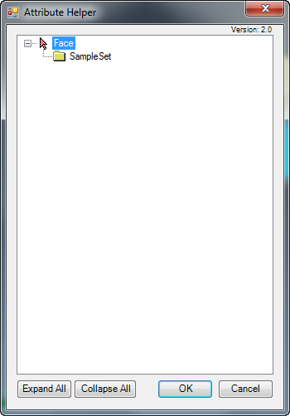

You can edit the name of an attribute set, delete it, or add attributes to it using the utility. If you right-click on the attribute set node in the dialog these are available as options in its context menu.

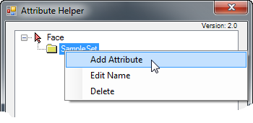

If you create an attribute the dialog shown below is displayed where you can specify the name, select the type, and input the value. The value of a Byte Array type of attribute is set using the syntax shown below; comma delimited numbers where the values can be any number from 0 to 255.

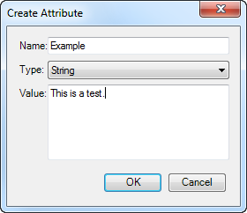 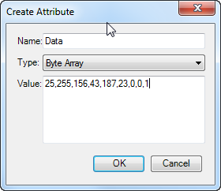

You can double-click or right-click on an attribute node in the dialog to edit its name or value, or to delete the attribute.

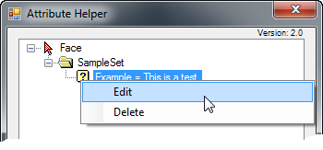

To report problems or to provide comments you can email Brian Ekins at brian.ekins@autodesk.com