Unit 5: HACKERS
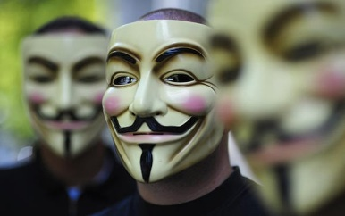
Code is never finished, only abandoned.
Anonymous
WARM-UP
- Look at the pictures below and try to describe them. What associations do you have with these pictures?
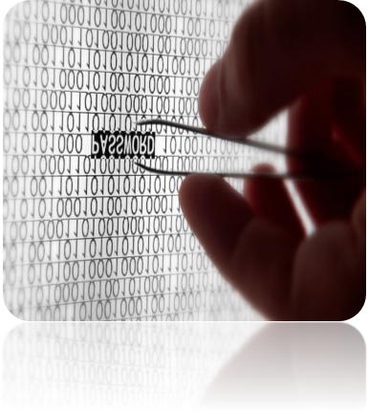 | 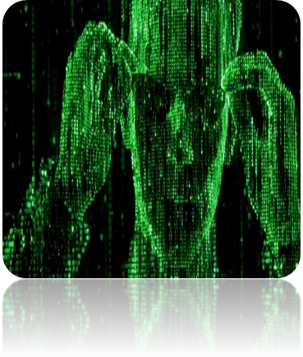
A | B
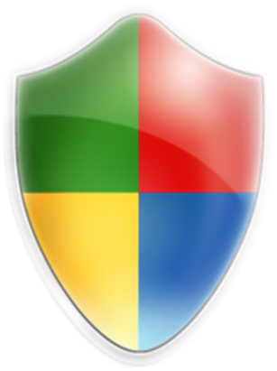 | 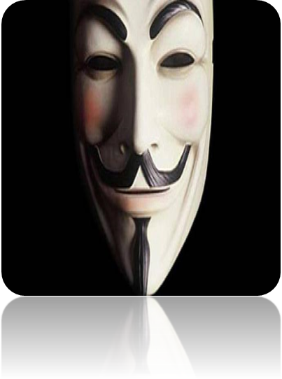
C | D
- Spend one minute writing down all of the different words you associate with the word 'hacker'. Share your words with your partner(s).
- Give your own definitions to the terms "hacker" and "5".
- In pairs, discuss the following questions.
- Why is security so important on the Internet?
- What do we mean when we talk about sensitive information on the Internet?
- How easy do you think it is to infiltrate the Internet and steal sensitive information?
- How can you protect your computer from viruses and spyware?
- What do you know about the history of hacking?
- Who are the most famous hackers in the world?
- How to become a qualified and professional ethical hacker?
- Why do you think hackers do what they do?
- Do you think hackers add to new technology developments? Why (not)?
- What do you think technology companies think about hackers?
- Are you worried someone could hack into your computer?
- Do you think large companies fear hackers? Why (not)?
- Who do you think is ahead of the game, the hackers or the software companies?
- Discuss the following quotations together. Which quotation is closer to your own ideas?
- "Never underestimate the determination of a kid who is time-rich and cash-poor."
Cory Doctorow, Little Brother
- "There are few sources of energy so powerful as a procrastinating college student."
Paul Graham, Hackers & Painters
- "The workstation-class machines built by Sun and the others opened up new worlds for hackers."
Eric S. Raymond
- "Are hackers a threat? The degree of threat presented by any conduct, whether legal or illegal, depends on the actions and intent of the individual and the harm they cause."
Kevin Mitnick
- "Hackers are breaking the systems for profit. Before, it was about intellectual curiosity and pursuit of knowledge and thrill, and now hacking is big business."
Kevin Mitnick
- "Hackers often describe what they do as playfully creative problem solving."
Heather Brook
- Read the facts about hackers below and decide if they are true (T) or false (F).
T | T | T | F | F | T | F
- Hacker originally meant "one who makes furniture with an ax."
- Computer hacking was born in the late 1950s, when members of MIT’s Tech Model Railroad Club, obsessed with electric switching, began preparing punch cards to control an IBM 704 mainframe.
- By the early 1970s, hacker "Cap’n Crunch" (a.k.a. John Draper) had used a toy whistle to match the 2,600-hertz tone used by AT&T’s long-distance switching system. This gave him access to call routing (and brief access to jail).
- Hacking went Hollywood in the 1990 movie WarGames, about a whiz kid who breaks into a Defense Department computer and, at one point, hijacks a pay phone by hot-wiring it with a soda can pull-ring.
- Japanese hacker Gary McKinnon broke into 97 U.S. Navy, Army, Pentagon, and NASA computers in 2001 and 2002.
- It took IBM researcher Scott Lunsford just one day to penetrate the network of a nuclear power station: "I thought, 'Gosh, this is a big problem."
- In 1978 Robert T. Morris created a worm, or self-replicating program, purportedly to evaluate Internet security.
- Match the following types of hackers with their definitions.
Phreaker (telecommunication systems), hobby hacker, academic hacker, computer security hacker, black hat, hacktivist, grey hat, white hat, script kiddy
- _white hat_ has the skills to break into computer systems and do damage. However, they use their skills to help organizations. For example, he might work for an organization to test for security weaknesses and vulnerabilities in the network.
- _black hat_ also known as a cracker uses his skills to break into computer systems for unethical reasons. For example, steal user data like, username and password, credit card numbers, bank information.
- _grey hat_ can be thought of as a white hat attacker who sometimes acts unethically. He could be employed as a legit network security administrator. But, during this person's duties, he may find an opportunity for gaining access to company data and stealing that data.
- _Phreaker_ is simply a hacker of telecommunications. An example of this is tricking the phone system into letting you make free long distance calls.
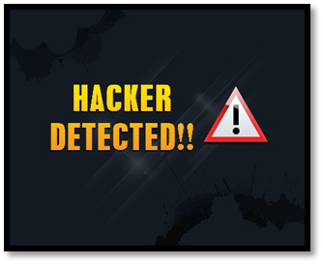
- _script kiddy_ is someone who lacks the skills of a typical hacker. They rely on downloading hacking programs or utilities sometimes calls scripts to perform an attack.
- _hacktivist_ is a person with political motivations, such as someone defacing a website and leaving messages on the hacked site for the world to see.
- _computer security hacker_ knows the technical aspects of computer networking and security. This person could attack a network protected by a firewall or IPS by fragmenting packets.
- _ academic hacker_ is typically an employee or student at an institution of higher education. They would use the institutions computing resources to write malicious programs.
- _hobby hacker_ tends to focus more on home computing. Such as, modifying existing hardware or software, use software without a license, unlock Apple iPhone.
READING
- Underline the stressed syllable in each word as in the example. Practise reading.
diffuse, curtains, effective, transparent, intensity, phosphors, detectable, photodiodes, legible, countermeasures, fluorescent
- Read the text "Hacking at light speed" and answer the following questions.
- What is optical hacking?
- What is the principle of working of optical hacking?
- How can we combat optical hacking?
- How does Kuhn answer this question: "How close does a spy have to be for it to work?"?
- What are the main advantages and disadvantages of optical hacking?
- Find the synonyms to the highlighted words in the text.
HACKING AT LIGHT SPEED

Companies that have spent a small fortune trying to thwart hackers now face a completely new security threat. It's called optical hacking.
Computer scientists at Cambridge University say plain text on a computer screen can now be read at a distance simply by capturing the diffuse glow from the screen. And it works even if the light has bounced off walls and passed through curtains.
Markus Kuhn of the university's computer lab will explain how optical hacking works at an IEEE security conference in Oakland, California. And he'll tell delegates why it could be every bit as effective as snooping on stray radio signals from monitors.
Although you can securely encrypt the data stored on a PC, it has to be decrypted at some point so that you can work with it on screen. Computer scientists have known since the mid-1980s that you can pick up stray electromagnetic signals from a computer screen with a sensitive radio receiver, and display the screen's contents on a modified TV set. Therefore, some firms now install protective metal meshes, casings and cables to stop data leakage, and treat windows with transparent shielding materials.
However, that won't stop someone reading what's on the screen. A basic astronomical telescope makes even small fonts legible up to 60 meters away, so some people keep screens displaying sensitive data well away from windows. But now even that measure has been defeated.
Kuhn has found that it is possible to reconstruct the image of someone's computer screen by grabbing its reflected glow. You don't need to see the screen directly. Its diffuse flickering will do.
Most monitors work like a TV set, using "raster" scanning. An electron beam sweeps across the phosphor dots on the screen line-by-line, and its varying intensity determines how brightly each of the dots glows. The intensity of the beam is governed by the varying voltage of the video signal sent from computer to monitor.
Screen phosphors have an afterglow of milliseconds, which helps to ensure that the eye sees a complete picture rather than a moving spot of light. But there is a sharp, detectable fall-off in intensity as soon as the beam leaves the phosphor spot. As the beam scans the dots, its fluctuating brightness can be picked up by off-the-shelf light sensors called photodiodes.
Kuhn's team used an electronic filter to reduce the "noise" produced by ambient light, and they easily "tuned out" light from electric lamps because it flickers at a different frequency to the monitor. When the remaining signal was processed and fed to another monitor, the text from the original screen was clearly legible, Kuhn says. A snooper could even record these screen images on a video, and then read them at their leisure.
So how close does a spy have to be for it to work? Not very Kuhn says you could pick up the signal from 100 meters away or more by using a telescope to home in on a patch of reflected screen light on, say, a ceiling tile in an office block.
Kuhn says exposing this new risk will help people take countermeasures. Simple solutions include swamping the screen glow by choosing fluorescent office lights with similar phosphors to the monitor. Avoiding darkened rooms, and using flat LCD screens, which are dimmer and have slower refresh rates, should make signals harder to track.
From New Scientist
- Look through the list of words and phrases and check if you know their Ukrainian equivalents. Take turns to ask each other. Use the MINI-DICTIONARY section to Unit 2 if necessary.
optical hacking | to reduce the noise
to spent a fortune | to stop data leakage
to thwart hackers | transparent shielding materials
to face a new security threat | to make small fonts legible
diffuse glow | reflected glow
stray signals | intensity
screen's contents | off-the-shelf light sensors
protective metal meshes | ambient light
to take countermeasures | to swamp
to refresh rate | to track
- Explain the meaning of the words and phrases.
a fortune, shielding materials, legible, sensitive data, to reconstruct, intensity, a fall-off, data leakage, off-the-shelf, to take countermeasures, to swamp, to avoid

